ANTENNA QY73606XL4D29
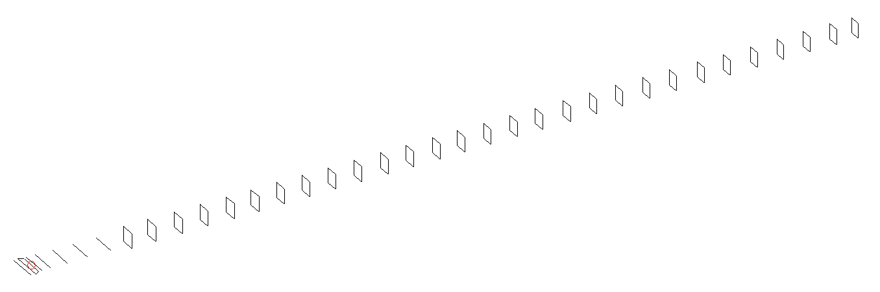
DESCRIPTION
Radiator |  |  |  |  | Number of  yagi elements |  |  |  |  |  | Number of  oblong elements |  |  |  |  |  | Total number  of elements |  |  |  |  |  |  | Boomlength  (mm)
LFA |  |  |  |  | 6 |  |  |  |  |  | 29 |  |  |  |  |  | 36 |  |  |  |  |  |  | 9425
DIMENSIONS
 | Ref |  | De1 |  |  | De2 |  | D1 | D2 |  |  |  | D3 |  | D4 | D5 |  |  |  |  | DQ1 | DQ2 |  |  | DQ3 |  |  | DQ4 |  | DQ5
Position | 0 |  | 60 |  |  | 105 |  | 143 | 244 |  |  |  | 428 |  | 659 | 917 |  |  |  |  | 1192 | 1467 |  |  | 1756 |  |  | 2062 |  | 2352
Length | 333 |  | 332 |  |  | 332 |  | 303.5 | 307.5 |  |  |  | 298 |  | 291 | 284 |  |  |  |  | 171 | 165 |  |  | 162 |  |  | 159 |  | 157
 | DQ6 |  | DQ7 |  |  | DQ8 |  | DQ9 | DQ10 |  |  |  | DQ11 |  | DQ12 | DQ13 |  |  |  |  | DQ14 | DQ15 |  |  | DQ16 |  |  | DQ17 |  | DQ18
Position | 2649 |  | 2935 |  |  | 3221 |  | 3507 | 3796 |  |  |  | 4072 |  | 4362 | 4638 |  |  |  |  | 4930 | 5225 |  |  | 5503 |  |  | 5815 |  | 6114
Length | 156 |  | 155 |  |  | 154 |  | 153 | 152 |  |  |  | 151 |  | 150 | 149 |  |  |  |  | 148 | 147 |  |  | 146 |  |  | 145 |  | 144
 | DQ19 |  | DQ20 |  |  | DQ21 |  | DQ22 | DQ23 |  |  |  | DQ24 |  | DQ25 | DQ26 |  |  |  |  | DQ27 | DQ28 |  |  | DQ29
Position | 6421 |  | 6719 |  |  | 7039 |  | 7361 | 7657 |  |  |  | 7971 |  | 8274 | 8585 |  |  |  |  | 8880 | 9168 |  |  | 9425
Length | 143 |  | 142 |  |  | 141 |  | 140 | 139 |  |  |  | 138 |  | 137 | 137 |  |  |  |  | 137 | 132 |  |  | 132
Remark | All elements made of Al tubes Ǿ6 mm  The height of rectangles is 170 mm  All dimensions given in milimetres
PERFORMANCES (No loss condition)
G  (dBi) |  | F/B  (dB) |  |  |  |  | F/Sh  (dBi) |  |  | F/Sv  (dBi) |  |  |  | Hor  (◦) |  |  |  |  |  | Ver  (◦) |  |  | Temp  (◦K) |  |  |  |  |  | G/T  (dB)
20.98 |  | 33.60 |  |  |  |  | 18.48 |  |  | 17.50 |  |  |  | 18.2 |  |  |  |  |  | 18.2 |  |  | 25.0 |  |  |  |  |  | +7.54
DIAGRAMS
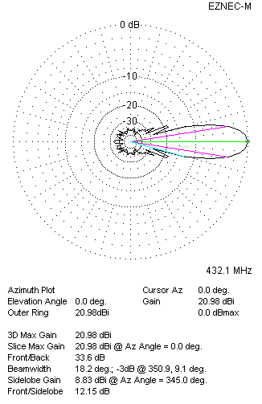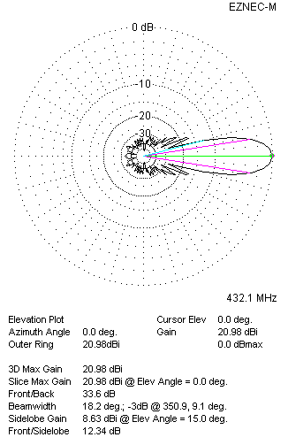
Horizontal and verticall pattern in free space, no loss condition
PERFORMANCES (Loss included for aluminum)
Aluminum |  |  |  |  |  |  | G  (dBi) |  |  | Tloss  (K) |  |  |  | T_{A}  (◦K) |  |  |  |  |  | G/T  (dB) |  |  | Bandwidth for SWR=1.5  (MHz)
After NEC/EZNEC |  |  |  |  |  |  | 20.91 |  |  | 4.9 |  |  |  | 25.1 |  |  |  |  |  | +6.64 |  |  | 424.000 – 438.700
After KF2YN correction |  |  |  |  |  |  | 20.86 |  |  | 4.9 |  |  |  | 29.5 |  |  |  |  |  | +6.17
Remark: Red coloured data are the final antenna data, which means: KF2YN correction formula applied and loss for aluminum included
DIAGRAMS
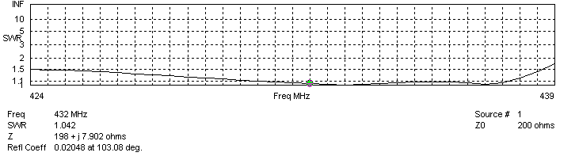
Frequency diagram for SWR better than 1.5
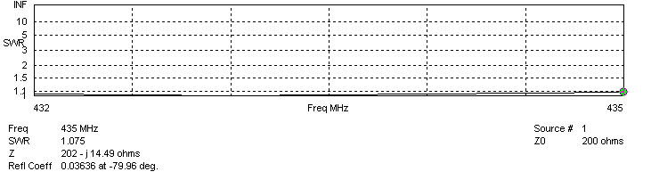
SWR diagram for the range from 432.000 – 435.000 MHz
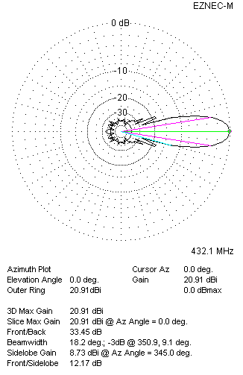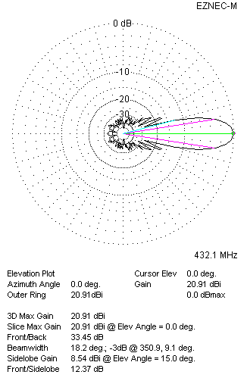
Horizontal and vertical pattern in free space, loss included for aluminum
STACKING
(ALL DATA GIVEN IN ACCORDANCE WITH KF2YN CORRECTION, LOSS INCLUDED)
RECOMMENDED STACKING DISTANCES
 |  |  |  |  |  |  | Two antennas vertically  (mm) |  |  |  |  |  |  | Two antennas horizontally  (mm) |  |  |  |  |  |  |  |  | Four antennas in H-stack  (mm)
Horizontal distance |  |  |  |  |  |  |  |  |  |  |  |  |  | 2780 |  |  |  |  |  |  |  |  | 2780
Vertical distance |  |  |  |  |  |  | 2620 |  |  |  |  |  |  |  |  |  |  |  |  |  |  |  | 2620
TWO ANTENNAS STACKED VERTICALLY
DISTANCE  (mm) |  |  |  | G  (dBi) |  |  |  |  |  |  |  | TA  (K) |  |  |  |  |  | Tloss  (K) |  |  |  |  |  |  |  | G/T  (dB)
2620 |  |  |  | 23.90 |  |  |  |  |  |  |  | 29.9 |  |  |  |  |  | 4.9 |  |  |  |  |  |  |  | +9.15
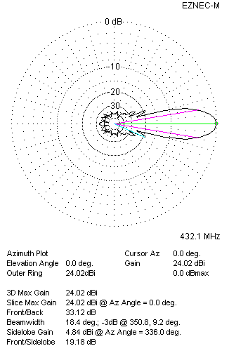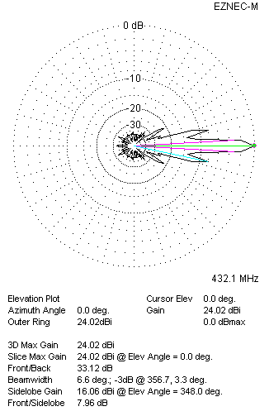
Two antennas stacked vertically
TWO ANTENNAS STACKED HORIZONTALLY
DISTANCE  (mm) |  |  |  | G  (dBi) |  |  |  |  |  |  |  | TA  (K) |  |  |  |  |  |  | Tloss  (K) |  |  |  |  |  |  |  | G/T  (dB)
2720 |  |  |  | 23.92 |  |  |  |  |  |  |  | 29.2 |  |  |  |  |  |  | 4.9 |  |  |  |  |  |  |  | +9.27
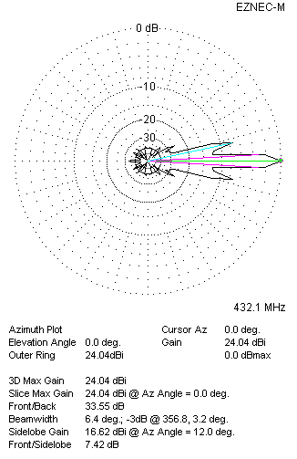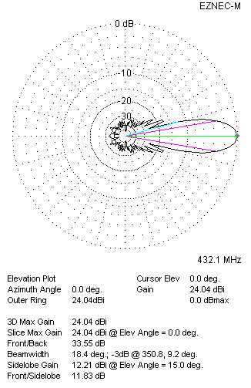
Two antennas stacked horizontally
FOUR ANTENNAS IN H-STACK
DISTANCE  (mm) |  |  |  | G  (dBi) |  |  |  |  |  |  |  | TA  (K) |  |  |  |  |  |  | Tloss  (K) |  |  |  |  |  |  |  | G/T  (dB)
H = 2720 |  |  |  | 26.96 |  |  |  |  |  |  |  | 29.7 |  |  |  |  |  |  | 4.9 |  |  |  |  |  |  |  | +12.24
V = 2620
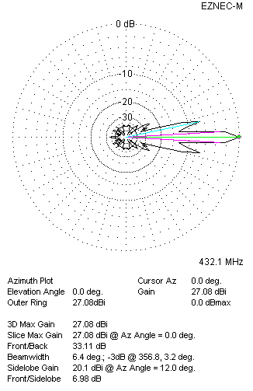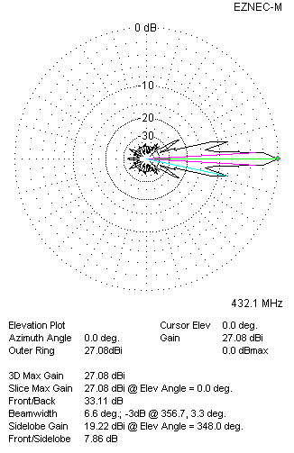
Four antennas in H-stack

