ANTENNA QY73006XL3D23
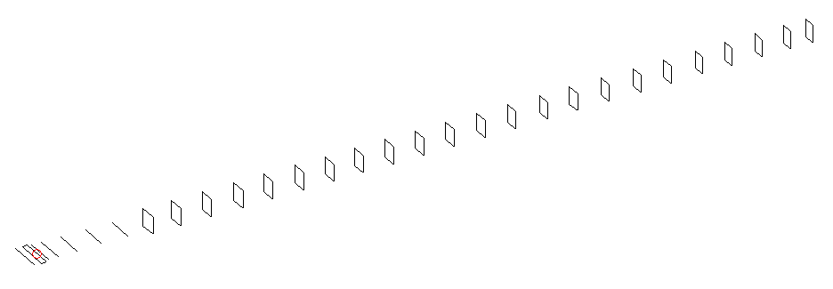
DESCRIPTION
Radiator |  |  | Number of  yagi elements |  |  | Number of  oblong elements |  |  |  | Total number  of elements |  |  | Boomlength  (mm)
LFA |  |  | 6 |  |  | 23 |  |  |  | 30 |  |  | 7615
DIMENSIONS
 | Ref | De1 |  | De2 | D1 |  | D2 | D3 | D4 |  | D5 | DQ1 |  | DQ2 | DQ3
Position | 0 | 50 |  | 100 | 138 |  | 239 | 425 | 666 |  | 924 | 1195 |  | 1467 | 1761
Length | 334 | 361 |  | 288 | 309.5 |  | 309 | 297.5 | 291 |  | 285 | 172 |  | 164 | 162
 | DQ4 | DQ5 |  | DQ6 | DQ7 |  | DQ8 | DQ9 | DQ10 |  | DQ11 | DQ12 |  | DQ13 | DQ14
Position | 2053 | 2342 |  | 2625 | 2921 |  | 3209 | 3502 | 3804 |  | 4099 | 4383 |  | 4686 | 4968
Length | 160 | 158 |  | 156 | 154 |  | 152 | 150 | 149 |  | 148 | 148 |  | 147 | 147
 | DQ15 | DQ16 |  | DQ17 | DQ18 |  | DQ19 | DQ20 | DQ21 |  | DQ22 | DQ23
Position | 5257 | 5559 |  | 5845 | 6159 |  | 6461 | 6767 | 7064 |  | 7356 | 7615
Length | 145 | 145 |  | 143 | 143 |  | 141 | 141 | 141 |  | 135 | 133

Remark | All elements made of Al tubes Ǿ6 mm  The height of rectangles is 170 mm  All dimensions given in milimetres
PERFORMANCES (No loss condition)
G  (dBi) |  | F/B  (dB) |  | F/Sh  (dBi) | F/Sv  (dBi) |  | Hor  (◦) |  |  | Ver  (◦) | Temp  (◦K) |  |  | G/T  (dB)
20.18 |  | 45.56 |  | 18.29 | 16.61 |  | 19.8 |  |  | 20.0 | 24.6 |  |  | +7.01
DIAGRAMS
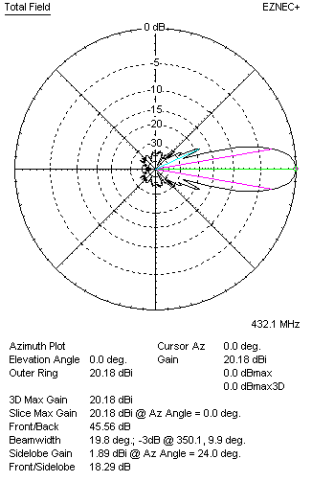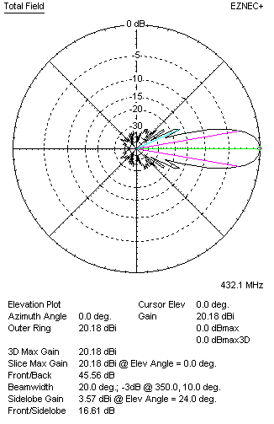
Horizontal and verticall pattern in free space, no loss condition
PERFORMANCES (Loss included for aluminum)
Aluminum |  |  |  | G  (dBi) | Tloss  (K) |  | T_{A}  (◦K) |  |  | G/T  (dB) | Bandwidth for SWR=1.5  (MHz)
After NEC/EZNEC |  |  |  | 20.10 | 5.2 |  | 24.6 |  |  | +5.99 | 419.500 – 437.200
After KF2YN correction |  |  |  | 20.04 | 5.2 |  | 29.2 |  |  | +5.39
Remark: Red coloured data are the final antenna data, which means: KF2YN correction formula applied and loss for aluminum included
DIAGRAMS
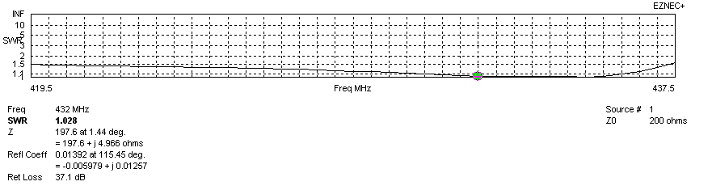
Frequency diagram for SWR better than 1.5
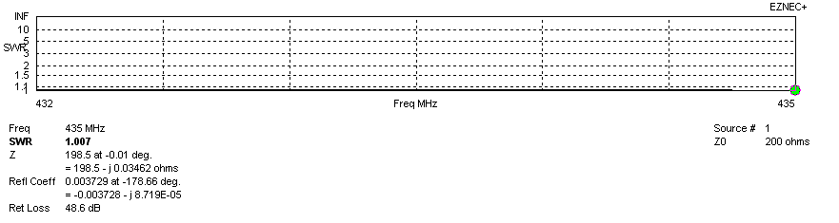
SWR diagram for the range from 432.000 – 435.000 MHz
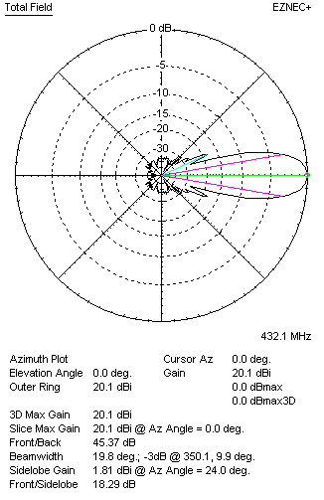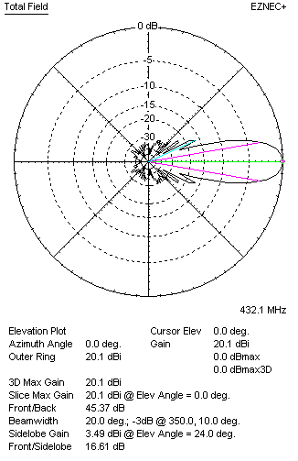
Horizontal and vertical pattern in free space, loss included for aluminum
STACKING
(ALL DATA GIVEN IN ACCORDANCE WITH KF2YN CORRECTION, LOSS INCLUDED)
RECOMMENDED STACKING DISTANCES
 |  |  |  | Two antennas vertically  (mm) |  |  | Two antennas horizontally  (mm) |  |  |  | Four antennas in H-stack  (mm)
Horizontal distance |  |  |  |  |  |  | 2620 |  |  |  | 2620
Vertical distance |  |  |  | 2120 |  |  |  |  |  |  | 2120
TWO ANTENNAS STACKED VERTICALLY
DISTANCE  (mm) |  |  | G  (dBi) |  |  | TA  (K) |  | Tloss  (K) |  |  |  | G/T  (dB)
2120 |  |  | 22.99 |  |  | 28.8 |  | 5.2 |  |  |  | +8.39
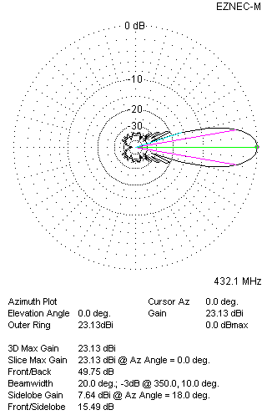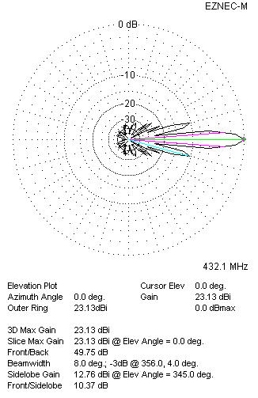
Two antennas stacked vertically
TWO ANTENNAS STACKED HORIZONTALLY
DISTANCE  (mm) |  |  | G  (dBi) |  |  | TA  (K) |  |  | Tloss  (K) |  |  |  | G/T  (dB)
2620 |  |  | 23.12 |  |  | 29.1 |  |  | 5.2 |  |  |  | +8.48
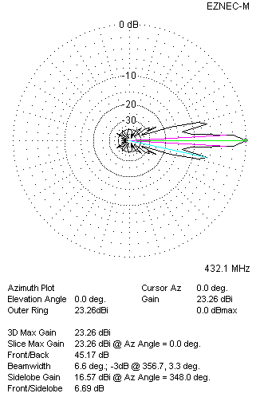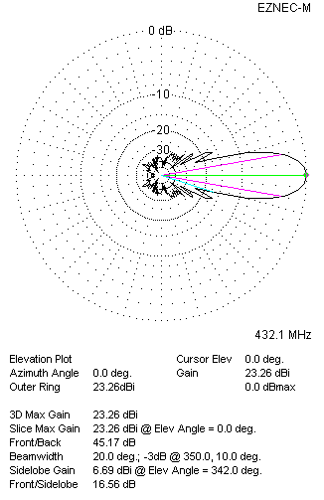
Two antennas stacked horizontally
FOUR ANTENNAS IN H-STACK
DISTANCE  (mm) |  |  | G  (dBi) |  |  | TA  (K) |  |  | Tloss  (K) |  |  |  | G/T  (dB)
H = 2620 |  |  | 26.07 |  |  | 28.6 |  |  | 5.2 |  |  |  | +11.50
V = 2120
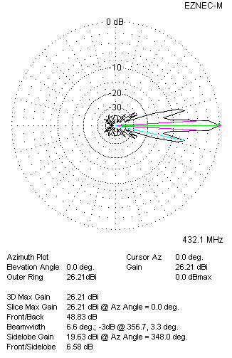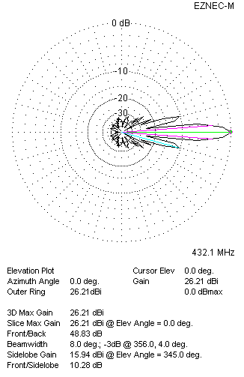
Four antennas in H-stack

