ANTENNA QY73005XL3D23
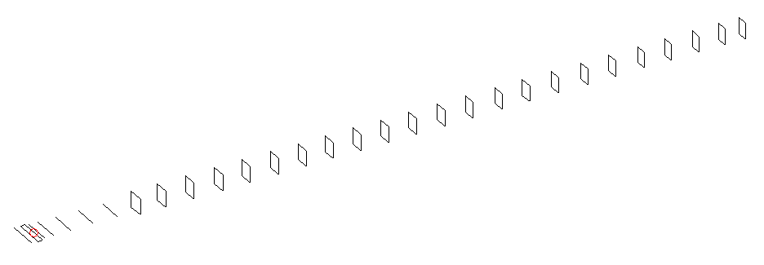
DESCRIPTION
Radiator |  |  | Number of  yagi elements |  |  | Number of  oblong elements |  |  |  | Total number  of elements |  |  | Boomlength  (mm)
LFA |  |  | 6 |  |  | 23 |  |  |  | 30 |  |  | 7615
DIMENSIONS
 | Ref | De1 |  | De2 | D1 |  | D2 | D3 | D4 |  | D5 | DQ1 |  | DQ2 | DQ3
Position | 0 | 50 |  | 100 | 136 |  | 238 | 424 | 665 |  | 929 | 1196 |  | 1468 | 1756
Length | 336 | 370 |  | 288 | 312 |  | 310.5 | 299.5 | 293.5 |  | 287 | 173 |  | 165 | 163
 | DQ4 | DQ5 |  | DQ6 | DQ7 |  | DQ8 | DQ9 | DQ10 |  | DQ11 | DQ12 |  | DQ13 | DQ14
Position | 2048 | 2342 |  | 2624 | 2921 |  | 3209 | 3503 | 3804 |  | 4098 | 4381 |  | 4685 | 4969
Length | 159 | 157 |  | 155 | 154 |  | 152 | 150 | 149 |  | 149 | 149 |  | 147 | 147
 | DQ15 | DQ16 |  | DQ17 | DQ18 |  | DQ19 | DQ20 | DQ21 |  | DQ22 | DQ23
Position | 5257 | 5559 |  | 5847 | 6154 |  | 6454 | 6765 | 7062 |  | 7364 | 7615
Length | 147 | 147 |  | 143 | 143 |  | 143 | 143 | 139 |  | 135 | 133

Remark | All elements made of Al tubes Ǿ5 mm  The height of rectangles is 170 mm  All dimensions given in milimetres
PERFORMANCES (No loss condition)
G  (dBi) |  | F/B  (dB) |  | F/Sh  (dBi) | F/Sv  (dBi) |  | Hor  (◦) |  |  | Ver  (◦) | Temp  (◦K) |  |  | G/T  (dB)
20.12 |  | 46.44 |  | 18.14 | 16.47 |  | 20.0 |  |  | 20.0 | 24.7 |  |  | +6.88
DIAGRAMS
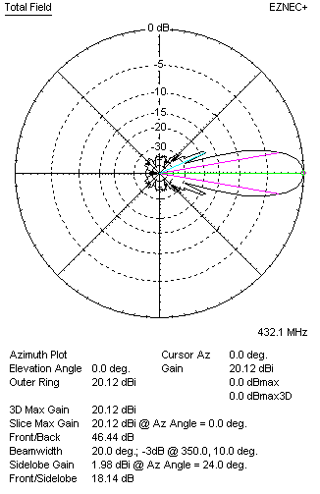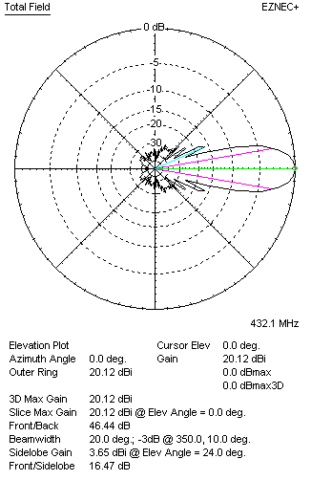
Horizontal and verticall pattern in free space, no loss condition
PERFORMANCES (Loss included for aluminum)
Aluminum |  |  |  | G  (dBi) | Tloss  (K) |  | T_{A}  (◦K) |  |  | G/T  (dB) | Bandwidth for SWR=1.5  (MHz)
After NEC/EZNEC |  |  |  | 20.03 | 6.0 |  | 24.7 |  |  | +5.78 | 411.400 – 437.500
After KF2YN correction |  |  |  | 19.97 | 6.0 |  | 30.2 |  |  | +5.17
Remark: Red coloured data are the final antenna data, which means: KF2YN correction formula applied and loss for aluminum included
DIAGRAMS
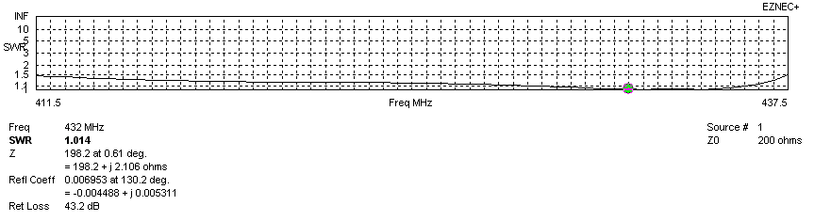
Frequency diagram for SWR better than 1.5
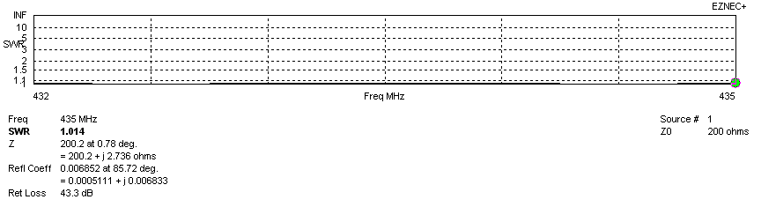
SWR diagram for the range from 432.000 – 435.000 MHz
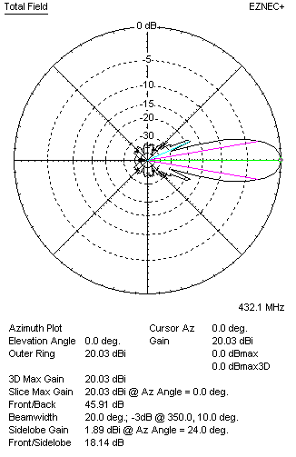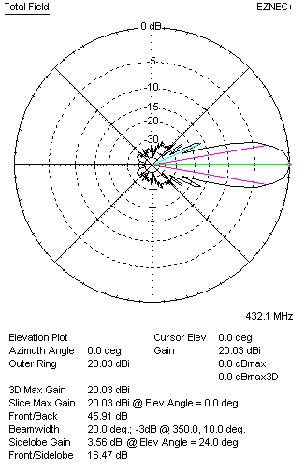
Horizontal and vertical pattern in free space, loss included for aluminum
STACKING
(ALL DATA GIVEN IN ACCORDANCE WITH KF2YN CORRECTION, LOSS INCLUDED)
RECOMMENDED STACKING DISTANCES
 |  |  |  | Two antennas vertically  (mm) |  |  | Two antennas horizontally  (mm) |  |  |  | Four antennas in H-stack  (mm)
Horizontal distance |  |  |  |  |  |  | 2540 |  |  |  | 2540
Vertical distance |  |  |  | 1980 |  |  |  |  |  |  | 1980
TWO ANTENNAS STACKED VERTICALLY
DISTANCE  (mm) |  |  | G  (dBi) |  |  | TA  (K) |  | Tloss  (K) |  |  |  | G/T  (dB)
1980 |  |  | 22.83 |  |  | 29.4 |  | 6.0 |  |  |  | +8.14
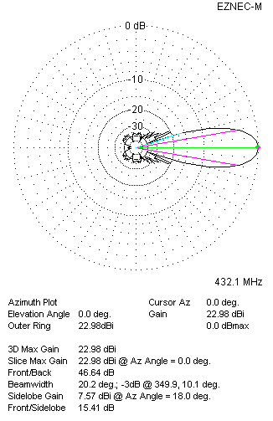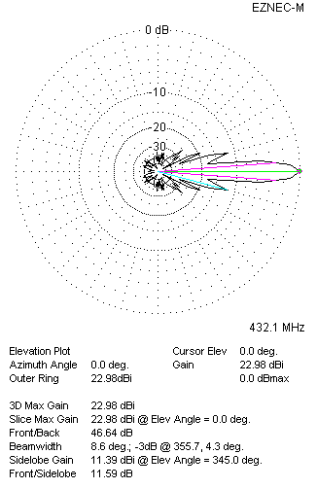
Two antennas stacked vertically
TWO ANTENNAS STACKED HORIZONTALLY
DISTANCE  (mm) |  |  | G  (dBi) |  |  | TA  (K) |  |  | Tloss  (K) |  |  |  | G/T  (dB)
2540 |  |  | 23.05 |  |  | 30.0 |  |  | 6.0 |  |  |  | +8.28
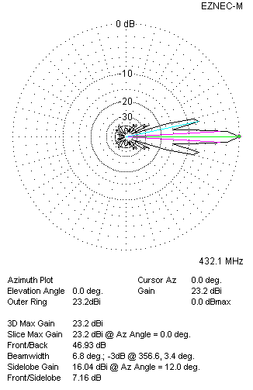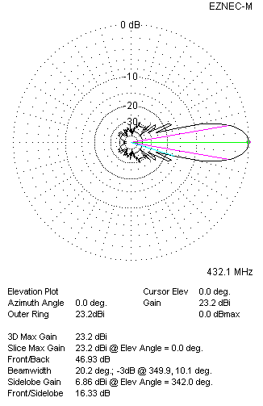
Two antennas stacked horizontally
FOUR ANTENNAS IN H-STACK
DISTANCE  (mm) |  |  | G  (dBi) |  |  | TA  (K) |  |  | Tloss  (K) |  |  |  | G/T  (dB)
H = 2540 |  |  | 25.93 |  |  | 29.1 |  |  | 6.0 |  |  |  | +11.29
V = 1980
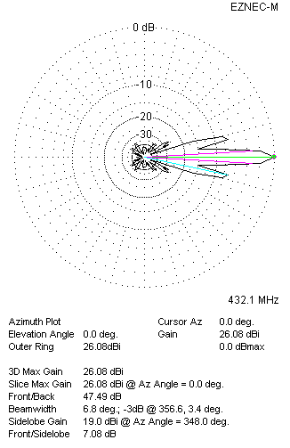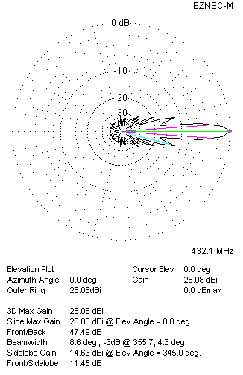
Four antennas in H-stack

