ANTENNA QY72808XL8D21
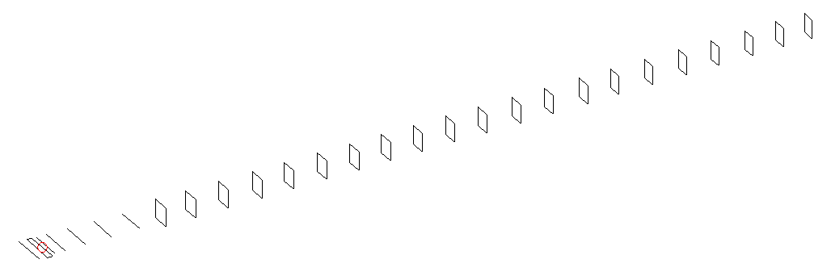
DESCRIPTION
Radiator |  |  | Number of  yagi elements |  |  | Number of  oblong elements |  |  | Total number  of elements |  |  | Boomlength  (mm)
LFA |  |  | 6 |  |  | 21 |  |  | 28 |  |  | 7125
DIMENSIONS
 | Ref | De1 |  | De2 | D1 |  | D2 | D3 |  | D4 | D5 |  | DQ1 | DQ2
Position | 0 | 55 |  | 115 | 151 |  | 249 | 431 |  | 659 | 918 |  | 1182 | 1458
Length | 333 | 336 |  | 336 | 306 |  | 305.5 | 295 |  | 289 | 280 |  | 173.5 | 164.5
 | DQ3 | DQ4 |  | DQ5 | DQ6 |  | DQ7 | DQ8 |  | DQ9 | DQ10 |  | DQ11 | DQ12
Position | 1749 | 2045 |  | 2336 | 2625 |  | 2924 | 3203 |  | 3498 | 3792 |  | 4095 | 4377
Length | 160.5 | 158.5 |  | 156.5 | 154.5 |  | 152.5 | 151.5 |  | 149.5 | 149 |  | 148 | 148
 | DQ13 | DQ14 |  | DQ15 | DQ16 |  | DQ17 | DQ18 |  | DQ19 | DQ20 |  | DQ21
Position | 4675 | 4965 |  | 5262 | 5550 |  | 5867 | 6143 |  | 6465 | 6755 |  | 7015
Length | 147 | 146 |  | 144 | 144 |  | 144 | 144 |  | 144 | 141 |  | 141

Remark | All elements made of Al tubes Ǿ8 mm, except LFA radiator which is 6 mm  The height of rectangles is 170 mm  All dimensions given in milimetres
PERFORMANCES (No loss condition)
G  (dBi) |  | F/B  (dB) |  | F/Sh  (dBi) | F/Sv  (dBi) |  | Hor  (◦) |  |  | Ver  (◦) | Temp  (◦K) |  |  | G/T  (dB)
19.96 |  | 33.74 |  | 17.97 | 16.74 |  | 20.0 |  |  | 20.2 | 25.5 |  |  | +6.39
DIAGRAMS
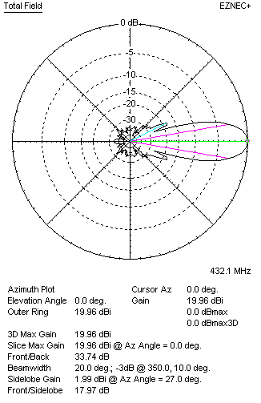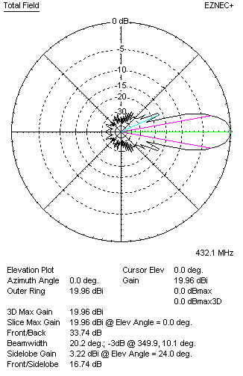
Horizontal and verticall pattern in free space, no loss condition
PERFORMANCES (Loss included for aluminum)
Aluminum |  |  |  | G  (dBi) | Tloss  (K) |  | T_{A}  (◦K) |  |  | G/T  (dB) | Bandwidth for SWR=1.5  (MHz)
After NEC/EZNEC |  |  |  | 19.90 | 4.3 |  | 25.6 |  |  | +5.59 | 412.000 – 436.900
After KF2YN correction |  |  |  | 19.85 | 4.3 |  | 29.4 |  |  | +5.16
Remark: Red coloured data are the final antenna data, which means: KF2YN correction formula applied and loss for aluminum included
DIAGRAMS
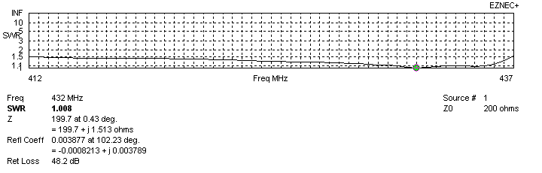
Frequency diagram for SWR better than 1.5
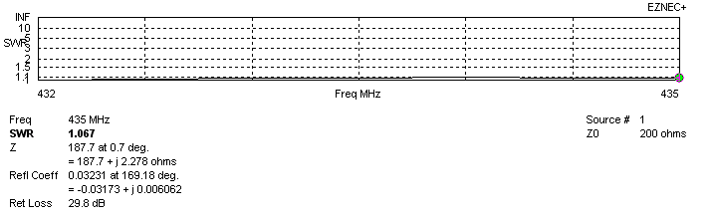
SWR diagram for the range from 432.000 – 435.000 MHz
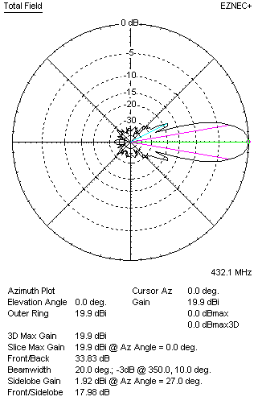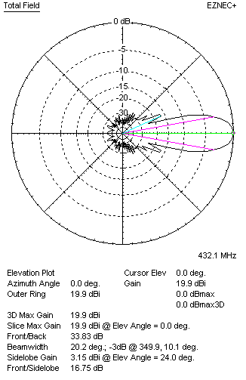
Horizontal and vertical pattern in free space, loss included for aluminum
STACKING
(ALL DATA GIVEN IN ACCORDANCE WITH KF2YN CORRECTION, LOSS INCLUDED)
RECOMMENDED STACKING DISTANCES
 |  |  |  | Two antennas vertically  (mm) |  |  | Two antennas horizontally  (mm) |  |  |  | Four antennas in H-stack  (mm)
Horizontal distance |  |  |  |  |  |  | 2480 |  |  |  | 2480
Vertical distance |  |  |  | 2000 |  |  |  |  |  |  | 2000
TWO ANTENNAS STACKED VERTICALLY
DISTANCE  (mm) |  |  | G  (dBi) |  |  | TA  (K) |  | Tloss  (K) |  |  |  | G/T  (dB)
2000 |  |  | 22.78 |  |  | 28.4 |  | 4.3 |  |  |  | +8.09
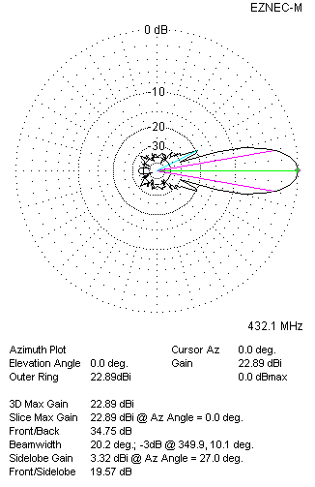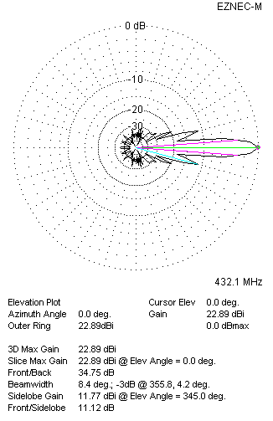
Two antennas stacked vertically
TWO ANTENNAS STACKED HORIZONTALLY
DISTANCE  (mm) |  |  | G  (dBi) |  |  | TA  (K) |  |  | Tloss  (K) |  |  |  | G/T  (dB)
2480 |  |  | 22.93 |  |  | 29.2 |  |  | 4.3 |  |  |  | +8.27
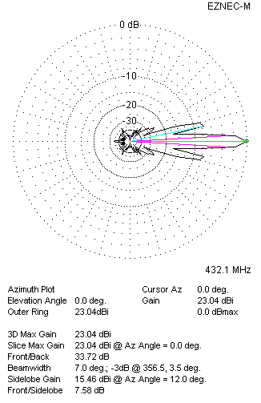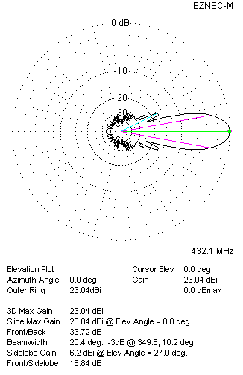
Two antennas stacked horizontally
FOUR ANTENNAS IN H-STACK
DISTANCE  (mm) |  |  | G  (dBi) |  |  | TA  (K) |  |  | Tloss  (K) |  |  |  | G/T  (dB)
H = 2480 |  |  | 25.87 |  |  | 28.3 |  |  | 4.3 |  |  |  | +11.35
V = 2000
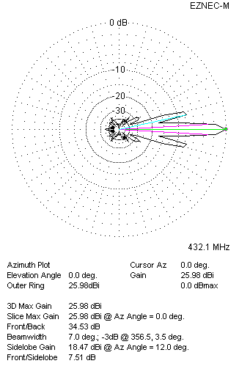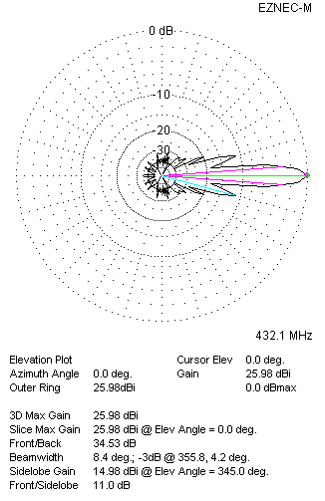
Four antennas in H-stack

