ANTENNA QY72310XL7D16
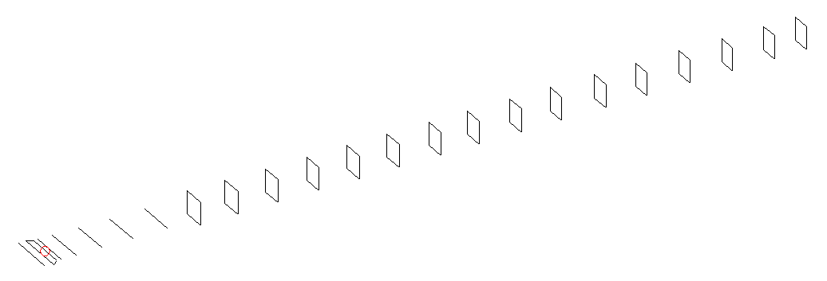
DESCRIPTION
Radiator |  |  | Number of  yagi elements |  |  | Number of  oblong elements |  |  |  | Total number  of elements |  |  |  | Boomlength  (mm)
LFA |  |  | 6 |  |  | 16 |  |  |  | 23 |  |  |  | 5595
DIMENSIONS
 | Ref | De1 |  | De2 | D1 |  | D2 | D3 | D4 |  | D5 | DQ1 | DQ2 |  | DQ3 | DQ4
Position | 0 | 70 |  | 120 | 152 |  | 246 | 435 | 672 |  | 932 | 1203 | 1478 |  | 1775 | 2086
Length | 331 | 330 |  | 330 | 295 |  | 301 | 289.5 | 281.5 |  | 274 | 171 | 163 |  | 157 | 155
 | DQ5 | DQ6 |  | DQ7 | DQ8 |  | DQ9 | DQ10 | DQ11 |  | DQ12 | DQ13 | DQ14 |  | DQ15 | DQ16
Position | 2378 | 2678 |  | 2972 | 3262 |  | 3556 | 3852 | 4148 |  | 4454 | 4752 | 5058 |  | 5346 | 5595
Length | 153 | 151 |  | 147 | 143 |  | 139 | 135 | 133 |  | 131 | 131 | 131 |  | 129 | 123

Remark | All elements made of Al tubes Ǿ10 mm  The height of rectangles is 170 mm  All dimensions given in milimetres
PERFORMANCES (No loss condition)
G  (dBi) |  | F/B  (dB) |  | F/Sh  (dBi) | F/Sv  (dBi) |  | Hor  (◦) |  |  | Ver  (◦) | Temp  (◦K) |  |  | G/T  (dB)
18.65 |  | 35.34 |  | 24.47 | 20.34 |  | 24.2 |  |  | 24.6 | 24.0 |  |  | +5.44
DIAGRAMS
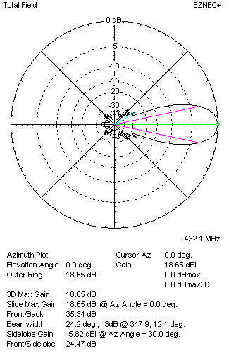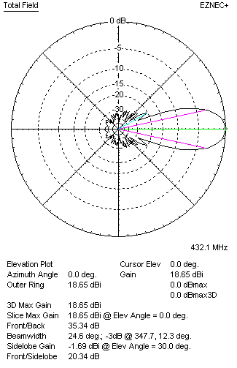
Horizontal and verticall pattern in free space, no loss condition
PERFORMANCES (Loss included for aluminum)
Aluminum |  |  |  | G  (dBi) | Tloss  (K) |  | T_{A}  (◦K) |  |  | G/T  (dB) | Bandwidth for SWR=1.5  (MHz)
After NEC/EZNEC |  |  |  | 18.61 | 3.2 |  | 24.0 |  |  | +4.85 | 425.500 – 437.800
After KF2YN correction |  |  |  | 18.55 | 3.2 |  | 26.9 |  |  | +4.25
Remark: Red coloured data are the final antenna data, which means: KF2YN correction formula applied and loss for aluminum included
DIAGRAMS
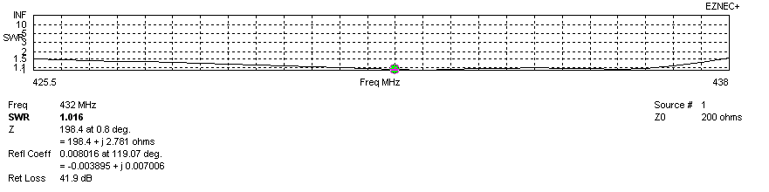
Frequency diagram for SWR better than 1.5
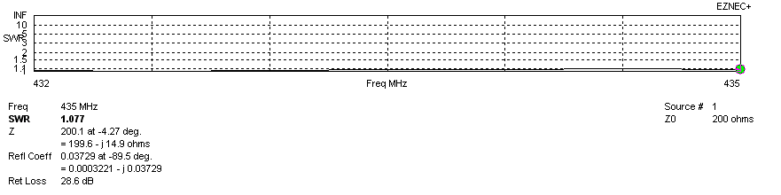
SWR diagram for the range from 432.000 – 435.000 MHz
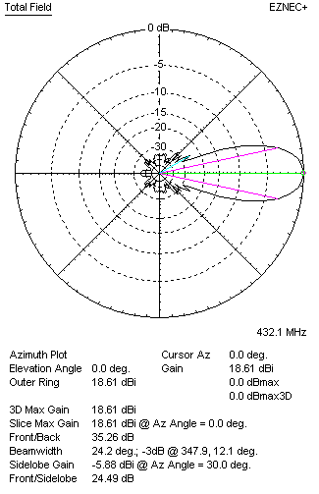 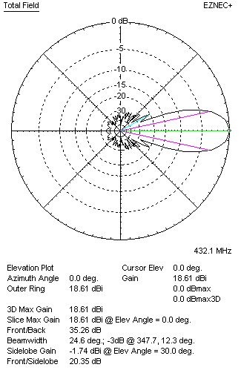Horizontal and vertical pattern in free space, loss included for aluminum
STACKING
(ALL DATA GIVEN IN ACCORDANCE WITH KF2YN CORRECTION, LOSS INCLUDED)
RECOMMENDED STACKING DISTANCES
 |  |  |  | Two antennas vertically  (mm) |  |  | Two antennas horizontally  (mm) |  |  |  | Four antennas in H-stack  (mm)
Horizontal distance |  |  |  |  |  |  | 2020 |  |  |  | 2020
Vertical distance |  |  |  | 1900 |  |  |  |  |  |  | 1900
TWO ANTENNAS STACKED VERTICALLY
DISTANCE  (mm) |  |  | G  (dBi) |  |  | TA  (K) |  | Tloss  (K) |  |  |  | G/T  (dB)
1900 |  |  | 21.56 |  |  | 26.3 |  | 3.2 |  |  |  | +7.36
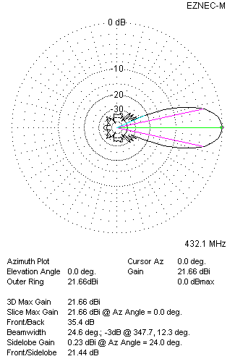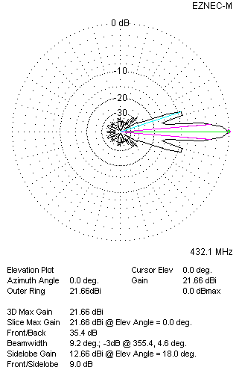
Two antennas stacked vertically
TWO ANTENNAS STACKED HORIZONTALLY
DISTANCE  (mm) |  |  | G  (dBi) |  |  | TA  (K) |  |  | Tloss  (K) |  |  |  | G/T  (dB)
2020 |  |  | 21.58 |  |  | 26.7 |  |  | 3.2 |  |  |  | +7.32
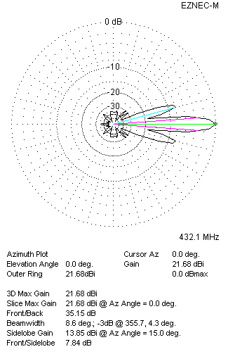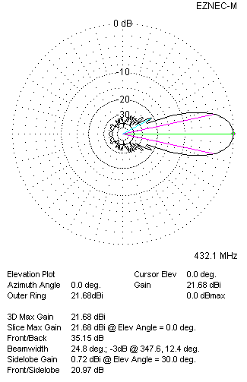
Two antennas stacked horizontally
FOUR ANTENNAS IN H-STACK
DISTANCE  (mm) |  |  | G  (dBi) |  |  | TA  (K) |  |  | Tloss  (K) |  |  |  | G/T  (dB)
H = 2020 |  |  | 24.60 |  |  | 26.0 |  |  | 3.2 |  |  |  | +10.45
V = 1900
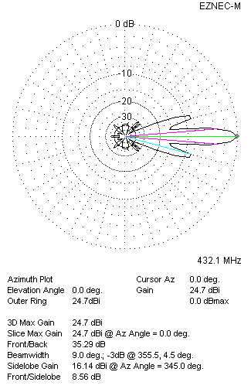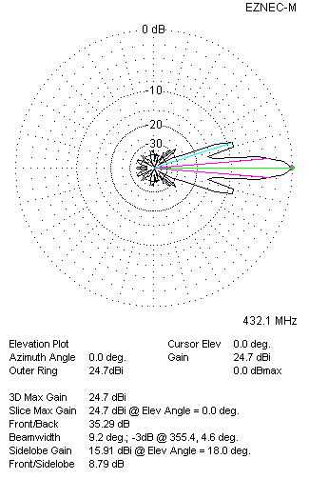
Four antennas in H-stack

