ANTENNA QY72308XL4D16
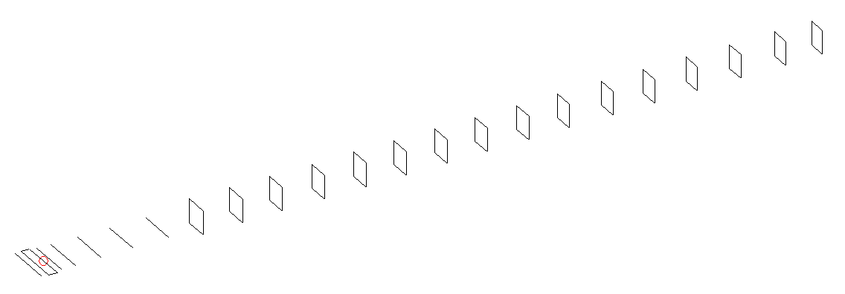
DESCRIPTION
Radiator |  |  | Number of  yagi elements |  |  | Number of  oblong elements |  |  |  | Total number  of elements |  |  |  | Boomlength  (mm)
LFA |  |  | 6 |  |  | 16 |  |  |  | 23 |  |  |  | 5595
DIMENSIONS
 | Ref | De1 |  | De2 | D1 |  | D2 | D3 | D4 |  | D5 | DQ1 | DQ2 |  | DQ3 | DQ4
Position | 0 | 45 |  | 97 | 128 |  | 220 | 406 | 626 |  | 886 | 1161 | 1439 |  | 1729 | 2034
Length | 331 | 331 |  | 331 | 303 |  | 305 | 294 | 287 |  | 278.5 | 170 | 164 |  | 158 | 153
 | DQ5 | DQ6 |  | DQ7 | DQ8 |  | DQ9 | DQ10 | DQ11 |  | DQ12 | DQ13 | DQ14 |  | DQ15 | DQ16
Position | 2351 | 2634 |  | 2932 | 3205 |  | 3506 | 3792 | 4114 |  | 4402 | 4712 | 5048 |  | 5318 | 5595
Length | 151 | 150 |  | 149 | 147 |  | 145 | 143 | 143 |  | 143 | 141 | 141 |  | 141 | 139

Remark | All elements made of Al tubes Ǿ8 mm  The height of rectangles is 170 mm  All dimensions given in milimetres
PERFORMANCES (No loss condition)
G  (dBi) |  | F/B  (dB) |  | F/Sh  (dBi) | F/Sv  (dBi) |  | Hor  (◦) |  |  | Ver  (◦) | Temp  (◦K) |  |  | G/T  (dB)
19.03 |  | 30.47 |  | 19.96 | 17.53 |  | 22.6 |  |  | 22.8 | 25.7 |  |  | +5.39
DIAGRAMS
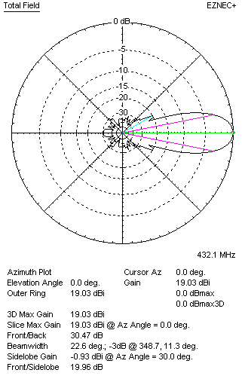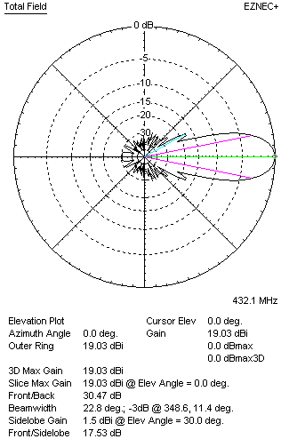
Horizontal and verticall pattern in free space, no loss condition
PERFORMANCES (Loss included for aluminum)
Aluminum |  |  |  | G  (dBi) | Tloss  (K) |  | T_{A}  (◦K) |  |  | G/T  (dB) | Bandwidth for SWR=1.5  (MHz)
After NEC/EZNEC |  |  |  | 18.96 | 4.6 |  | 25.7 |  |  | +4.60 | 423.000 – 437.300
After KF2YN correction |  |  |  | 18.92 | 4.6 |  | 29.9 |  |  | +4.16
Remark: Red coloured data are the final antenna data, which means: KF2YN correction formula applied and loss for aluminum included
DIAGRAMS
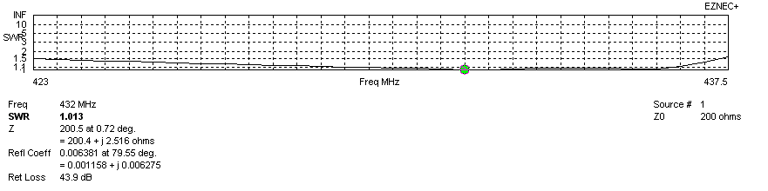
Frequency diagram for SWR better than 1.5
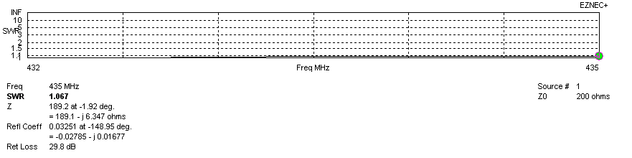
SWR diagram for the range from 432.000 – 435.000 MHz
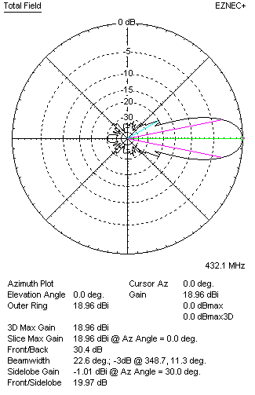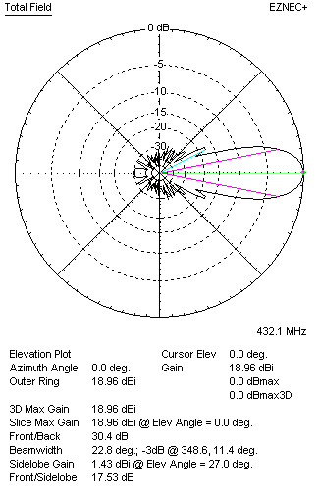
Horizontal and vertical pattern in free space, loss included for aluminum
STACKING
(ALL DATA GIVEN IN ACCORDANCE WITH KF2YN CORRECTION, LOSS INCLUDED)
RECOMMENDED STACKING DISTANCES
 |  |  |  | Two antennas vertically  (mm) |  |  | Two antennas horizontally  (mm) |  |  |  | Four antennas in H-stack  (mm)
Horizontal distance |  |  |  |  |  |  | 1980 |  |  |  | 1980
Vertical distance |  |  |  | 1840 |  |  |  |  |  |  | 1840
TWO ANTENNAS STACKED VERTICALLY
DISTANCE  (mm) |  |  | G  (dBi) |  |  | TA  (K) |  | Tloss  (K) |  |  |  | G/T  (dB)
1840 |  |  | 21.88 |  |  | 28.7 |  | 4.6 |  |  |  | +7.30
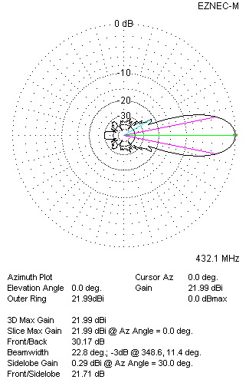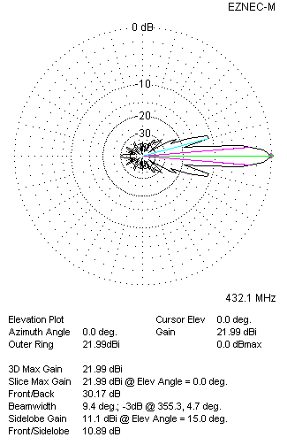
Two antennas stacked vertically
TWO ANTENNAS STACKED HORIZONTALLY
DISTANCE  (mm) |  |  | G  (dBi) |  |  | TA  (K) |  |  | Tloss  (K) |  |  |  | G/T  (dB)
1980 |  |  | 21.98 |  |  | 29.8 |  |  | 4.6 |  |  |  | +7.24
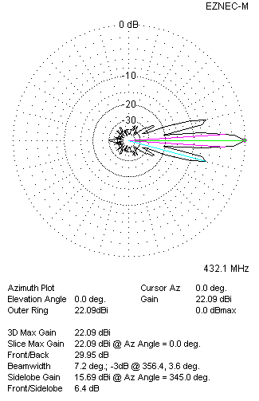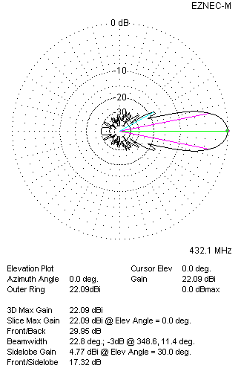
Two antennas stacked horizontally
FOUR ANTENNAS IN H-STACK
DISTANCE  (mm) |  |  | G  (dBi) |  |  | TA  (K) |  |  | Tloss  (K) |  |  |  | G/T  (dB)
H = 1980 |  |  | 24.94 |  |  | 28.4 |  |  | 4.6 |  |  |  | +10.40
V = 1840
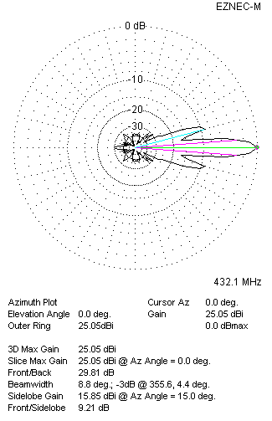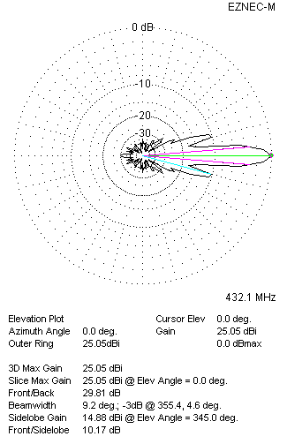
Four antennas in H-stack

