ANTENNA QY72305XL4D11
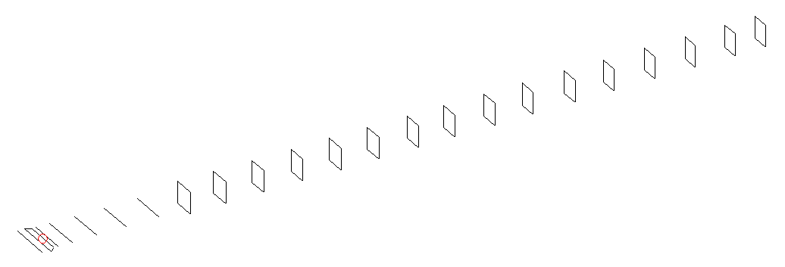
DESCRIPTION
Radiator |  |  | Number of  yagi elements |  |  | Number of  oblong elements |  |  |  | Total number  of elements |  |  |  | Boomlength  (mm)
LFA |  |  | 11 |  |  | 11 |  |  |  | 23 |  |  |  | 5595
DIMENSIONS
 | Ref | De1 |  | De2 | D1 |  | D2 | D3 | D4 |  | D5 | D6 | D7 |  | D8 | D9
Position | 0 | 55 |  | 105 | 138 |  | 245 | 434 | 658 |  | 911 | 1184 | 1456 |  | 1746 | 2044
Length | 334 | 342 |  | 296 | 304 |  | 307 | 298 | 291 |  | 285 | 283 | 279 |  | 275 | 273
 | D10 | DQ1 |  | DQ2 | DQ3 |  | DQ4 | DQ5 | DQ6 |  | DQ7 | DQ8 | DQ9 |  | DQ10 | DQ11
Position | 2342 | 2633 |  | 2932 | 3221 |  | 3519 | 3818 | 4138 |  | 4434 | 4742 | 5044 |  | 5334 | 5595
Length | 268 | 159 |  | 157 | 155 |  | 252 | 147 | 145 |  | 141 | 139 | 137 |  | 137 | 133

Remark | All elements made of Al tubes Ǿ6 mm  The height of rectangles is 170 mm  All dimensions given in milimetres
PERFORMANCES (No loss condition)
G  (dBi) |  | F/B  (dB) |  | F/Sh  (dBi) | F/Sv  (dBi) |  | Hor  (◦) |  |  | Ver  (◦) | Temp  (◦K) |  |  | G/T  (dB)
18.91 |  | 30.80 |  | 18.43 | 17.79 |  | 23.0 |  |  | 23.8 | 25.1 |  |  | +5.79
DIAGRAMS
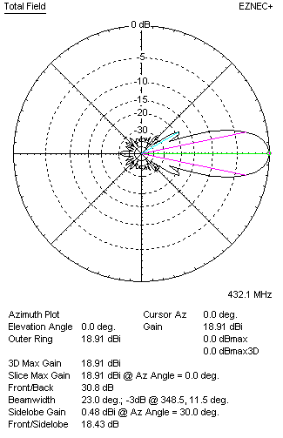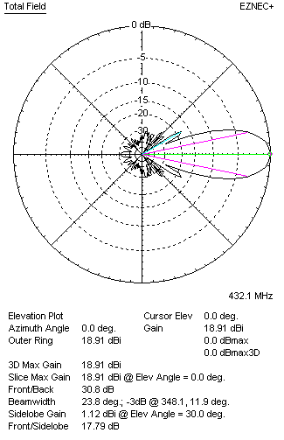
Horizontal and verticall pattern in free space, no loss condition
PERFORMANCES (Loss included for aluminum)
Aluminum |  |  |  | G  (dBi) | Tloss  (K) |  | T_{A}  (◦K) |  |  | G/T  (dB) | Bandwidth for SWR=1.5  (MHz)
After NEC/EZNEC |  |  |  | 18.84 | 4.6 |  | 25.1 |  |  | +4.87 | 423.500 – 438.400
After KF2YN correction |  |  |  | 18.77 | 4.6 |  | 29.3 |  |  | +4.10
Remark: Red coloured data are the final antenna data, which means: KF2YN correction formula applied and loss for aluminum included
DIAGRAMS
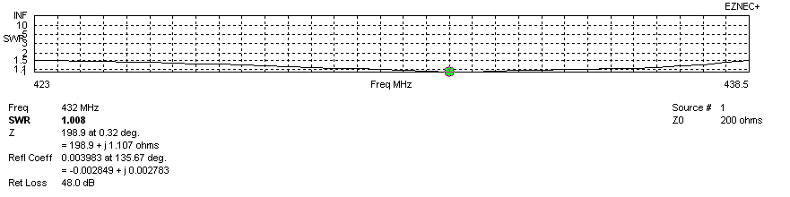
Frequency diagram for SWR better than 1.5
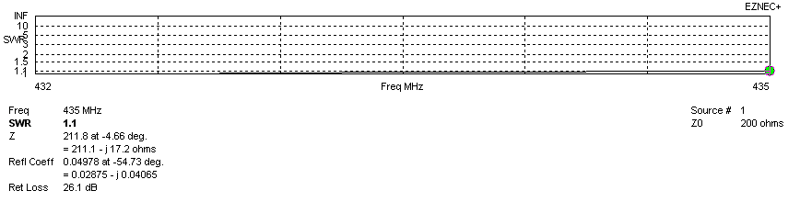
SWR diagram for the range from 432.000 – 435.000 MHz
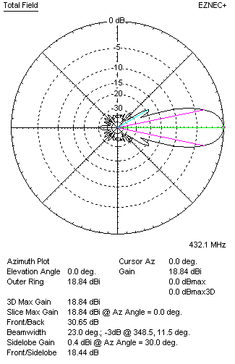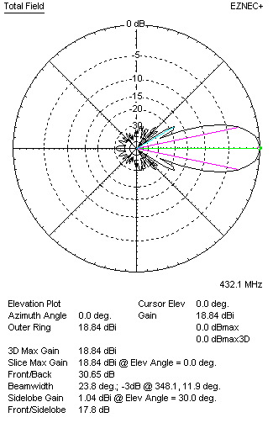
Horizontal and vertical pattern in free space, loss included for aluminum
STACKING
(ALL DATA GIVEN IN ACCORDANCE WITH KF2YN CORRECTION, LOSS INCLUDED)
RECOMMENDED STACKING DISTANCES
 |  |  |  | Two antennas vertically  (mm) |  |  | Two antennas horizontally  (mm) |  |  |  | Four antennas in H-stack  (mm)
Horizontal distance |  |  |  |  |  |  | 1980 |  |  |  | 1980
Vertical distance |  |  |  | 1860 |  |  |  |  |  |  | 1860
TWO ANTENNAS STACKED VERTICALLY
DISTANCE  (mm) |  |  | G  (dBi) |  |  | TA  (K) |  | Tloss  (K) |  |  |  | G/T  (dB)
1860 |  |  | 21.76 |  |  | 28.5 |  | 4.6 |  |  |  | +7.21
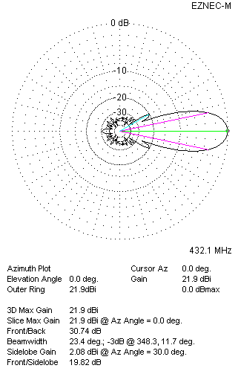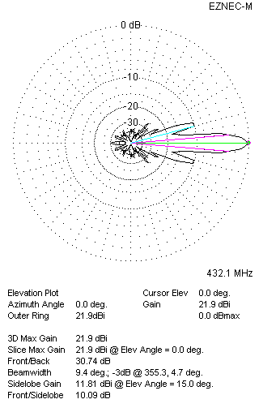
Two antennas stacked vertically
TWO ANTENNAS STACKED HORIZONTALLY
DISTANCE  (mm) |  |  | G  (dBi) |  |  | TA  (K) |  |  | Tloss  (K) |  |  |  | G/T  (dB)
1980 |  |  | 21.78 |  |  | 28.8 |  |  | 4.6 |  |  |  | +7.19
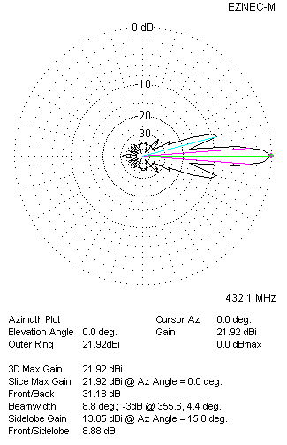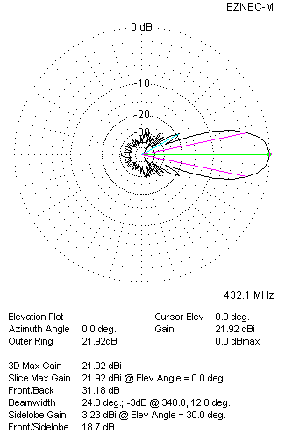
Two antennas stacked horizontally
FOUR ANTENNAS IN H-STACK
DISTANCE  (mm) |  |  | G  (dBi) |  |  | TA  (K) |  |  | Tloss  (K) |  |  |  | G/T  (dB)
H = 1980 |  |  | 24.80 |  |  | 28.3 |  |  | 4.6 |  |  |  | +10.28
V = 1860
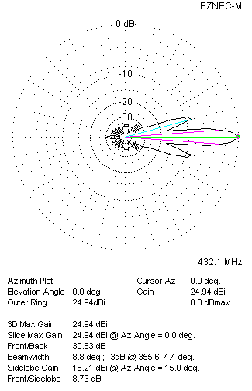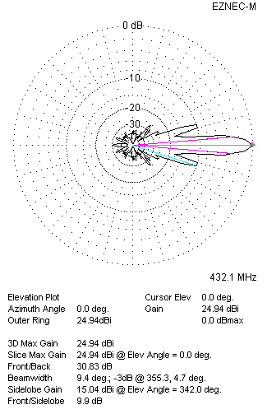
Four antennas in H-stack

