ANTENNA QY72210XL3D15
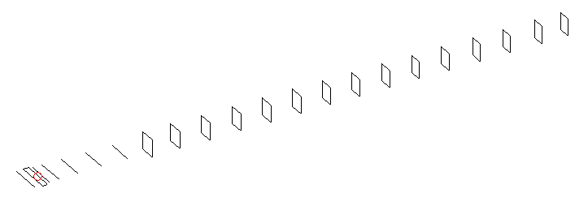
DESCRIPTION
Radiator |  |  | Number of  yagi elements |  |  | Number of  oblong elements |  |  |  | Total number  of elements |  |  |  | Boomlength  (mm)
LFA |  |  | 6 |  |  | 15 |  |  |  | 22 |  |  |  | 5325
DIMENSIONS
 | Ref | De1 |  | De2 | D1 |  | D2 | D3 | D4 |  | D5 | DQ1 | DQ2 |  | DQ3 | DQ4
Position | 0 | 70 |  | 120 | 152 |  | 246 | 435 | 672 |  | 932 | 1203 | 1478 |  | 1775 | 2086
Length | 331 | 331 |  | 331 | 295 |  | 301 | 289.5 | 281.5 |  | 275 | 171 | 163 |  | 157 | 155
 | DQ5 | DQ6 |  | DQ7 | DQ8 |  | DQ9 | DQ10 | DQ11 |  | DQ12 | DQ13 | DQ14 |  | DQ15
Position | 2378 | 2678 |  | 2972 | 3262 |  | 3556 | 3852 | 4152 |  | 4458 | 4758 | 5074 |  | 5325
Length | 153 | 151 |  | 147 | 143 |  | 139 | 135 | 133 |  | 131 | 131 | 129 |  | 125

Remark | All elements made of Al tubes Ǿ10 mm  The height of rectangles is 170 mm  All dimensions given in milimetres
PERFORMANCES (No loss condition)
G  (dBi) |  | F/B  (dB) |  | F/Sh  (dBi) | F/Sv  (dBi) |  | Hor  (◦) |  |  | Ver  (◦) | Temp  (◦K) |  |  | G/T  (dB)
18.50 |  | 42.16 |  | 24.35 | 20.18 |  | 24.6 |  |  | 24.8 | 24.1 |  |  | +5.26
DIAGRAMS
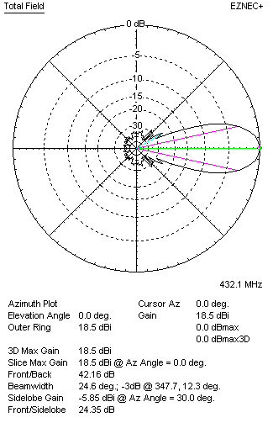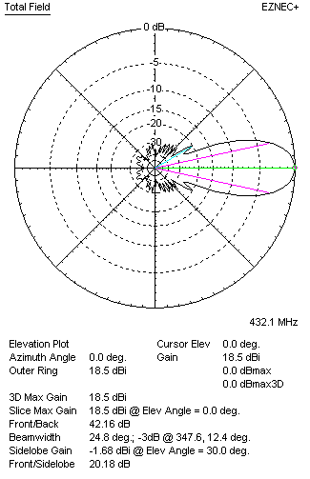
Horizontal and verticall pattern in free space, no loss condition
PERFORMANCES (Loss included for aluminum)
Aluminum |  |  |  | G  (dBi) | Tloss  (K) |  | T_{A}  (◦K) |  |  | G/T  (dB) | Bandwidth for SWR=1.5  (MHz)
After NEC/EZNEC |  |  |  | 18.46 | 2.9 |  | 24.1 |  |  | +4.67 | 424.100 – 437.800
After KF2YN correction |  |  |  | 18.41 | 2.9 |  | 26.7 |  |  | +4.14
Remark: Red coloured data are the final antenna data, which means: KF2YN correction formula applied and loss for aluminum included
DIAGRAMS
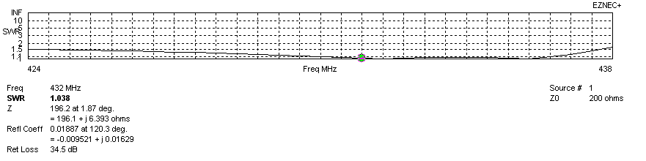
Frequency diagram for SWR better than 1.5
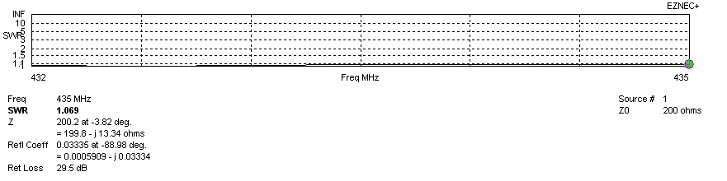
SWR diagram for the range from 432.000 – 435.000 MHz
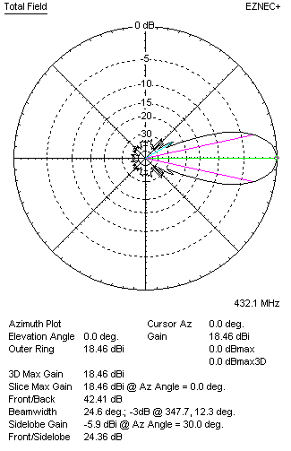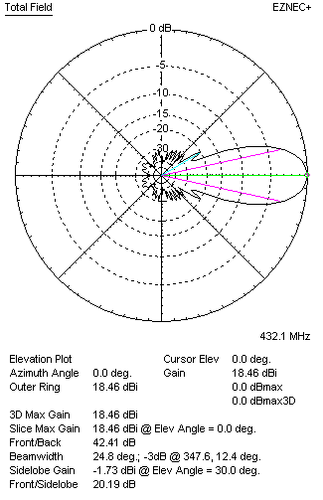
Horizontal and vertical pattern in free space, loss included for aluminum
STACKING
(ALL DATA GIVEN IN ACCORDANCE WITH KF2YN CORRECTION, LOSS INCLUDED)
RECOMMENDED STACKING DISTANCES
 |  |  |  | Two antennas vertically  (mm) |  |  | Two antennas horizontally  (mm) |  |  |  | Four antennas in H-stack  (mm)
Horizontal distance |  |  |  |  |  |  | 1900 |  |  |  | 1900
Vertical distance |  |  |  | 1900 |  |  |  |  |  |  | 1900
TWO ANTENNAS STACKED VERTICALLY
DISTANCE  (mm) |  |  | G  (dBi) |  |  | TA  (K) |  | Tloss  (K) |  |  |  | G/T  (dB)
1900 |  |  | 21.44 |  |  | 26.1 |  | 2.9 |  |  |  | +7.27
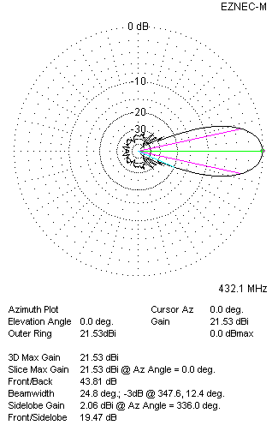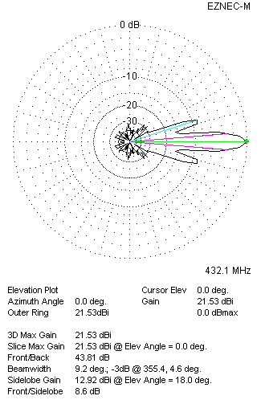
Two antennas stacked vertically
TWO ANTENNAS STACKED HORIZONTALLY
DISTANCE  (mm) |  |  | G  (dBi) |  |  | TA  (K) |  |  | Tloss  (K) |  |  |  | G/T  (dB)
1900 |  |  | 21.42 |  |  | 26.2 |  |  | 2.9 |  |  |  | +7.23
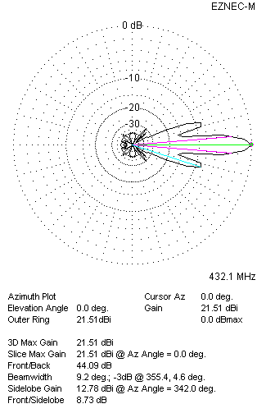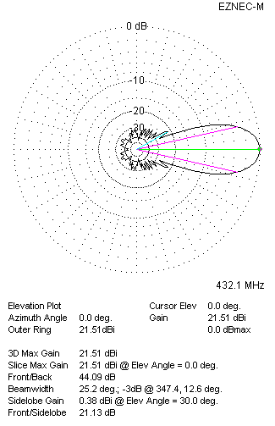
Two antennas stacked horizontally
FOUR ANTENNAS IN H-STACK
DISTANCE  (mm) |  |  | G  (dBi) |  |  | TA  (K) |  |  | Tloss  (K) |  |  |  | G/T  (dB)
H = 1900 |  |  | 24.47 |  |  | 25.7 |  |  | 2.9 |  |  |  | +10.36
V = 1900
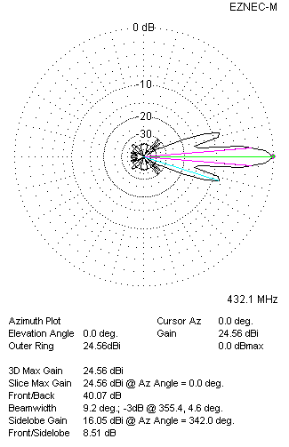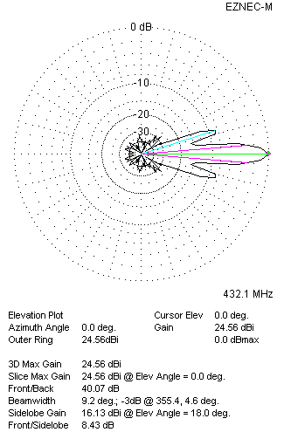
Four antennas in H-stack

