ANTENNA QY72208XL4D15
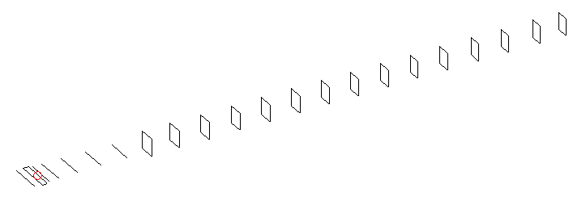
DESCRIPTION
Radiator |  |  | Number of  yagi elements |  |  | Number of  oblong elements |  |  |  | Total number  of elements |  |  |  | Boomlength  (mm)
LFA |  |  | 6 |  |  | 15 |  |  |  | 22 |  |  |  | 5325
DIMENSIONS
 | Ref | De1 |  | De2 | D1 |  | D2 | D3 | D4 |  | D5 | DQ1 | DQ2 |  | DQ3 | DQ4
Position | 0 | 65 |  | 97 | 133 |  | 232 | 423 | 654 |  | 920 | 1184 | 1474 |  | 1774 | 2062
Length | 333 | 350 |  | 290 | 303 |  | 305 | 294.5 | 285.5 |  | 279 | 172 | 161 |  | 159 | 155
 | DQ5 | DQ6 |  | DQ7 | DQ8 |  | DQ9 | DQ10 | DQ11 |  | DQ12 | DQ13 | DQ14 |  | DQ15
Position | 2388 | 2682 |  | 2982 | 3286 |  | 3580 | 3888 | 4178 |  | 4482 | 4776 | 5078 |  | 5325
Length | 151 | 151 |  | 147 | 143 |  | 143 | 137 | 137 |  | 137 | 137 | 131 |  | 131

Remark | All elements made of Al tubes Ǿ8 mm  The height of rectangles is 170 mm  All dimensions given in milimetres
PERFORMANCES (No loss condition)
G  (dBi) |  | F/B  (dB) |  | F/Sh  (dBi) | F/Sv  (dBi) |  | Hor  (◦) |  |  | Ver  (◦) | Temp  (◦K) |  |  | G/T  (dB)
18.56 |  | 38.35 |  | 22.77 | 19.10 |  | 24.6 |  |  | 24.8 | 24.1 |  |  | +5.92
DIAGRAMS
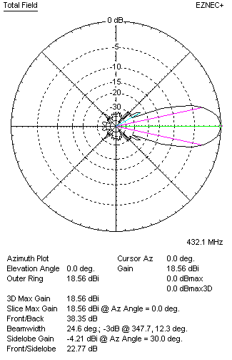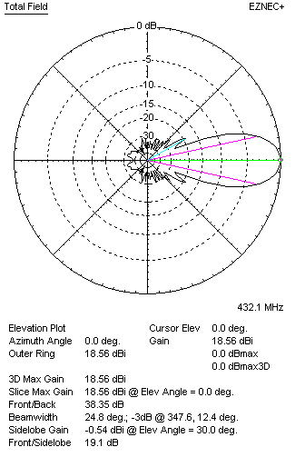
Horizontal and verticall pattern in free space, no loss condition
PERFORMANCES (Loss included for aluminum)
Aluminum |  |  |  | G  (dBi) | Tloss  (K) |  | T_{A}  (◦K) |  |  | G/T  (dB) | Bandwidth for SWR=1.5  (MHz)
After NEC/EZNEC |  |  |  | 18.51 | 4.0 |  | 24.1 |  |  | +5.06 | 426.400 – 437.600
After KF2YN correction |  |  |  | 18.45 | 4.0 |  | 24.9 |  |  | +4.49
Remark: Red coloured data are the final antenna data, which means: KF2YN correction formula applied and loss for aluminum included
DIAGRAMS
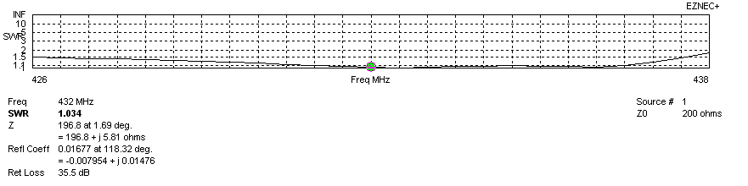
Frequency diagram for SWR better than 1.5
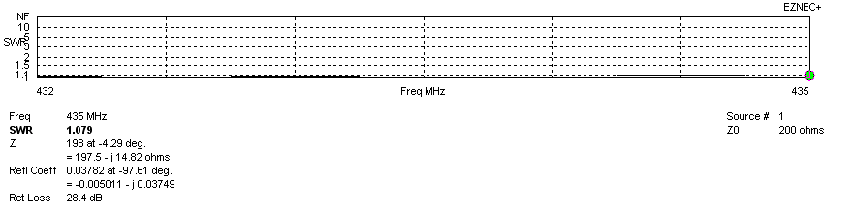
SWR diagram for the range from 432.000 – 435.000 MHz
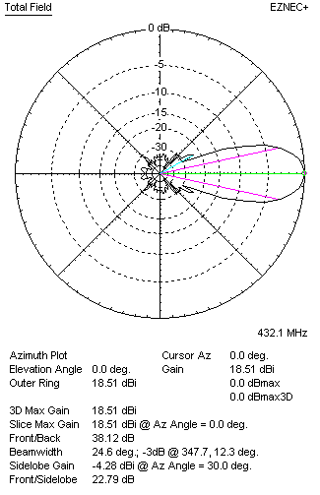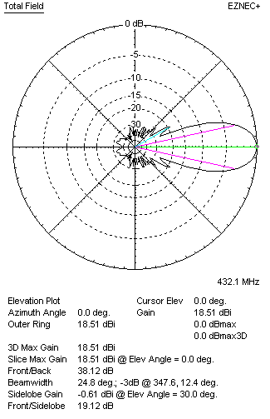
Horizontal and vertical pattern in free space, loss included for aluminum
STACKING
(ALL DATA GIVEN IN ACCORDANCE WITH KF2YN CORRECTION, LOSS INCLUDED)
RECOMMENDED STACKING DISTANCES
 |  |  |  | Two antennas vertically  (mm) |  |  | Two antennas horizontally  (mm) |  |  |  | Four antennas in H-stack  (mm)
Horizontal distance |  |  |  |  |  |  | 1900 |  |  |  | 1900
Vertical distance |  |  |  | 1900 |  |  |  |  |  |  | 1900
TWO ANTENNAS STACKED VERTICALLY
DISTANCE  (mm) |  |  | G  (dBi) |  |  | TA  (K) |  | Tloss  (K) |  |  |  | G/T  (dB)
1900 |  |  | 21.44 |  |  | 27.0 |  | 4.0 |  |  |  | +7.13
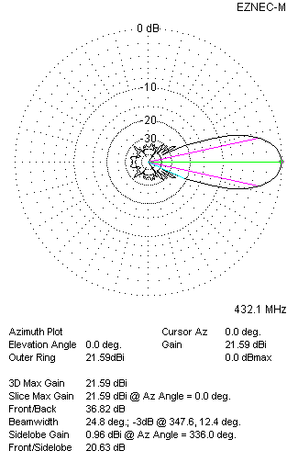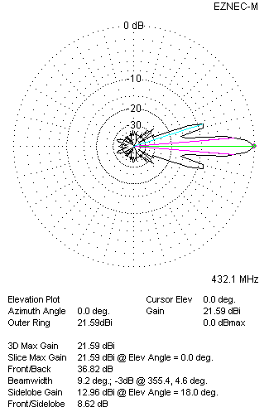
Two antennas stacked vertically
TWO ANTENNAS STACKED HORIZONTALLY
DISTANCE  (mm) |  |  | G  (dBi) |  |  | TA  (K) |  |  | Tloss  (K) |  |  |  | G/T  (dB)
1900 |  |  | 21.42 |  |  | 27.4 |  |  | 4.0 |  |  |  | +7.05
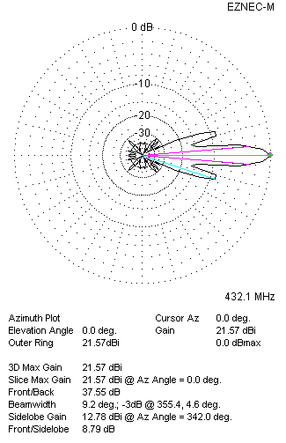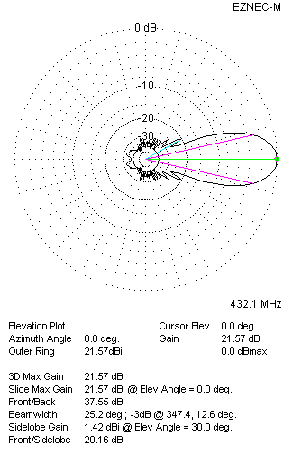
Two antennas stacked horizontally
FOUR ANTENNAS IN H-STACK
DISTANCE  (mm) |  |  | G  (dBi) |  |  | TA  (K) |  |  | Tloss  (K) |  |  |  | G/T  (dB)
H = 1900 |  |  | 24.47 |  |  | 26.8 |  |  | 4.0 |  |  |  | +10.19
V = 1900
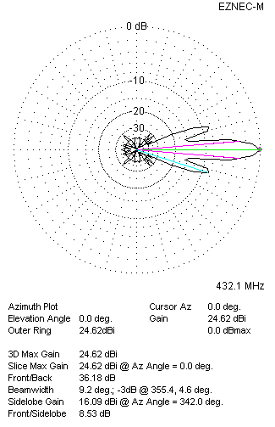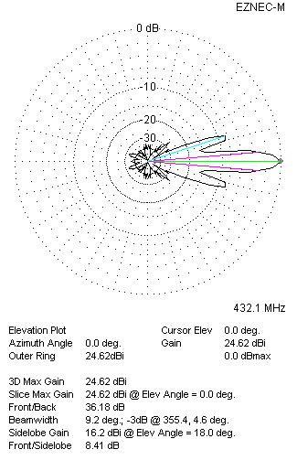
Four antennas in H-stack

