ANTENNA QY72206XL1D15
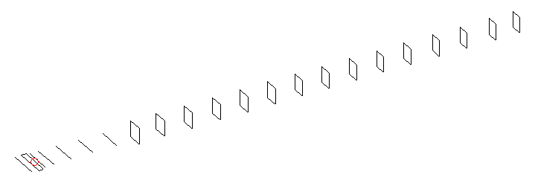
DESCRIPTION
Radiator |  |  | Number of  yagi elements |  |  | Number of  oblong elements |  |  |  | Total number  of elements |  |  |  | Boomlength  (mm)
LFA |  |  | 6 |  |  | 15 |  |  |  | 22 |  |  |  | 5325
DIMENSIONS
 | Ref | De1 |  | De2 | D1 |  | D2 | D3 | D4 |  | D5 | DQ1 | DQ2 |  | DQ3 | DQ4
Position | 0 | 65 |  | 100 | 131 |  | 233 | 419 | 648 |  | 905 | 1182 | 1456 |  | 1754 | 2058
Length | 336 | 349 |  | 304 | 304 |  | 307.5 | 298 | 291.5 |  | 283.5 | 171 | 163 |  | 159 | 155
 | DQ5 | DQ6 |  | DQ7 | DQ8 |  | DQ9 | DQ10 | DQ11 |  | DQ12 | DQ13 | DQ14 |  | DQ15
Position | 2364 | 2672 |  | 2974 | 3272 |  | 3589 | 3878 | 4192 |  | 4478 | 4782 | 5084 |  | 5325
Length | 151 | 149 |  | 147 | 145 |  | 145 | 141 | 141 |  | 141 | 135 | 135 |  | 135

Remark | All elements made of Al tubes Ǿ6 mm  The height of rectangles is 170 mm  All dimensions given in milimetres
PERFORMANCES (No loss condition)
G  (dBi) |  | F/B  (dB) |  | F/Sh  (dBi) | F/Sv  (dBi) |  | Hor  (◦) |  |  | Ver  (◦) | Temp  (◦K) |  |  | G/T  (dB)
18.48 |  | 42.92 |  | 21.67 | 18.32 |  | 24.6 |  |  | 25.0 | 24.4 |  |  | +5.46
DIAGRAMS
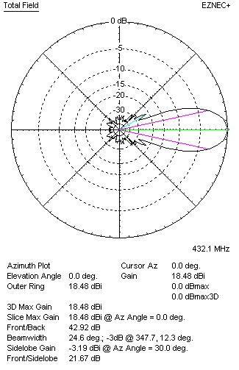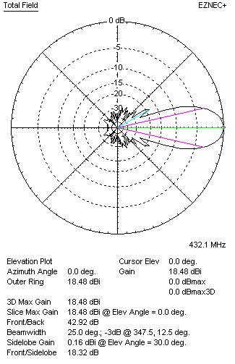
Horizontal and verticall pattern in free space, no loss condition
PERFORMANCES (Loss included for aluminum)
Aluminum |  |  |  | G  (dBi) | Tloss  (K) |  | T_{A}  (◦K) |  |  | G/T  (dB) | Bandwidth for SWR=1.5  (MHz)
After NEC/EZNEC |  |  |  | 18.51 | 4.3 |  | 24.1 |  |  | +5.06 | 421.500 – 438.500
After KF2YN correction |  |  |  | 18.35 | 4.3 |  | 28.3 |  |  | +3.83
Remark: Red coloured data are the final antenna data, which means: KF2YN correction formula applied and loss for aluminum included
DIAGRAMS
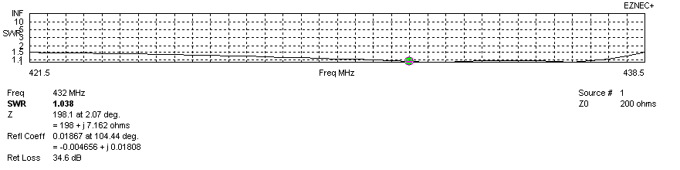
Frequency diagram for SWR better than 1.5
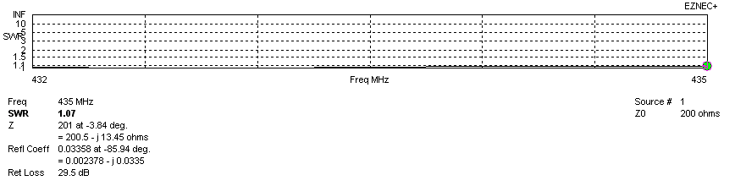
SWR diagram for the range from 432.000 – 435.000 MHz
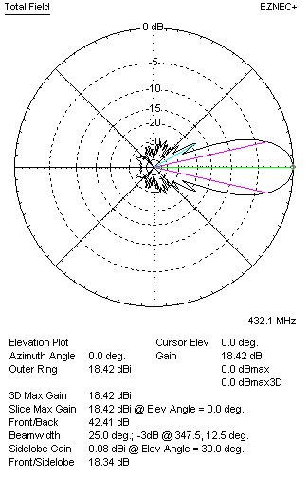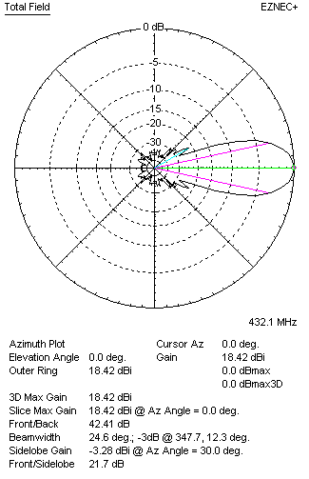
Horizontal and vertical pattern in free space, loss included for aluminum
STACKING
(ALL DATA GIVEN IN ACCORDANCE WITH KF2YN CORRECTION, LOSS INCLUDED)
RECOMMENDED STACKING DISTANCES
 |  |  |  | Two antennas vertically  (mm) |  |  | Two antennas horizontally  (mm) |  |  |  | Four antennas in H-stack  (mm)
Horizontal distance |  |  |  |  |  |  | 1980 |  |  |  | 1980
Vertical distance |  |  |  | 2000 |  |  |  |  |  |  | 2000
TWO ANTENNAS STACKED VERTICALLY
DISTANCE  (mm) |  |  | G  (dBi) |  |  | TA  (K) |  | Tloss  (K) |  |  |  | G/T  (dB)
1980 |  |  | 21.40 |  |  | 27.4 |  | 4.3 |  |  |  | +7.01
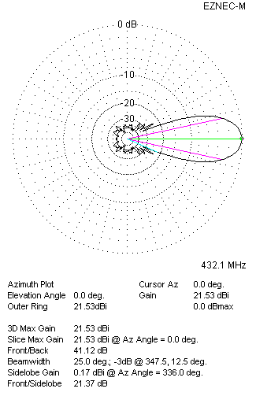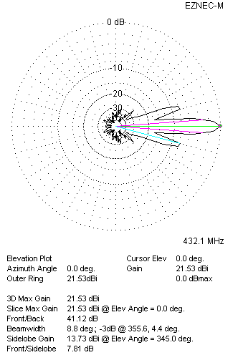
Two antennas stacked vertically
TWO ANTENNAS STACKED HORIZONTALLY
DISTANCE  (mm) |  |  | G  (dBi) |  |  | TA  (K) |  |  | Tloss  (K) |  |  |  | G/T  (dB)
2000 |  |  | 21.39 |  |  | 28.0 |  |  | 4.3 |  |  |  | +6.91
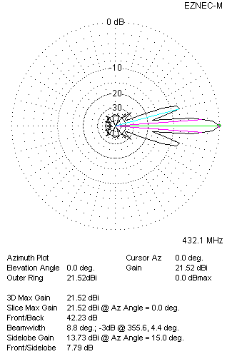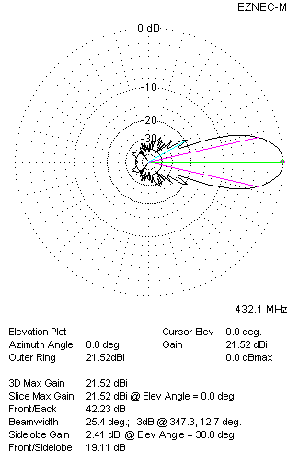
Two antennas stacked horizontally
FOUR ANTENNAS IN H-STACK
DISTANCE  (mm) |  |  | G  (dBi) |  |  | TA  (K) |  |  | Tloss  (K) |  |  |  | G/T  (dB)
H = 2000 |  |  | 24.45 |  |  | 27.5 |  |  | 4.3 |  |  |  | +10.05
V = 1980
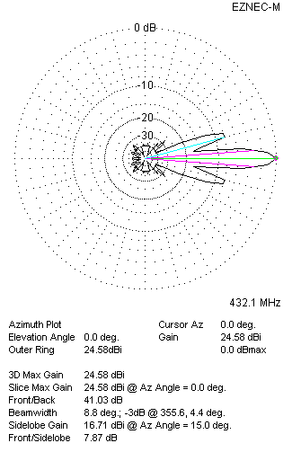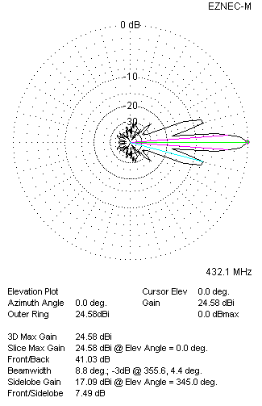
Four antennas in H-stack

