ANTENNA QY72205XL1D15
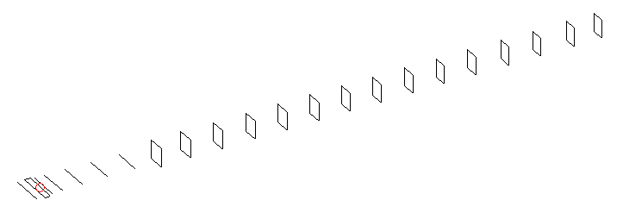
DESCRIPTION
Radiator |  |  | Number of  yagi elements |  |  | Number of  oblong elements |  |  |  | Total number  of elements |  |  |  | Boomlength  (mm)
LFA |  |  | 6 |  |  | 15 |  |  |  | 22 |  |  |  | 5325
DIMENSIONS
 | Ref | De1 |  | De2 | D1 |  | D2 | D3 | D4 |  | D5 | DQ1 | DQ2 |  | DQ3 | DQ4
Position | 0 | 60 |  | 100 | 132 |  | 238 | 426 | 656 |  | 911 | 1176 | 1458 |  | 1746 | 2046
Length | 336 | 346 |  | 292 | 308 |  | 310 | 301 | 295.5 |  | 288 | 171 | 165 |  | 159 | 157
 | DQ5 | DQ6 |  | DQ7 | DQ8 |  | DQ9 | DQ10 | DQ11 |  | DQ12 | DQ13 | DQ14 |  | DQ15
Position | 2338 | 2628 |  | 2926 | 3215 |  | 3512 | 3818 | 4142 |  | 4438 | 4756 | 5079 |  | 5325
Length | 156 | 154 |  | 153 | 152 |  | 149 | 145 | 143 |  | 141 | 137 | 137 |  | 137

Remark | All elements made of Al tubes Ǿ5 mm  The height of rectangles is 170 mm  All dimensions given in milimetres
PERFORMANCES (No loss condition)
G  (dBi) |  | F/B  (dB) |  | F/Sh  (dBi) | F/Sv  (dBi) |  | Hor  (◦) |  |  | Ver  (◦) | Temp  (◦K) |  |  | G/T  (dB)
18.62 |  | 34.68 |  | 21.22 | 17.95 |  | 24.2 |  |  | 24.6 | 24.6 |  |  | +5.54
DIAGRAMS
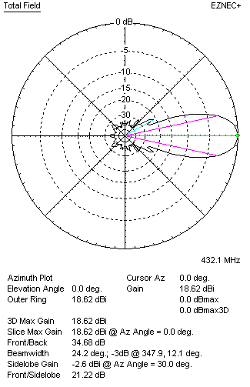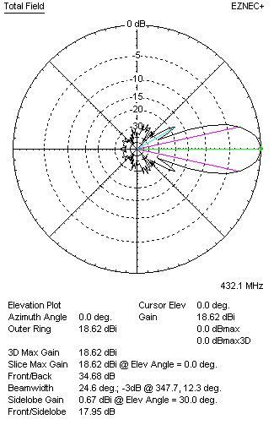
Horizontal and verticall pattern in free space, no loss condition
PERFORMANCES (Loss included for aluminum)
Aluminum |  |  |  | G  (dBi) | Tloss  (K) |  | T_{A}  (◦K) |  |  | G/T  (dB) | Bandwidth for SWR=1.5  (MHz)
After NEC/EZNEC |  |  |  | 18.54 | 5.7 |  | 24.7 |  |  | +4.42 | 426.000 – 437.600
After KF2YN correction |  |  |  | 18.46 | 5.7 |  | 29.8 |  |  | +3.72
Remark: Red coloured data are the final antenna data, which means: KF2YN correction formula applied and loss for aluminum included
DIAGRAMS
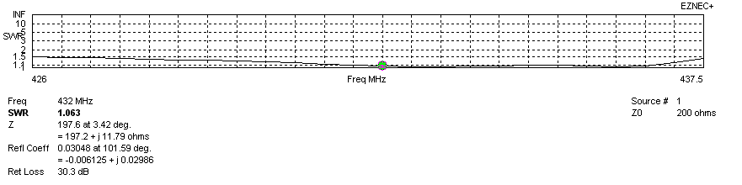
Frequency diagram for SWR better than 1.5
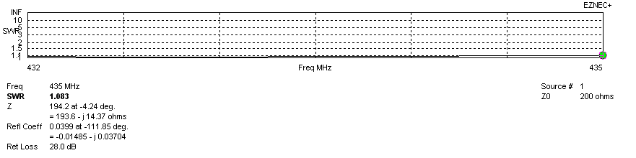
SWR diagram for the range from 432.000 – 435.000 MHz
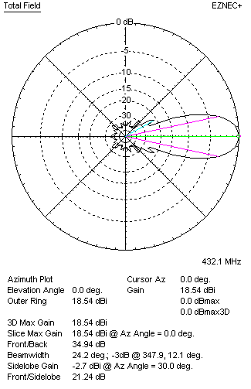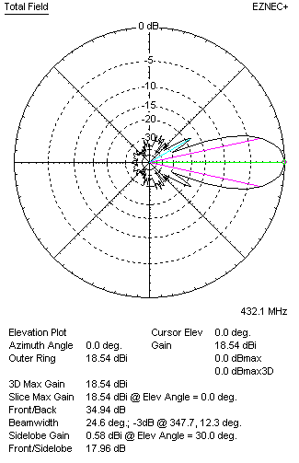
Horizontal and vertical pattern in free space, loss included for aluminum
STACKING
(ALL DATA GIVEN IN ACCORDANCE WITH KF2YN CORRECTION, LOSS INCLUDED)
RECOMMENDED STACKING DISTANCES
 |  |  |  | Two antennas vertically  (mm) |  |  | Two antennas horizontally  (mm) |  |  |  | Four antennas in H-stack  (mm)
Horizontal distance |  |  |  |  |  |  | 2020 |  |  |  | 2020
Vertical distance |  |  |  | 2020 |  |  |  |  |  |  | 2020
TWO ANTENNAS STACKED VERTICALLY
DISTANCE  (mm) |  |  | G  (dBi) |  |  | TA  (K) |  | Tloss  (K) |  |  |  | G/T  (dB)
2020 |  |  | 21.52 |  |  | 28.8 |  | 5.7 |  |  |  | +6.92
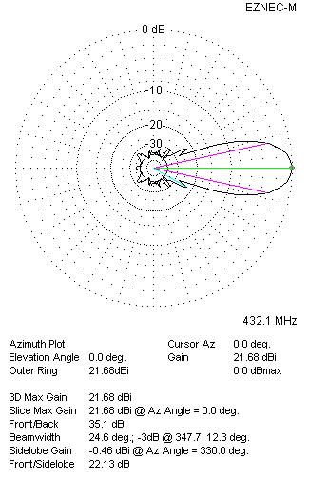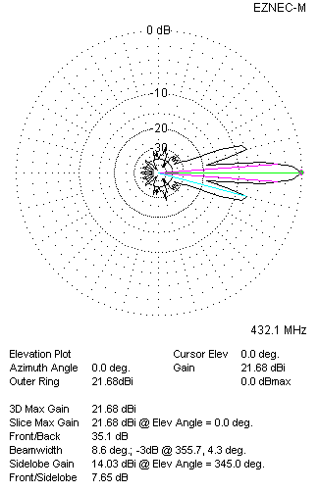
Two antennas stacked vertically
TWO ANTENNAS STACKED HORIZONTALLY
DISTANCE  (mm) |  |  | G  (dBi) |  |  | TA  (K) |  |  | Tloss  (K) |  |  |  | G/T  (dB)
2020 |  |  | 21.50 |  |  | 29.3 |  |  | 5.7 |  |  |  | +6.83
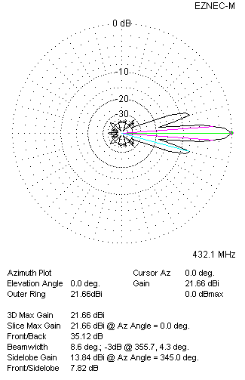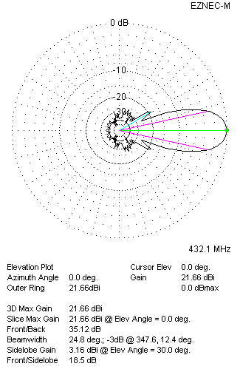
Two antennas stacked horizontally
FOUR ANTENNAS IN H-STACK
DISTANCE  (mm) |  |  | G  (dBi) |  |  | TA  (K) |  |  | Tloss  (K) |  |  |  | G/T  (dB)
H = 2020 |  |  | 24.56 |  |  | 28.8 |  |  | 5.7 |  |  |  | +9.96
V = 2020
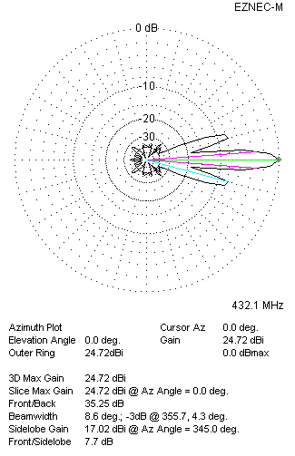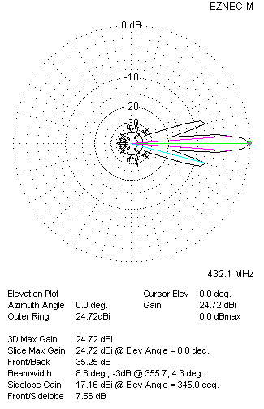
Four antennas in H-stack

