ANTENNA QY72108XL4D14
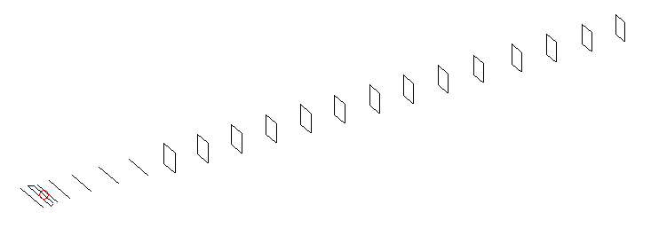
DESCRIPTION
Radiator |  |  | Number of  yagi elements |  |  | Number of  oblong elements |  |  |  | Total number  of elements |  |  | Boomlength  (mm)
LFA |  |  | 6 |  |  | 14 |  |  |  | 21 |  |  | 5025
DIMENSIONS
 | Ref | De1 |  | De2 | D1 |  | D2 | D3 | D4 |  | D5 | DQ1 |  | DQ2 | DQ3
Position | 0 | 66 |  | 98 | 133 |  | 232 | 422 | 654 |  | 921 | 1185 |  | 1474 | 1774
Length | 333 | 348 |  | 300 | 303 |  | 305 | 294.5 | 291.5 |  | 279 | 171 |  | 162 | 159
 | DQ4 | DQ5 |  | DQ6 | DQ7 |  | DQ8 | DQ9 | DQ10 |  | DQ11 | DQ12 |  | DQ13 | DQ13
Position | 2062 | 2388 |  | 2682 | 2982 |  | 3286 | 3580 | 3888 |  | 4178 | 4482 |  | 4772 | 5025
Length | 155 | 151 |  | 151 | 147 |  | 143 | 143 | 137 |  | 137 | 137 |  | 137 | 131

Remark | All elements made of Al tubes Ǿ8 mm  The height of rectangles is 170 mm  All dimensions given in milimetres
PERFORMANCES (No loss condition)
G  (dBi) |  | F/B  (dB) |  | F/Sh  (dBi) | F/Sv  (dBi) |  | Hor  (◦) |  |  | Ver  (◦) | Temp  (◦K) |  |  | G/T  (dB)
18.40 |  | 40.88 |  | 23.07 | 19.20 |  | 24.8 |  |  | 25.2 | 24.2 |  |  | +5.71
DIAGRAMS
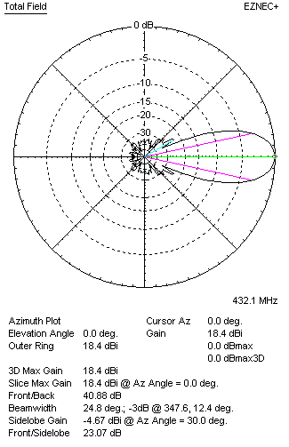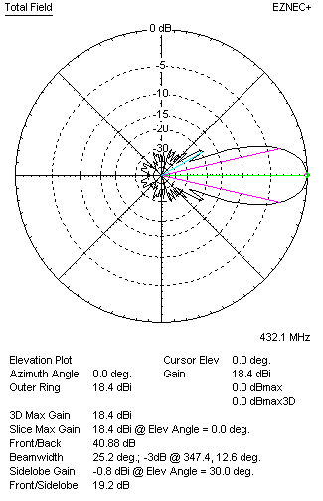
Horizontal and verticall pattern in free space, no loss condition
PERFORMANCES (Loss included for aluminum)
Aluminum |  |  |  | G  (dBi) | Tloss  (K) |  | T_{A}  (◦K) |  |  | G/T  (dB) | Bandwidth for SWR=1.5  (MHz)
After NEC/EZNEC |  |  |  | 18.24 | 2.9 |  | 24.2 |  |  | +4.85 | 426.500 – 437.600
After KF2YN correction |  |  |  | 18.28 | 2.9 |  | 25.8 |  |  | +4.16
Remark: Red coloured data are the final antenna data, which means: KF2YN correction formula applied and loss for aluminum included
DIAGRAMS
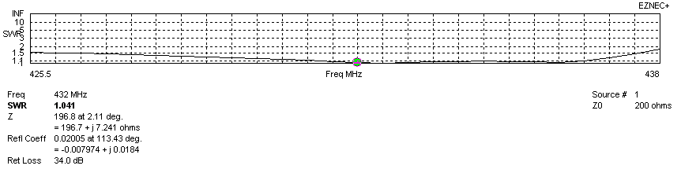
Frequency diagram for SWR better than 1.5
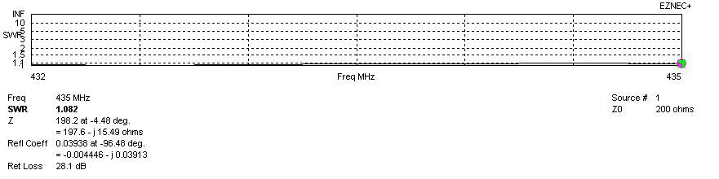
SWR diagram for the range from 432.000 – 435.000 MHz
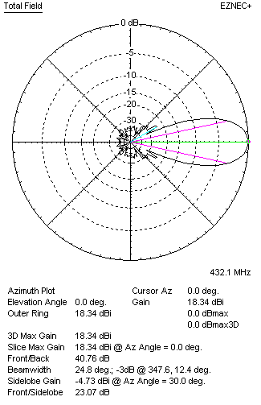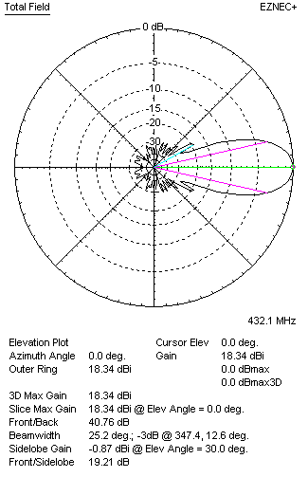
Horizontal and vertical pattern in free space, loss included for aluminum
STACKING
(ALL DATA GIVEN IN ACCORDANCE WITH KF2YN CORRECTION, LOSS INCLUDED)
RECOMMENDED STACKING DISTANCES
 |  |  |  | Two antennas vertically  (mm) |  |  | Two antennas horizontally  (mm) |  |  |  | Four antennas in H-stack  (mm)
Horizontal distance |  |  |  |  |  |  | 1900 |  |  |  | 1900
Vertical distance |  |  |  | 1900 |  |  |  |  |  |  | 1900
TWO ANTENNAS STACKED VERTICALLY
DISTANCE  (mm) |  |  | G  (dBi) |  |  | TA  (K) |  | Tloss  (K) |  |  |  | G/T  (dB)
1900 |  |  | 21.32 |  |  | 25.8 |  | 2.9 |  |  |  | +7.20
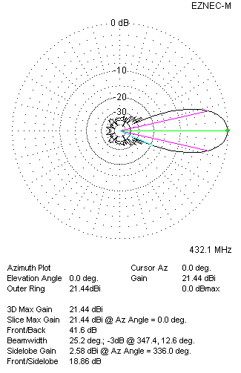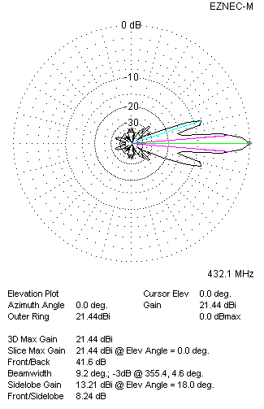
Two antennas stacked vertically
TWO ANTENNAS STACKED HORIZONTALLY
DISTANCE  (mm) |  |  | G  (dBi) |  |  | TA  (K) |  |  | Tloss  (K) |  |  |  | G/T  (dB)
1900 |  |  | 21.31 |  |  | 26.3 |  |  | 2.9 |  |  |  | +7.11
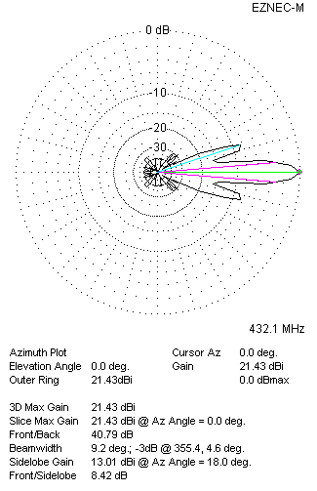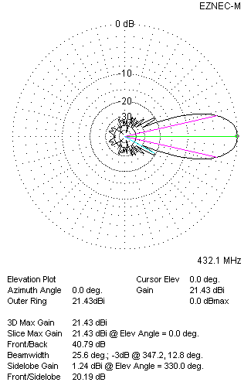
Two antennas stacked horizontally
FOUR ANTENNAS IN H-STACK
DISTANCE  (mm) |  |  | G  (dBi) |  |  | TA  (K) |  |  | Tloss  (K) |  |  |  | G/T  (dB)
H = 1900 |  |  | 24.36 |  |  | 25.6 |  |  | 2.9 |  |  |  | +10.28
V = 1900
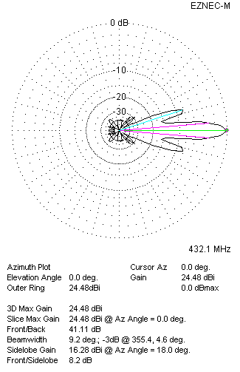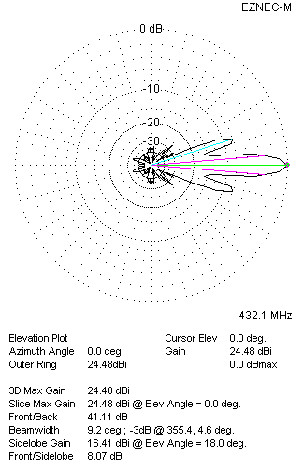
Four antennas in H-stack

