ANTENNA QY72106XL3D14
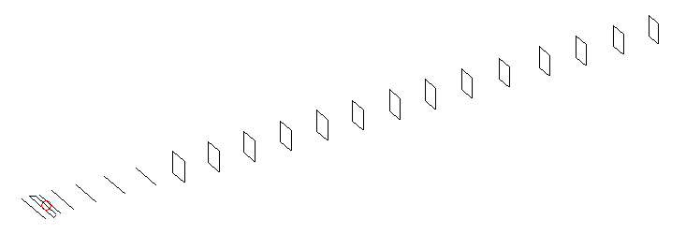
DESCRIPTION
Radiator |  |  | Number of  yagi elements |  |  | Number of  oblong elements |  |  |  | Total number  of elements |  |  | Boomlength  (mm)
LFA |  |  | 6 |  |  | 14 |  |  |  | 21 |  |  | 5025
DIMENSIONS
 | Ref | De1 |  | De2 | D1 |  | D2 | D3 | D4 |  | D5 | DQ1 |  | DQ2 | DQ3
Position | 0 | 65 |  | 100 | 131 |  | 233 | 419 | 648 |  | 905 | 1182 |  | 1456 | 1754
Length | 336 | 349 |  | 304 | 304 |  | 307.5 | 298 | 291.5 |  | 283.5 | 171 |  | 163 | 159
 | DQ4 | DQ5 |  | DQ6 | DQ7 |  | DQ8 | DQ9 | DQ10 |  | DQ11 | DQ12 |  | DQ13 | DQ13
Position | 2058 | 2364 |  | 2672 | 2974 |  | 3272 | 3589 | 3878 |  | 4192 | 4478 |  | 4776 | 5025
Length | 155 | 151 |  | 149 | 147 |  | 145 | 143 | 141 |  | 137 | 137 |  | 137 | 131

Remark | All elements made of Al tubes Ǿ6 mm  The height of rectangles is 170 mm  All dimensions given in milimetres
PERFORMANCES (No loss condition)
G  (dBi) |  | F/B  (dB) |  | F/Sh  (dBi) | F/Sv  (dBi) |  | Hor  (◦) |  |  | Ver  (◦) | Temp  (◦K) |  |  | G/T  (dB)
18.27 |  | 41.75 |  | 23.19 | 19.26 |  | 25.2 |  |  | 25.6 | 24.4 |  |  | +5.30
DIAGRAMS
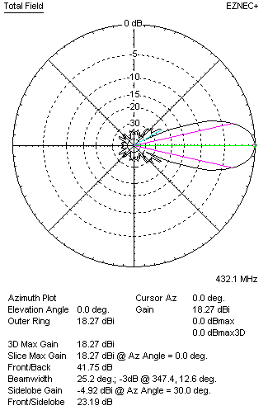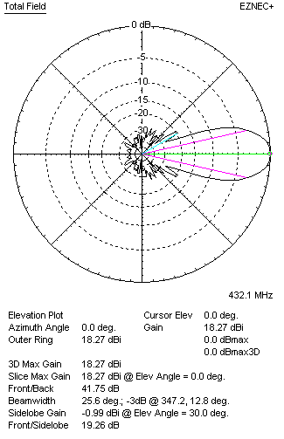
Horizontal and verticall pattern in free space, no loss condition
PERFORMANCES (Loss included for aluminum)
Aluminum |  |  |  | G  (dBi) | Tloss  (K) |  | T_{A}  (◦K) |  |  | G/T  (dB) | Bandwidth for SWR=1.5  (MHz)
After NEC/EZNEC |  |  |  | 18.21 | 4.6 |  | 24.4 |  |  | +4.40 | 421.000 – 438.500
After KF2YN correction |  |  |  | 18.13 | 4.6 |  | 28.6 |  |  | +3.57
Remark: Red coloured data are the final antenna data, which means: KF2YN correction formula applied and loss for aluminum included
DIAGRAMS
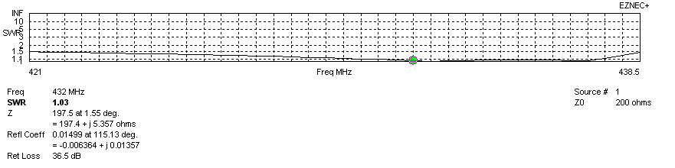
Frequency diagram for SWR better than 1.5
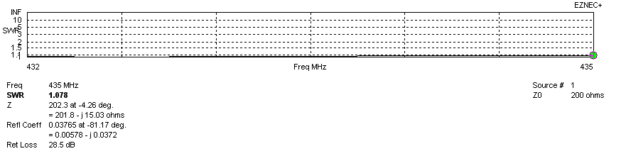
SWR diagram for the range from 432.000 – 435.000 MHz
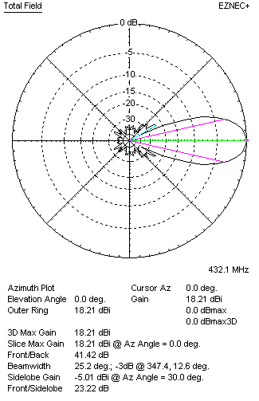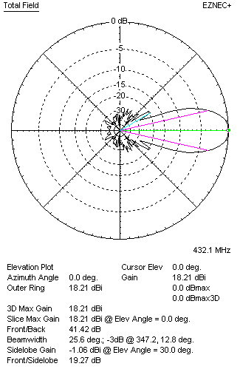
Horizontal and vertical pattern in free space, loss included for aluminum
STACKING
(ALL DATA GIVEN IN ACCORDANCE WITH KF2YN CORRECTION, LOSS INCLUDED)
RECOMMENDED STACKING DISTANCES
 |  |  |  | Two antennas vertically  (mm) |  |  | Two antennas horizontally  (mm) |  |  |  | Four antennas in H-stack  (mm)
Horizontal distance |  |  |  |  |  |  | 1960 |  |  |  | 1960
Vertical distance |  |  |  | 1900 |  |  |  |  |  |  | 1900
TWO ANTENNAS STACKED VERTICALLY
DISTANCE  (mm) |  |  | G  (dBi) |  |  | TA  (K) |  | Tloss  (K) |  |  |  | G/T  (dB)
1900 |  |  | 21.17 |  |  | 27.6 |  | 4.6 |  |  |  | +6.76
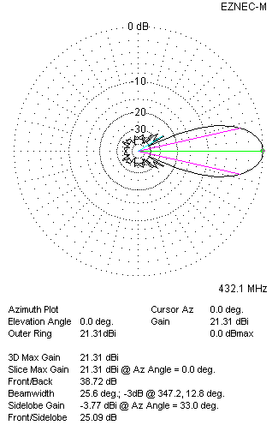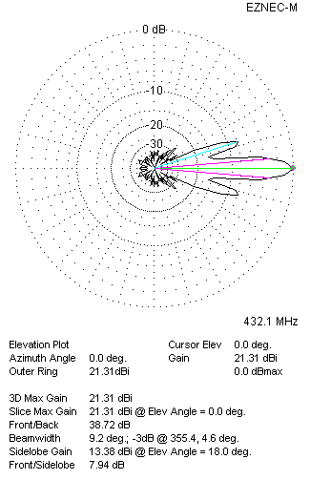
Two antennas stacked vertically
TWO ANTENNAS STACKED HORIZONTALLY
DISTANCE  (mm) |  |  | G  (dBi) |  |  | TA  (K) |  |  | Tloss  (K) |  |  |  | G/T  (dB)
1960 |  |  | 21.17 |  |  | 28.2 |  |  | 4.6 |  |  |  | +6.67
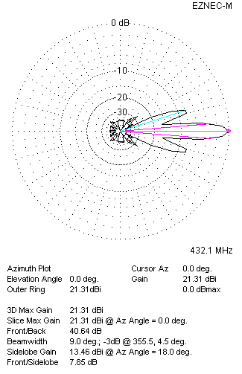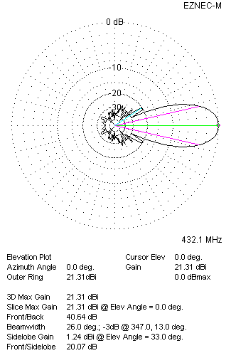
Two antennas stacked horizontally
FOUR ANTENNAS IN H-STACK
DISTANCE  (mm) |  |  | G  (dBi) |  |  | TA  (K) |  |  | Tloss  (K) |  |  |  | G/T  (dB)
H = 1960 |  |  | 24.22 |  |  | 27.4 |  |  | 4.6 |  |  |  | +9.84
V = 1900
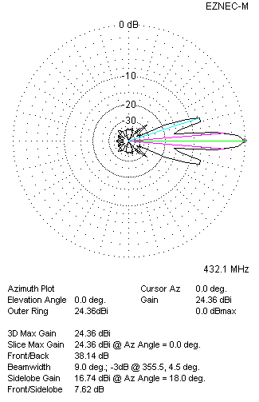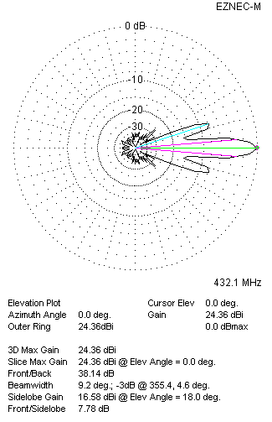
Four antennas in H-stack

