ANTENNA QY72105XL3D14
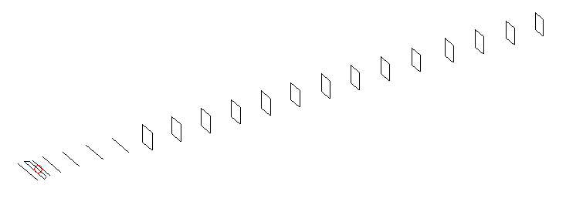
DESCRIPTION
Radiator |  |  | Number of  yagi elements |  |  | Number of  oblong elements |  |  |  | Total number  of elements |  |  | Boomlength  (mm)
LFA |  |  | 6 |  |  | 14 |  |  |  | 21 |  |  | 5025
DIMENSIONS
 | Ref | De1 |  | De2 | D1 |  | D2 | D3 | D4 |  | D5 | DQ1 |  | DQ2 | DQ3
Position | 0 | 60 |  | 100 | 132 |  | 238 | 426 | 656 |  | 911 | 1176 |  | 1458 | 1746
Length | 336 | 346 |  | 292 | 308 |  | 310 | 301 | 295.5 |  | 288 | 171 |  | 165 | 159
 | DQ4 | DQ5 |  | DQ6 | DQ7 |  | DQ8 | DQ9 | DQ10 |  | DQ11 | DQ12 |  | DQ13 | DQ13
Position | 2046 | 2338 |  | 2628 | 2926 |  | 3215 | 3512 | 3818 |  | 4142 | 4438 |  | 4742 | 5025
Length | 157 | 156 |  | 154 | 153 |  | 152 | 149 | 145 |  | 143 | 141 |  | 139 | 137

Remark | All elements made of Al tubes Ǿ5 mm  The height of rectangles is 170 mm  All dimensions given in milimetres
PERFORMANCES (No loss condition)
G  (dBi) |  | F/B  (dB) |  | F/Sh  (dBi) | F/Sv  (dBi) |  | Hor  (◦) |  |  | Ver  (◦) | Temp  (◦K) |  |  | G/T  (dB)
18.45 |  | 35.01 |  | 21.28 | 17.93 |  | 24.6 |  |  | 25.0 | 25.1 |  |  | +5.27
DIAGRAMS
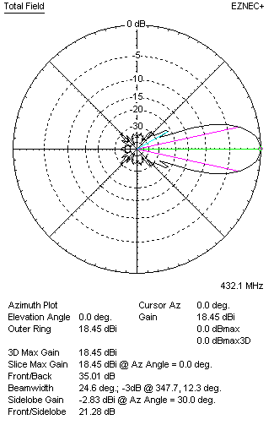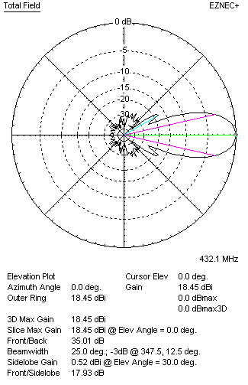
Horizontal and verticall pattern in free space, no loss condition
PERFORMANCES (Loss included for aluminum)
Aluminum |  |  |  | G  (dBi) | Tloss  (K) |  | T_{A}  (◦K) |  |  | G/T  (dB) | Bandwidth for SWR=1.5  (MHz)
After NEC/EZNEC |  |  |  | 18.37 | 5.7 |  | 25.1 |  |  | +4.20 | 425.900 – 437.600
After KF2YN correction |  |  |  | 18.29 | 5.7 |  | 30.3 |  |  | +3.48
Remark: Red coloured data are the final antenna data, which means: KF2YN correction formula applied and loss for aluminum included
DIAGRAMS
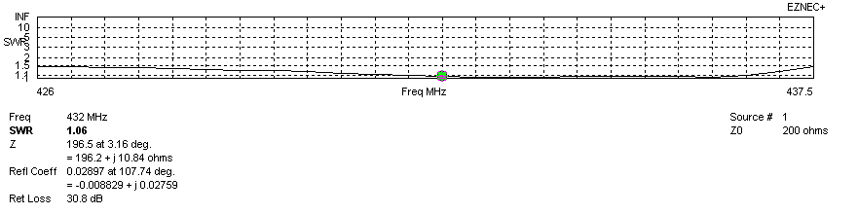
Frequency diagram for SWR better than 1.5
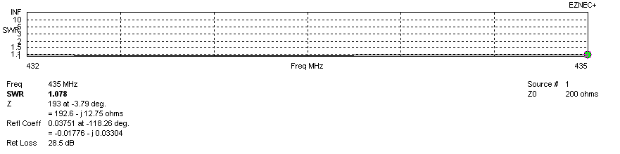
SWR diagram for the range from 432.000 – 435.000 MHz
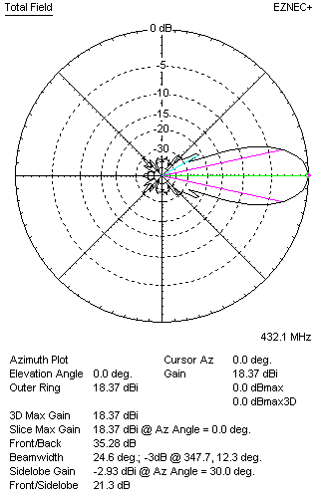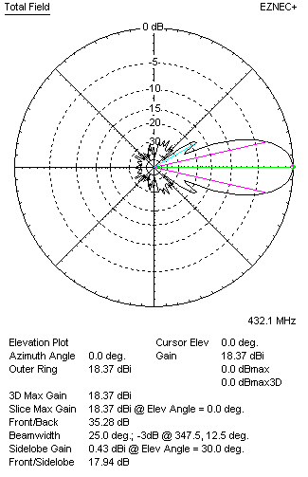
Horizontal and vertical pattern in free space, loss included for aluminum
STACKING
(ALL DATA GIVEN IN ACCORDANCE WITH KF2YN CORRECTION, LOSS INCLUDED)
RECOMMENDED STACKING DISTANCES
 |  |  |  | Two antennas vertically  (mm) |  |  | Two antennas horizontally  (mm) |  |  |  | Four antennas in H-stack  (mm)
Horizontal distance |  |  |  |  |  |  | 1980 |  |  |  | 1980
Vertical distance |  |  |  | 1980 |  |  |  |  |  |  | 1980
TWO ANTENNAS STACKED VERTICALLY
DISTANCE  (mm) |  |  | G  (dBi) |  |  | TA  (K) |  | Tloss  (K) |  |  |  | G/T  (dB)
1980 |  |  | 21.36 |  |  | 29.0 |  | 5.7 |  |  |  | +6.43
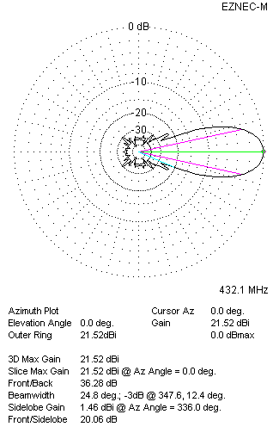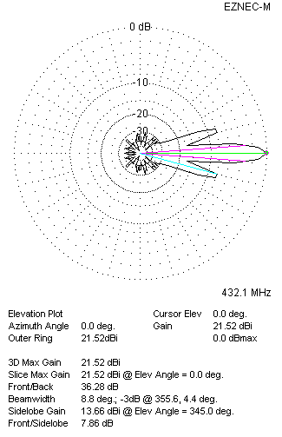
Two antennas stacked vertically
TWO ANTENNAS STACKED HORIZONTALLY
DISTANCE  (mm) |  |  | G  (dBi) |  |  | TA  (K) |  |  | Tloss  (K) |  |  |  | G/T  (dB)
1940 |  |  | 21.34 |  |  | 29.7 |  |  | 5.7 |  |  |  | +6.61
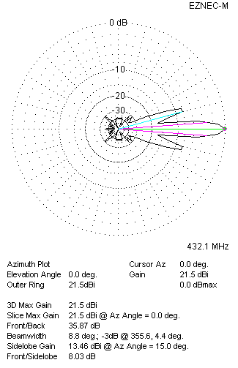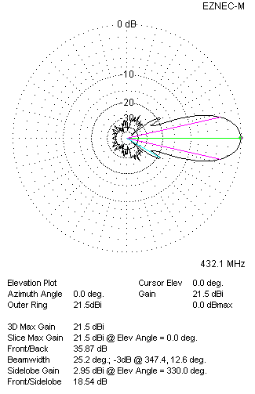
Two antennas stacked horizontally
FOUR ANTENNAS IN H-STACK
DISTANCE  (mm) |  |  | G  (dBi) |  |  | TA  (K) |  |  | Tloss  (K) |  |  |  | G/T  (dB)
H = 1940 |  |  | 24.40 |  |  | 28.8 |  |  | 5.7 |  |  |  | +9.80
V = 1820
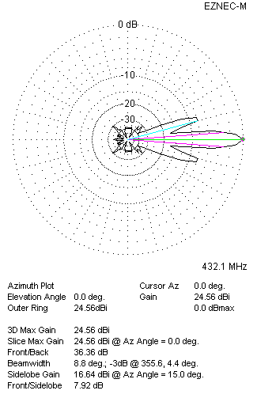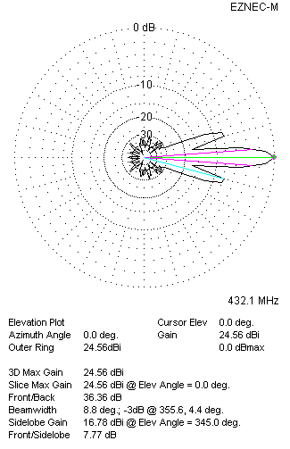
Four antennas in H-stack

