ANTENNA QY72010XL9D13
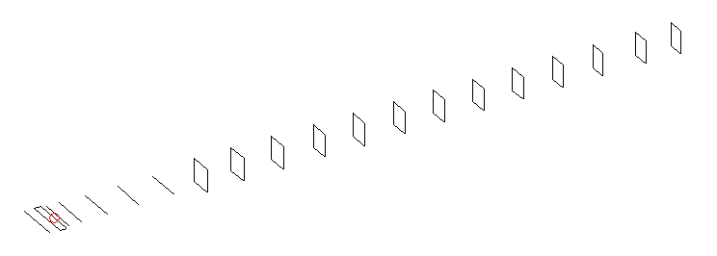
DESCRIPTION
Radiator |  |  | Number of  yagi elements |  |  | Number of  oblong elements |  |  |  | Total number  of elements |  |  | Boomlength  (mm)
LFA |  |  | 6 |  |  | 13 |  |  |  | 20 |  |  | 4725
DIMENSIONS
 | Ref | De1 |  | De2 | D1 |  | D2 | D3 | D4 |  | D5 | DQ1 |  | DQ2 | DQ3
Position | 0 | 70 |  | 120 | 152 |  | 245 | 435 | 672 |  | 932 | 1206 |  | 1479 | 1775
Length | 331 | 331 |  | 331 | 295 |  | 301 | 289.5 | 281.5 |  | 275 | 171 |  | 163 | 157
 | DQ4 | DQ5 |  | DQ6 | DQ7 |  | DQ8 | DQ9 | DQ10 |  | DQ11 | DQ12 |  | DQ13
Position | 2086 | 2378 |  | 2678 | 2972 |  | 3262 | 3556 | 3852 |  | 4148 | 4466 |  | 4725
Length | 155 | 153 |  | 151 | 147 |  | 143 | 139 | 135 |  | 133 | 129 |  | 129

Remark | All elements made of Al tubes Ǿ10 mm  The height of rectangles is 170 mm  All dimensions given in milimetres
PERFORMANCES (No loss condition)
G  (dBi) |  | F/B  (dB) |  | F/Sh  (dBi) | F/Sv  (dBi) |  | Hor  (◦) |  |  | Ver  (◦) | Temp  (◦K) |  |  | G/T  (dB)
18.16 |  | 30.85 |  | 23.55 | 19.43 |  | 25.2 |  |  | 25.6 | 24.6 |  |  | +5.44
DIAGRAMS
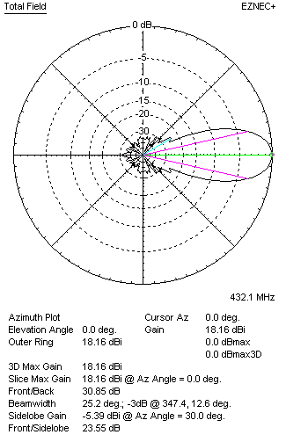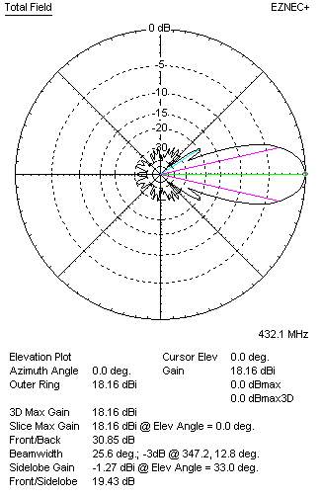
Horizontal and verticall pattern in free space, no loss condition
PERFORMANCES (Loss included for aluminum)
Aluminum |  |  |  | G  (dBi) | Tloss  (K) |  | T_{A}  (◦K) |  |  | G/T  (dB) | Bandwidth for SWR=1.5  (MHz)
After NEC/EZNEC |  |  |  | 18.11 | 2.9 |  | 24.8 |  |  | +4.20 | 425.500 – 437.300
After KF2YN correction |  |  |  | 18.07 | 2.9 |  | 27.4 |  |  | +3.69
Remark: Red coloured data are the final antenna data, which means: KF2YN correction formula applied and loss for aluminum included
DIAGRAMS
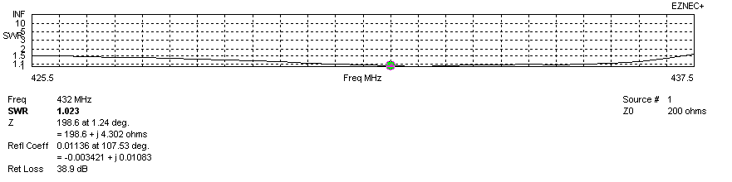
Frequency diagram for SWR better than 1.5
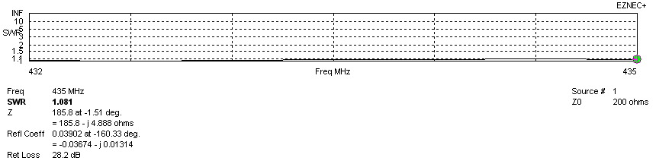
SWR diagram for the range from 432.000 – 435.000 MHz
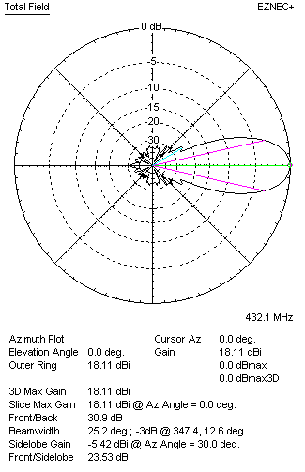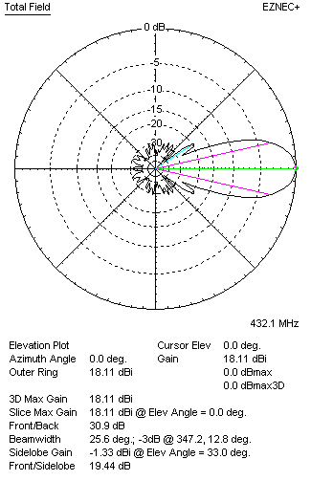
Horizontal and vertical pattern in free space, loss included for aluminum
STACKING
(ALL DATA GIVEN IN ACCORDANCE WITH KF2YN CORRECTION, LOSS INCLUDED)
RECOMMENDED STACKING DISTANCES
 |  |  |  | Two antennas vertically  (mm) |  |  | Two antennas horizontally  (mm) |  |  |  | Four antennas in H-stack  (mm)
Horizontal distance |  |  |  |  |  |  | 1860 |  |  |  | 1860
Vertical distance |  |  |  | 1840 |  |  |  |  |  |  | 1840
TWO ANTENNAS STACKED VERTICALLY
DISTANCE  (mm) |  |  | G  (dBi) |  |  | TA  (K) |  | Tloss  (K) |  |  |  | G/T  (dB)
1840 |  |  | 21.11 |  |  | 26.5 |  | 2.9 |  |  |  | +6.87
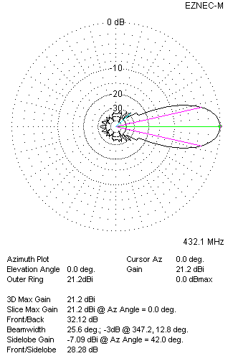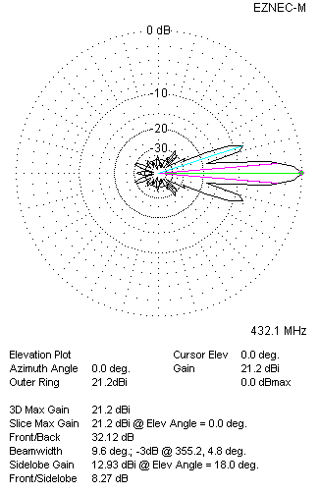
Two antennas stacked vertically
TWO ANTENNAS STACKED HORIZONTALLY
DISTANCE  (mm) |  |  | G  (dBi) |  |  | TA  (K) |  |  | Tloss  (K) |  |  |  | G/T  (dB)
1860 |  |  | 21.09 |  |  | 26.8 |  |  | 2.9 |  |  |  | +6.80
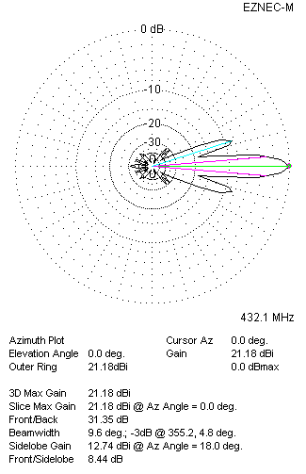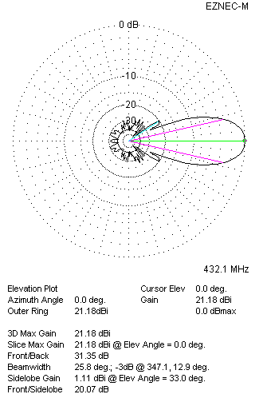
Two antennas stacked horizontally
FOUR ANTENNAS IN H-STACK
DISTANCE  (mm) |  |  | G  (dBi) |  |  | TA  (K) |  |  | Tloss  (K) |  |  |  | G/T  (dB)
H = 1860 |  |  | 24.15 |  |  | 26.0 |  |  | 2.9 |  |  |  | +9.99
V = 1840
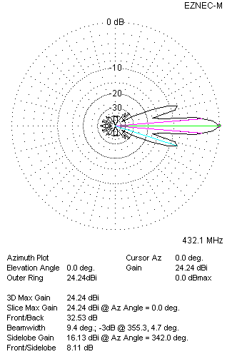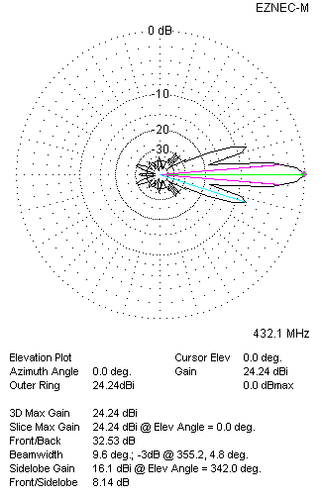
Four antennas in H-stack

