ANTENNA QY72005XL2D13
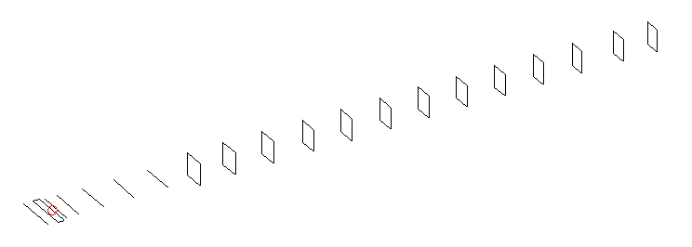
DESCRIPTION
Radiator |  |  | Number of  yagi elements |  |  | Number of  oblong elements |  |  |  | Total number  of elements |  |  | Boomlength  (mm)
LFA |  |  | 6 |  |  | 13 |  |  |  | 20 |  |  | 4725
DIMENSIONS
 | Ref | De1 |  | De2 | D1 |  | D2 | D3 | D4 |  | D5 | DQ1 |  | DQ2 | DQ3
Position | 0 | 65 |  | 100 | 133 |  | 236 | 419 | 646 |  | 910 | 1178 |  | 1458 | 1751
Length | 336 | 351 |  | 298 | 306 |  | 308.5 | 299.5 | 292.5 |  | 286 | 171 |  | 162 | 158
 | DQ3 | DQ4 |  | DQ5 | DQ6 |  | DQ7 | DQ8 | DQ9 |  | DQ10 | DQ11 |  | DQ12
Position | DQ4 | DQ5 |  | DQ6 | DQ7 |  | DQ8 | DQ9 | DQ10 |  | DQ11 | DQ12 |  | DQ13
Length | 2058 | 2360 |  | 2666 | 2968 |  | 3272 | 3584 | 3884 |  | 4182 | 4486 |  | 4725

Remark | All elements made of Al tubes Ǿ5 mm  The height of rectangles is 170 mm  All dimensions given in milimetres
PERFORMANCES (No loss condition)
G  (dBi) |  | F/B  (dB) |  | F/Sh  (dBi) | F/Sv  (dBi) |  | Hor  (◦) |  |  | Ver  (◦) | Temp  (◦K) |  |  | G/T  (dB)
18.05 |  | 43.73 |  | 21.60 | 17.91 |  | 25.6 |  |  | 26.2 | 25.6 |  |  | +4.72
DIAGRAMS
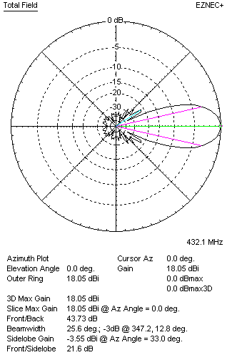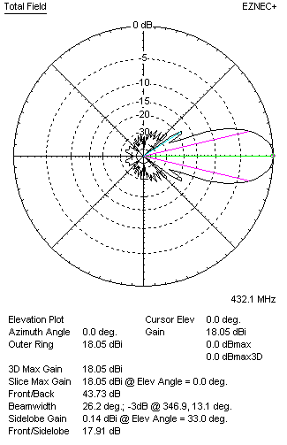
Horizontal and verticall pattern in free space, no loss condition
PERFORMANCES (Loss included for aluminum)
Aluminum |  |  |  | G  (dBi) | Tloss  (K) |  | T_{A}  (◦K) |  |  | G/T  (dB) | Bandwidth for SWR=1.5  (MHz)
After NEC/EZNEC |  |  |  | 17.99 | 4.6 |  | 25.6 |  |  | +3.87 | 418.500 – 439.400
After KF2YN correction |  |  |  | 17.92 | 4.6 |  | 29.8 |  |  | +3.18
Remark: Red coloured data are the final antenna data, which means: KF2YN correction formula applied and loss for aluminum included
DIAGRAMS
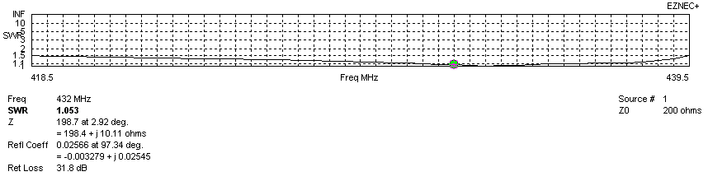
Frequency diagram for SWR better than 1.5
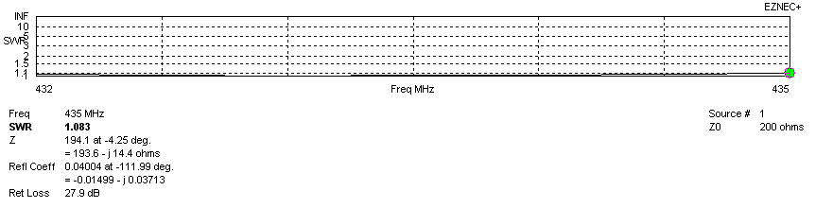
SWR diagram for the range from 432.000 – 435.000 MHz
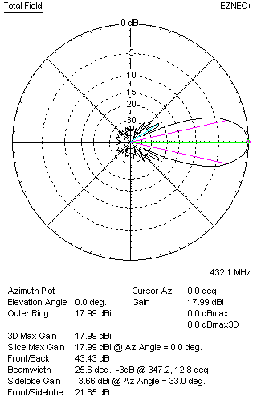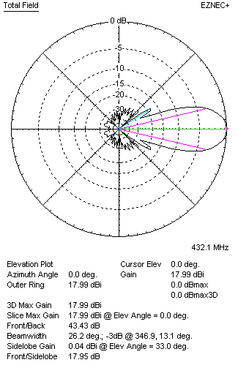
Horizontal and vertical pattern in free space, loss included for aluminum
STACKING
(ALL DATA GIVEN IN ACCORDANCE WITH KF2YN CORRECTION, LOSS INCLUDED)
RECOMMENDED STACKING DISTANCES
 |  |  |  | Two antennas vertically  (mm) |  |  | Two antennas horizontally  (mm) |  |  |  | Four antennas in H-stack  (mm)
Horizontal distance |  |  |  |  |  |  | 1940 |  |  |  | 1940
Vertical distance |  |  |  | 1820 |  |  |  |  |  |  | 1820
TWO ANTENNAS STACKED VERTICALLY
DISTANCE  (mm) |  |  | G  (dBi) |  |  | TA  (K) |  | Tloss  (K) |  |  |  | G/T  (dB)
1820 |  |  | 20.95 |  |  | 28.3 |  | 4.6 |  |  |  | +6.43
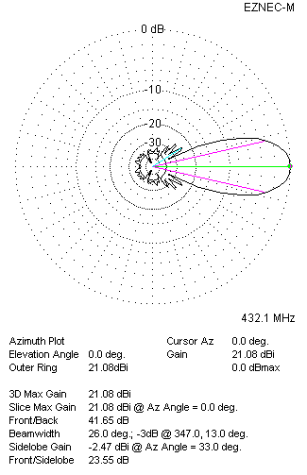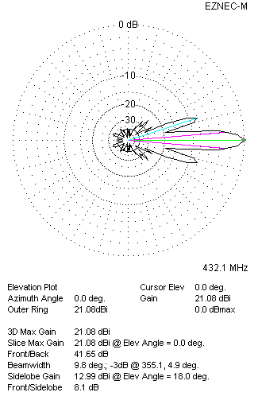
Two antennas stacked vertically
TWO ANTENNAS STACKED HORIZONTALLY
DISTANCE  (mm) |  |  | G  (dBi) |  |  | TA  (K) |  |  | Tloss  (K) |  |  |  | G/T  (dB)
1940 |  |  | 20.97 |  |  | 29.2 |  |  | 4.6 |  |  |  | +6.32
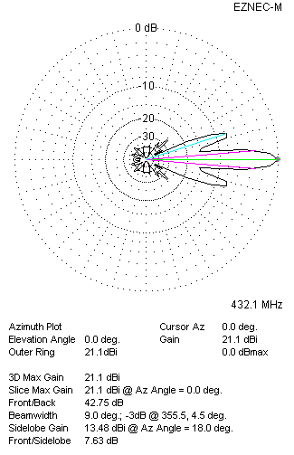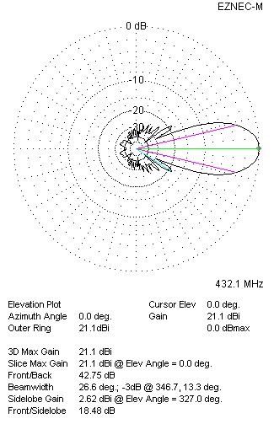
Two antennas stacked horizontally
FOUR ANTENNAS IN H-STACK
DISTANCE  (mm) |  |  | G  (dBi) |  |  | TA  (K) |  |  | Tloss  (K) |  |  |  | G/T  (dB)
H = 1940 |  |  | 24.01 |  |  | 28.0 |  |  | 4.6 |  |  |  | +9.54
V = 1820
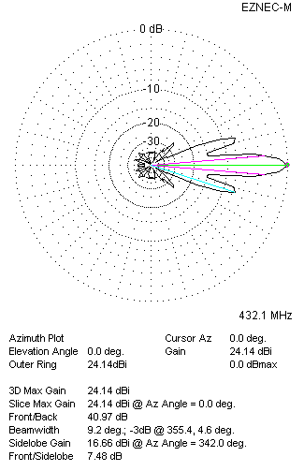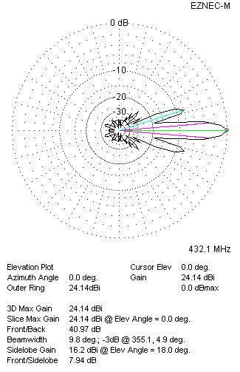
Four antennas in H-stack

