ANTENNA QY71908XL3D12
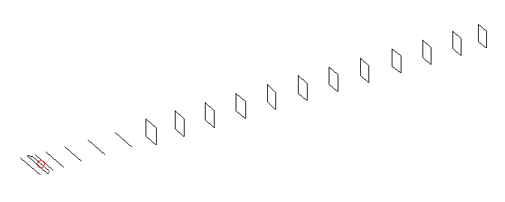
DESCRIPTION
Radiator |  |  | Number of  yagi elements |  |  | Number of  oblong elements |  |  | Total number  of elements |  |  | Boomlength  (mm)
LFA |  |  | 6 |  |  | 12 |  |  | 19 |  |  | 4425
DIMENSIONS
 | Ref | De1 |  | De2 | D1 |  | D2 | D3 |  | D4 | D5 |  | DQ1 | DQ2
Position | 0 | 64 |  | 96 | 133 |  | 234 | 421 |  | 654 | 918 |  | 1185 | 1474
Length | 333 | 351 |  | 288 | 303 |  | 305 | 294.5 |  | 285.5 | 279 |  | 169 | 161
 | DQ3 | DQ4 |  | DQ5 | DQ6 |  | DQ7 | DQ8 |  | DQ9 | DQ10 |  | DQ11 | DQ12
Position | 1774 | 2062 |  | 2388 | 2682 |  | 2982 | 3286 |  | 3580 | 3884 |  | 4184 | 4425
Length | 159 | 154 |  | 152 | 150 |  | 147 | 145 |  | 143 | 139 |  | 139 | 139

Remark | All elements made of Al tubes Ǿ8 mm  The height of rectangles is 170 mm  All dimensions given in milimetres
PERFORMANCES (No loss condition)
G  (dBi) |  | F/B  (dB) |  | F/Sh  (dBi) | F/Sv  (dBi) |  | Hor  (◦) |  |  | Ver  (◦) | Temp  (◦K) |  |  | G/T  (dB)
18.03 |  | 31.35 |  | 21.42 | 17.74 |  | 25.8 |  |  | 26.2 | 25.3 |  |  | +5.09
DIAGRAMS
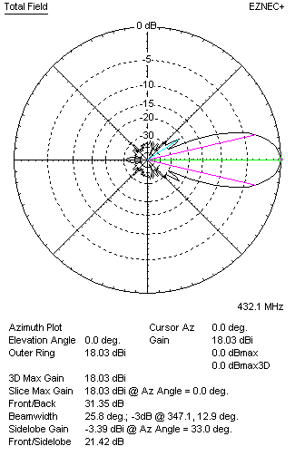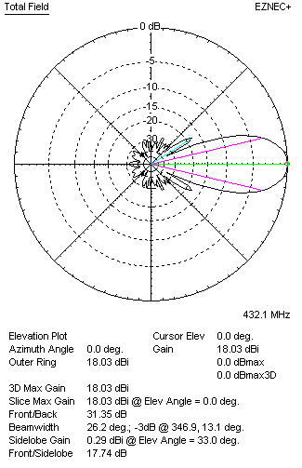
Horizontal and verticall pattern in free space, no loss condition
PERFORMANCES (Loss included for aluminum)
Aluminum |  |  |  | G  (dBi) | Tloss  (K) |  | T_{A}  (◦K) |  |  | G/T  (dB) | Bandwidth for SWR=1.5  (MHz)
After NEC/EZNEC |  |  |  | 17.98 | 3.7 |  | 25.3 |  |  | +4.32 | 426.500 – 437.600
After KF2YN correction |  |  |  | 17.88 | 3.7 |  | 28.7 |  |  | +3.31
Remark: Red coloured data are the final antenna data, which means: KF2YN correction formula applied and loss for aluminum included
DIAGRAMS
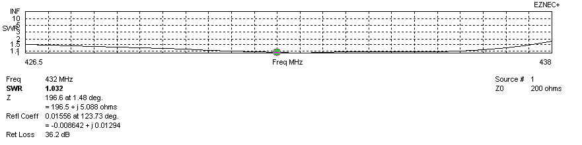
Frequency diagram for SWR better than 1.5
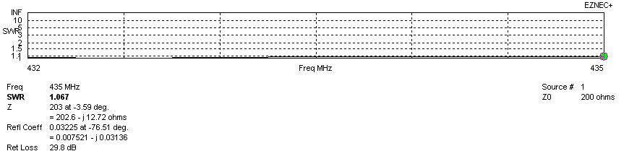
SWR diagram for the range from 432.000 – 435.000 MHz
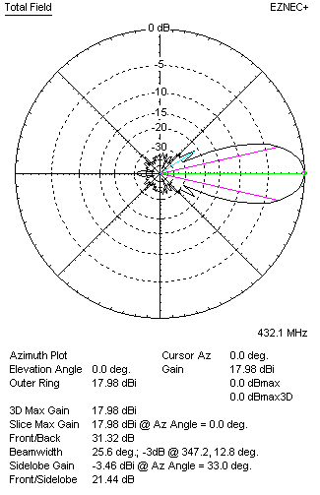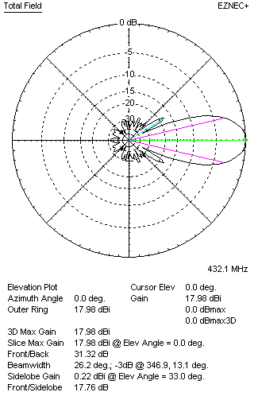
Horizontal and vertical pattern in free space, loss included for aluminum
STACKING
(ALL DATA GIVEN IN ACCORDANCE WITH KF2YN CORRECTION, LOSS INCLUDED)
RECOMMENDED STACKING DISTANCES
 |  |  |  | Two antennas vertically  (mm) |  |  | Two antennas horizontally  (mm) |  |  |  | Four antennas in H-stack  (mm)
Horizontal distance |  |  |  |  |  |  | 1900 |  |  |  | 1900
Vertical distance |  |  |  | 1900 |  |  |  |  |  |  | 1900
TWO ANTENNAS STACKED VERTICALLY
DISTANCE  (mm) |  |  | G  (dBi) |  |  | TA  (K) |  | Tloss  (K) |  |  |  | G/T  (dB)
1900 |  |  | 20.96 |  |  | 27.1 |  | 3.7 |  |  |  | +6.64
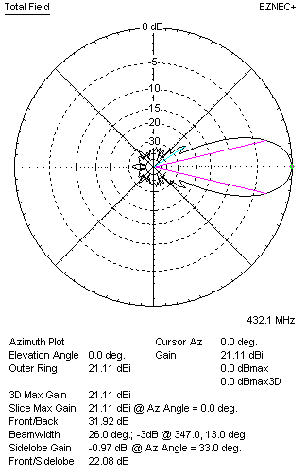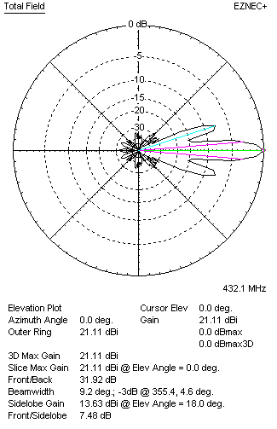
Two antennas stacked vertically
TWO ANTENNAS STACKED HORIZONTALLY
DISTANCE  (mm) |  |  | G  (dBi) |  |  | TA  (K) |  |  | Tloss  (K) |  |  |  | G/T  (dB)
1900 |  |  | 20.93 |  |  | 28.1 |  |  | 3.7 |  |  |  | +6.45
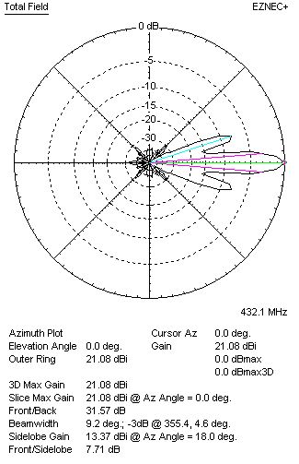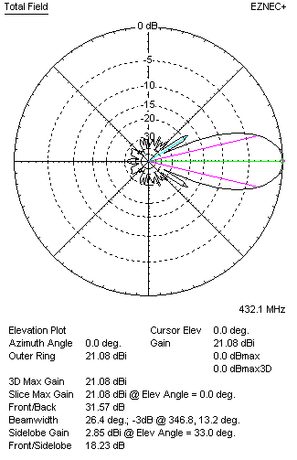
Two antennas stacked horizontally
FOUR ANTENNAS IN H-STACK
DISTANCE  (mm) |  |  | G  (dBi) |  |  | TA  (K) |  |  | Tloss  (K) |  |  |  | G/T  (dB)
H = 1900 |  |  | 24.00 |  |  | 27.0 |  |  | 3.7 |  |  |  | +9.69
V = 1880
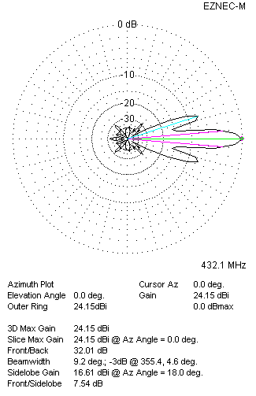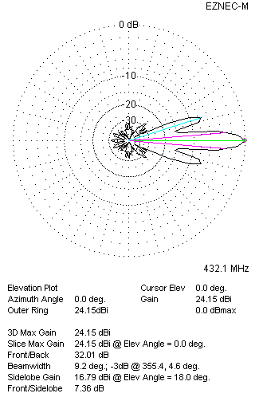
Four antennas in H-stack

