ANTENNA QY71905XL2D12
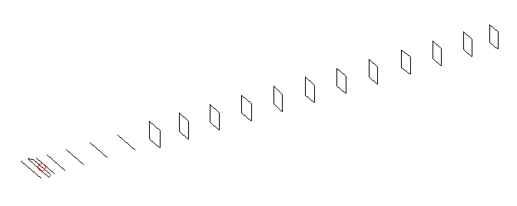
DESCRIPTION
Radiator |  |  | Number of  yagi elements |  |  | Number of  oblong elements |  |  | Total number  of elements |  |  | Boomlength  (mm)
LFA |  |  | 6 |  |  | 12 |  |  | 19 |  |  | 4425
DIMENSIONS
 | Ref | De1 |  | De2 | D1 |  | D2 | D3 |  | D4 | D5 |  | DQ1 | DQ2
Position | 0 | 65 |  | 100 | 133 |  | 236 | 419 |  | 646 | 910 |  | 1178 | 1458
Length | 336 | 350 |  | 298 | 306 |  | 308.5 | 299.5 |  | 292 | 286 |  | 171 | 162
 | DQ3 | DQ4 |  | DQ5 | DQ6 |  | DQ7 | DQ8 |  | DQ9 | DQ10 |  | DQ11 | DQ12
Position | 1751 | 2058 |  | 2360 | 2666 |  | 2968 | 3272 |  | 3584 | 3884 |  | 4178 | 4425
Length | 158 | 154 |  | 151 | 149 |  | 147 | 145 |  | 143 | 143 |  | 143 | 140

Remark | All elements made of Al tubes Ǿ5 mm  The height of rectangles is 170 mm  All dimensions given in milimetres
PERFORMANCES (No loss condition)
G  (dBi) |  | F/B  (dB) |  | F/Sh  (dBi) | F/Sv  (dBi) |  | Hor  (◦) |  |  | Ver  (◦) | Temp  (◦K) |  |  | G/T  (dB)
17.84 |  | 38.14 |  | 21.65 | 17.77 |  | 26.2 |  |  | 26.8 | 25.7 |  |  | +4.49
DIAGRAMS
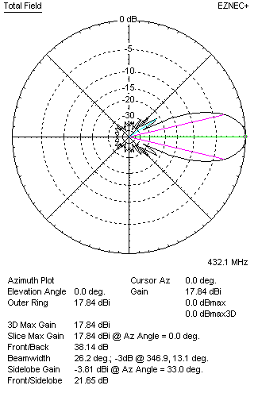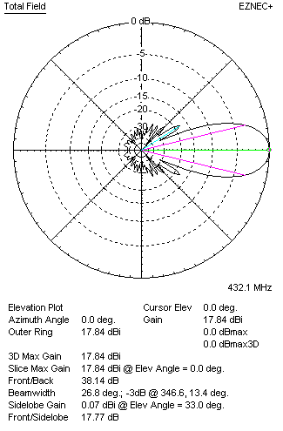
Horizontal and verticall pattern in free space, no loss condition
PERFORMANCES (Loss included for aluminum)
Aluminum |  |  |  | G  (dBi) | Tloss  (K) |  | T_{A}  (◦K) |  |  | G/T  (dB) | Bandwidth for SWR=1.5  (MHz)
After NEC/EZNEC |  |  |  | 17.77 | 4.6 |  | 25.7 |  |  | +3.65 | 419.600 – 439.700
After KF2YN correction |  |  |  | 17.71 | 4.6 |  | 29.9 |  |  | +2.95
Remark: Red coloured data are the final antenna data, which means: KF2YN correction formula applied and loss for aluminum included
DIAGRAMS
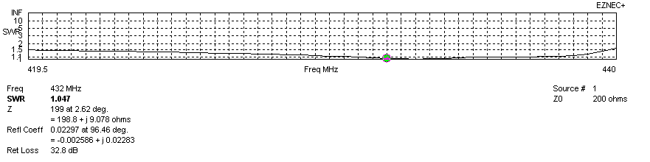
Frequency diagram for SWR better than 1.5
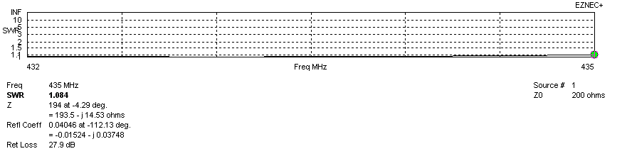
SWR diagram for the range from 432.000 – 435.000 MHz
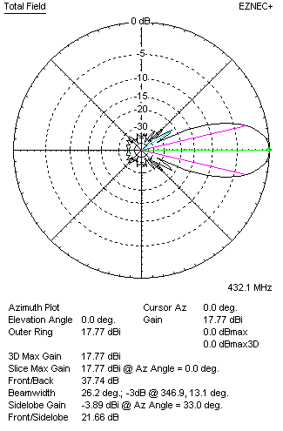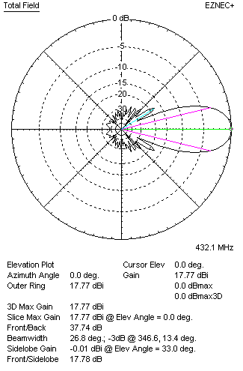
Horizontal and vertical pattern in free space, loss included for aluminum
STACKING
(ALL DATA GIVEN IN ACCORDANCE WITH KF2YN CORRECTION, LOSS INCLUDED)
RECOMMENDED STACKING DISTANCES
 |  |  |  | Two antennas vertically  (mm) |  |  | Two antennas horizontally  (mm) |  |  |  | Four antennas in H-stack  (mm)
Horizontal distance |  |  |  |  |  |  | 1920 |  |  |  | 1920
Vertical distance |  |  |  | 1880 |  |  |  |  |  |  | 1880
TWO ANTENNAS STACKED VERTICALLY
DISTANCE  (mm) |  |  | G  (dBi) |  |  | TA  (K) |  | Tloss  (K) |  |  |  | G/T  (dB)
1880 |  |  | 20.78 |  |  | 28.5 |  | 4.6 |  |  |  | +6.23
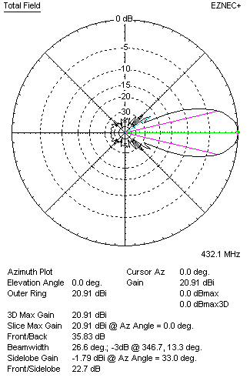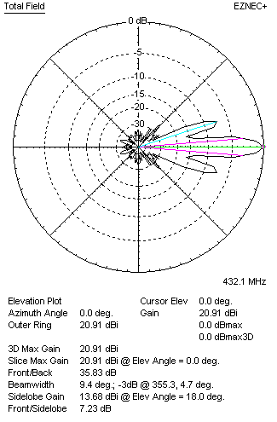
Two antennas stacked vertically
TWO ANTENNAS STACKED HORIZONTALLY
DISTANCE  (mm) |  |  | G  (dBi) |  |  | TA  (K) |  |  | Tloss  (K) |  |  |  | G/T  (dB)
1920 |  |  | 20.76 |  |  | 29.3 |  |  | 4.6 |  |  |  | +6.09
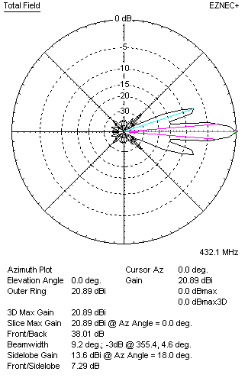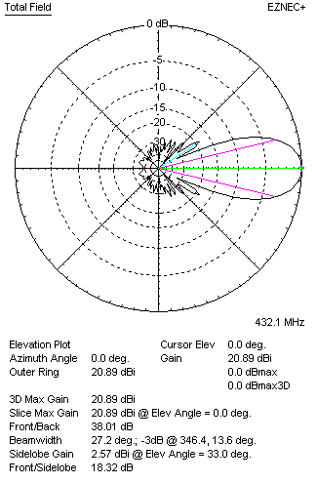
Two antennas stacked horizontally
FOUR ANTENNAS IN H-STACK
DISTANCE  (mm) |  |  | G  (dBi) |  |  | TA  (K) |  |  | Tloss  (K) |  |  |  | G/T  (dB)
H = 1920 |  |  | 23.83 |  |  | 28.4 |  |  | 4.6 |  |  |  | +9.29
V = 1880
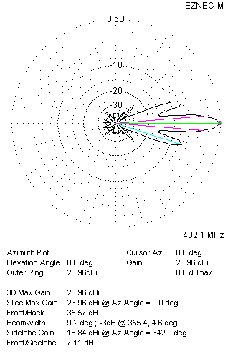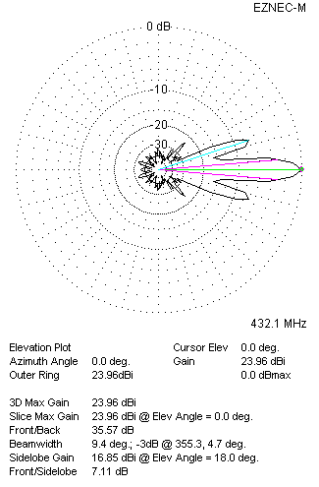
Four antennas in H-stack

