ANTENNA QY71810XL7D11
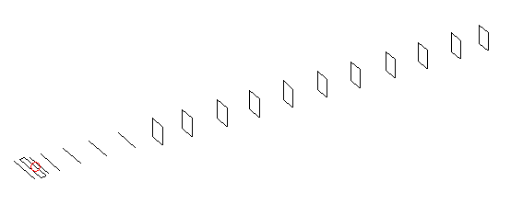
DESCRIPTION
Radiator |  |  | Number of  yagi elements |  |  | Number of  oblong elements |  |  | Total number  of elements |  |  | Boomlength  (mm)
LFA |  |  | 6 |  |  | 11 |  |  | 18 |  |  | 4125
DIMENSIONS
 | Ref | De1 |  | De2 | D1 |  | D2 | D3 |  | D4 | D5 |  | DQ1 | DQ2
Position | 0 | 50 |  | 95 | 136 |  | 234 | 428 |  | 658 | 918 |  | 1194 | 1462
Length | 331 | 334 |  | 334 | 302 |  | 301 | 289.5 |  | 281 | 273.5 |  | 170 | 162
 | DQ3 | DQ4 |  | DQ5 | DQ6 |  | DQ7 | DQ8 |  | DQ9 | DQ10 |  | DQ11
Position | 1772 | 2066 |  | 2368 | 2673 |  | 2972 | 3292 |  | 3578 | 3876 |  | 4125
Length | 157 | 153 |  | 151 | 147 |  | 143 | 141 |  | 141 | 139 |  | 137

Remark | All elements made of Al tubes Ǿ10 mm  The height of rectangles is 170 mm  All dimensions given in milimetres
PERFORMANCES (No loss condition)
G  (dBi) |  | F/B  (dB) |  | F/Sh  (dBi) | F/Sv  (dBi) |  | Hor  (◦) |  |  | Ver  (◦) | Temp  (◦K) |  |  | G/T  (dB)
17.75 |  | 29.06 |  | 22.53 | 18.72 |  | 26.2 |  |  | 26.8 | 25.6 |  |  | +4.07
DIAGRAMS
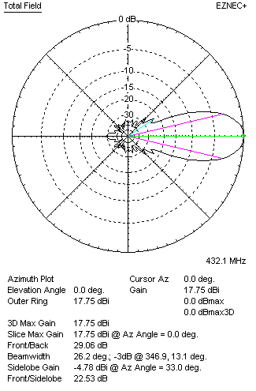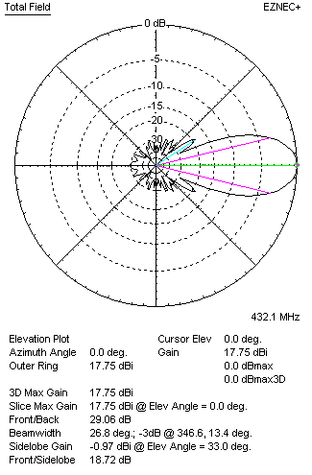
Horizontal and verticall pattern in free space, no loss condition
PERFORMANCES (Loss included for aluminum)
Aluminum |  |  |  | G  (dBi) | Tloss  (K) |  | T_{A}  (◦K) |  |  | G/T  (dB) | Bandwidth for SWR=1.5  (MHz)
After NEC/EZNEC |  |  |  | 17.71 | 3.2 |  | 25.6 |  |  | +3.52 | 426.500 – 438.500
After KF2YN correction |  |  |  | 17.67 | 3.2 |  | 28.5 |  |  | +3.12
Remark: Red coloured data are the final antenna data, which means: KF2YN correction formula applied and loss for aluminum included
DIAGRAMS
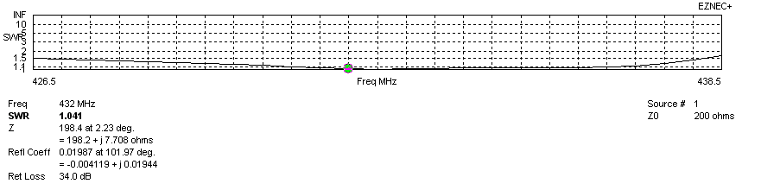
Frequency diagram for SWR better than 1.5
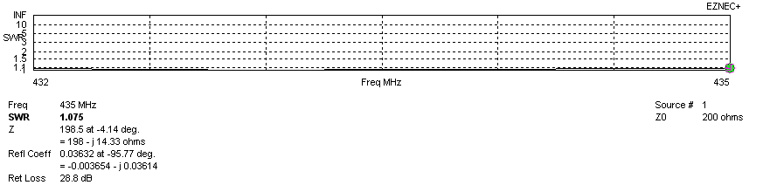
SWR diagram for the range from 432.000 – 435.000 MHz
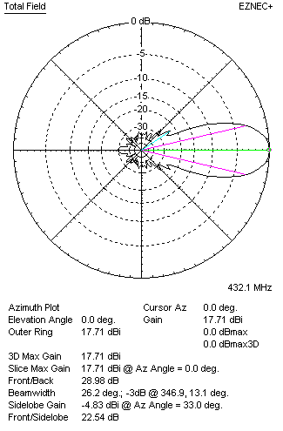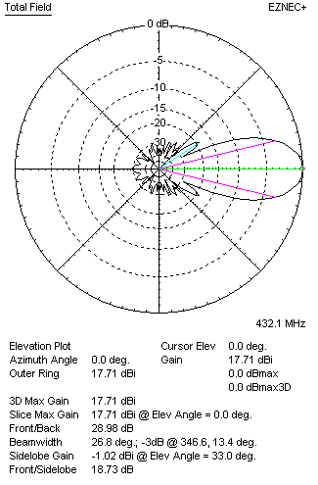
Horizontal and vertical pattern in free space, loss included for aluminum
STACKING
(ALL DATA GIVEN IN ACCORDANCE WITH KF2YN CORRECTION, LOSS INCLUDED)
RECOMMENDED STACKING DISTANCES
 |  |  |  | Two antennas vertically  (mm) |  |  | Two antennas horizontally  (mm) |  |  |  | Four antennas in H-stack  (mm)
Horizontal distance |  |  |  |  |  |  | 1840 |  |  |  | 1840
Vertical distance |  |  |  | 1900 |  |  |  |  |  |  | 1900
TWO ANTENNAS STACKED VERTICALLY
DISTANCE  (mm) |  |  | G  (dBi) |  |  | TA  (K) |  | Tloss  (K) |  |  |  | G/T  (dB)
1900 |  |  | 20.75 |  |  | 27.1 |  | 3.2 |  |  |  | +6.42
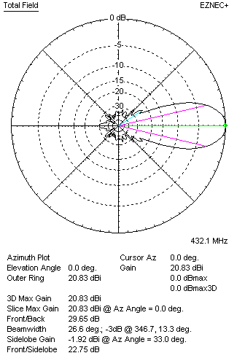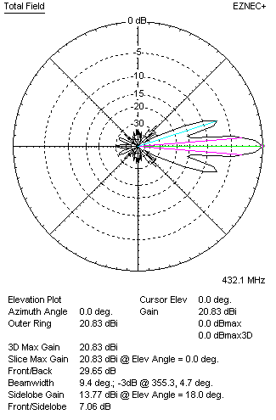
Two antennas stacked vertically
TWO ANTENNAS STACKED HORIZONTALLY
DISTANCE  (mm) |  |  | G  (dBi) |  |  | TA  (K) |  |  | Tloss  (K) |  |  |  | G/T  (dB)
1840 |  |  | 20.72 |  |  | 27.7 |  |  | 3.2 |  |  |  | +6.29
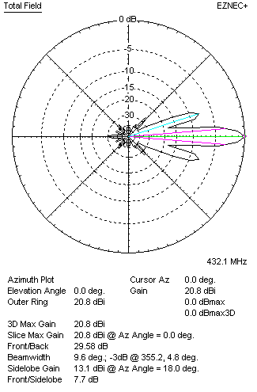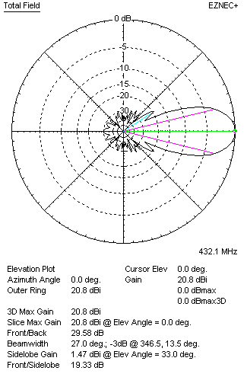
Two antennas stacked horizontally
FOUR ANTENNAS IN H-STACK
DISTANCE  (mm) |  |  | G  (dBi) |  |  | TA  (K) |  |  | Tloss  (K) |  |  |  | G/T  (dB)
H = 1840 |  |  | 23.79 |  |  | 26.8 |  |  | 3.2 |  |  |  | +9.51
V = 1940
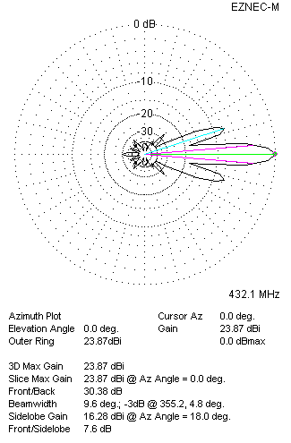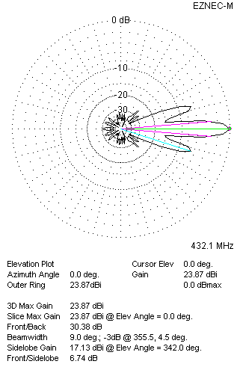
Four antennas in H-stack

