ANTENNA QY71806XL6D11
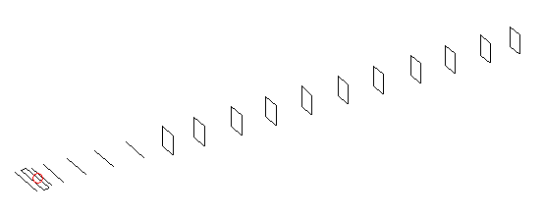
DESCRIPTION
Radiator |  |  | Number of  yagi elements |  |  | Number of  oblong elements |  |  | Total number  of elements |  |  | Boomlength  (mm)
LFA |  |  | 6 |  |  | 11 |  |  | 18 |  |  | 4125
DIMENSIONS
 | Ref | De1 |  | De2 | D1 |  | D2 | D3 |  | D4 | D5 |  | DQ1 | DQ2
Position | 0 | 65 |  | 100 | 131 |  | 233 | 419 |  | 648 | 905 |  | 1182 | 1456
Length | 336 | 349 |  | 304 | 304 |  | 307.5 | 298 |  | 291.5 | 283.5 |  | 171 | 163
 | DQ3 | DQ4 |  | DQ5 | DQ6 |  | DQ7 | DQ8 |  | DQ9 | DQ10 |  | DQ11
Position | 1754 | 2058 |  | 2364 | 2672 |  | 2974 | 3276 |  | 3594 | 3878 |  | 4125
Length | 159 | 155 |  | 151 | 149 |  | 145 | 143 |  | 141 | 139 |  | 137

Remark | All elements made of Al tubes Ǿ6 mm  The height of rectangles is 170 mm  All dimensions given in milimetres
PERFORMANCES (No loss condition)
G  (dBi) |  | F/B  (dB) |  | F/Sh  (dBi) | F/Sv  (dBi) |  | Hor  (◦) |  |  | Ver  (◦) | Temp  (◦K) |  |  | G/T  (dB)
17.66 |  | 45.55 |  | 23.82 | 19.56 |  | 26.8 |  |  | 27.4 | 24.9 |  |  | +4.57
DIAGRAMS
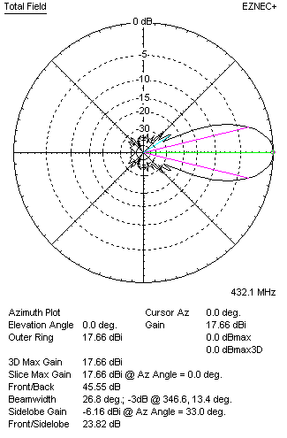 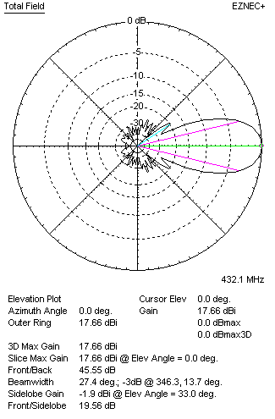Horizontal and verticall pattern in free space, no loss condition
PERFORMANCES (Loss included for aluminum)
Aluminum |  |  |  | G  (dBi) | Tloss  (K) |  | T_{A}  (◦K) |  |  | G/T  (dB) | Bandwidth for SWR=1.5  (MHz)
After NEC/EZNEC |  |  |  | 17.60 | 4.3 |  | 24.9 |  |  | +3.71 | 420.000 – 438.500
After KF2YN correction |  |  |  | 17.52 | 4.3 |  | 28.8 |  |  | +2.93
Remark: Red coloured data are the final antenna data, which means: KF2YN correction formula applied and loss for aluminum included
DIAGRAMS
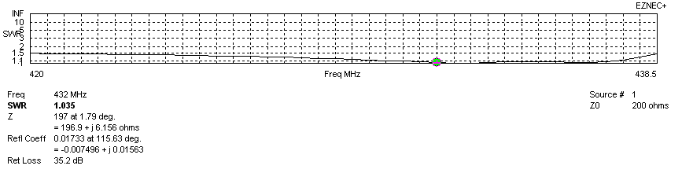
Frequency diagram for SWR better than 1.5
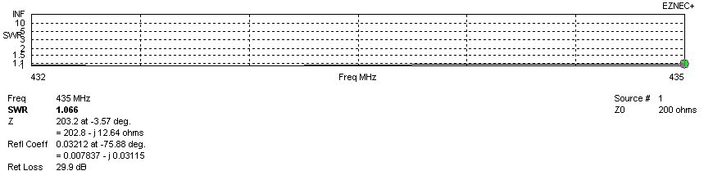
SWR diagram for the range from 432.000 – 435.000 MHz
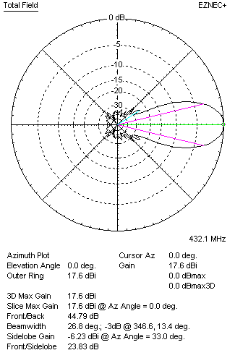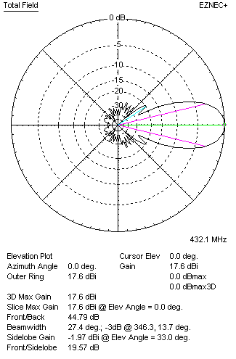
Horizontal and vertical pattern in free space, loss included for aluminum
STACKING
(ALL DATA GIVEN IN ACCORDANCE WITH KF2YN CORRECTION, LOSS INCLUDED)
RECOMMENDED STACKING DISTANCES
 |  |  |  | Two antennas vertically  (mm) |  |  | Two antennas horizontally  (mm) |  |  |  | Four antennas in H-stack  (mm)
Horizontal distance |  |  |  |  |  |  | 1840 |  |  |  | 1840
Vertical distance |  |  |  | 1880 |  |  |  |  |  |  | 1880
TWO ANTENNAS STACKED VERTICALLY
DISTANCE  (mm) |  |  | G  (dBi) |  |  | TA  (K) |  | Tloss  (K) |  |  |  | G/T  (dB)
1880 |  |  | 20.59 |  |  | 27.7 |  | 4.3 |  |  |  | +6.16
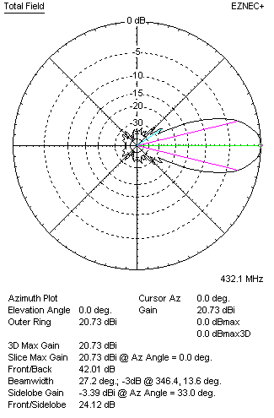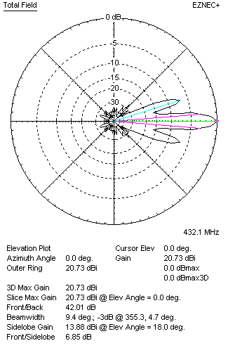
Two antennas stacked vertically
TWO ANTENNAS STACKED HORIZONTALLY
DISTANCE  (mm) |  |  | G  (dBi) |  |  | TA  (K) |  |  | Tloss  (K) |  |  |  | G/T  (dB)
1840 |  |  | 20.56 |  |  | 28.3 |  |  | 4.3 |  |  |  | +6.04
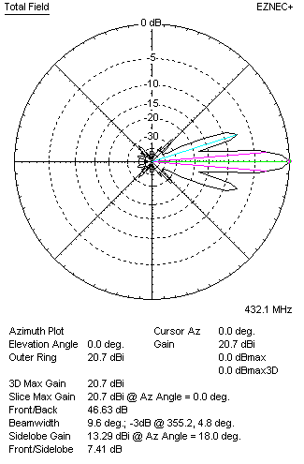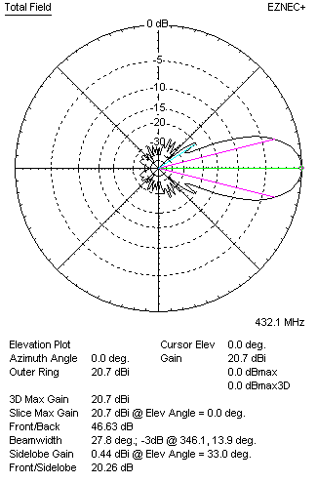
Two antennas stacked horizontally
FOUR ANTENNAS IN H-STACK
DISTANCE  (mm) |  |  | G  (dBi) |  |  | TA  (K) |  |  | Tloss  (K) |  |  |  | G/T  (dB)
H = 1840 |  |  | 23.64 |  |  | 27.4 |  |  | 4.3 |  |  |  | +9.26
V = 1880
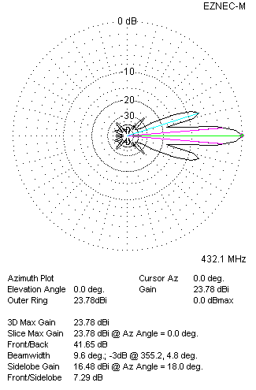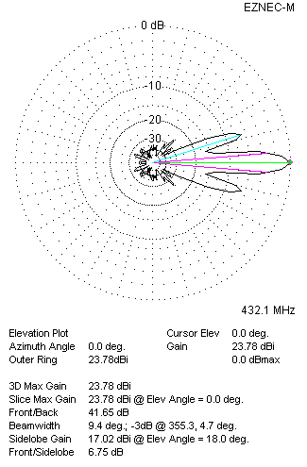
Four antennas in H-stack

