ANTENNA QY71710XL7D10
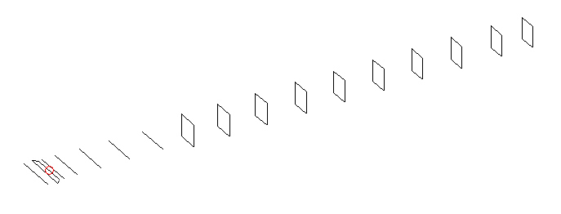
DESCRIPTION
Radiator |  | Number of  yagi elements |  |  | Number of  oblong elements |  |  | Total number  of elements |  |  | Boomlength  (mm)
LFA |  | 6 |  |  | 10 |  |  | 17 |  |  | 3825
DIMENSIONS
 | Ref |  | De1 | De2 |  | D1 | D2 |  | D3 | D4 |  | D5 | DQ1
Position | 0 |  | 45 | 95 |  | 138 | 241 |  | 430 | 660 |  | 920 | 1196
Length | 331 |  | 338 | 338 |  | 301 | 300 |  | 289 | 281.5 |  | 273.5 | 170
 | DQ2 |  | DQ3 | DQ4 |  | DQ5 | DQ6 |  | DQ7 | DQ8 |  | DQ9 | DQ10
Position | 1461 |  | 1772 | 2064 |  | 2368 | 2673 |  | 2972 | 3292 |  | 3578 | 3825
Length | 162 |  | 157 | 154 |  | 151 | 147 |  | 143 | 141 |  | 139 | 137

Remark | All elements made of Al tubes Ǿ10 mm  The height of rectangles is 170 mm  All dimensions given in milimetres
PERFORMANCES (No loss condition)
G  (dBi) |  | F/B  (dB) |  | F/Sh  (dBi) | F/Sv  (dBi) |  | Hor  (◦) |  |  | Ver  (◦) | Temp  (◦K) |  |  | G/T  (dB)
17.50 |  | 38.68 |  | 22.62 | 19.05 |  | 27.0 |  |  | 27.6 | 25.8 |  |  | +3.84
DIAGRAMS
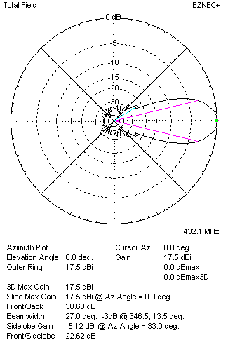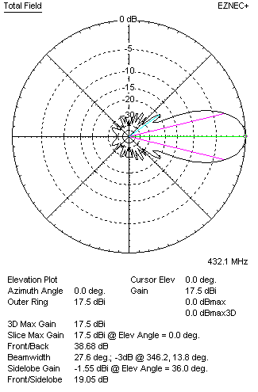
Horizontal and verticall pattern in free space, no loss condition
PERFORMANCES (Loss included for aluminum)
Aluminum |  |  |  | G  (dBi) | Tloss  (K) |  | T_{A}  (◦K) |  |  | G/T  (dB) | Bandwidth for SWR=1.5  (MHz)
After NEC/EZNEC |  |  |  | 17.46 | 2.9 |  | 25.8 |  |  | +3.31 | 420.000 – 439.000
After KF2YN correction |  |  |  | 17.41 | 2.9 |  | 28.4 |  |  | +2.88
Remark: Red coloured data are the final antenna data, which means: KF2YN correction formula applied and loss for aluminum included
DIAGRAMS
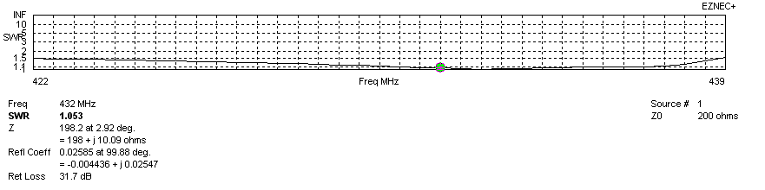
Frequency diagram for SWR better than 1.5
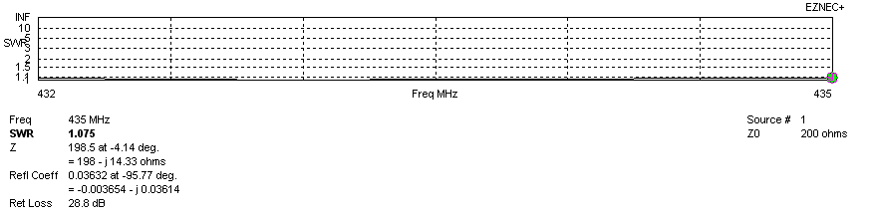
SWR diagram for the range from 432.000 – 435.000 MHz
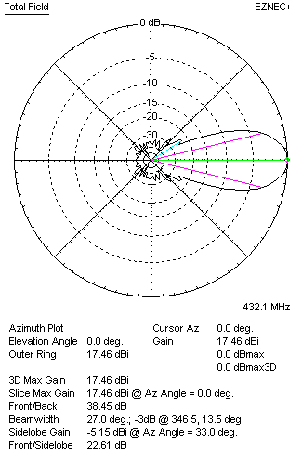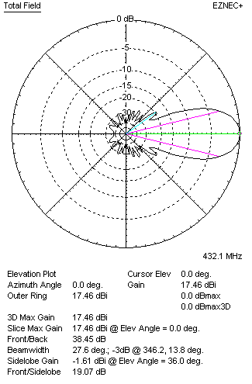
Horizontal and vertical pattern in free space, loss included for aluminum
STACKING
(ALL DATA GIVEN IN ACCORDANCE WITH KF2YN CORRECTION, LOSS INCLUDED)
RECOMMENDED STACKING DISTANCES
 |  |  |  | Two antennas vertically  (mm) |  |  | Two antennas horizontally  (mm) |  |  |  | Four antennas in H-stack  (mm)
Horizontal distance |  |  |  |  |  |  | 1780 |  |  |  | 1780
Vertical distance |  |  |  | 1800 |  |  |  |  |  |  | 1800
TWO ANTENNAS STACKED VERTICALLY
DISTANCE  (mm) |  |  | G  (dBi) |  |  | TA  (K) |  | Tloss  (K) |  |  |  | G/T  (dB)
1800 |  |  | 20.47 |  |  | 27.1 |  | 2.9 |  |  |  | +6.14
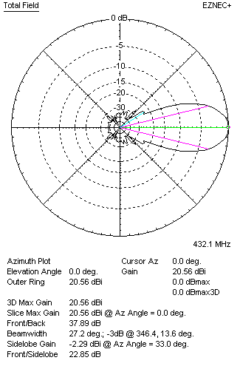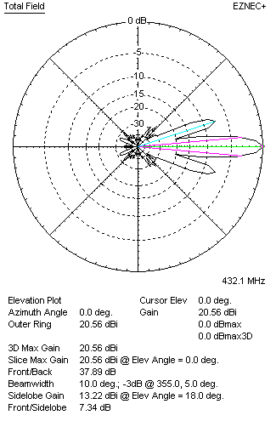
Two antennas stacked vertically
TWO ANTENNAS STACKED HORIZONTALLY
DISTANCE  (mm) |  |  | G  (dBi) |  |  | TA  (K) |  |  | Tloss  (K) |  |  |  | G/T  (dB)
1780 |  |  | 20.45 |  |  | 27.7 |  |  | 2.9 |  |  |  | +6.03
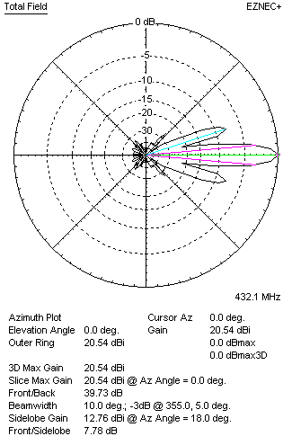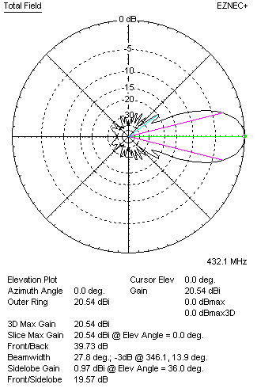
Two antennas stacked horizontally
FOUR ANTENNAS IN H-STACK
DISTANCE  (mm) |  |  | G  (dBi) |  |  | TA  (K) |  |  | Tloss  (K) |  |  |  | G/T  (dB)
H = 1780 |  |  | 23.52 |  |  | 26.6 |  |  | 2.9 |  |  |  | +9.27
V = 1800
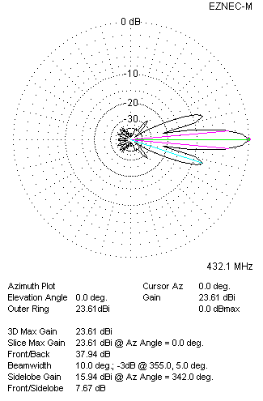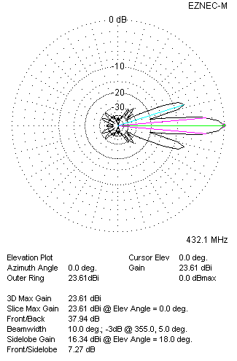
Four antennas in H-stack

