ANTENNA QY71708XL5D10
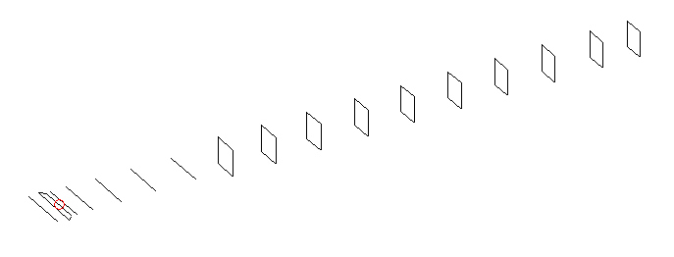
DESCRIPTION
Radiator |  | Number of  yagi elements |  |  | Number of  oblong elements |  |  | Total number  of elements |  |  | Boomlength  (mm)
LFA |  | 6 |  |  | 10 |  |  | 17 |  |  | 3825
DIMENSIONS
 | Ref |  | De1 | De2 |  | D1 | D2 |  | D3 | D4 |  | D5 | DQ1
Position | 0 |  | 61 | 93 |  | 130 | 230 |  | 421 | 654 |  | 916 | 1186
Length | 333 |  | 353 | 288 |  | 303.5 | 305 |  | 294 | 286 |  | 279 | 170
 | DQ2 |  | DQ3 | DQ4 |  | DQ5 | DQ6 |  | DQ7 | DQ8 |  | DQ9 | DQ10
Position | 1474 |  | 1774 | 2062 |  | 2388 | 2682 |  | 2982 | 3286 |  | 3582 | 3825
Length | 162 |  | 158 | 154 |  | 152 | 150 |  | 147 | 145 |  | 143 | 140

Remark | All elements made of Al tubes Ǿ8 mm  The height of rectangles is 170 mm  All dimensions given in milimetres
PERFORMANCES (No loss condition)
G  (dBi) |  | F/B  (dB) |  | F/Sh  (dBi) | F/Sv  (dBi) |  | Hor  (◦) |  |  | Ver  (◦) | Temp  (◦K) |  |  | G/T  (dB)
17.59 |  | 30.91 |  | 22.02 | 18.15 |  | 26.8 |  |  | 27.4 | 25.8 |  |  | +4.53
DIAGRAMS
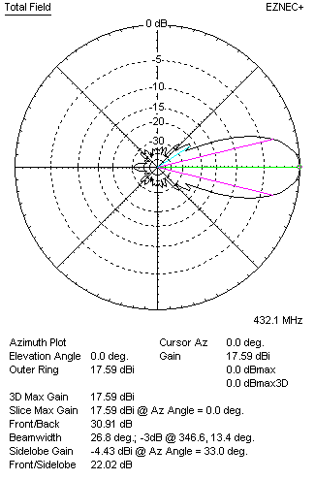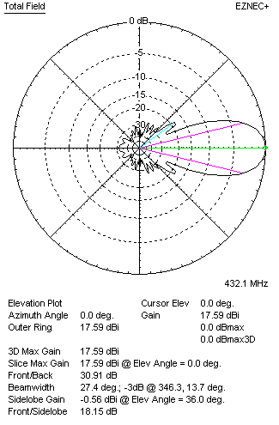
Horizontal and verticall pattern in free space, no loss condition
PERFORMANCES (Loss included for aluminum)
Aluminum |  |  |  | G  (dBi) | Tloss  (K) |  | T_{A}  (◦K) |  |  | G/T  (dB) | Bandwidth for SWR=1.5  (MHz)
After NEC/EZNEC |  |  |  | 17.53 | 3.7 |  | 25.8 |  |  | +3.76 | 425.400 – 437.400
After KF2YN correction |  |  |  | 17.44 | 3.7 |  | 29.2 |  |  | +2.80
Remark: Red coloured data are the final antenna data, which means: KF2YN correction formula applied and loss for aluminum included
DIAGRAMS
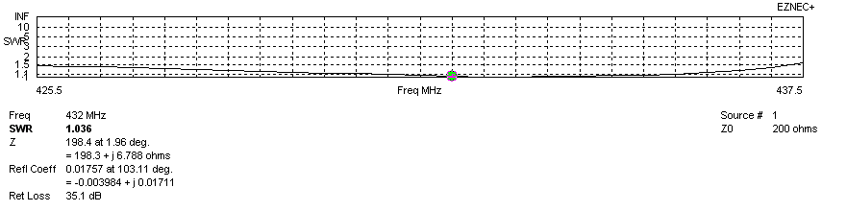
Frequency diagram for SWR better than 1.5
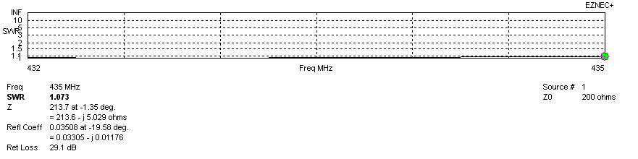
SWR diagram for the range from 432.000 – 435.000 MHz
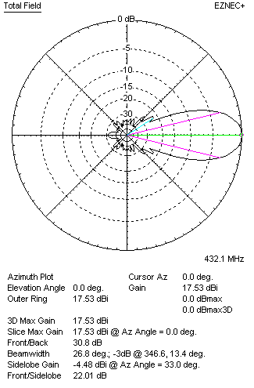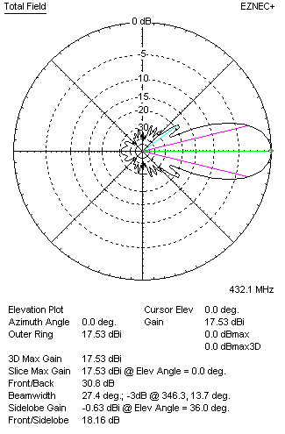
Horizontal and vertical pattern in free space, loss included for aluminum
STACKING
(ALL DATA GIVEN IN ACCORDANCE WITH KF2YN CORRECTION, LOSS INCLUDED)
RECOMMENDED STACKING DISTANCES
 |  |  |  | Two antennas vertically  (mm) |  |  | Two antennas horizontally  (mm) |  |  |  | Four antennas in H-stack  (mm)
Horizontal distance |  |  |  |  |  |  | 1800 |  |  |  | 1800
Vertical distance |  |  |  | 1800 |  |  |  |  |  |  | 1800
TWO ANTENNAS STACKED VERTICALLY
DISTANCE  (mm) |  |  | G  (dBi) |  |  | TA  (K) |  | Tloss  (K) |  |  |  | G/T  (dB)
1800 |  |  | 20.51 |  |  | 27.5 |  | 3.7 |  |  |  | +6.12
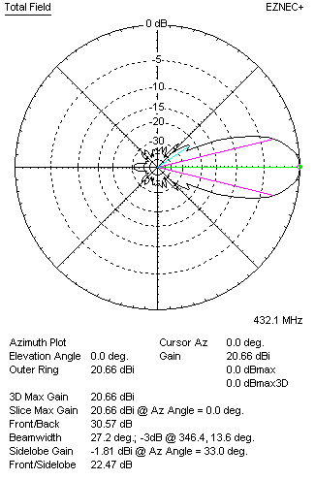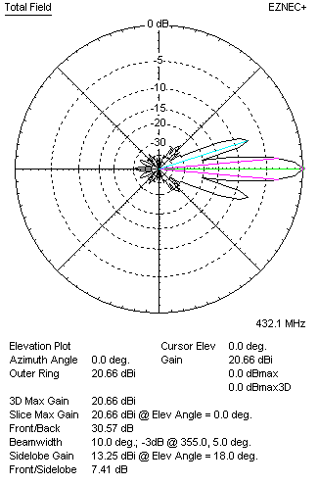
Two antennas stacked vertically
TWO ANTENNAS STACKED HORIZONTALLY
DISTANCE  (mm) |  |  | G  (dBi) |  |  | TA  (K) |  |  | Tloss  (K) |  |  |  | G/T  (dB)
1800 |  |  | 20.49 |  |  | 28.5 |  |  | 3.7 |  |  |  | +5.95
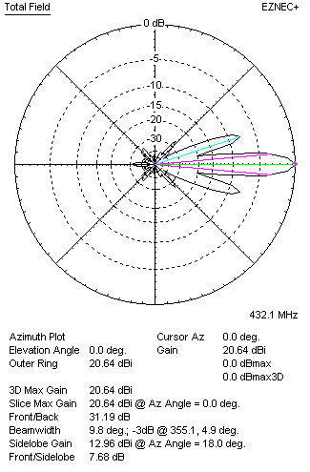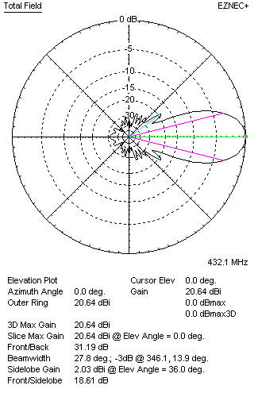
Two antennas stacked horizontally
FOUR ANTENNAS IN H-STACK
DISTANCE  (mm) |  |  | G  (dBi) |  |  | TA  (K) |  |  | Tloss  (K) |  |  |  | G/T  (dB)
H = 1800 |  |  | 23.56 |  |  | 27.0 |  |  | 3.7 |  |  |  | +9.25
V = 1800
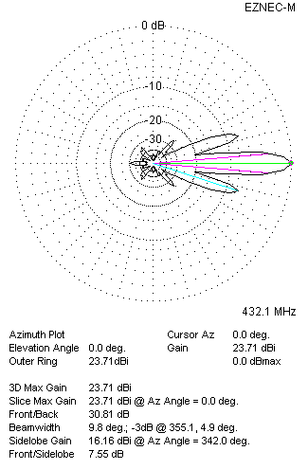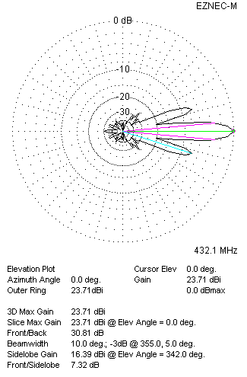
Four antennas in H-stack

