ANTENNA QY71706XL5D10
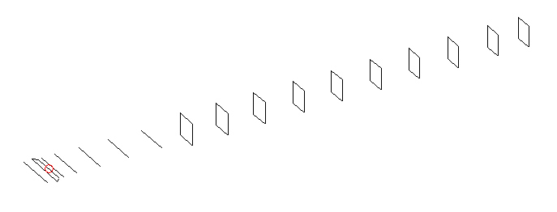
DESCRIPTION
Radiator |  | Number of  yagi elements |  |  | Number of  oblong elements |  |  | Total number  of elements |  |  | Boomlength  (mm)
LFA |  | 6 |  |  | 10 |  |  | 17 |  |  | 3825
DIMENSIONS
 | Ref |  | De1 | De2 |  | D1 | D2 |  | D3 | D4 |  | D5 | DQ1
Position | 0 |  | 65 | 100 |  | 133 | 236 |  | 420 | 649 |  | 906 | 1182
Length | 335 |  | 346 | 300 |  | 304 | 307.5 |  | 298.5 | 290.5 |  | 283.5 | 173
 | DQ2 |  | DQ3 | DQ4 |  | DQ5 | DQ6 |  | DQ7 | DQ8 |  | DQ9 | DQ10
Position | 1456 |  | 1754 | 2058 |  | 2364 | 2672 |  | 2974 | 3276 |  | 3594 | 3825
Length | 163 |  | 159 | 155 |  | 152 | 148 |  | 145 | 143 |  | 141 | 138

Remark | All elements made of Al tubes Ǿ6 mm  The height of rectangles is 170 mm  All dimensions given in milimetres
PERFORMANCES (No loss condition)
G  (dBi) |  | F/B  (dB) |  | F/Sh  (dBi) | F/Sv  (dBi) |  | Hor  (◦) |  |  | Ver  (◦) | Temp  (◦K) |  |  | G/T  (dB)
17.44 |  | 31.47 |  | 24.12 | 19.58 |  | 27.4 |  |  | 28.2 | 25.1 |  |  | +4.29
DIAGRAMS
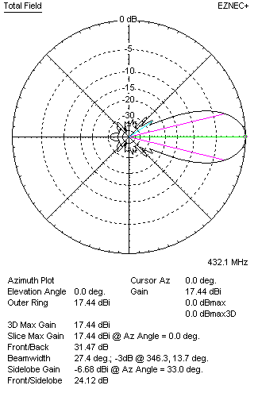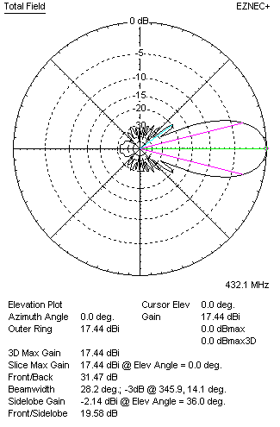
Horizontal and verticall pattern in free space, no loss condition
PERFORMANCES (Loss included for aluminum)
Aluminum |  |  |  | G  (dBi) | Tloss  (K) |  | T_{A}  (◦K) |  |  | G/T  (dB) | Bandwidth for SWR=1.5  (MHz)
After NEC/EZNEC |  |  |  | 17.38 | 4.6 |  | 25.1 |  |  | +3.43 | 424.500 – 439.000
After KF2YN correction |  |  |  | 17.30 | 4.6 |  | 29.3 |  |  | +2.63
Remark: Red coloured data are the final antenna data, which means: KF2YN correction formula applied and loss for aluminum included
DIAGRAMS
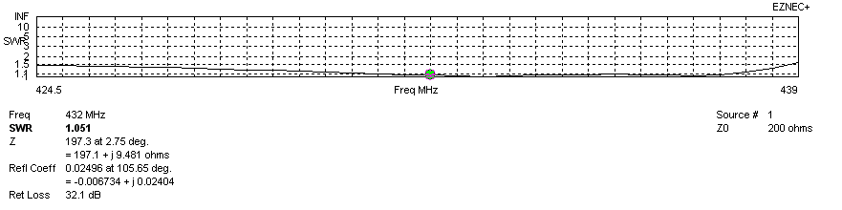
Frequency diagram for SWR better than 1.5
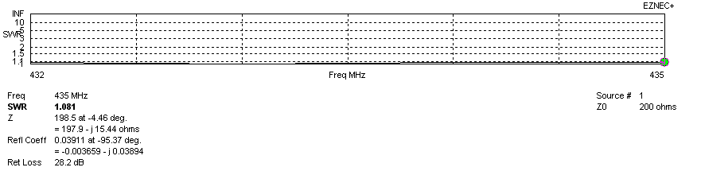
SWR diagram for the range from 432.000 – 435.000 MHz
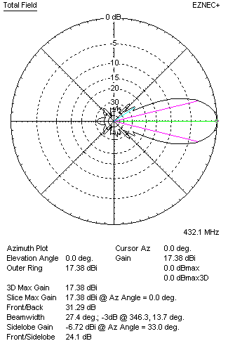 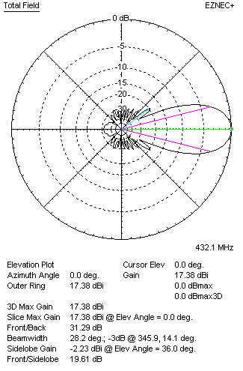Horizontal and vertical pattern in free space, loss included for aluminum
STACKING
(ALL DATA GIVEN IN ACCORDANCE WITH KF2YN CORRECTION, LOSS INCLUDED)
RECOMMENDED STACKING DISTANCES
 |  |  |  | Two antennas vertically  (mm) |  |  | Two antennas horizontally  (mm) |  |  |  | Four antennas in H-stack  (mm)
Horizontal distance |  |  |  |  |  |  | 1820 |  |  |  | 1820
Vertical distance |  |  |  | 1820 |  |  |  |  |  |  | 1820
TWO ANTENNAS STACKED VERTICALLY
DISTANCE  (mm) |  |  | G  (dBi) |  |  | TA  (K) |  | Tloss  (K) |  |  |  | G/T  (dB)
1820 |  |  | 20.37 |  |  | 28.1 |  | 4.6 |  |  |  | +5.88
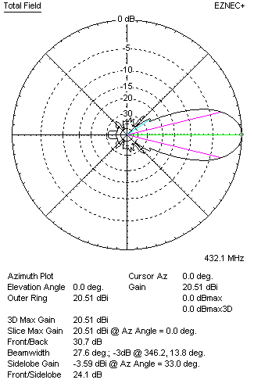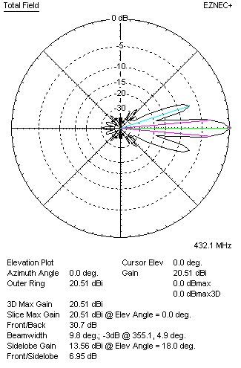
Two antennas stacked vertically
TWO ANTENNAS STACKED HORIZONTALLY
DISTANCE  (mm) |  |  | G  (dBi) |  |  | TA  (K) |  |  | Tloss  (K) |  |  |  | G/T  (dB)
1820 |  |  | 20.35 |  |  | 28.8 |  |  | 4.6 |  |  |  | +5.76
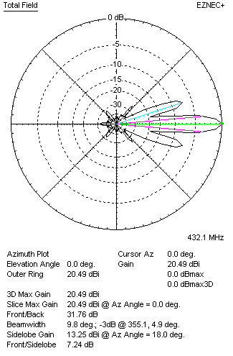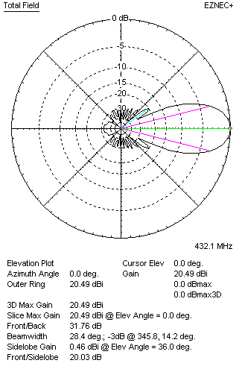
Two antennas stacked horizontally
FOUR ANTENNAS IN H-STACK
DISTANCE  (mm) |  |  | G  (dBi) |  |  | TA  (K) |  |  | Tloss  (K) |  |  |  | G/T  (dB)
H = 1820 |  |  | 23.42 |  |  | 27.8 |  |  | 4.6 |  |  |  | +8.98
V = 1820
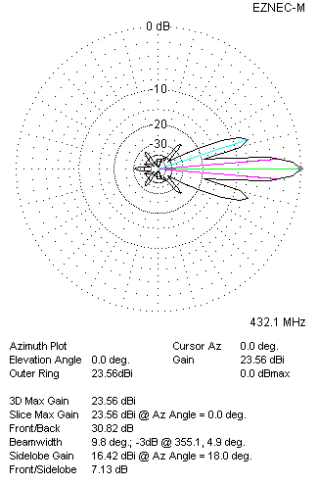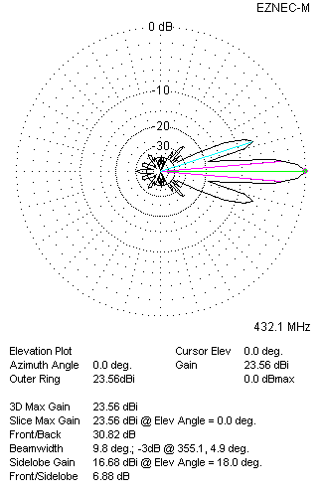
Four antennas in H-stack

