ANTENNA QY71705XL4D10
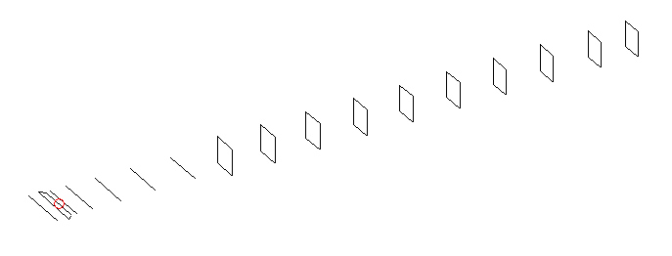
DESCRIPTION
Radiator |  | Number of  yagi elements |  |  | Number of  oblong elements |  |  | Total number  of elements |  |  | Boomlength  (mm)
LFA |  | 6 |  |  | 10 |  |  | 17 |  |  | 3825
DIMENSIONS
 | Ref |  | De1 | De2 |  | D1 | D2 |  | D3 | D4 |  | D5 | DQ1
Position | 0 |  | 65 | 100 |  | 133 | 236 |  | 419 | 648 |  | 908 | 1178
Length | 336 |  | 351 | 296 |  | 305.5 | 308 |  | 298.5 | 292 |  | 285 | 171
 | DQ2 |  | DQ3 | DQ4 |  | DQ5 | DQ6 |  | DQ7 | DQ8 |  | DQ9 | DQ10
Position | 1458 |  | 1751 | 2058 |  | 2360 | 2666 |  | 2968 | 3272 |  | 3584 | 3825
Length | 162 |  | 158 | 153 |  | 151 | 149 |  | 147 | 145 |  | 143 | 141

Remark | All elements made of Al tubes Ǿ5 mm  The height of rectangles is 170 mm  All dimensions given in milimetres
PERFORMANCES (No loss condition)
G  (dBi) |  | F/B  (dB) |  | F/Sh  (dBi) | F/Sv  (dBi) |  | Hor  (◦) |  |  | Ver  (◦) | Temp  (◦K) |  |  | G/T  (dB)
17.36 |  | 29.64 |  | 22.06 | 17.89 |  | 27.6 |  |  | 28.6 | 26.3 |  |  | +3.89
DIAGRAMS
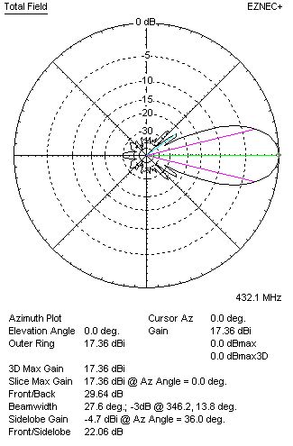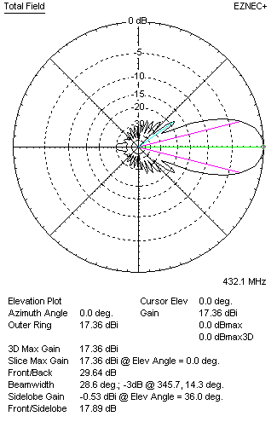
Horizontal and verticall pattern in free space, no loss condition
PERFORMANCES (Loss included for aluminum)
Aluminum |  |  |  | G  (dBi) | Tloss  (K) |  | T_{A}  (◦K) |  |  | G/T  (dB) | Bandwidth for SWR=1.5  (MHz)
After NEC/EZNEC |  |  |  | 17.30 | 4.3 |  | 26.3 |  |  | +3.11 | 420.000 – 441.000
After KF2YN correction |  |  |  | 17.23 | 4.3 |  | 30.2 |  |  | +2.43
Remark: Red coloured data are the final antenna data, which means: KF2YN correction formula applied and loss for aluminum included
DIAGRAMS
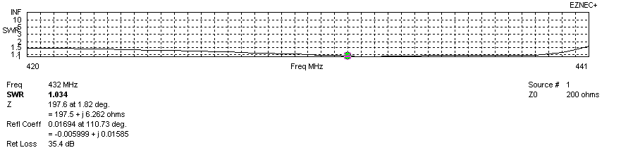
Frequency diagram for SWR better than 1.5
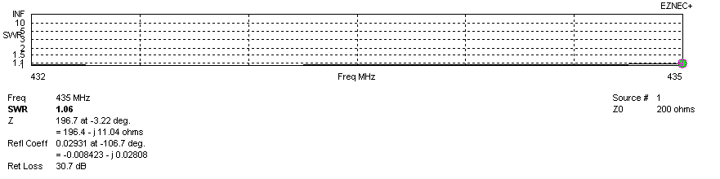
SWR diagram for the range from 432.000 – 435.000 MHz
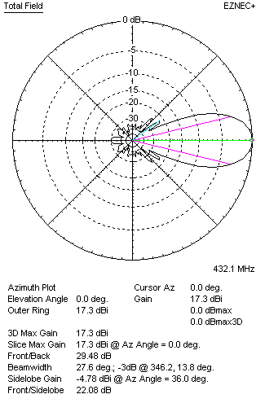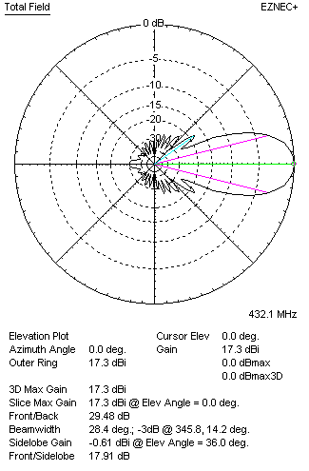
Horizontal and vertical pattern in free space, loss included for aluminum
STACKING
(ALL DATA GIVEN IN ACCORDANCE WITH KF2YN CORRECTION, LOSS INCLUDED)
RECOMMENDED STACKING DISTANCES
 |  |  |  | Two antennas vertically  (mm) |  |  | Two antennas horizontally  (mm) |  |  |  | Four antennas in H-stack  (mm)
Horizontal distance |  |  |  |  |  |  | 1840 |  |  |  | 1840
Vertical distance |  |  |  | 1820 |  |  |  |  |  |  | 1820
TWO ANTENNAS STACKED VERTICALLY
DISTANCE  (mm) |  |  | G  (dBi) |  |  | TA  (K) |  | Tloss  (K) |  |  |  | G/T  (dB)
1820 |  |  | 20.31 |  |  | 28.6 |  | 4.3 |  |  |  | +5.74
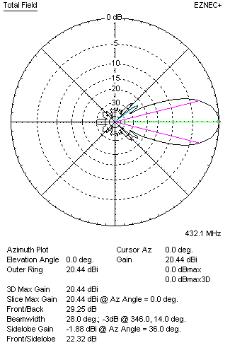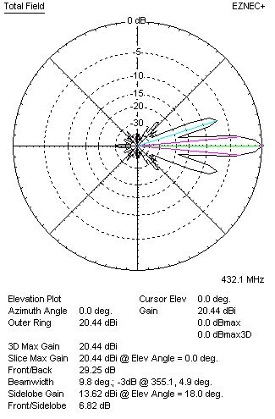
Two antennas stacked vertically
TWO ANTENNAS STACKED HORIZONTALLY
DISTANCE  (mm) |  |  | G  (dBi) |  |  | TA  (K) |  |  | Tloss  (K) |  |  |  | G/T  (dB)
1840 |  |  | 20.29 |  |  | 29.5 |  |  | 4.3 |  |  |  | +5.59
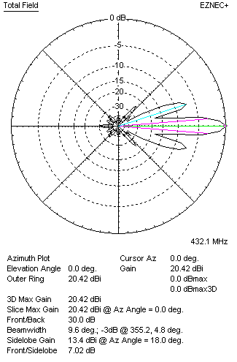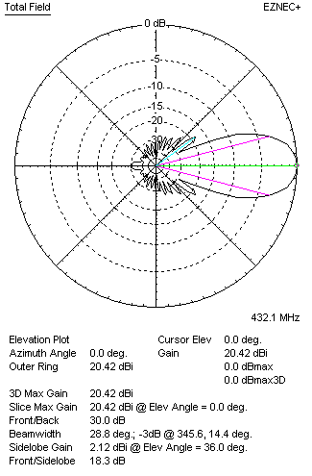
Two antennas stacked horizontally
FOUR ANTENNAS IN H-STACK
DISTANCE  (mm) |  |  | G  (dBi) |  |  | TA  (K) |  |  | Tloss  (K) |  |  |  | G/T  (dB)
H = 1840 |  |  | 23.36 |  |  | 28.3 |  |  | 4.3 |  |  |  | +8.84
V = 1820
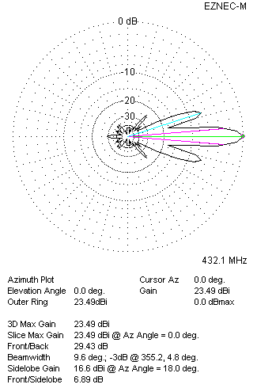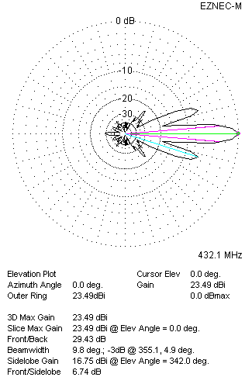
Four antennas in H-stack

