ANTENNA QY71610XL3D9
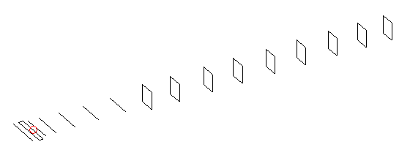
DESCRIPTION
Radiator |  | Number of  yagi elements |  |  | Number of  oblong elements |  |  | Total number  of elements |  |  | Boomlength  (mm)
LFA |  | 6 |  |  | 9 |  |  | 16 |  |  | 3525
DIMENSIONS
 | Ref |  | De1 | De2 |  | D1 | D2 |  | D3 | D4 |  | D5 | DQ1
Position | 0 |  | 54 | 91 |  | 135 | 235 |  | 424 | 654 |  | 916 | 1196
Length | 331 |  | 343 | 343 |  | 302 | 300.5 |  | 289 | 281 |  | 272 | 169
 | DQ2 |  | DQ3 | DQ4 |  | DQ5 | DQ6 |  | DQ7 | DQ8 |  | DQ9
Position | 1468 |  | 1788 | 2076 |  | 2392 | 2692 |  | 2986 | 3225 |  | 3525
Length | 159 |  | 153 | 151 |  | 149 | 147 |  | 147 | 147 |  | 143

Remark | All elements made of Al tubes Ǿ10 mm  The height of rectangles is 170 mm  All dimensions given in milimetres
PERFORMANCES (No loss condition)
G  (dBi) |  | F/B  (dB) |  | F/Sh  (dBi) | F/Sv  (dBi) |  | Hor  (◦) |  |  | Ver  (◦) | Temp  (◦K) |  |  | G/T  (dB)
17.26 |  | 29.36 |  | 21.07 | 17.47 |  | 27.6 |  |  | 28.4 | 27.2 |  |  | +3.33
DIAGRAMS
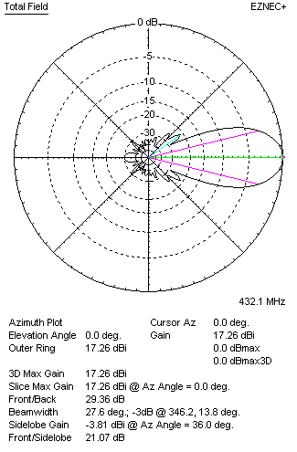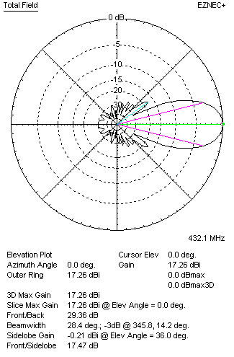
Horizontal and verticall pattern in free space, no loss condition
PERFORMANCES (Loss included for aluminum)
Aluminum |  |  |  | G  (dBi) | Tloss  (K) |  | T_{A}  (◦K) |  |  | G/T  (dB) | Bandwidth for SWR=1.5  (MHz)
After NEC/EZNEC |  |  |  | 17.22 | 2.9 |  | 27.3 |  |  | +2.86 | 423.000 – 438.500
After KF2YN correction |  |  |  | 17.17 | 2.9 |  | 29.8 |  |  | +2.43
Remark: Red coloured data are the final antenna data, which means: KF2YN correction formula applied and loss for aluminum included
DIAGRAMS
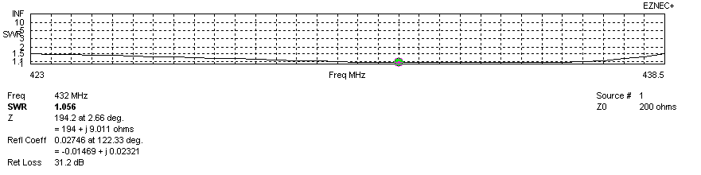
Frequency diagram for SWR better than 1.5
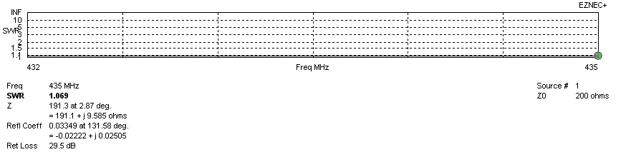
SWR diagram for the range from 432.000 – 435.000 MHz
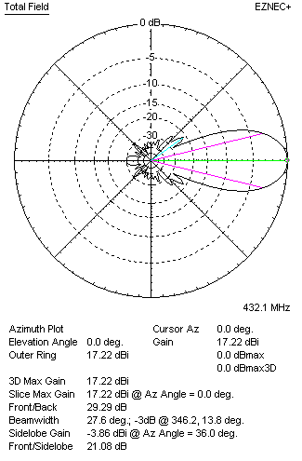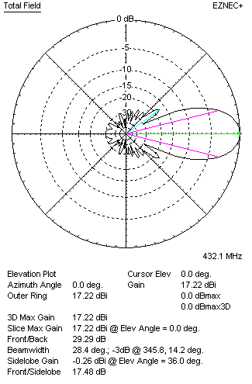
Horizontal and vertical pattern in free space, loss included for aluminum
STACKING
(ALL DATA GIVEN IN ACCORDANCE WITH KF2YN CORRECTION, LOSS INCLUDED)
RECOMMENDED STACKING DISTANCES
 |  |  |  | Two antennas vertically  (mm) |  |  | Two antennas horizontally  (mm) |  |  |  | Four antennas in H-stack  (mm)
Horizontal distance |  |  |  |  |  |  | 1720 |  |  |  | 1720
Vertical distance |  |  |  | 1780 |  |  |  |  |  |  | 1780
TWO ANTENNAS STACKED VERTICALLY
DISTANCE  (mm) |  |  | G  (dBi) |  |  | TA  (K) |  | Tloss  (K) |  |  |  | G/T  (dB)
1780 |  |  | 20.26 |  |  | 27.9 |  | 2.9 |  |  |  | +5.80
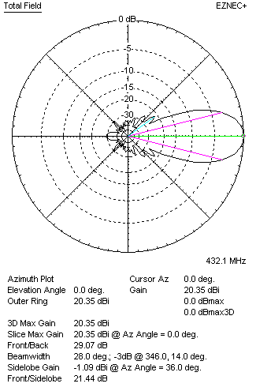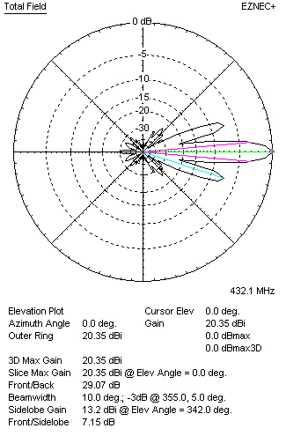
Two antennas stacked vertically
TWO ANTENNAS STACKED HORIZONTALLY
DISTANCE  (mm) |  |  | G  (dBi) |  |  | TA  (K) |  |  | Tloss  (K) |  |  |  | G/T  (dB)
1720 |  |  | 20.21 |  |  | 28.9 |  |  | 2.9 |  |  |  | +5.60
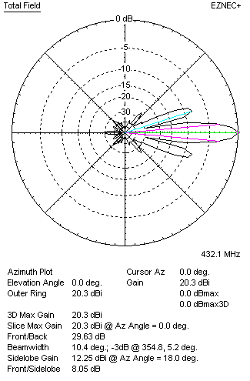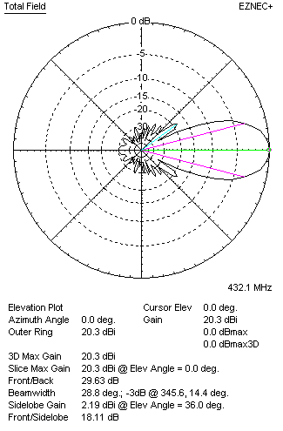
Two antennas stacked horizontally
FOUR ANTENNAS IN H-STACK
DISTANCE  (mm) |  |  | G  (dBi) |  |  | TA  (K) |  |  | Tloss  (K) |  |  |  | G/T  (dB)
H = 1720 |  |  | 23.29 |  |  | 27.4 |  |  | 2.9 |  |  |  | +8.91
V = 1780
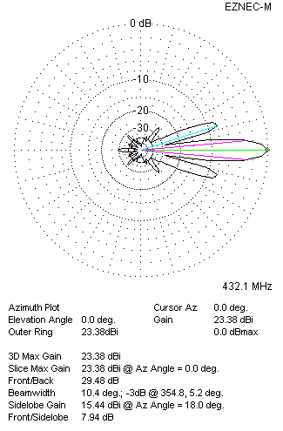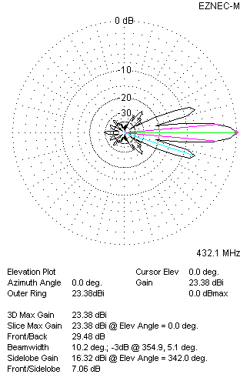
Four antennas in H-stack

