ANTENNA QY71605XL4D9
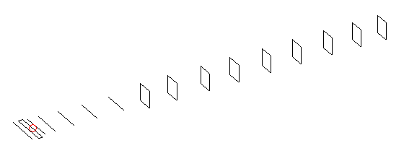
DESCRIPTION
Radiator |  | Number of  yagi elements |  |  | Number of  oblong elements |  |  | Total number  of elements |  |  | Boomlength  (mm)
LFA |  | 6 |  |  | 9 |  |  | 16 |  |  | 3525
DIMENSIONS
 | Ref |  | De1 | De2 |  | D1 | D2 |  | D3 | D4 |  | D5 | DQ1
Position | 0 |  | 65 | 100 |  | 133 | 236 |  | 419 | 646 |  | 906 | 1181
Length | 336 |  | 350 | 296 |  | 305 | 307.5 |  | 298 | 291.5 |  | 284.5 | 171
 | DQ2 |  | DQ3 | DQ4 |  | DQ5 | DQ6 |  | DQ7 | DQ8 |  | DQ9
Position | 1456 |  | 1754 | 2058 |  | 2364 | 2666 |  | 2978 | 3276 |  | 3525
Length | 161 |  | 157 | 153 |  | 149 | 148 |  | 145 | 143 |  | 141

Remark | All elements made of Al tubes Ǿ5 mm  The height of rectangles is 170 mm  All dimensions given in milimetres
PERFORMANCES (No loss condition)
G  (dBi) |  | F/B  (dB) |  | F/Sh  (dBi) | F/Sv  (dBi) |  | Hor  (◦) |  |  | Ver  (◦) | Temp  (◦K) |  |  | G/T  (dB)
17.03 |  | 29.76 |  | 21.86 | 17.99 |  | 28.6 |  |  | 29.8 | 26.5 |  |  | +3.52
DIAGRAMS
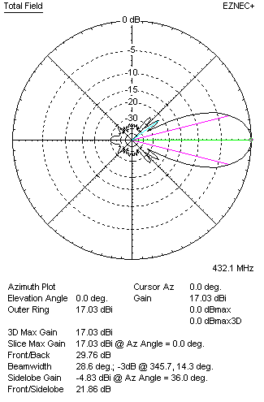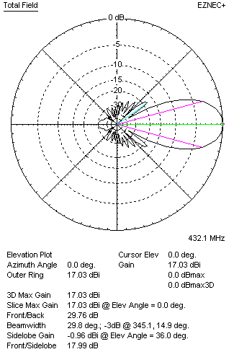
Horizontal and verticall pattern in free space, no loss condition
PERFORMANCES (Loss included for aluminum)
Aluminum |  |  |  | G  (dBi) | Tloss  (K) |  | T_{A}  (◦K) |  |  | G/T  (dB) | Bandwidth for SWR=1.5  (MHz)
After NEC/EZNEC |  |  |  | 16.98 | 4.0 |  | 26.5 |  |  | +2.80 | 420.000 – 441.500
After KF2YN correction |  |  |  | 16.91 | 4.0 |  | 30.1 |  |  | +2.11
Remark: Red coloured data are the final antenna data, which means: KF2YN correction formula applied and loss for aluminum included
DIAGRAMS
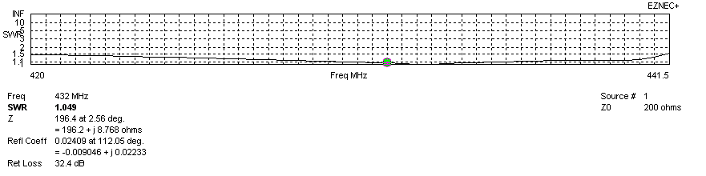
Frequency diagram for SWR better than 1.5
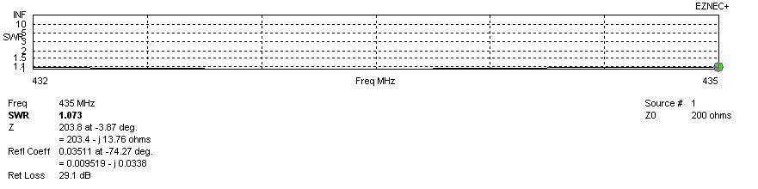
SWR diagram for the range from 432.000 – 435.000 MHz
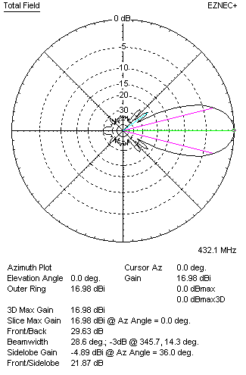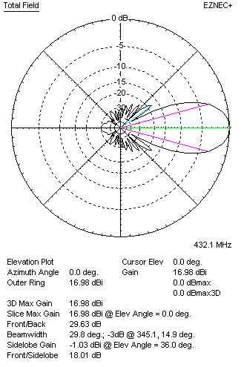
Horizontal and vertical pattern in free space, loss included for aluminum
STACKING
(ALL DATA GIVEN IN ACCORDANCE WITH KF2YN CORRECTION, LOSS INCLUDED)
RECOMMENDED STACKING DISTANCES
 |  |  |  | Two antennas vertically  (mm) |  |  | Two antennas horizontally  (mm) |  |  |  | Four antennas in H-stack  (mm)
Horizontal distance |  |  |  |  |  |  | 1780 |  |  |  | 1780
Vertical distance |  |  |  | 1780 |  |  |  |  |  |  | 1780
TWO ANTENNAS STACKED VERTICALLY
DISTANCE  (mm) |  |  | G  (dBi) |  |  | TA  (K) |  | Tloss  (K) |  |  |  | G/T  (dB)
1780 |  |  | 20.00 |  |  | 28.7 |  | 4.0 |  |  |  | +5.42
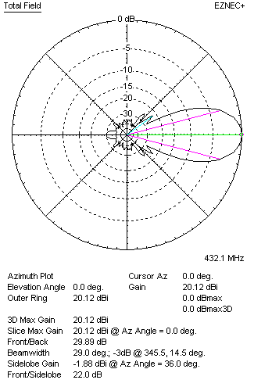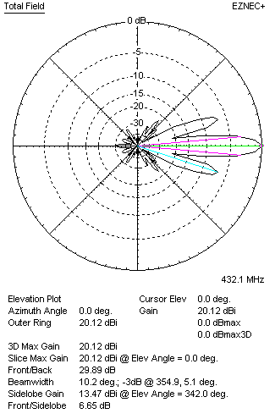
Two antennas stacked vertically
TWO ANTENNAS STACKED HORIZONTALLY
DISTANCE  (mm) |  |  | G  (dBi) |  |  | TA  (K) |  |  | Tloss  (K) |  |  |  | G/T  (dB)
1780 |  |  | 18.87 |  |  | 28.7 |  |  | 4.0 |  |  |  | +5.39
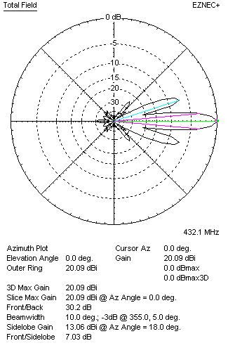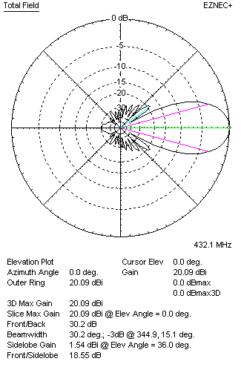
Two antennas stacked horizontally
FOUR ANTENNAS IN H-STACK
DISTANCE  (mm) |  |  | G  (dBi) |  |  | TA  (K) |  |  | Tloss  (K) |  |  |  | G/T  (dB)
H = 1780 |  |  | 23.04 |  |  | 28.5 |  |  | 4.0 |  |  |  | +8.49
V = 1780
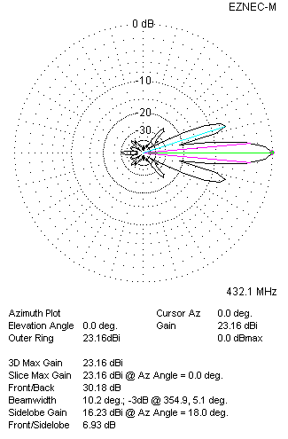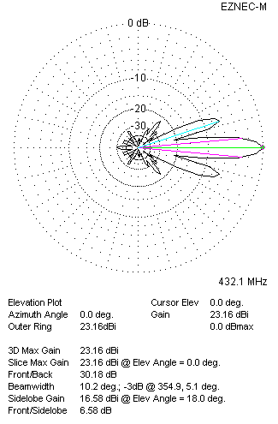
Four antennas in H-stack

