ANTENNA QY71508XL2D8
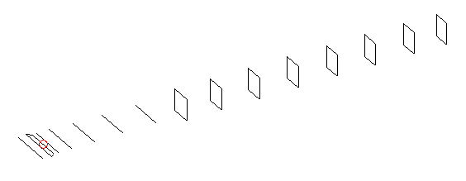
DESCRIPTION
Radiator |  |  |  | Number of  yagi elements |  |  |  |  |  |  | Number of  oblong elements |  |  |  |  | Total number  of elements |  |  |  |  |  |  |  | Boomlength  (mm)
LFA |  |  |  | 6 |  |  |  |  |  |  | 8 |  |  |  |  | 15 |  |  |  |  |  |  |  | 3225
DIMENSIONS
 | Ref |  | De1 |  | De2 |  | D1 | D2 |  | D3 |  | D4 | D5 |  | DQ1 |  |  | DQ2 |  | DQ3 | DQ4 |  | DQ5 |  |  | DQ6 |  | DQ7 | DQ8
Position | 0 |  | 60 |  | 95 |  | 133 | 233 |  | 421 |  | 653 | 912 |  | 1186 |  |  | 1470 |  | 1774 | 2062 |  | 2388 |  |  | 2682 |  | 2982 | 3225
Length | 333 |  | 354 |  | 288 |  | 303.5 | 304.5 |  | 294.5 |  | 285 | 278.5 |  | 169 |  |  | 161 |  | 156 | 152 |  | 149 |  |  | 147 |  | 145 | 143
Remark | All elements made of Al tubes Ǿ8 mm  The height of rectangles is 170 mm  All dimensions given in milimetres
PERFORMANCES (No loss condition)
G  (dBi) |  | F/B  (dB) |  |  |  | F/Sh  (dBi) |  |  | F/Sv  (dBi) |  |  |  |  | Hor  (◦) |  |  |  |  | Ver  (◦) |  |  | Temp  (◦K) |  |  |  |  | G/T  (dB)
16.91 |  | 31.86 |  |  |  | 23.03 |  |  | 19.16 |  |  |  |  | 29.0 |  |  |  |  | 30.0 |  |  | 26.1 |  |  |  |  | +3.60
DIAGRAMS
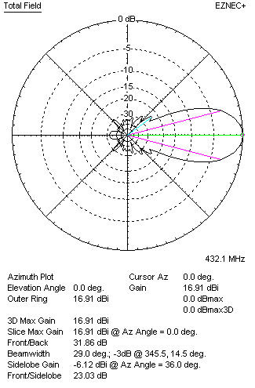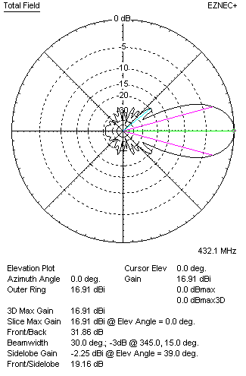
Horizontal and verticall pattern in free space, no loss condition
PERFORMANCES (Loss included for aluminum)
Aluminum |  |  |  |  |  | G  (dBi) |  |  | Tloss  (K) |  |  |  |  | T_{A}  (◦K) |  |  |  |  | G/T  (dB) |  |  | Bandwidth for SWR=1.5  (MHz)
After NEC/EZNEC |  |  |  |  |  | 16.86 |  |  | 3.4 |  |  |  |  | 26.1 |  |  |  |  | +2.91 |  |  | 425.000 – 438.000
After KF2YN correction |  |  |  |  |  | 16.79 |  |  | 3.4 |  |  |  |  | 29.2 |  |  |  |  | +2.13
Remark: Red coloured data are the final antenna data, which means: KF2YN correction formula applied and loss for aluminum included
DIAGRAMS
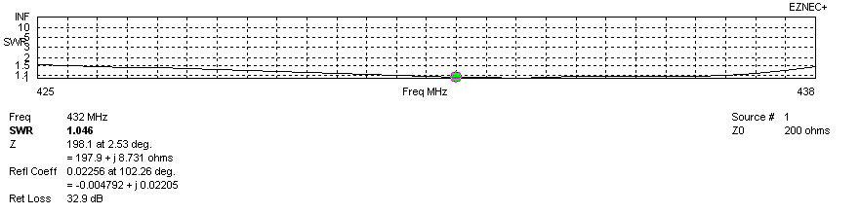
Frequency diagram for SWR better than 1.5
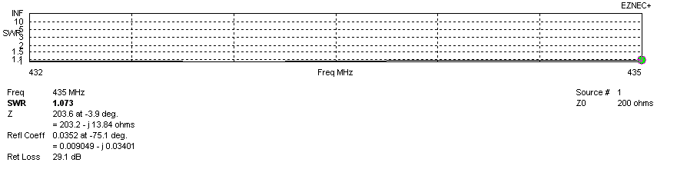
SWR diagram for the range from 432.000 – 435.000 MHz
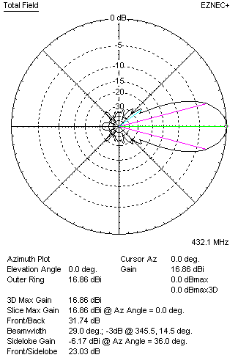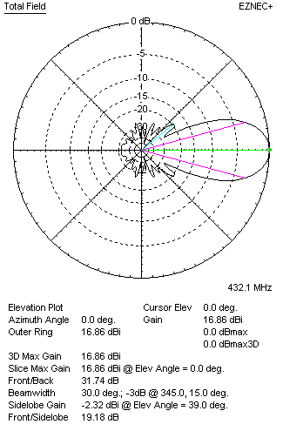
Horizontal and vertical pattern in free space, loss included for aluminum
STACKING
(ALL DATA GIVEN IN ACCORDANCE WITH KF2YN CORRECTION, LOSS INCLUDED)
RECOMMENDED STACKING DISTANCES
 |  |  |  |  |  | Two antennas vertically  (mm) |  |  |  |  |  |  |  | Two antennas horizontally  (mm) |  |  |  |  |  |  |  | Four antennas in H-stack  (mm)
Horizontal distance |  |  |  |  |  |  |  |  |  |  |  |  |  | 1720 |  |  |  |  |  |  |  | 1720
Vertical distance |  |  |  |  |  | 1780 |  |  |  |  |  |  |  |  |  |  |  |  |  |  |  | 1780
TWO ANTENNAS STACKED VERTICALLY
DISTANCE  (mm) |  |  |  | G  (dBi) |  |  |  |  |  |  | TA  (K) |  |  |  |  | Tloss  (K) |  |  |  |  |  |  |  | G/T  (dB)
1780 |  |  |  | 19.88 |  |  |  |  |  |  | 27.8 |  |  |  |  | 3.4 |  |  |  |  |  |  |  | +5.43
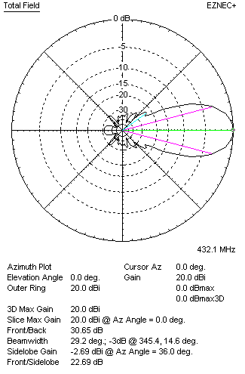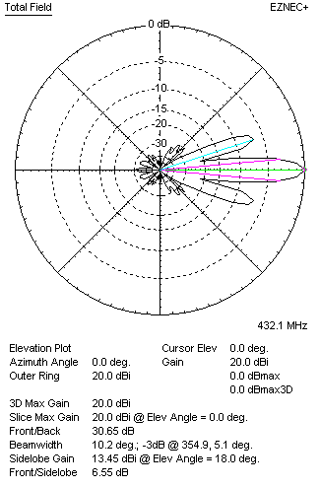
Two antennas stacked vertically
TWO ANTENNAS STACKED HORIZONTALLY
DISTANCE  (mm) |  |  |  | G  (dBi) |  |  |  |  |  |  | TA  (K) |  |  |  |  |  | Tloss  (K) |  |  |  |  |  |  |  | G/T  (dB)
1720 |  |  |  | 19.84 |  |  |  |  |  |  | 28.8 |  |  |  |  |  | 3.4 |  |  |  |  |  |  |  | +5.24
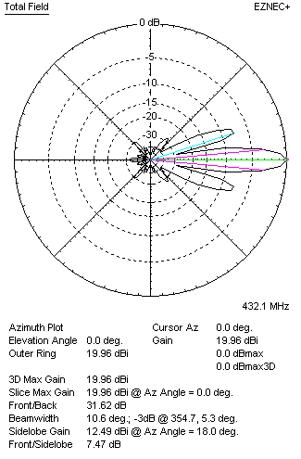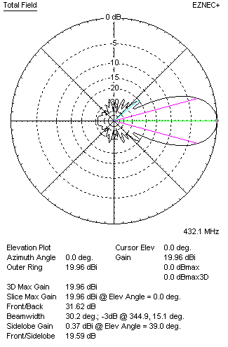
Two antennas stacked horizontally
FOUR ANTENNAS IN H-STACK
DISTANCE  (mm) |  |  |  | G  (dBi) |  |  |  |  |  |  | TA  (K) |  |  |  |  |  | Tloss  (K) |  |  |  |  |  |  |  | G/T  (dB)
H = 1720 |  |  |  | 22.92 |  |  |  |  |  |  | 27.7 |  |  |  |  |  | 3.4 |  |  |  |  |  |  |  | +8.49
V = 1780
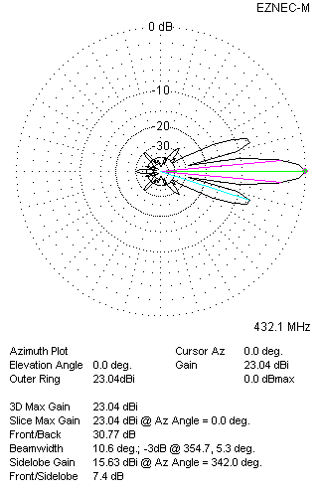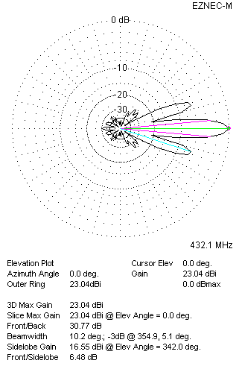
Four antennas in H-stack

