ANTENNA QY71505XL6D8
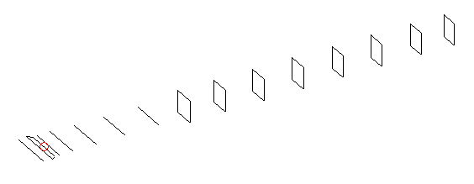
DESCRIPTION
Radiator |  |  |  | Number of  yagi elements |  |  |  |  |  |  | Number of  oblong elements |  |  |  |  | Total number  of elements |  |  |  |  |  |  |  | Boomlength  (mm)
LFA |  |  |  | 6 |  |  |  |  |  |  | 8 |  |  |  |  | 15 |  |  |  |  |  |  |  | 3225
DIMENSIONS
 | Ref |  | De1 |  | De2 |  | D1 | D2 |  | D3 |  | D4 | D5 |  | DQ1 |  |  | DQ2 |  | DQ3 | DQ4 |  | DQ5 |  |  | DQ6 |  | DQ7 | DQ8
Position | 0 |  | 65 |  | 100 |  | 133 | 235 |  | 421 |  | 646 | 906 |  | 1181 |  |  | 1456 |  | 1754 | 2058 |  | 2364 |  |  | 2666 |  | 2968 | 3225
Length | 336 |  | 350 |  | 296 |  | 305 | 307.5 |  | 298 |  | 291.5 | 284.5 |  | 171 |  |  | 161 |  | 157 | 152 |  | 149 |  |  | 147 |  | 145 | 141
Remark | All elements made of Al tubes Ǿ5 mm  The height of rectangles is 170 mm  All dimensions given in milimetres
PERFORMANCES (No loss condition)
G  (dBi) |  | F/B  (dB) |  |  |  | F/Sh  (dBi) |  |  | F/Sv  (dBi) |  |  |  |  | Hor  (◦) |  |  |  |  | Ver  (◦) |  |  | Temp  (◦K) |  |  |  |  | G/T  (dB)
16.75 |  | 29.01 |  |  |  | 22.22 |  |  | 18.26 |  |  |  |  | 29.6 |  |  |  |  | 30.8 |  |  | 26.4 |  |  |  |  | +3.25
DIAGRAMS
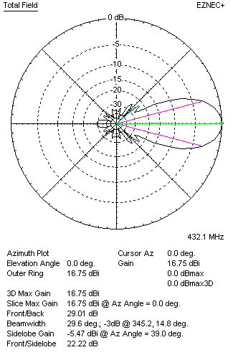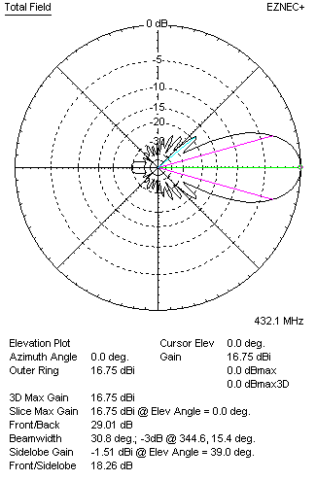
Horizontal and verticall pattern in free space, no loss condition
PERFORMANCES (Loss included for aluminum)
Aluminum |  |  |  |  |  | G  (dBi) |  |  | Tloss  (K) |  |  |  |  | T_{A}  (◦K) |  |  |  |  | G/T  (dB) |  |  | Bandwidth for SWR=1.5  (MHz)
After NEC/EZNEC |  |  |  |  |  | 16.69 |  |  | 4.0 |  |  |  |  | 26.5 |  |  |  |  | +2.51 |  |  | 421.500 – 441.400
After KF2YN correction |  |  |  |  |  | 16.63 |  |  | 4.0 |  |  |  |  | 30.0 |  |  |  |  | +1.85
Remark: Red coloured data are the final antenna data, which means: KF2YN correction formula applied and loss for aluminum included
DIAGRAMS
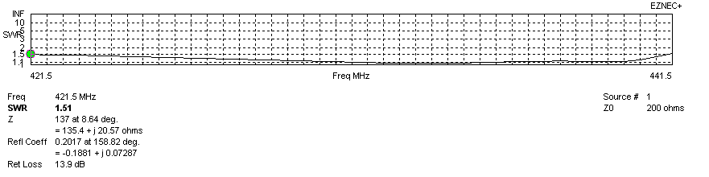
Frequency diagram for SWR better than 1.5
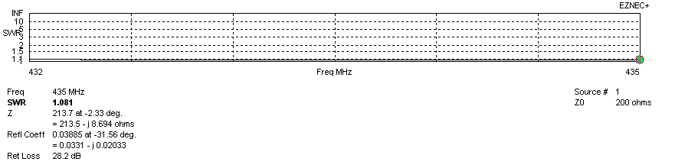
SWR diagram for the range from 432.000 – 435.000 MHz
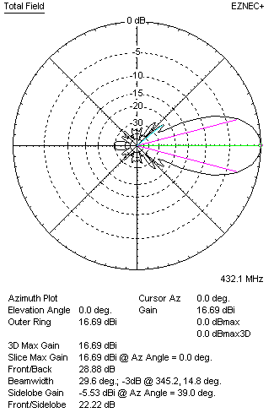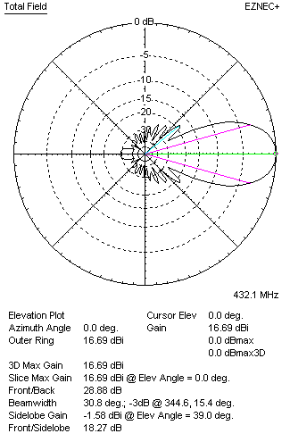
Horizontal and vertical pattern in free space, loss included for aluminum
STACKING
(ALL DATA GIVEN IN ACCORDANCE WITH KF2YN CORRECTION, LOSS INCLUDED)
RECOMMENDED STACKING DISTANCES
 |  |  |  |  |  | Two antennas vertically  (mm) |  |  |  |  |  |  |  | Two antennas horizontally  (mm) |  |  |  |  |  |  |  | Four antennas in H-stack  (mm)
Horizontal distance |  |  |  |  |  |  |  |  |  |  |  |  |  | 1720 |  |  |  |  |  |  |  | 1720
Vertical distance |  |  |  |  |  | 1800 |  |  |  |  |  |  |  |  |  |  |  |  |  |  |  | 1800
TWO ANTENNAS STACKED VERTICALLY
DISTANCE  (mm) |  |  |  | G  (dBi) |  |  |  |  |  |  | TA  (K) |  |  |  |  | Tloss  (K) |  |  |  |  |  |  |  | G/T  (dB)
1800 |  |  |  | 19.72 |  |  |  |  |  |  | 28.8 |  |  |  |  | 4.0 |  |  |  |  |  |  |  | +5.13
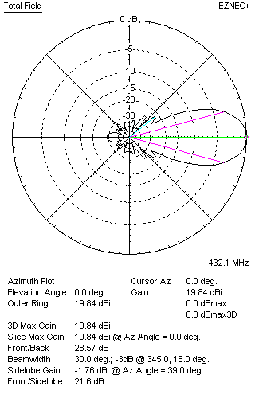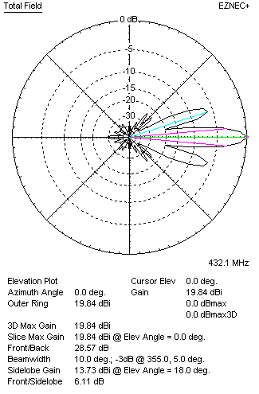
Two antennas stacked vertically
TWO ANTENNAS STACKED HORIZONTALLY
DISTANCE  (mm) |  |  |  | G  (dBi) |  |  |  |  |  |  | TA  (K) |  |  |  |  |  | Tloss  (K) |  |  |  |  |  |  |  | G/T  (dB)
1720 |  |  |  | 19.68 |  |  |  |  |  |  | 29.7 |  |  |  |  |  | 4.0 |  |  |  |  |  |  |  | +4.94
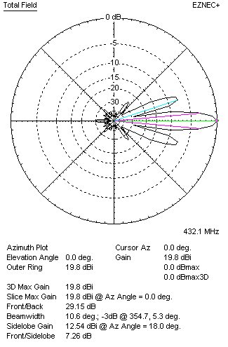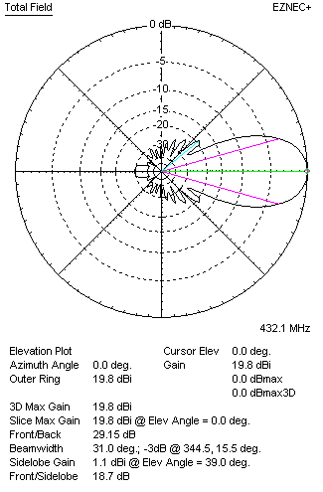
Two antennas stacked horizontally
FOUR ANTENNAS IN H-STACK
DISTANCE  (mm) |  |  |  | G  (dBi) |  |  |  |  |  |  | TA  (K) |  |  |  |  |  | Tloss  (K) |  |  |  |  |  |  |  | G/T  (dB)
H = 1720 |  |  |  | 22.75 |  |  |  |  |  |  | 28.9 |  |  |  |  |  | 4.0 |  |  |  |  |  |  |  | +8.14
V = 1800
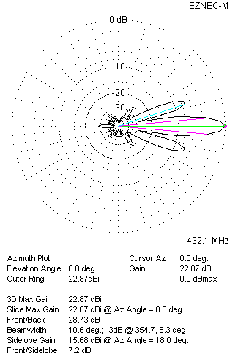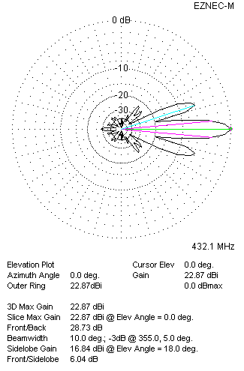
Four antennas in H-stack

