ANTENNA QY71405XL7D7
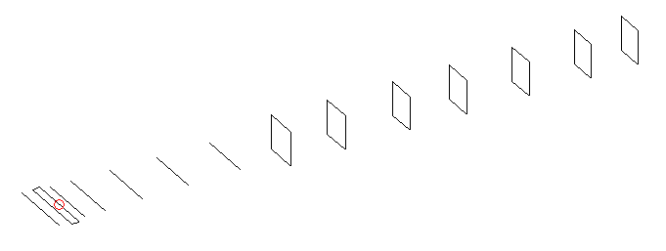
DESCRIPTION
Radiator |  |  |  | Number of  yagi elements |  |  |  |  |  | Number of  oblong elements |  |  |  |  |  | Total number  of elements |  |  |  |  |  |  | Boomlength  (mm)
LFA |  |  |  | 6 |  |  |  |  |  | 7 |  |  |  |  |  | 14 |  |  |  |  |  |  | 2925
DIMENSIONS
 | Ref |  | De1 |  | De2 |  | D1 | D2 |  |  | D3 | D4 |  | D5 | DQ1 |  |  |  | DQ2 | DQ3 |  | DQ4 |  |  | DQ5 |  | DQ6 | DQ7
Position | 0 |  | 60 |  | 100 |  | 129 | 230 |  |  | 418 | 652 |  | 909 | 1196 |  |  |  | 1481 | 1788 |  | 2093 |  |  | 2386 |  | 2688 | 2925
Length | 335 |  | 342 |  | 292 |  | 303 | 309 |  |  | 298 | 291 |  | 284 | 166 |  |  |  | 158 | 151 |  | 149 |  |  | 147 |  | 145 | 141
Remark | All elements made of Al tubes Ǿ5 mm  The height of rectangles is 170 mm  All dimensions given in milimetres
PERFORMANCES (No loss condition)
G  (dBi) |  | F/B  (dB) |  |  |  | F/Sh  (dBi) |  |  | F/Sv  (dBi) |  |  |  | Hor  (◦) |  |  |  |  | Ver  (◦) |  |  | Temp  (◦K) |  |  |  |  | G/T  (dB)
16.26 |  | 27.96 |  |  |  | 22.57 |  |  | 18.71 |  |  |  | 31.2 |  |  |  |  | 32.8 |  |  | 26.0 |  |  |  |  | +2.90
DIAGRAMS
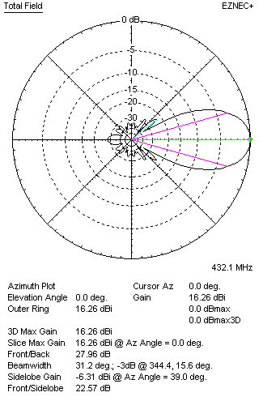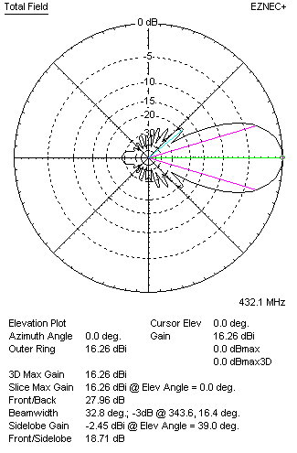
Horizontal and verticall pattern in free space, no loss condition
PERFORMANCES (Loss included for aluminum)
Aluminum |  |  |  |  |  | G  (dBi) |  |  | Tloss  (K) |  |  |  | T_{A}  (◦K) |  |  |  |  | G/T  (dB) |  |  | Bandwidth for SWR=1.5  (MHz)
After NEC/EZNEC |  |  |  |  |  | 16.20 |  |  | 4.0 |  |  |  | 26.0 |  |  |  |  | +2.15 |  |  | 426.000 – 439.800
After KF2YN correction |  |  |  |  |  | 16.13 |  |  | 4.0 |  |  |  | 29.6 |  |  |  |  | +1.41
Remark: Red coloured data are the final antenna data, which means: KF2YN correction formula applied and loss for aluminum included
DIAGRAMS
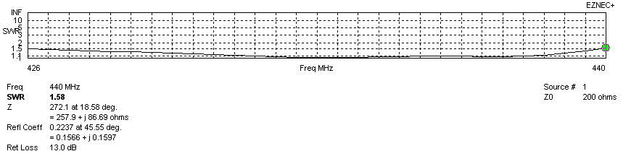
Frequency diagram for SWR better than 1.5
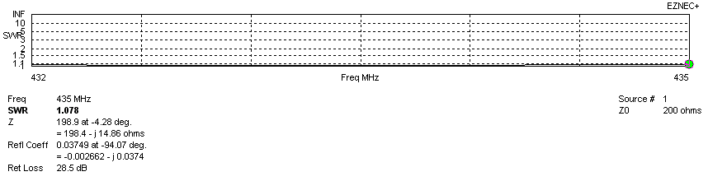
SWR diagram for the range from 432.000 – 435.000 MHz
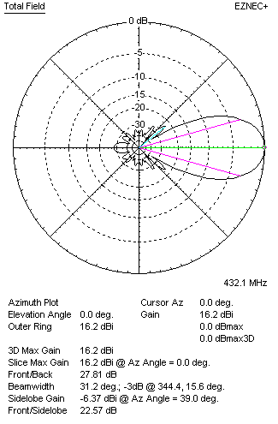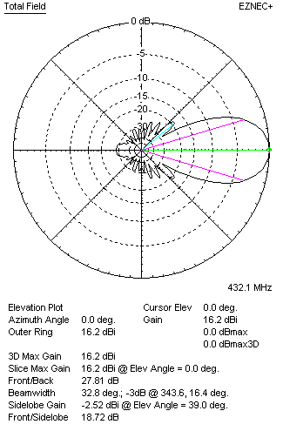
Horizontal and vertical pattern in free space, loss included for aluminum
STACKING
(ALL DATA GIVEN IN ACCORDANCE WITH KF2YN CORRECTION, LOSS INCLUDED)
RECOMMENDED STACKING DISTANCES
 |  |  |  |  |  | Two antennas vertically  (mm) |  |  |  |  |  |  | Two antennas horizontally  (mm) |  |  |  |  |  |  |  | Four antennas in H-stack  (mm)
Horizontal distance |  |  |  |  |  |  |  |  |  |  |  |  | 1540 |  |  |  |  |  |  |  | 1540
Vertical distance |  |  |  |  |  | 1680 |  |  |  |  |  |  |  |  |  |  |  |  |  |  | 1680
TWO ANTENNAS STACKED VERTICALLY
DISTANCE  (mm) |  |  |  | G  (dBi) |  |  |  |  |  | TA  (K) |  |  |  |  |  | Tloss  (K) |  |  |  |  |  |  | G/T  (dB)
1680 |  |  |  | 19.22 |  |  |  |  |  | 28.6 |  |  |  |  |  | 4.0 |  |  |  |  |  |  | +4.66
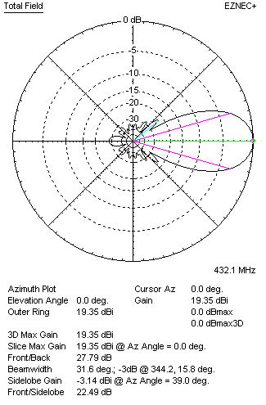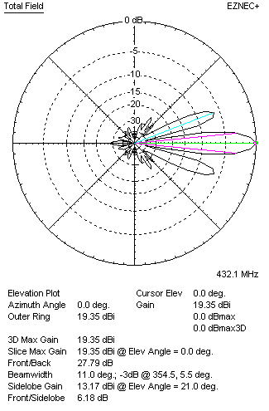
Two antennas stacked vertically
TWO ANTENNAS STACKED HORIZONTALLY
DISTANCE  (mm) |  |  |  | G  (dBi) |  |  |  |  |  | TA  (K) |  |  |  |  |  |  | Tloss  (K) |  |  |  |  |  |  | G/T  (dB)
1540 |  |  |  | 19.16 |  |  |  |  |  | 29.3 |  |  |  |  |  |  | 4.0 |  |  |  |  |  |  | +4.49
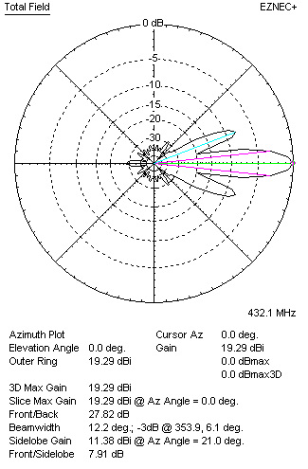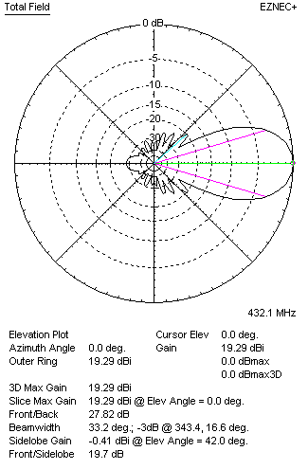
Two antennas stacked horizontally
FOUR ANTENNAS IN H-STACK
DISTANCE  (mm) |  |  |  | G  (dBi) |  |  |  |  |  | TA  (K) |  |  |  |  |  |  | Tloss  (K) |  |  |  |  |  |  | G/T  (dB)
H = 1540 |  |  |  | 22.23 |  |  |  |  |  | 29.1 |  |  |  |  |  |  | 4.0 |  |  |  |  |  |  | +7.60
V = 1680
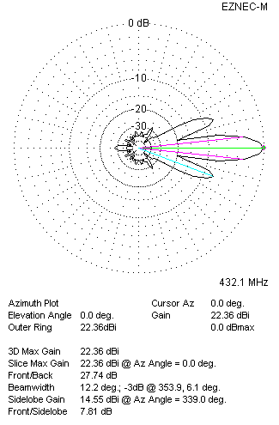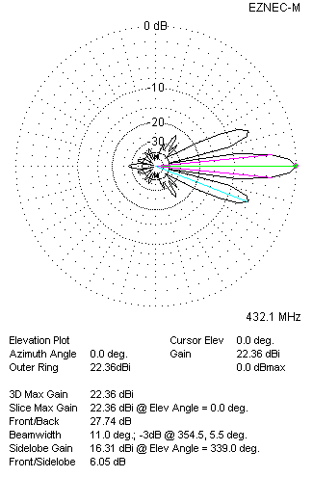
Four antennas in H-stack

