ANTENNA QY71310XL3D6
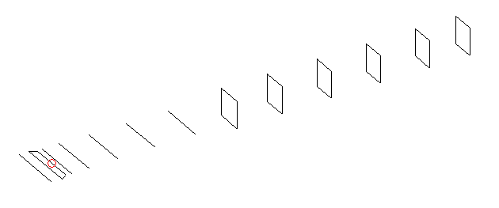
DESCRIPTION
Radiator |  |  |  | Number of  yagi elements |  |  |  |  |  | Number of  oblong elements |  |  |  |  | Total number  of elements |  |  |  |  |  |  | Boomlength  (mm)
LFA |  |  |  | 6 |  |  |  |  |  | 6 |  |  |  |  | 13 |  |  |  |  |  |  | 2645
DIMENSIONS
 | Ref |  | De1 |  | De2 |  | D1 | D2 |  |  | D3 | D4 |  | D5 |  |  | DQ1 |  | DQ2 | DQ3 |  |  |  | DQ4 |  | DQ5 | DQ6
Position | 0 |  | 45 |  | 90 |  | 134 | 237 |  |  | 423 | 656 |  | 919 |  |  | 1202 |  | 1472 | 1786 |  |  |  | 2072 |  | 2382 | 2645
Length | 331 |  | 345 |  | 345 |  | 302 | 300.5 |  |  | 289 | 281 |  | 271.5 |  |  | 169 |  | 160 | 154 |  |  |  | 151 |  | 149 | 147
Remark | All elements made of Al tubes Ǿ10 mm  The height of rectangles is 170 mm  All dimensions given in milimetres
PERFORMANCES (No loss condition)
G  (dBi) |  | F/B  (dB) |  |  |  | F/Sh  (dBi) |  |  | F/Sv  (dBi) |  |  |  | Hor  (◦) |  |  |  |  | Ver  (◦) |  |  | Temp  (◦K) |  |  |  | G/T  (dB)
16.27 |  | 35.97 |  |  |  | 21.36 |  |  | 19.21 |  |  |  | 30.6 |  |  |  |  | 31.8 |  |  | 27.6 |  |  |  | +2.16
DIAGRAMS
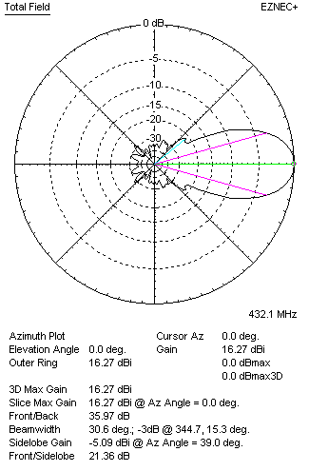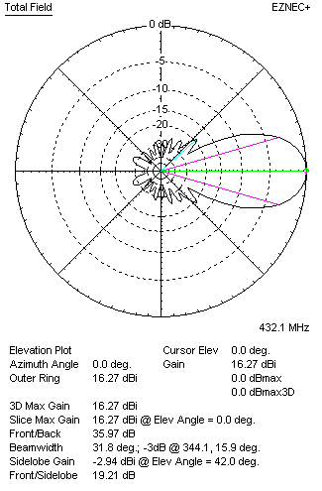
Horizontal and verticall pattern in free space, no loss condition
PERFORMANCES (Loss included for aluminum)
Aluminum |  |  |  |  |  | G  (dBi) |  |  | Tloss  (K) |  |  |  | T_{A}  (◦K) |  |  |  |  | G/T  (dB) |  |  | Bandwidth for SWR=1.5  (MHz)
After NEC/EZNEC |  |  |  |  |  | 16.23 |  |  | 2.9 |  |  |  | 27.6 |  |  |  |  | +1.70 |  |  | 417.500 – 438.500
After KF2YN correction |  |  |  |  |  | 16.20 |  |  | 2.9 |  |  |  | 30.2 |  |  |  |  | +1.40
Remark: Red coloured data are the final antenna data, which means: KF2YN correction formula applied and loss for aluminum included
DIAGRAMS
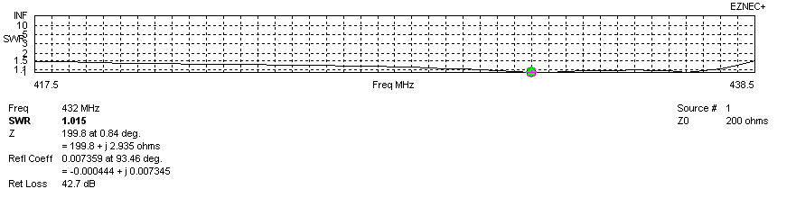
Frequency diagram for SWR better than 1.5
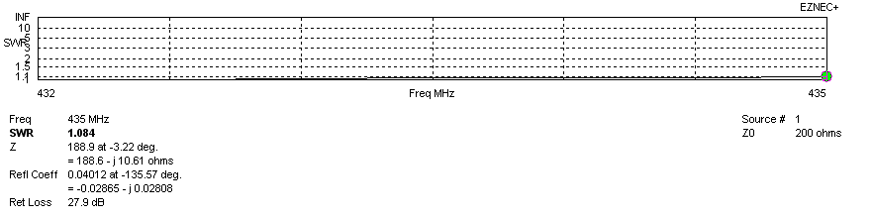
SWR diagram for the range from 432.000 – 435.000 MHz
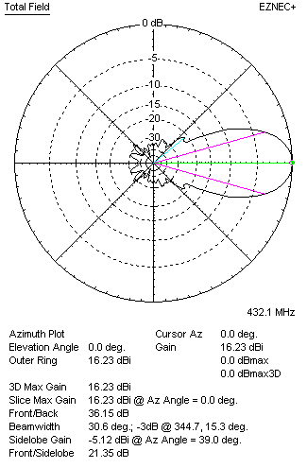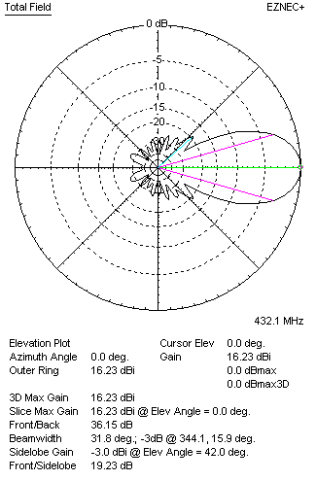
Horizontal and vertical pattern in free space, loss included for aluminum
STACKING
(ALL DATA GIVEN IN ACCORDANCE WITH KF2YN CORRECTION, LOSS INCLUDED)
RECOMMENDED STACKING DISTANCES
 |  |  |  |  |  | Two antennas vertically  (mm) |  |  |  |  |  |  | Two antennas horizontally  (mm) |  |  |  |  |  |  |  | Four antennas in H-stack  (mm)
Horizontal distance |  |  |  |  |  |  |  |  |  |  |  |  | 1360 |  |  |  |  |  |  |  | 1360
Vertical distance |  |  |  |  |  | 1600 |  |  |  |  |  |  |  |  |  |  |  |  |  |  | 1600
TWO ANTENNAS STACKED VERTICALLY
DISTANCE  (mm) |  |  |  | G  (dBi) |  |  |  |  |  | TA  (K) |  |  |  |  | Tloss  (K) |  |  |  |  |  |  | G/T  (dB)
1600 |  |  |  | 19.27 |  |  |  |  |  | 29.6 |  |  |  |  | 2.9 |  |  |  |  |  |  | +4.55
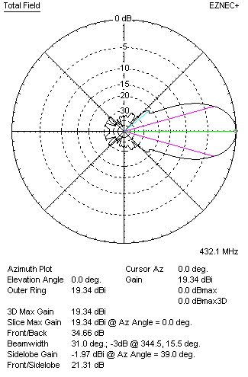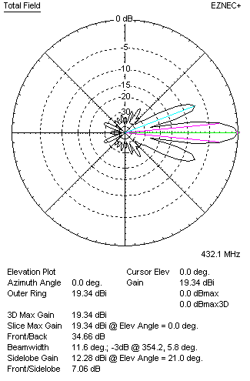
Two antennas stacked vertically
TWO ANTENNAS STACKED HORIZONTALLY
DISTANCE  (mm) |  |  |  | G  (dBi) |  |  |  |  |  | TA  (K) |  |  |  |  |  | Tloss  (K) |  |  |  |  |  |  | G/T  (dB)
1360 |  |  |  | 19.15 |  |  |  |  |  | 29.3 |  |  |  |  |  | 2.9 |  |  |  |  |  |  | +4.48
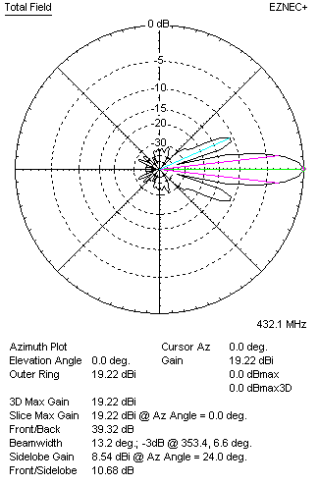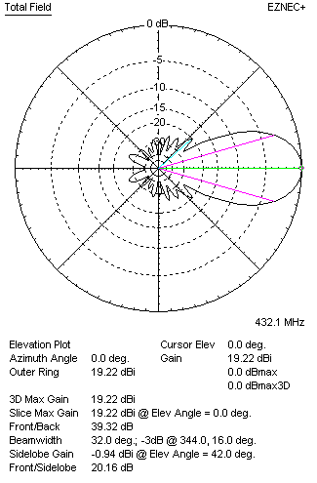
Two antennas stacked horizontally
FOUR ANTENNAS IN H-STACK
DISTANCE  (mm) |  |  |  | G  (dBi) |  |  |  |  |  | TA  (K) |  |  |  |  |  | Tloss  (K) |  |  |  |  |  |  | G/T  (dB)
H = 1360 |  |  |  | 22.22 |  |  |  |  |  | 29.4 |  |  |  |  |  | 2.9 |  |  |  |  |  |  | +7.53
V = 1600
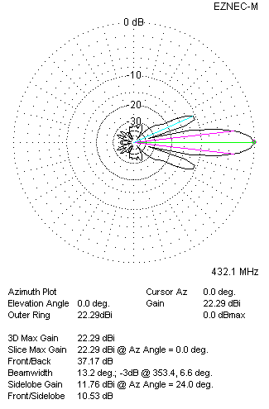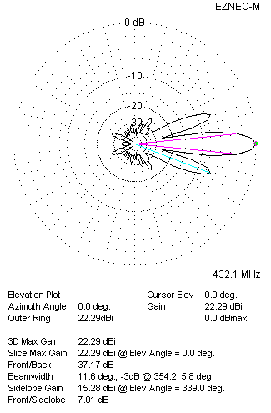
Four antennas in H-stack

