ANTENNA QY71306XL8D6
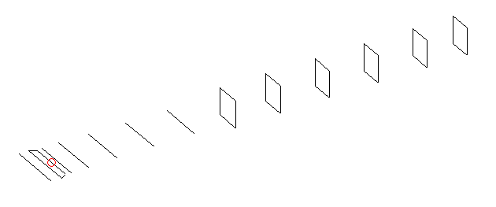
DESCRIPTION
Radiator |  |  |  | Number of  yagi elements |  |  |  |  |  | Number of  oblong elements |  |  |  |  | Total number  of elements |  |  |  |  |  |  | Boomlength  (mm)
LFA |  |  |  | 6 |  |  |  |  |  | 6 |  |  |  |  | 13 |  |  |  |  |  |  | 2645
DIMENSIONS
 | Ref |  | De1 |  | De2 |  | D1 | D2 |  |  | D3 | D4 |  | D5 |  |  | DQ1 |  | DQ2 | DQ3 |  |  |  | DQ4 |  | DQ5 | DQ6
Position | 0 |  | 71 |  | 105 |  | 136 | 235 |  |  | 417 | 645 |  | 907 |  |  | 1192 |  | 1472 | 1776 |  |  |  | 2078 |  | 2394 | 2645
Length | 334 |  | 341 |  | 330 |  | 303.5 | 306.5 |  |  | 297 | 289.5 |  | 281 |  |  | 167 |  | 159 | 153 |  |  |  | 151 |  | 149 | 147
Remark | All elements made of Al tubes Ǿ6 mm  The height of rectangles is 170 mm  All dimensions given in milimetres
PERFORMANCES (No loss condition)
G  (dBi) |  | F/B  (dB) |  |  |  | F/Sh  (dBi) |  |  | F/Sv  (dBi) |  |  |  | Hor  (◦) |  |  |  |  | Ver  (◦) |  |  | Temp  (◦K) |  |  |  | G/T  (dB)
16.10 |  | 30.49 |  |  |  | 22.05 |  |  | 18.82 |  |  |  | 31.6 |  |  |  |  | 33.2 |  |  | 26.7 |  |  |  | +2.39
DIAGRAMS
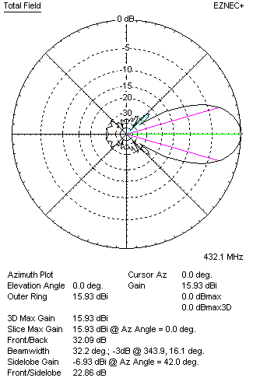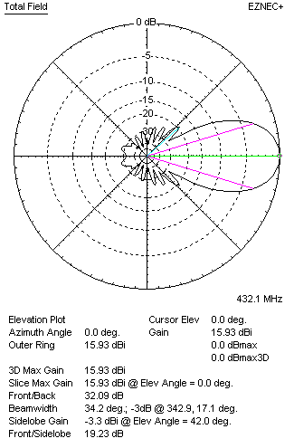
Horizontal and verticall pattern in free space, no loss condition
PERFORMANCES (Loss included for aluminum)
Aluminum |  |  |  |  |  | G  (dBi) |  |  | Tloss  (K) |  |  |  | T_{A}  (◦K) |  |  |  |  | G/T  (dB) |  |  | Bandwidth for SWR=1.5  (MHz)
After NEC/EZNEC |  |  |  |  |  | 16.06 |  |  | 3.4 |  |  |  | 26.7 |  |  |  |  | +1.77 |  |  | 416.000 – 439.800
After KF2YN correction |  |  |  |  |  | 16.00 |  |  | 3.4 |  |  |  | 29.8 |  |  |  |  | +1.25
Remark: Red coloured data are the final antenna data, which means: KF2YN correction formula applied and loss for aluminum included
DIAGRAMS
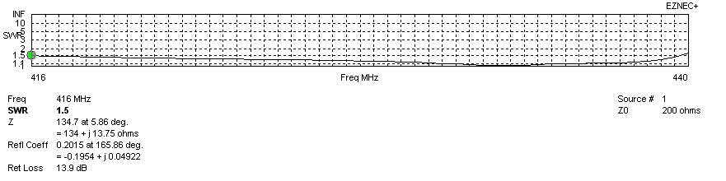
Frequency diagram for SWR better than 1.5
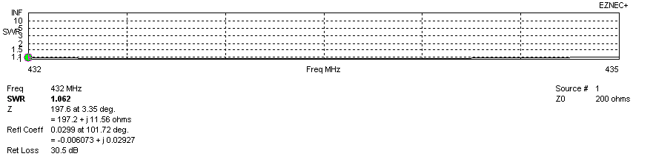
SWR diagram for the range from 432.000 – 435.000 MHz
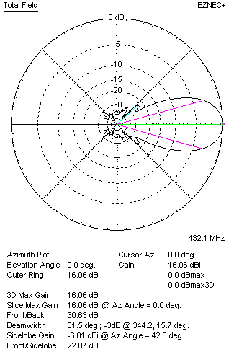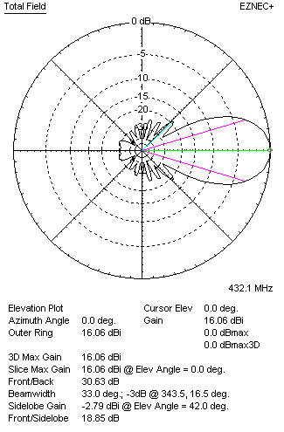
Horizontal and vertical pattern in free space, loss included for aluminum
STACKING
(ALL DATA GIVEN IN ACCORDANCE WITH KF2YN CORRECTION, LOSS INCLUDED)
RECOMMENDED STACKING DISTANCES
 |  |  |  |  |  | Two antennas vertically  (mm) |  |  |  |  |  |  | Two antennas horizontally  (mm) |  |  |  |  |  |  |  | Four antennas in H-stack  (mm)
Horizontal distance |  |  |  |  |  |  |  |  |  |  |  |  | 1340 |  |  |  |  |  |  |  | 1340
Vertical distance |  |  |  |  |  | 1580 |  |  |  |  |  |  |  |  |  |  |  |  |  |  | 1580
TWO ANTENNAS STACKED VERTICALLY
DISTANCE  (mm) |  |  |  | G  (dBi) |  |  |  |  |  | TA  (K) |  |  |  |  | Tloss  (K) |  |  |  |  |  |  | G/T  (dB)
1580 |  |  |  | 19.08 |  |  |  |  |  | 29.2 |  |  |  |  | 3.4 |  |  |  |  |  |  | +4.42
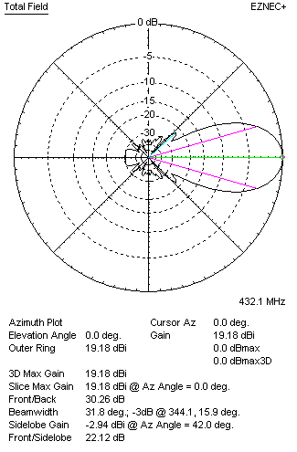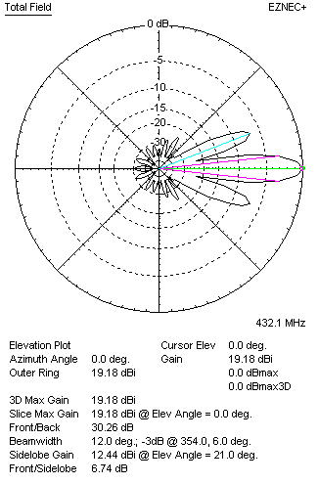
Two antennas stacked vertically
TWO ANTENNAS STACKED HORIZONTALLY
DISTANCE  (mm) |  |  |  | G  (dBi) |  |  |  |  |  | TA  (K) |  |  |  |  |  | Tloss  (K) |  |  |  |  |  |  | G/T  (dB)
1340 |  |  |  | 18.94 |  |  |  |  |  | 29.1 |  |  |  |  |  | 3.4 |  |  |  |  |  |  | +4.29
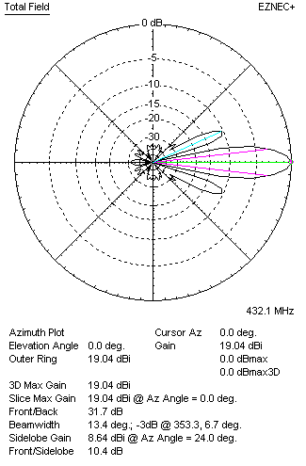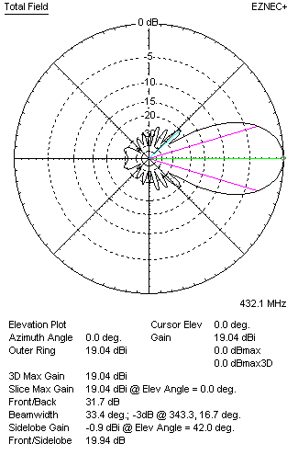
Two antennas stacked horizontally
FOUR ANTENNAS IN H-STACK
DISTANCE  (mm) |  |  |  | G  (dBi) |  |  |  |  |  | TA  (K) |  |  |  |  |  | Tloss  (K) |  |  |  |  |  |  | G/T  (dB)
H = 1340 |  |  |  | 22.03 |  |  |  |  |  | 29.2 |  |  |  |  |  | 3.4 |  |  |  |  |  |  | +7.37
V = 1580
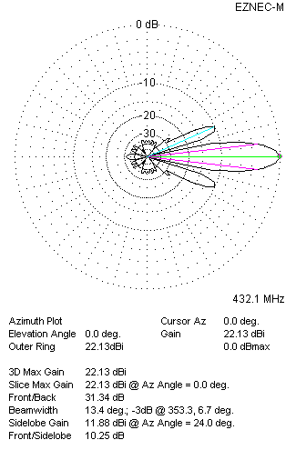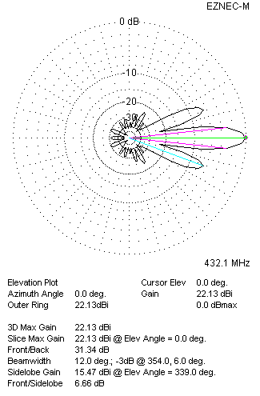
Four antennas in H-stack

