ANTENNA QY71208XL5D5
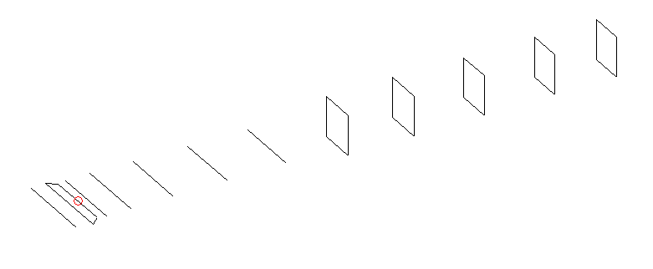
DESCRIPTION
Radiator |  |  |  | Number of  yagi elements |  |  |  |  |  | Number of  oblong elements |  |  |  |  | Total number  of elements |  |  |  |  |  |  | Boomlength  (mm)
LFA |  |  |  | 6 |  |  |  |  |  | 5 |  |  |  |  | 12 |  |  |  |  |  |  | 2345
DIMENSIONS
 | Ref |  | De1 |  | De2 |  | D1 |  | D2 |  | D3 |  | D4 | D5 |  |  |  | DQ1 | DQ2 |  | DQ3 |  |  | DQ4 |  | DQ5
Position | 0 |  | 60 |  | 90 |  | 131 |  | 233 |  | 422 |  | 656 | 918 |  |  |  | 1202 | 1498 |  | 1784 |  |  | 2096 |  | 2345
Length | 332 |  | 355 |  | 300 |  | 305.5 |  | 305.5 |  | 294.5 |  | 285.5 | 276 |  |  |  | 167 | 157 |  | 155 |  |  | 153 |  | 147
Remark | All elements made of Al tubes Ǿ8 mm  The height of rectangles is 170 mm  All dimensions given in milimetres
PERFORMANCES (No loss condition)
G  (dBi) |  | F/B  (dB) |  |  |  | F/Sh  (dBi) |  | F/Sv  (dBi) |  |  |  | Hor  (◦) |  |  |  |  | Ver  (◦) |  |  | Temp  (◦K) |  |  |  |  | G/T  (dB)
15.79 |  | 26.06 |  |  |  | 22.50 |  | 20.27 |  |  |  | 32.4 |  |  |  |  | 34.2 |  |  | 26.9 |  |  |  |  | +2.06
DIAGRAMS
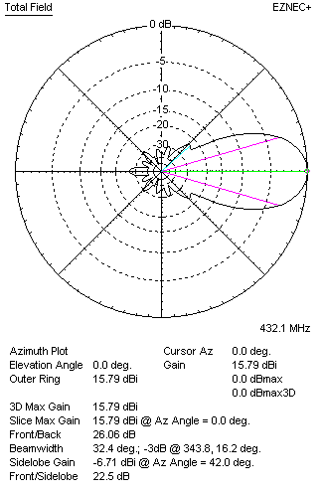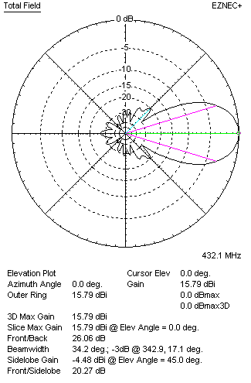
Horizontal and verticall pattern in free space, no loss condition
PERFORMANCES (Loss included for aluminum)
Aluminum |  |  |  |  |  | G  (dBi) |  | Tloss  (K) |  |  |  | T_{A}  (◦K) |  |  |  |  | G/T  (dB) |  |  | Bandwidth for SWR=1.5  (MHz)
After NEC/EZNEC |  |  |  |  |  | 15.74 |  | 3.7 |  |  |  | 26.9 |  |  |  |  | +1.43 |  |  | 425.000 – 437.000
After KF2YN correction |  |  |  |  |  | 15.68 |  | 3.7 |  |  |  | 30.3 |  |  |  |  | +0.87
Remark: Red coloured data are the final antenna data, which means: KF2YN correction formula applied and loss for aluminum included
DIAGRAMS
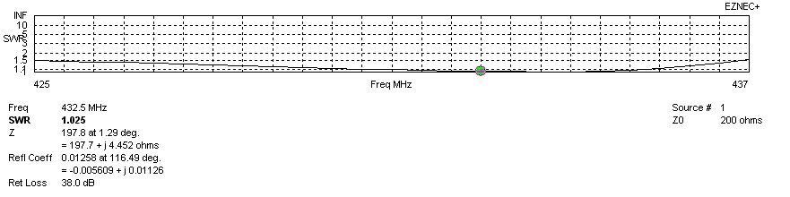
Frequency diagram for SWR better than 1.5
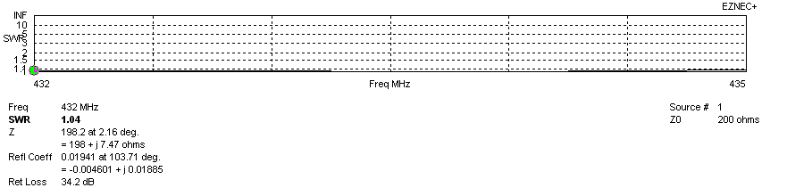
SWR diagram for the range from 432.000 – 435.000 MHz
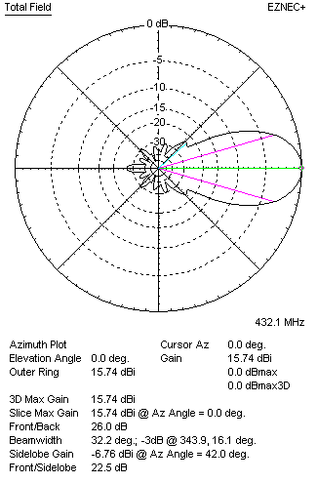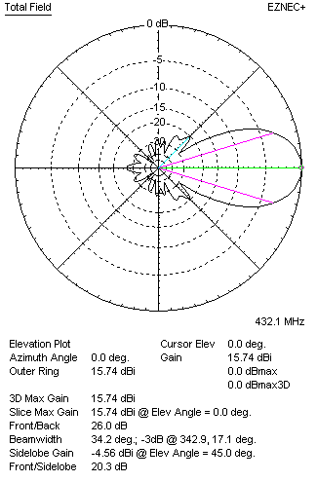
Horizontal and vertical pattern in free space, loss included for aluminum
STACKING
(ALL DATA GIVEN IN ACCORDANCE WITH KF2YN CORRECTION, LOSS INCLUDED)
RECOMMENDED STACKING DISTANCES
 |  |  |  |  |  | Two antennas vertically  (mm) |  |  |  |  |  | Two antennas horizontally  (mm) |  |  |  |  |  |  |  | Four antennas in H-stack  (mm)
Horizontal distance |  |  |  |  |  |  |  |  |  |  |  | 1320 |  |  |  |  |  |  |  | 1320
Vertical distance |  |  |  |  |  | 1220 |  |  |  |  |  |  |  |  |  |  |  |  |  | 1220
TWO ANTENNAS STACKED VERTICALLY
DISTANCE  (mm) |  |  |  | G  (dBi) |  |  |  |  |  | TA  (K) |  |  |  |  | Tloss  (K) |  |  |  |  |  |  | G/T  (dB)
1220 |  |  |  | 18.63 |  |  |  |  |  | 30.2 |  |  |  |  | 3.7 |  |  |  |  |  |  | +3.83
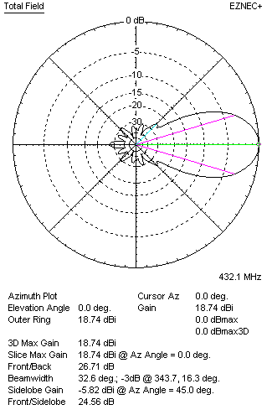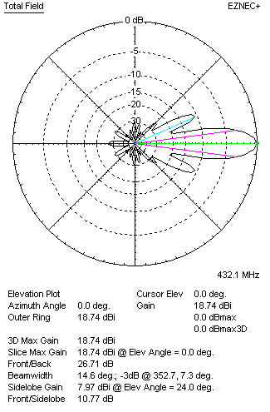
Two antennas stacked vertically
TWO ANTENNAS STACKED HORIZONTALLY
DISTANCE  (mm) |  |  |  | G  (dBi) |  |  |  |  |  | TA  (K) |  |  |  |  |  | Tloss  (K) |  |  |  |  |  |  | G/T  (dB)
1320 |  |  |  | 18.65 |  |  |  |  |  | 29.8 |  |  |  |  |  | 3.7 |  |  |  |  |  |  | +3.91
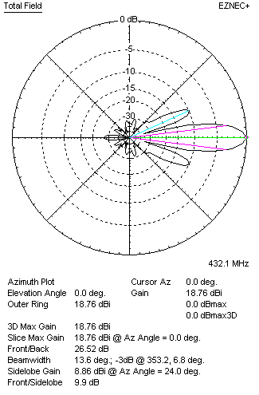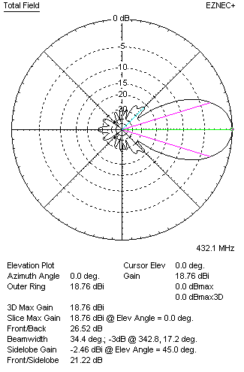
Two antennas stacked horizontally
FOUR ANTENNAS IN H-STACK
DISTANCE  (mm) |  |  |  | G  (dBi) |  |  |  |  |  | TA  (K) |  |  |  |  |  | Tloss  (K) |  |  |  |  |  |  | G/T  (dB)
H = 1320 |  |  |  | 21.63 |  |  |  |  |  | 30.3 |  |  |  |  |  | 3.7 |  |  |  |  |  |  | +6.82
V = 1220
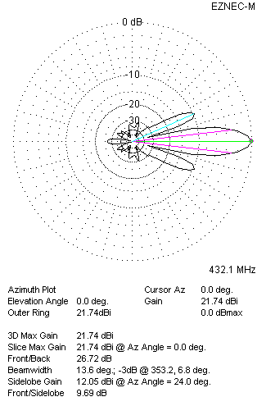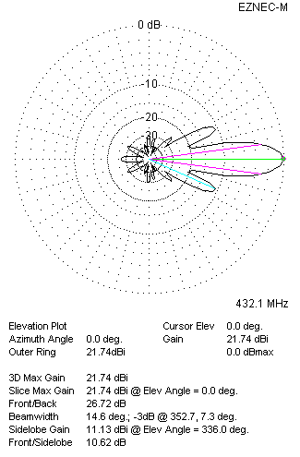
Four antennas in H-stack

