ANTENNA QY71206XL6D5
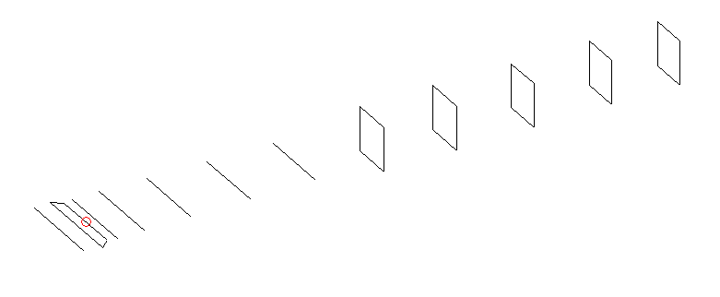
DESCRIPTION
Radiator |  |  |  | Number of  yagi elements |  |  |  |  |  | Number of  oblong elements |  |  |  |  | Total number  of elements |  |  |  |  |  |  | Boomlength  (mm)
LFA |  |  |  | 6 |  |  |  |  |  | 5 |  |  |  |  | 12 |  |  |  |  |  |  | 2345
DIMENSIONS
 | Ref |  | De1 |  | De2 |  | D1 |  | D2 |  | D3 |  | D4 | D5 |  |  |  | DQ1 | DQ2 |  | DQ3 |  |  | DQ4 |  | DQ5
Position | 0 |  | 65 |  | 102 |  | 138 |  | 240 |  | 421 |  | 652 | 905 |  |  |  | 1202 | 1483 |  | 1792 |  |  | 2083 |  | 2345
Length | 335 |  | 347 |  | 290 |  | 304 |  | 307.5 |  | 297 |  | 283.5 | 173 |  |  |  | 163 | 159 |  | 153 |  |  | 147 |  | 147
Remark | All elements made of Al tubes Ǿ6 mm  The height of rectangles is 170 mm  All dimensions given in milimetres
PERFORMANCES (No loss condition)
G  (dBi) |  | F/B  (dB) |  |  |  | F/Sh  (dBi) |  | F/Sv  (dBi) |  |  |  | Hor  (◦) |  |  |  |  | Ver  (◦) |  |  | Temp  (◦K) |  |  |  |  | G/T  (dB)
15.73 |  | 32.67 |  |  |  | 21.75 |  | 19.52 |  |  |  | 32.6 |  |  |  |  | 34.8 |  |  | 27.1 |  |  |  |  | +1.91
DIAGRAMS
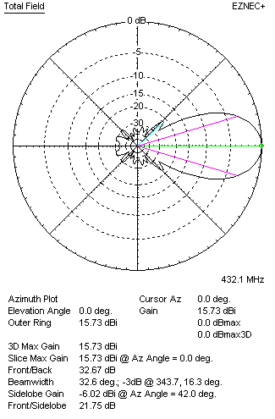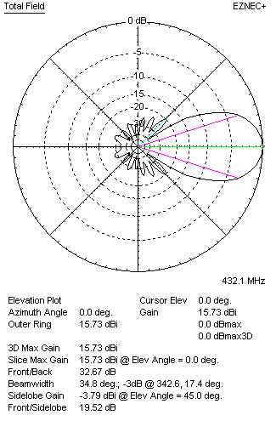
Horizontal and verticall pattern in free space, no loss condition
PERFORMANCES (Loss included for aluminum)
Aluminum |  |  |  |  |  | G  (dBi) |  | Tloss  (K) |  |  |  | T_{A}  (◦K) |  |  |  |  | G/T  (dB) |  |  | Bandwidth for SWR=1.5  (MHz)
After NEC/EZNEC |  |  |  |  |  | 15.68 |  | 3.7 |  |  |  | 27.1 |  |  |  |  | +1.32 |  |  | 416.000 – 438.800
After KF2YN correction |  |  |  |  |  | 15.62 |  | 3.7 |  |  |  | 30.5 |  |  |  |  | +0.78
Remark: Red coloured data are the final antenna data, which means: KF2YN correction formula applied and loss for aluminum included
DIAGRAMS
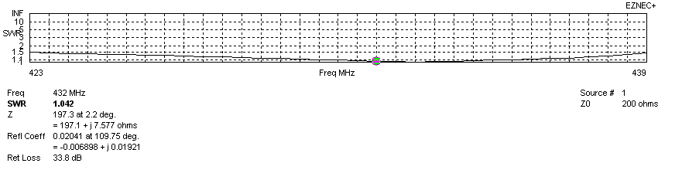
Frequency diagram for SWR better than 1.5
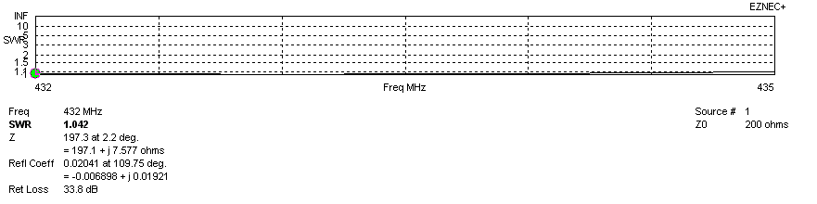
SWR diagram for the range from 432.000 – 435.000 MHz
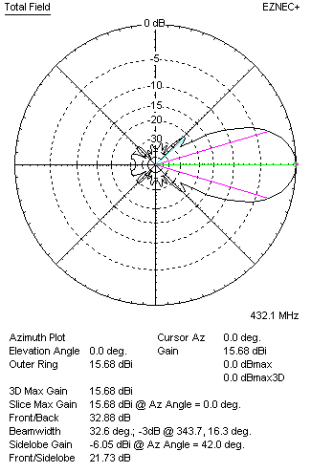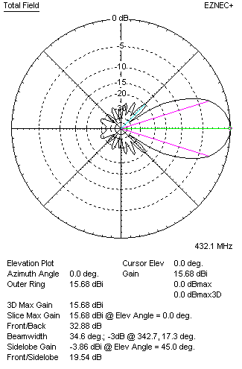
Horizontal and vertical pattern in free space, loss included for aluminum
STACKING
(ALL DATA GIVEN IN ACCORDANCE WITH KF2YN CORRECTION, LOSS INCLUDED)
RECOMMENDED STACKING DISTANCES
 |  |  |  |  |  | Two antennas vertically  (mm) |  |  |  |  |  | Two antennas horizontally  (mm) |  |  |  |  |  |  |  | Four antennas in H-stack  (mm)
Horizontal distance |  |  |  |  |  |  |  |  |  |  |  | 1280 |  |  |  |  |  |  |  | 1280
Vertical distance |  |  |  |  |  | 1120 |  |  |  |  |  |  |  |  |  |  |  |  |  | 1120
TWO ANTENNAS STACKED VERTICALLY
DISTANCE  (mm) |  |  |  | G  (dBi) |  |  |  |  |  | TA  (K) |  |  |  |  | Tloss  (K) |  |  |  |  |  |  | G/T  (dB)
1120 |  |  |  | 18.44 |  |  |  |  |  | 29.9 |  |  |  |  | 3.7 |  |  |  |  |  |  | +3.69
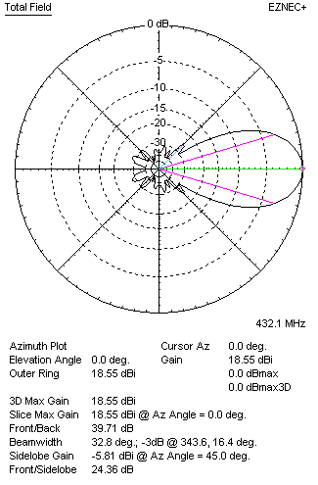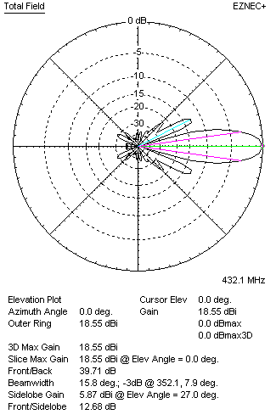
Two antennas stacked vertically
TWO ANTENNAS STACKED HORIZONTALLY
DISTANCE  (mm) |  |  |  | G  (dBi) |  |  |  |  |  | TA  (K) |  |  |  |  |  | Tloss  (K) |  |  |  |  |  |  | G/T  (dB)
1280 |  |  |  | 18.56 |  |  |  |  |  | 30.0 |  |  |  |  |  | 3.7 |  |  |  |  |  |  | +3.79
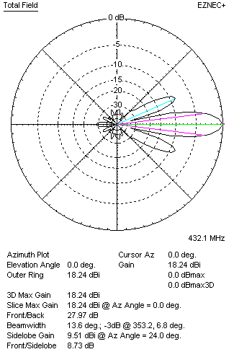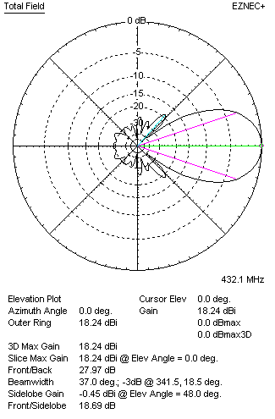
Two antennas stacked horizontally
FOUR ANTENNAS IN H-STACK
DISTANCE  (mm) |  |  |  | G  (dBi) |  |  |  |  |  | TA  (K) |  |  |  |  |  | Tloss  (K) |  |  |  |  |  |  | G/T  (dB)
H = 1280 |  |  |  | 21.49 |  |  |  |  |  | 29.8 |  |  |  |  |  | 3.7 |  |  |  |  |  |  | +6.75
V = 1120
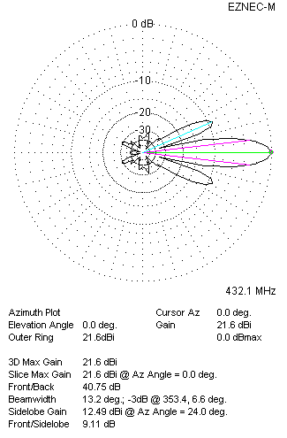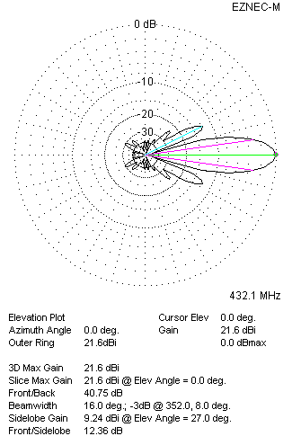
Four antennas in H-stack

