ANTENNA QY71110XL4D5
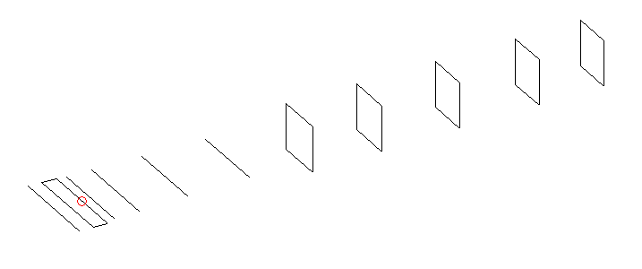
DESCRIPTION
Radiator |  |  |  | Number of  yagi elements |  |  |  |  | Number of  oblong elements |  |  |  |  | Total number  of elements |  |  |  |  |  |  | Boomlength  (mm)
LFA |  |  |  | 5 |  |  |  |  | 5 |  |  |  |  | 11 |  |  |  |  |  |  | 2005
DIMENSIONS
 | Ref |  | De1 |  |  | De2 | D1 |  |  | D2 | D3 |  | D4 |  |  |  | DQ1 | DQ2 |  | DQ3 |  |  | DQ4 |  | DQ5
Position | 0 |  | 60 |  |  | 100 | 131 |  |  | 222 | 411 |  | 644 |  |  |  | 896 | 1168 |  | 1461 |  |  | 1772 |  | 2005
Length | 333 |  | 337 |  |  | 337 | 296 |  |  | 301 | 289.5 |  | 278.5 |  |  |  | 171 | 159 |  | 155 |  |  | 153 |  | 151
Remark | All elements made of Al tubes Ǿ10 mm  The height of rectangles is 170 mm  All dimensions given in milimetres
PERFORMANCES (No loss condition)
G  (dBi) |  | F/B  (dB) |  |  | F/Sh  (dBi) |  |  | F/Sv  (dBi) |  |  |  | Hor  (◦) |  |  |  | Ver  (◦) |  |  | Temp  (◦K) |  |  |  |  | G/T  (dB)
15.24 |  | 25.25 |  |  | 23.84 |  |  | 19.32 |  |  |  | 34.4 |  |  |  | 36.4 |  |  | 29.0 |  |  |  |  | +1.14
DIAGRAMS
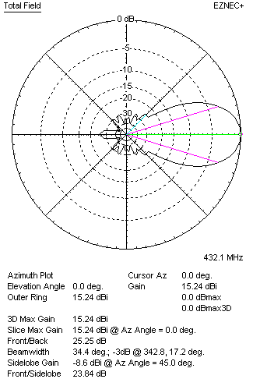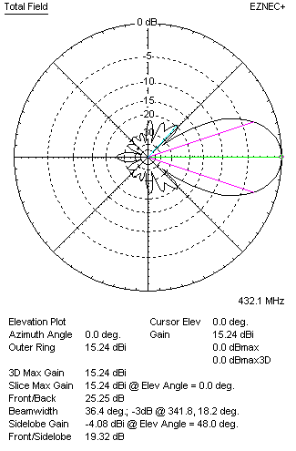
Horizontal and verticall pattern in free space, no loss condition
PERFORMANCES (Loss included for aluminum)
Aluminum |  |  |  |  | G  (dBi) |  |  | Tloss  (K) |  |  |  | T_{A}  (◦K) |  |  |  | G/T  (dB) |  |  | Bandwidth for SWR=1.5  (MHz)
After NEC/EZNEC |  |  |  |  | 15.20 |  |  | 2.3 |  |  |  | 29.0 |  |  |  | +0.72 |  |  | 424.000 – 438.500
After KF2YN correction |  |  |  |  | 14.15 |  |  | 2.3 |  |  |  | 31.1 |  |  |  | +0.23
Remark: Red coloured data are the final antenna data, which means: KF2YN correction formula applied and loss for aluminum included
DIAGRAMS
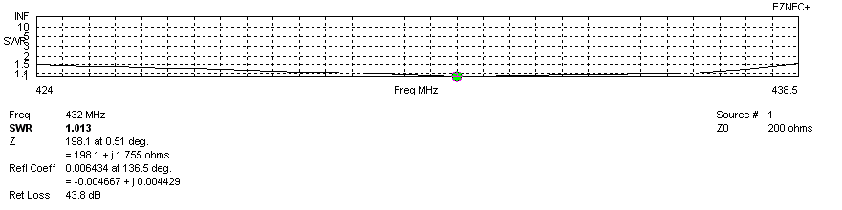
Frequency diagram for SWR better than 1.5
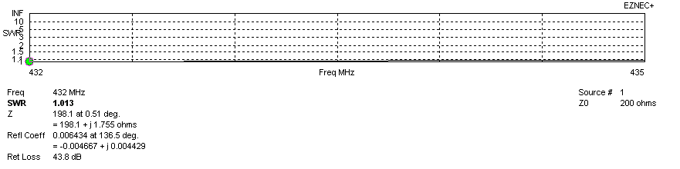
SWR diagram for the range from 432.000 – 435.000 MHz
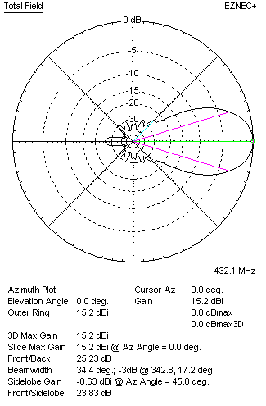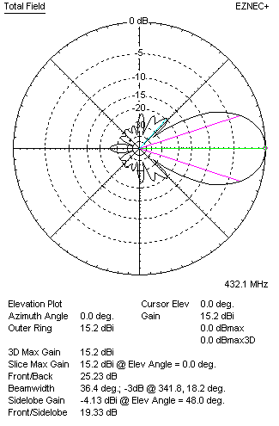
Horizontal and vertical pattern in free space, loss included for aluminum
STACKING
(ALL DATA GIVEN IN ACCORDANCE WITH KF2YN CORRECTION, LOSS INCLUDED)
RECOMMENDED STACKING DISTANCES
 |  |  |  |  | Two antennas vertically  (mm) |  |  |  |  |  |  | Two antennas horizontally  (mm) |  |  |  |  |  |  | Four antennas in H-stack  (mm)
Horizontal distance |  |  |  |  |  |  |  |  |  |  |  | 1320 |  |  |  |  |  |  | 1320
Vertical distance |  |  |  |  | 1120 |  |  |  |  |  |  |  |  |  |  |  |  |  | 1120
TWO ANTENNAS STACKED VERTICALLY
DISTANCE  (mm) |  |  |  | G  (dBi) |  |  |  |  | TA  (K) |  |  |  |  | Tloss  (K) |  |  |  |  |  |  | G/T  (dB)
1120 |  |  |  | 18.06 |  |  |  |  | 30.7 |  |  |  |  | 2.3 |  |  |  |  |  |  | +3.20
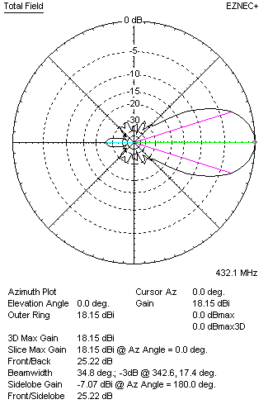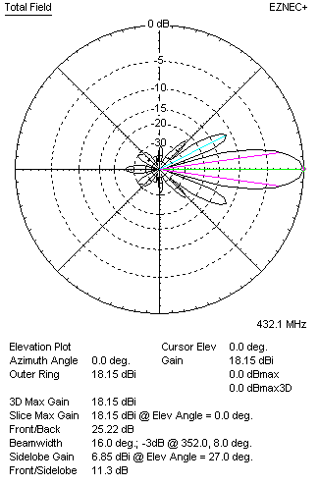
Two antennas stacked vertically
TWO ANTENNAS STACKED HORIZONTALLY
DISTANCE  (mm) |  |  |  | G  (dBi) |  |  |  |  | TA  (K) |  |  |  |  |  | Tloss  (K) |  |  |  |  |  |  | G/T  (dB)
1320 |  |  |  | 18.16 |  |  |  |  | 30.9 |  |  |  |  |  | 2.3 |  |  |  |  |  |  | +3.27
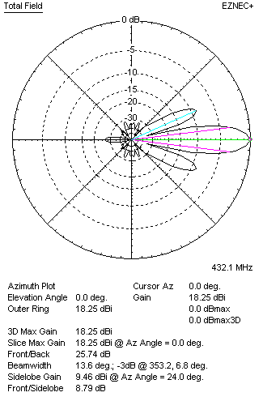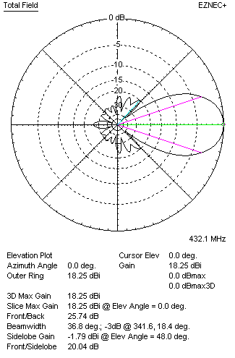
Two antennas stacked horizontally
FOUR ANTENNAS IN H-STACK
DISTANCE  (mm) |  |  |  | G  (dBi) |  |  |  |  | TA  (K) |  |  |  |  |  | Tloss  (K) |  |  |  |  |  |  | G/T  (dB)
H = 1320 |  |  |  | 21.08 |  |  |  |  | 31.2 |  |  |  |  |  | 2.3 |  |  |  |  |  |  | +6.15
V = 1120
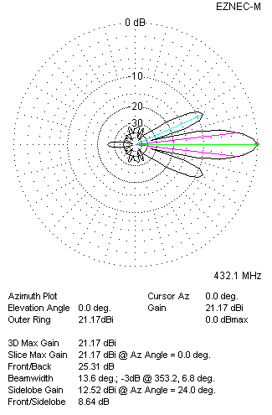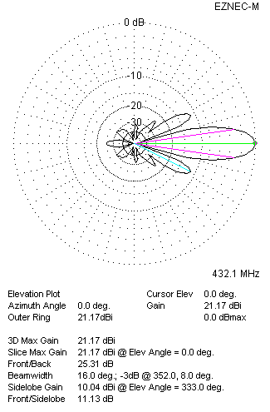
Four antennas in H-stack

