ANTENNA QY71108XL3D5
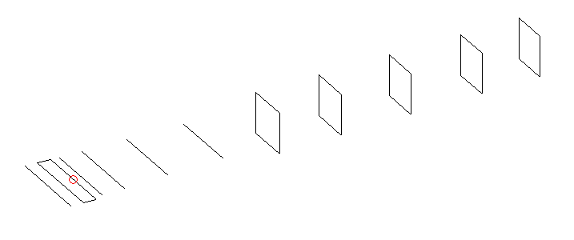
DESCRIPTION
Radiator |  |  |  | Number of  yagi elements |  |  |  |  | Number of  oblong elements |  |  |  |  | Total number  of elements |  |  |  |  |  |  | Boomlength  (mm)
LFA |  |  |  | 5 |  |  |  |  | 5 |  |  |  |  | 11 |  |  |  |  |  |  | 2005
DIMENSIONS
 | Ref |  | De1 |  |  | De2 | D1 |  |  | D2 | D3 |  | D4 |  |  |  | DQ1 | DQ2 |  | DQ3 |  |  | DQ4 |  | DQ5
Position | 0 |  | 60 |  |  | 100 | 131 |  |  | 226 | 413 |  | 642 |  |  |  | 894 | 1174 |  | 1461 |  |  | 1762 |  | 2005
Length | 336 |  | 335 |  |  | 335 | 299.5 |  |  | 303.5 | 293 |  | 283 |  |  |  | 171 | 161 |  | 157 |  |  | 155 |  | 153
Remark | All elements made of Al tubes Ǿ8 mm  The height of rectangles is 170 mm  All dimensions given in milimetres
PERFORMANCES (No loss condition)
G  (dBi) |  | F/B  (dB) |  |  | F/Sh  (dBi) |  |  | F/Sv  (dBi) |  |  |  | Hor  (◦) |  |  |  | Ver  (◦) |  |  | Temp  (◦K) |  |  |  |  | G/T  (dB)
15.27 |  | 28.68 |  |  | 22.71 |  |  | 18.60 |  |  |  | 34.2 |  |  |  | 36.4 |  |  | 29.2 |  |  |  |  | +1.13
DIAGRAMS
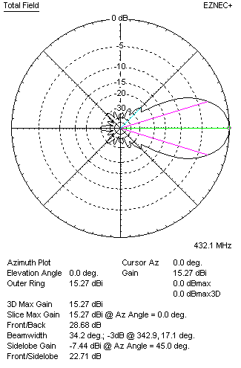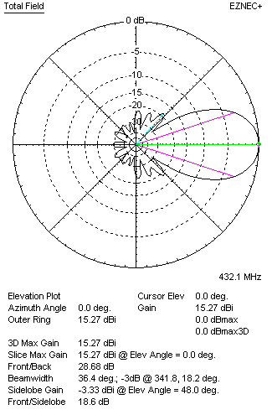
Horizontal and verticall pattern in free space, no loss condition
PERFORMANCES (Loss included for aluminum)
Aluminum |  |  |  |  | G  (dBi) |  |  | Tloss  (K) |  |  |  | T_{A}  (◦K) |  |  |  | G/T  (dB) |  |  | Bandwidth for SWR=1.5  (MHz)
After NEC/EZNEC |  |  |  |  | 15.24 |  |  | 2.6 |  |  |  | 29.2 |  |  |  | +0.69 |  |  | 422.000 – 439.500
After KF2YN correction |  |  |  |  | 14.18 |  |  | 2.6 |  |  |  | 31.5 |  |  |  | +0.19
Remark: Red coloured data are the final antenna data, which means: KF2YN correction formula applied and loss for aluminum included
DIAGRAMS
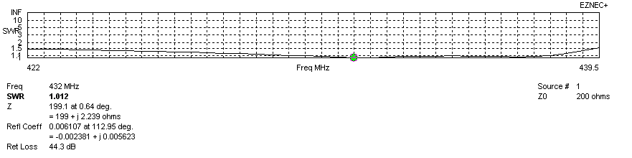
Frequency diagram for SWR better than 1.5
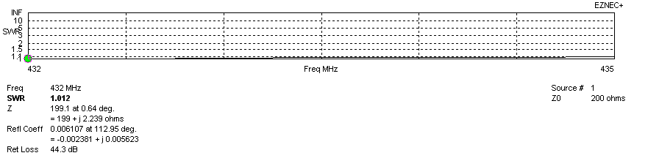
SWR diagram for the range from 432.000 – 435.000 MHz
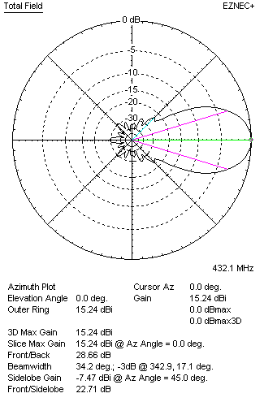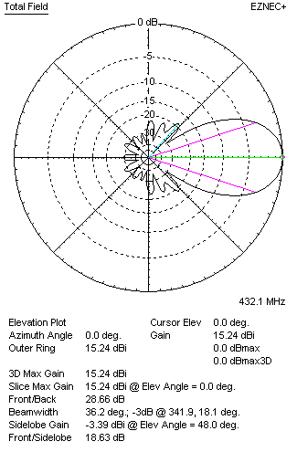
Horizontal and vertical pattern in free space, loss included for aluminum
STACKING
(ALL DATA GIVEN IN ACCORDANCE WITH KF2YN CORRECTION, LOSS INCLUDED)
RECOMMENDED STACKING DISTANCES
 |  |  |  |  | Two antennas vertically  (mm) |  |  |  |  |  |  | Two antennas horizontally  (mm) |  |  |  |  |  |  | Four antennas in H-stack  (mm)
Horizontal distance |  |  |  |  |  |  |  |  |  |  |  | 1280 |  |  |  |  |  |  | 1280
Vertical distance |  |  |  |  | 1120 |  |  |  |  |  |  |  |  |  |  |  |  |  | 1120
TWO ANTENNAS STACKED VERTICALLY
DISTANCE  (mm) |  |  |  | G  (dBi) |  |  |  |  | TA  (K) |  |  |  |  | Tloss  (K) |  |  |  |  |  |  | G/T  (dB)
1120 |  |  |  | 18.10 |  |  |  |  | 30.9 |  |  |  |  | 2.6 |  |  |  |  |  |  | +3.20
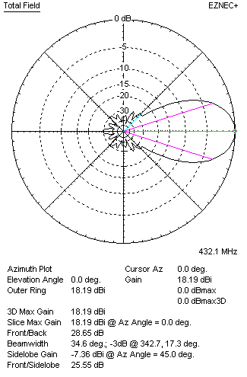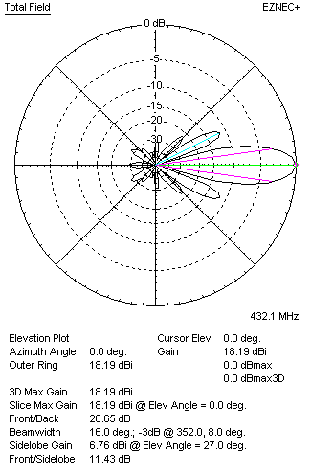
Two antennas stacked vertically
TWO ANTENNAS STACKED HORIZONTALLY
DISTANCE  (mm) |  |  |  | G  (dBi) |  |  |  |  | TA  (K) |  |  |  |  |  | Tloss  (K) |  |  |  |  |  |  | G/T  (dB)
1280 |  |  |  | 18.18 |  |  |  |  | 31.1 |  |  |  |  |  | 2.6 |  |  |  |  |  |  | +3.25
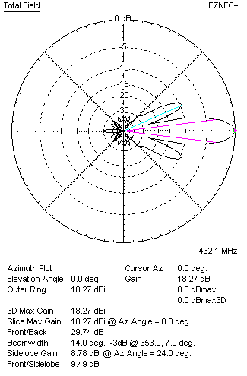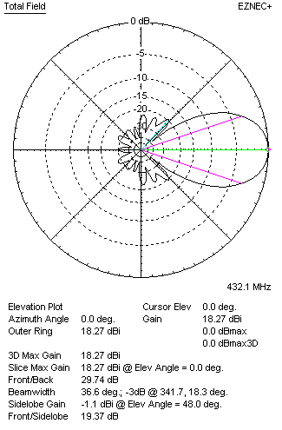
Two antennas stacked horizontally
FOUR ANTENNAS IN H-STACK
DISTANCE  (mm) |  |  |  | G  (dBi) |  |  |  |  | TA  (K) |  |  |  |  |  | Tloss  (K) |  |  |  |  |  |  | G/T  (dB)
H = 1280 |  |  |  | 21.13 |  |  |  |  | 31.2 |  |  |  |  |  | 2.6 |  |  |  |  |  |  | +6.18
V = 1120
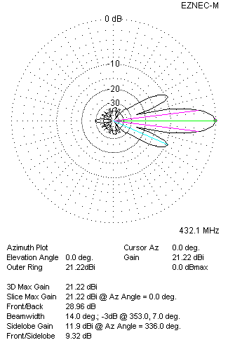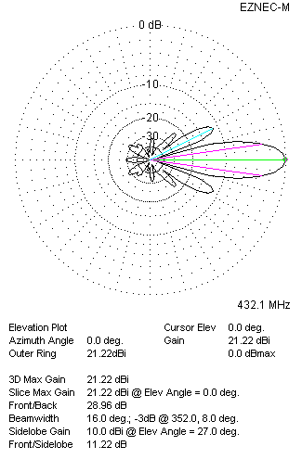
Four antennas in H-stack

