ANTENNA QY71106XL4D5
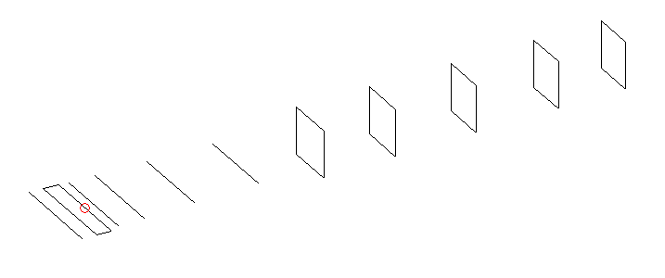
DESCRIPTION
Radiator |  |  |  | Number of  yagi elements |  |  |  |  | Number of  oblong elements |  |  |  |  | Total number  of elements |  |  |  |  |  |  | Boomlength  (mm)
LFA |  |  |  | 5 |  |  |  |  | 5 |  |  |  |  | 11 |  |  |  |  |  |  | 1945
DIMENSIONS
 | Ref |  | De1 |  |  | De2 | D1 |  |  | D2 | D3 |  | D4 |  |  |  | DQ1 | DQ2 |  | DQ3 |  |  | DQ4 |  | DQ5
Position | 0 |  | 50 |  |  | 105 | 134 |  |  | 226 | 408 |  | 636 |  |  |  | 881 | 1141 |  | 1422 |  |  | 1718 |  | 1945
Length | 336 |  | 330 |  |  | 330 | 306 |  |  | 309 | 297 |  | 288 |  |  |  | 173 | 164 |  | 156 |  |  | 152 |  | 150
Remark | All elements made of Al tubes Ǿ6 mm  The height of rectangles is 170 mm  All dimensions given in milimetres
PERFORMANCES (No loss condition)
G  (dBi) |  | F/B  (dB) |  |  | F/Sh  (dBi) |  |  | F/Sv  (dBi) |  |  |  | Hor  (◦) |  |  |  | Ver  (◦) |  |  | Temp  (◦K) |  |  |  |  | G/T  (dB)
15.03 |  | 29.44 |  |  | 23.46 |  |  | 19.70 |  |  |  | 35.4 |  |  |  | 37.6 |  |  | 28.1 |  |  |  |  | +1.01
DIAGRAMS
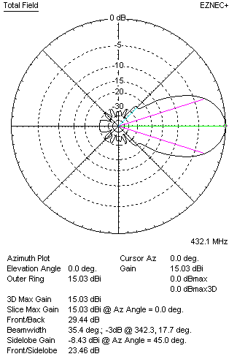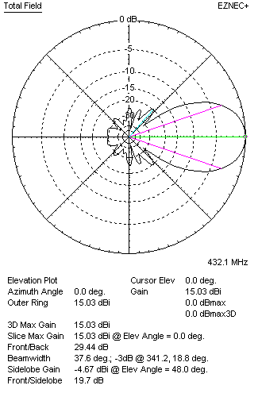
Horizontal and verticall pattern in free space, no loss condition
PERFORMANCES (Loss included for aluminum)
Aluminum |  |  |  |  | G  (dBi) |  |  | Tloss  (K) |  |  |  | T_{A}  (◦K) |  |  |  | G/T  (dB) |  |  | Bandwidth for SWR=1.5  (MHz)
After NEC/EZNEC |  |  |  |  | 14.98 |  |  | 3.7 |  |  |  | 28.2 |  |  |  | +0.41 |  |  | 423.000 – 439.000
After KF2YN correction |  |  |  |  | 14.93 |  |  | 3.7 |  |  |  | 31.5 |  |  |  | -0.05
Remark: Red coloured data are the final antenna data, which means: KF2YN correction formula applied and loss for aluminum included
DIAGRAMS
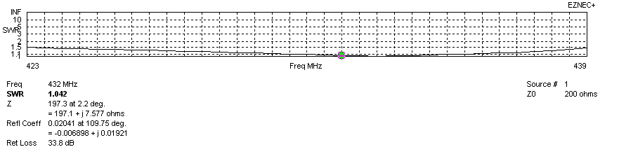
Frequency diagram for SWR better than 1.5
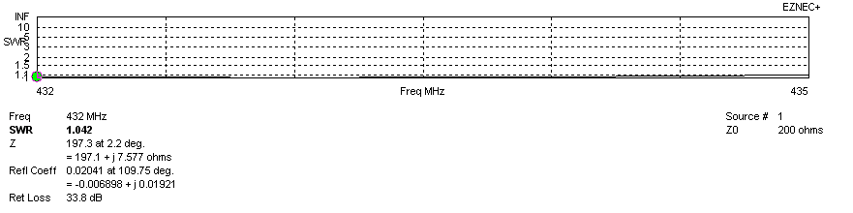
SWR diagram for the range from 432.000 – 435.000 MHz
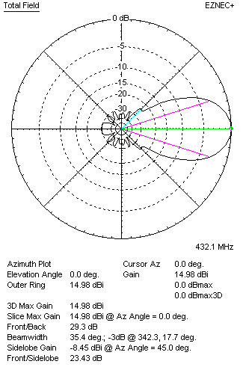 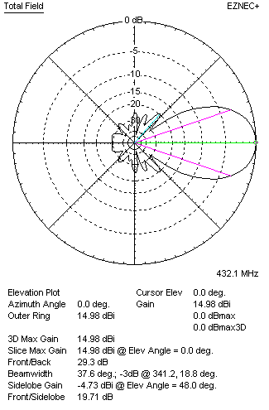Horizontal and vertical pattern in free space, loss included for aluminum
STACKING
(ALL DATA GIVEN IN ACCORDANCE WITH KF2YN CORRECTION, LOSS INCLUDED)
RECOMMENDED STACKING DISTANCES
 |  |  |  |  | Two antennas vertically  (mm) |  |  |  |  |  |  | Two antennas horizontally  (mm) |  |  |  |  |  |  | Four antennas in H-stack  (mm)
Horizontal distance |  |  |  |  |  |  |  |  |  |  |  | 1300 |  |  |  |  |  |  | 1300
Vertical distance |  |  |  |  | 1060 |  |  |  |  |  |  |  |  |  |  |  |  |  | 1060
TWO ANTENNAS STACKED VERTICALLY
DISTANCE  (mm) |  |  |  | G  (dBi) |  |  |  |  | TA  (K) |  |  |  |  | Tloss  (K) |  |  |  |  |  |  | G/T  (dB)
1060 |  |  |  | 17.81 |  |  |  |  | 31.2 |  |  |  |  | 3.7 |  |  |  |  |  |  | +2.87
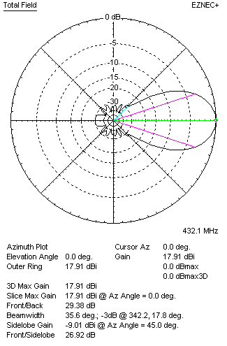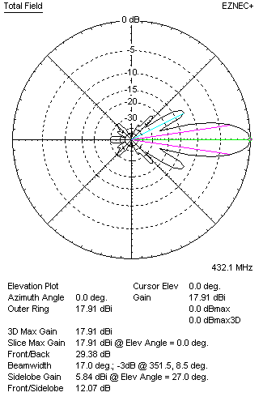
Two antennas stacked vertically
TWO ANTENNAS STACKED HORIZONTALLY
DISTANCE  (mm) |  |  |  | G  (dBi) |  |  |  |  | TA  (K) |  |  |  |  |  | Tloss  (K) |  |  |  |  |  |  | G/T  (dB)
1300 |  |  |  | 17.95 |  |  |  |  | 31.6 |  |  |  |  |  | 3.7 |  |  |  |  |  |  | +2.95
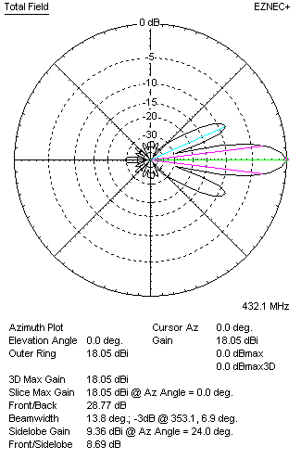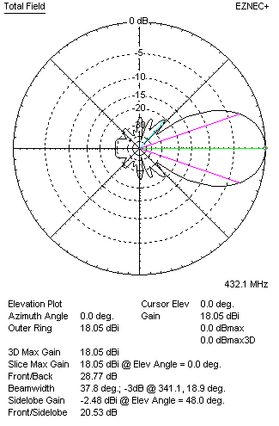
Two antennas stacked horizontally
FOUR ANTENNAS IN H-STACK
DISTANCE  (mm) |  |  |  | G  (dBi) |  |  |  |  | TA  (K) |  |  |  |  |  | Tloss  (K) |  |  |  |  |  |  | G/T  (dB)
H = 1300 |  |  |  | 20.86 |  |  |  |  | 31.7 |  |  |  |  |  | 3.7 |  |  |  |  |  |  | +5.85
V = 1060
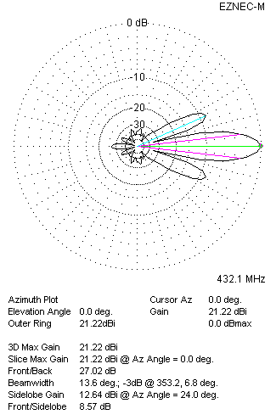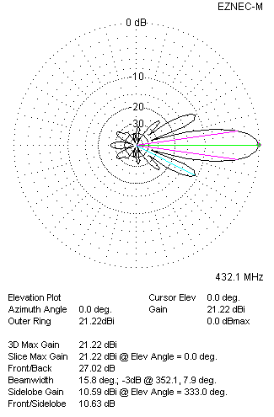
Four antennas in H-stack

