ANTENNA QY71010XL7D5
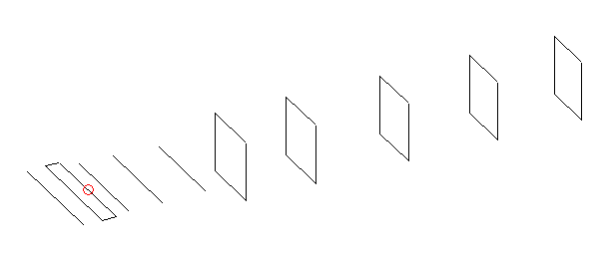
DESCRIPTION
Radiator |  |  |  | Number of  yagi elements |  |  |  |  | Number of  oblong elements |  |  |  | Total number  of elements |  |  |  |  |  |  | Boomlength  (mm)
LFA |  |  |  | 4 |  |  |  |  | 5 |  |  |  | 10 |  |  |  |  |  |  | 1475
DIMENSIONS
 | Ref |  | De1 |  |  | De2 | D1 |  |  | D2 |  | D3 |  |  | DQ1 |  | DQ2 |  | DQ3 |  |  | DQ4 |  | DQ5
Position | 0 |  | 54 |  |  | 95 | 138 |  |  | 236 |  | 364 |  |  | 506 |  | 708 |  | 976 |  |  | 1234 |  | 1475
Length | 331 |  | 330 |  |  | 330 | 292 |  |  | 291 |  | 274.5 |  |  | 181 |  | 171 |  | 165 |  |  | 161 |  | 157
Remark | All elements made of Al tubes Ǿ10 mm  The height of rectangles is 170 mm  All dimensions given in milimetres
PERFORMANCES (No loss condition)
G  (dBi) |  | F/B  (dB) |  |  | F/Sh  (dBi) |  |  | F/Sv  (dBi) |  |  | Hor  (◦) |  |  |  |  | Ver  (◦) |  | Temp  (◦K) |  |  |  |  | G/T  (dB)
14.35 |  | 21.09 |  |  | 22.09 |  |  | 15.35 |  |  | 37.6 |  |  |  |  | 39.6 |  | 35.5 |  |  |  |  | -0.77
DIAGRAMS
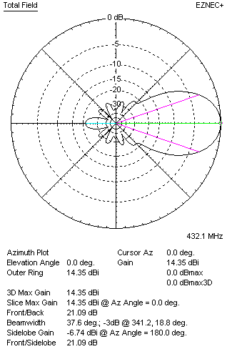 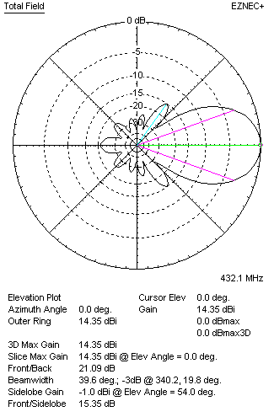Horizontal and verticall pattern in free space, no loss condition
PERFORMANCES (Loss included for aluminum)
Aluminum |  |  |  |  | G  (dBi) |  |  | Tloss  (K) |  |  | T_{A}  (◦K) |  |  |  |  | G/T  (dB) |  | Bandwidth for SWR=1.5  (MHz)
After NEC/EZNEC |  |  |  |  | 13.56 |  |  | 1.4 |  |  | 35.5 |  |  |  |  | -0.99 |  | 423.000 – 443.000
After KF2YN correction |  |  |  |  | 13.50 |  |  | 1.4 |  |  | 36.8 |  |  |  |  | -1.43
Remark: Red coloured data are the final antenna data, which means: KF2YN correction formula applied and loss for aluminum included
DIAGRAMS
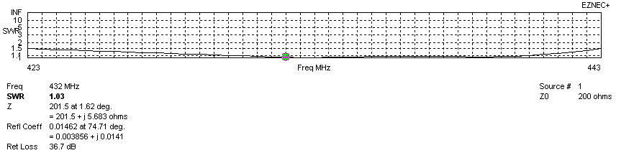
Frequency diagram for SWR better than 1.5
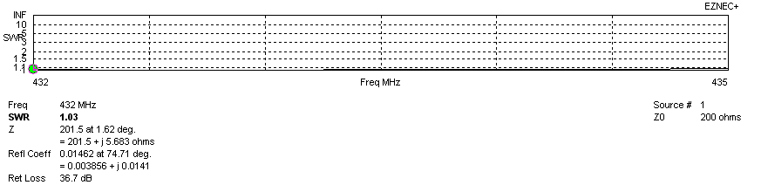
SWR diagram for the range from 432.000 – 435.000 MHz
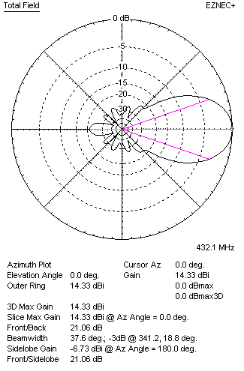 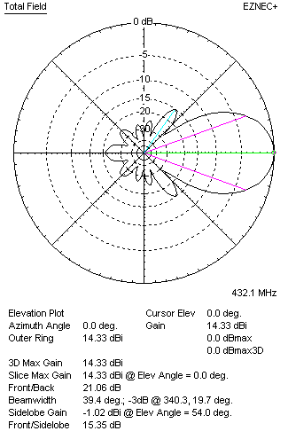Horizontal and vertical pattern in free space, loss included for aluminum
STACKING
(ALL DATA GIVEN IN ACCORDANCE WITH KF2YN CORRECTION, LOSS INCLUDED)
RECOMMENDED STACKING DISTANCES
 |  |  |  |  | Two antennas vertically  (mm) |  |  |  |  |  | Two antennas horizontally  (mm) |  |  |  |  |  |  | Four antennas in H-stack  (mm)
Horizontal distance |  |  |  |  |  |  |  |  |  |  | 1240 |  |  |  |  |  |  | 1240
Vertical distance |  |  |  |  | 1020 |  |  |  |  |  |  |  |  |  |  |  |  | 1020
TWO ANTENNAS STACKED VERTICALLY
DISTANCE  (mm) |  |  |  | G  (dBi) |  |  |  |  | TA  (K) |  |  |  | Tloss  (K) |  |  |  |  |  |  | G/T  (dB)
1020 |  |  |  | 17.19 |  |  |  |  | 36.1 |  |  |  | 1.4 |  |  |  |  |  |  | +1.62
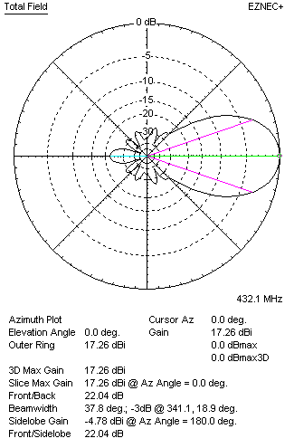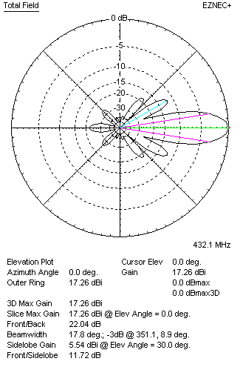
Two antennas stacked vertically
TWO ANTENNAS STACKED HORIZONTALLY
DISTANCE  (mm) |  |  |  | G  (dBi) |  |  |  |  | TA  (K) |  |  |  |  | Tloss  (K) |  |  |  |  |  |  | G/T  (dB)
1240 |  |  |  | 17.33 |  |  |  |  | 36.6 |  |  |  |  | 1.4 |  |  |  |  |  |  | +1.70
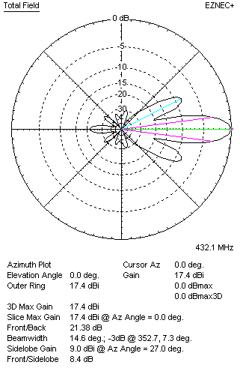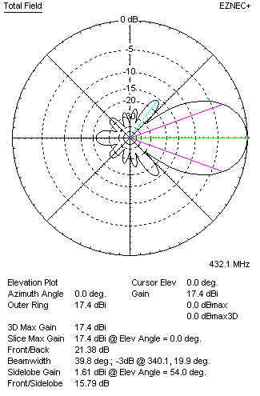
Two antennas stacked horizontally
FOUR ANTENNAS IN H-STACK
DISTANCE  (mm) |  |  |  | G  (dBi) |  |  |  |  | TA  (K) |  |  |  |  | Tloss  (K) |  |  |  |  |  |  | G/T  (dB)
H = 1240 |  |  |  | 20.26 |  |  |  |  | 37.0 |  |  |  |  | 1.4 |  |  |  |  |  |  | +4.58
V = 1020
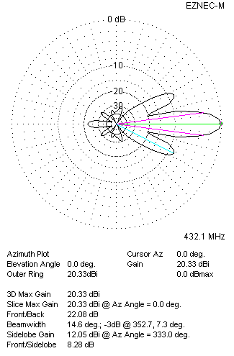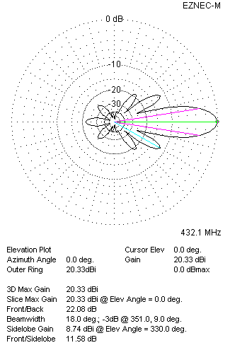
Four antennas in H-stack

