ANTENNA QY71008XL6D4
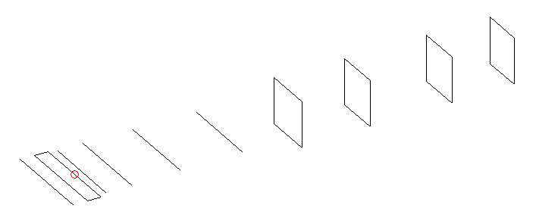
DESCRIPTION
Radiator |  |  |  | Number of  yagi elements |  |  |  |  | Number of  oblong elements |  |  |  | Total number  of elements |  |  |  |  |  | Boomlength  (mm)
LFA |  |  |  | 5 |  |  |  |  | 4 |  |  |  | 10 |  |  |  |  |  | 1665
DIMENSIONS
 | Ref |  | De1 |  |  | De2 | D1 |  |  | D2 |  | D3 |  |  |  | D4 | DQ1 |  |  | DQ2 |  |  | DQ3 | DQ4
Position | 0 |  | 50 |  |  | 105 | 138 |  |  | 226 |  | 403 |  |  |  | 639 | 878 |  |  | 1143 |  |  | 1418 | 1665
Length | 332 |  | 338 |  |  | 338 | 302 |  |  | 305 |  | 291 |  |  |  | 281 | 173 |  |  | 161 |  |  | 153 | 149
Remark | All elements made of Al tubes Ǿ8 mm  The height of rectangles is 170 mm  All dimensions given in milimetres
PERFORMANCES (No loss condition)
G  (dBi) |  | F/B  (dB) |  |  | F/Sh  (dBi) |  |  | F/Sv  (dBi) |  |  | Hor  (◦) |  |  |  | Ver  (◦) |  |  | Temp  (◦K) |  |  |  | G/T  (dB)
14.50 |  | 33.59 |  |  | 22.36 |  |  | 19.41 |  |  | 37.2 |  |  |  | 40.2 |  |  | 30.6 |  |  |  | +0.14
DIAGRAMS
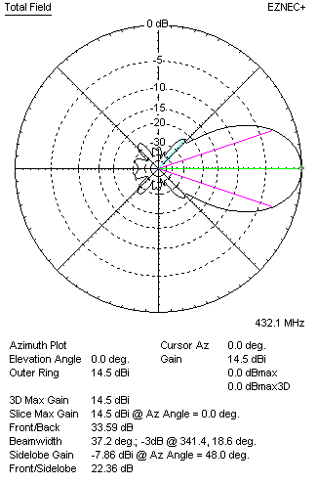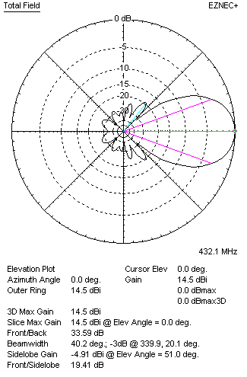
Horizontal and verticall pattern in free space, no loss condition
PERFORMANCES (Loss included for aluminum)
Aluminum |  |  |  |  | G  (dBi) |  |  | Tloss  (K) |  |  | T_{A}  (◦K) |  |  |  | G/T  (dB) |  |  | Bandwidth for SWR=1.5  (MHz)
After NEC/EZNEC |  |  |  |  | 14.47 |  |  | 2.6 |  |  | 30.7 |  |  |  | -0.25 |  |  | 418.000 – 440.500
After KF2YN correction |  |  |  |  | 14.41 |  |  | 2.6 |  |  | 32.9 |  |  |  | -0.77
Remark: Red coloured data are the final antenna data, which means: KF2YN correction formula applied and loss for aluminum included
DIAGRAMS
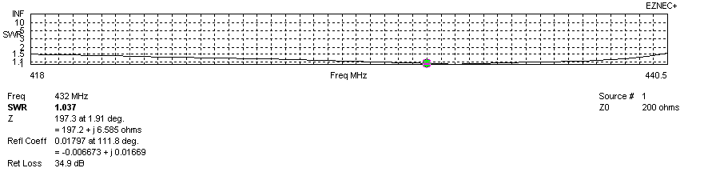
Frequency diagram for SWR better than 1.5
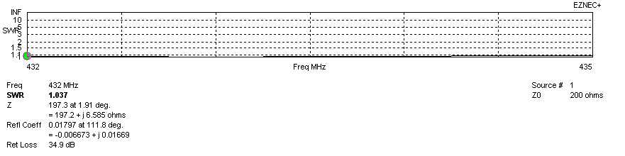
SWR diagram for the range from 432.000 – 435.000 MHz
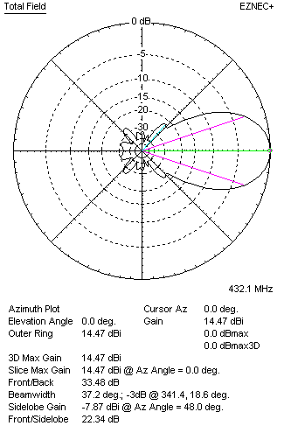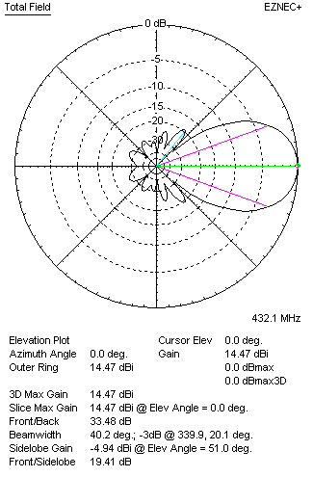
Horizontal and vertical pattern in free space, loss included for aluminum
STACKING
(ALL DATA GIVEN IN ACCORDANCE WITH KF2YN CORRECTION, LOSS INCLUDED)
RECOMMENDED STACKING DISTANCES
 |  |  |  |  | Two antennas vertically  (mm) |  |  |  |  |  | Two antennas horizontally  (mm) |  |  |  |  |  |  | Four antennas in H-stack  (mm)
Horizontal distance |  |  |  |  |  |  |  |  |  |  | 1380 |  |  |  |  |  |  | 1380
Vertical distance |  |  |  |  | 980 |  |  |  |  |  |  |  |  |  |  |  |  | 980
TWO ANTENNAS STACKED VERTICALLY
DISTANCE  (mm) |  |  |  | G  (dBi) |  |  |  |  | TA  (K) |  |  |  | Tloss  (K) |  |  |  |  |  | G/T  (dB)
980 |  |  |  | 17.28 |  |  |  |  | 32.0 |  |  |  | 2.6 |  |  |  |  |  | +2.22
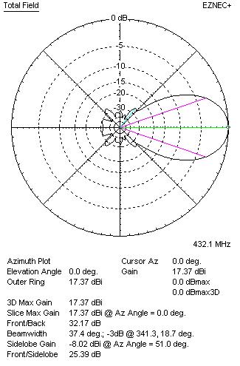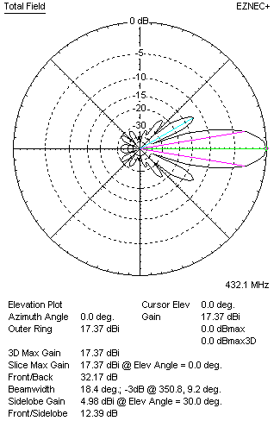
Two antennas stacked vertically
TWO ANTENNAS STACKED HORIZONTALLY
DISTANCE  (mm) |  |  |  | G  (dBi) |  |  |  |  | TA  (K) |  |  |  |  | Tloss  (K) |  |  |  |  |  |  | G/T  (dB)
1380 |  |  |  | 17.48 |  |  |  |  | 32.9 |  |  |  |  | 2.6 |  |  |  |  |  |  | +2.30
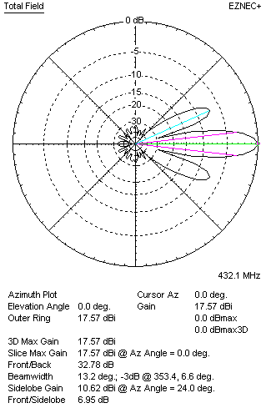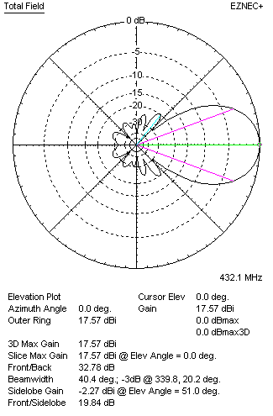
Two antennas stacked horizontally
FOUR ANTENNAS IN H-STACK
DISTANCE  (mm) |  |  |  | G  (dBi) |  |  |  |  | TA  (K) |  |  |  |  | Tloss  (K) |  |  |  |  |  |  | G/T  (dB)
H = 1380 |  |  |  | 20.35 |  |  |  |  | 32.2 |  |  |  |  | 2.6 |  |  |  |  |  |  | +5.27
V = 980
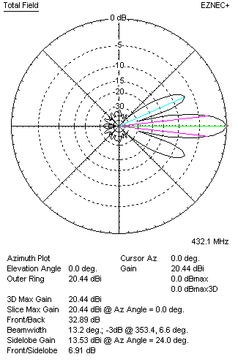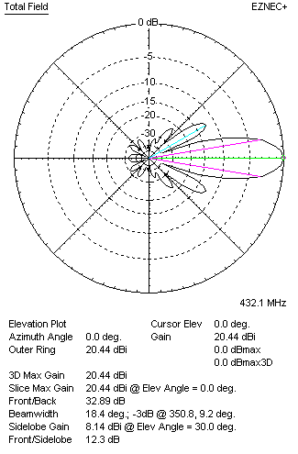
Four antennas in H-stack

