ANTENNA QY71006XL1D4
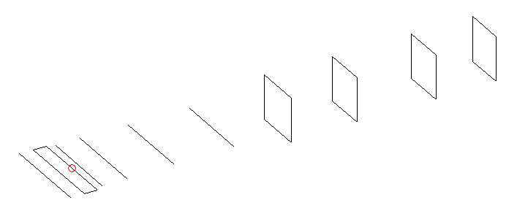
DESCRIPTION
Radiator |  |  |  | Number of  yagi elements |  |  |  |  | Number of  oblong elements |  |  |  | Total number  of elements |  |  |  |  |  | Boomlength  (mm)
LFA |  |  |  | 5 |  |  |  |  | 4 |  |  |  | 10 |  |  |  |  |  | 1665
DIMENSIONS
 | Ref |  | De1 |  |  | De2 | D1 |  |  | D2 |  | D3 |  |  |  | D4 | DQ1 |  |  | DQ2 |  |  | DQ3 | DQ4
Position | 0 |  | 50 |  |  | 100 | 129 |  |  | 220 |  | 402 |  |  |  | 632 | 882 |  |  | 1139 |  |  | 1435 | 1665
Length | 338 |  | 335 |  |  | 335 | 308 |  |  | 309.5 |  | 298.5 |  |  |  | 288.5 | 173 |  |  | 163 |  |  | 161 | 153
Remark | All elements made of Al tubes Ǿ6 mm  The height of rectangles is 170 mm  All dimensions given in milimetres
PERFORMANCES (No loss condition)
G  (dBi) |  | F/B  (dB) |  |  | F/Sh  (dBi) |  |  | F/Sv  (dBi) |  |  | Hor  (◦) |  |  |  | Ver  (◦) |  |  | Temp  (◦K) |  |  |  | G/T  (dB)
14.63 |  | 29.05 |  |  | 22.75 |  |  | 19.81 |  |  | 36.6 |  |  |  | 39.2 |  |  | 30.4 |  |  |  | +0.32
DIAGRAMS
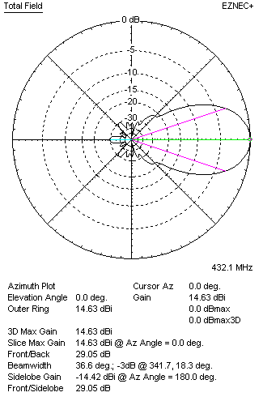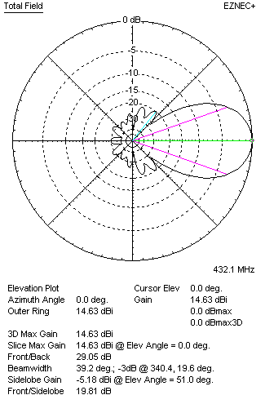
Horizontal and verticall pattern in free space, no loss condition
PERFORMANCES (Loss included for aluminum)
Aluminum |  |  |  |  | G  (dBi) |  |  | Tloss  (K) |  |  | T_{A}  (◦K) |  |  |  | G/T  (dB) |  |  | Bandwidth for SWR=1.5  (MHz)
After NEC/EZNEC |  |  |  |  | 14.57 |  |  | 4.0 |  |  | 30.4 |  |  |  | -0.29 |  |  | 424.000 – 438.000
After KF2YN correction |  |  |  |  | 14.51 |  |  | 4.0 |  |  | 34.0 |  |  |  | -0.80
Remark: Red coloured data are the final antenna data, which means: KF2YN correction formula applied and loss for aluminum included
DIAGRAMS
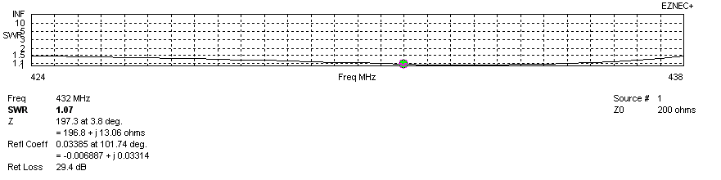
Frequency diagram for SWR better than 1.5
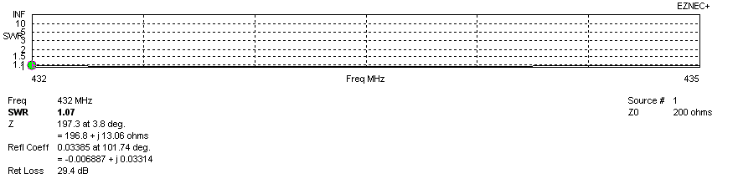
SWR diagram for the range from 432.000 – 435.000 MHz
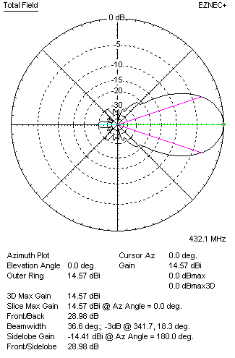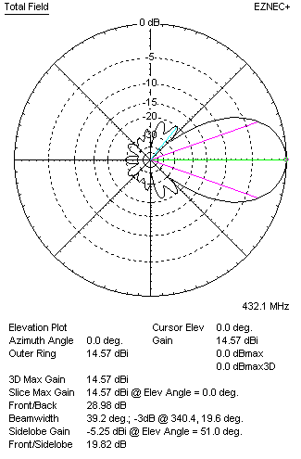
Horizontal and vertical pattern in free space, loss included for aluminum
STACKING
(ALL DATA GIVEN IN ACCORDANCE WITH KF2YN CORRECTION, LOSS INCLUDED)
RECOMMENDED STACKING DISTANCES
 |  |  |  |  | Two antennas vertically  (mm) |  |  |  |  |  | Two antennas horizontally  (mm) |  |  |  |  |  |  | Four antennas in H-stack  (mm)
Horizontal distance |  |  |  |  |  |  |  |  |  |  | 1320 |  |  |  |  |  |  | 1320
Vertical distance |  |  |  |  | 980 |  |  |  |  |  |  |  |  |  |  |  |  | 980
TWO ANTENNAS STACKED VERTICALLY
DISTANCE  (mm) |  |  |  | G  (dBi) |  |  |  |  | TA  (K) |  |  |  | Tloss  (K) |  |  |  |  |  | G/T  (dB)
980 |  |  |  | 17.35 |  |  |  |  | 32.7 |  |  |  | 4.0 |  |  |  |  |  | +2.21
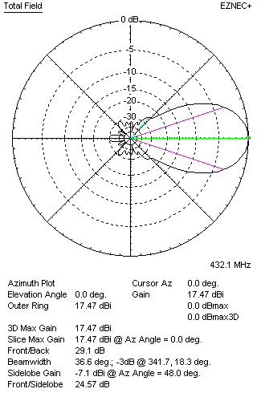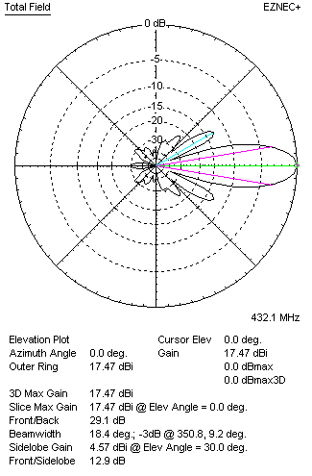
Two antennas stacked vertically
TWO ANTENNAS STACKED HORIZONTALLY
DISTANCE  (mm) |  |  |  | G  (dBi) |  |  |  |  | TA  (K) |  |  |  |  | Tloss  (K) |  |  |  |  |  |  | G/T  (dB)
1320 |  |  |  | 17.55 |  |  |  |  | 34.1 |  |  |  |  | 4.0 |  |  |  |  |  |  | +2.23
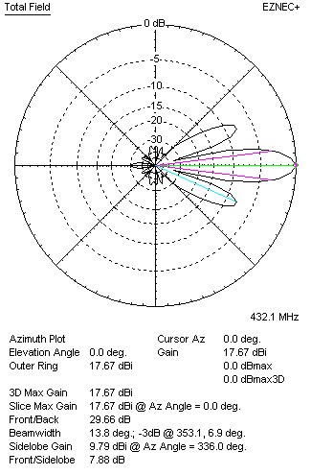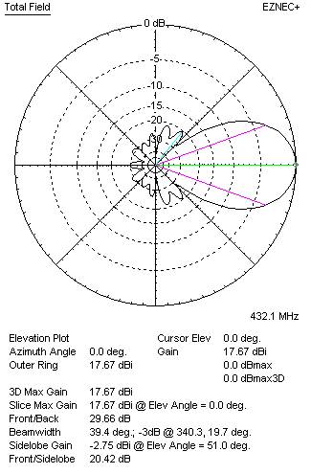
Two antennas stacked horizontally
FOUR ANTENNAS IN H-STACK
DISTANCE  (mm) |  |  |  | G  (dBi) |  |  |  |  | TA  (K) |  |  |  |  | Tloss  (K) |  |  |  |  |  |  | G/T  (dB)
H = 1320 |  |  |  | 20.42 |  |  |  |  | 33.3 |  |  |  |  | 4.0 |  |  |  |  |  |  | +5.20
V = 980
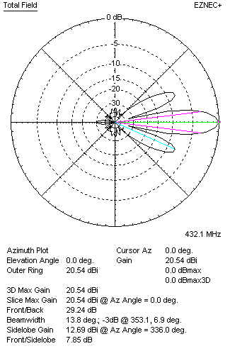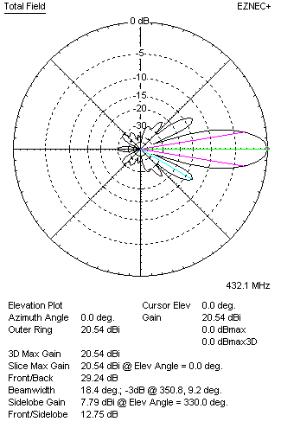
Four antennas in H-stack

