ANTENNA QY70908XL4D2
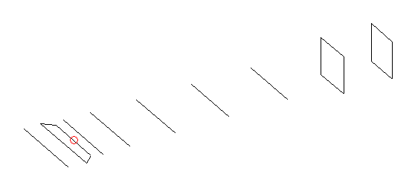
DESCRIPTION
Radiator |  |  | Number of  yagi elements |  |  |  |  | Number of  oblong elements |  |  |  | Total number  of elements |  |  |  |  |  | Boomlength  (mm)
LFA |  |  | 6 |  |  |  |  | 2 |  |  |  | 9 |  |  |  |  |  | 1475
DIMENSIONS
 | 0 |  | 50 |  | 110 |  | 155 |  | 274 |  | 474 |  |  |  | 719 | 978 |  |  |  | 1246 |  | 1475
Position | 331 |  | 330 |  | 330 |  | 303 |  | 301 |  | 290 |  |  |  | 283 | 274.5 |  |  |  | 171 |  | 157
Length | 0 |  | 50 |  | 110 |  | 154 |  | 277 |  | 481 |  |  |  | 719 | 981 |  |  |  | 1249 |  | 1475
Remark | All elements made of Al tubes Ǿ8 mm  The height of rectangles is 165 mm  All dimensions given in milimetres
PERFORMANCES (No loss condition)
G  (dBi) |  | F/B  (dB) |  | F/Sh  (dBi) |  | F/Sv  (dBi) |  |  |  | Hor  (◦) |  |  |  | Ver  (◦) |  |  | Temp  (◦K) |  |  |  | G/T  (dB)
14.25 |  | 23.20 |  | 20.29 |  | 17.42 |  |  |  | 37.2 |  |  |  | 41.0 |  |  | 35.0 |  |  |  | -0.88
DIAGRAMS
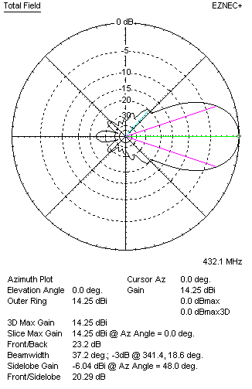 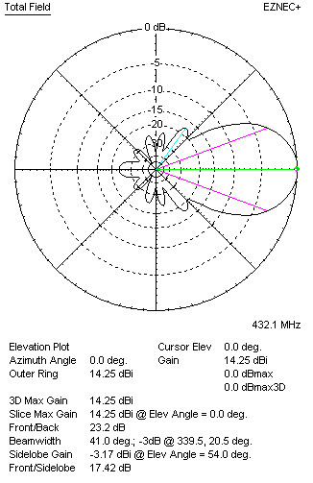Horizontal and verticall pattern in free space, no loss condition
PERFORMANCES (Loss included for aluminum)
Aluminum |  |  |  | G  (dBi) |  | Tloss  (K) |  |  |  | T_{A}  (◦K) |  |  |  | G/T  (dB) |  |  | Bandwidth for SWR=1.5  (MHz)
After NEC/EZNEC |  |  |  | 14.21 |  | 2.6 |  |  |  | 35.0 |  |  |  | -1.23 |  |  | 421.500 – 438.000
After KF2YN correction |  |  |  | 14.21 |  | 2.6 |  |  |  | 37.3 |  |  |  | -1.50
Remark: Red coloured data are the final antenna data, which means: KF2YN correction formula applied and loss for aluminum included
DIAGRAMS
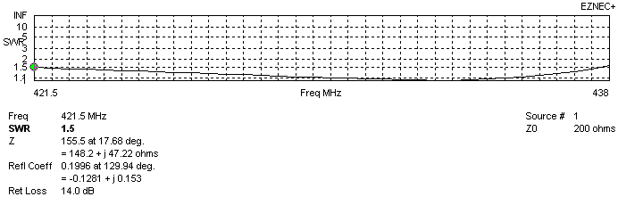
Frequency diagram for SWR better than 1.5
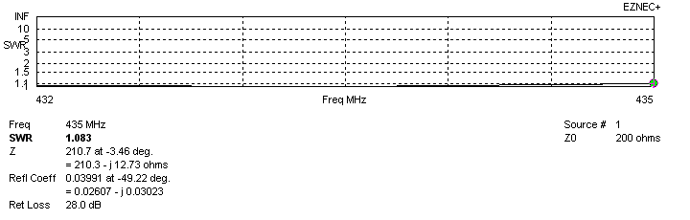
SWR diagram for the range from 432.000 – 435.000 MHz
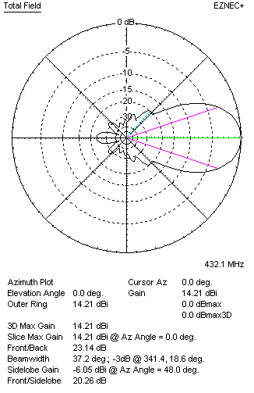 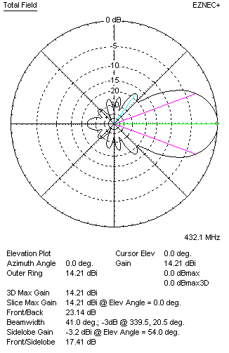Horizontal and vertical pattern in free space, loss included for aluminum
STACKING
(ALL DATA GIVEN IN ACCORDANCE WITH KF2YN CORRECTION, LOSS INCLUDED)
RECOMMENDED STACKING DISTANCES
 |  |  |  | Two antennas vertically  (mm) |  |  |  |  |  | Two antennas horizontally  (mm) |  |  |  |  |  |  | Four antennas in H-stack  (mm)
Horizontal distance |  |  |  |  |  |  |  |  |  | 1280 |  |  |  |  |  |  | 1280
Vertical distance |  |  |  | 940 |  |  |  |  |  |  |  |  |  |  |  |  | 940
TWO ANTENNAS STACKED VERTICALLY
DISTANCE  (mm) |  |  | G  (dBi) |  |  |  |  | TA  (K) |  |  |  | Tloss  (K) |  |  |  |  |  | G/T  (dB)
940 |  |  | 17.04 |  |  |  |  | 34.9 |  |  |  | 2.6 |  |  |  |  |  | +1.61
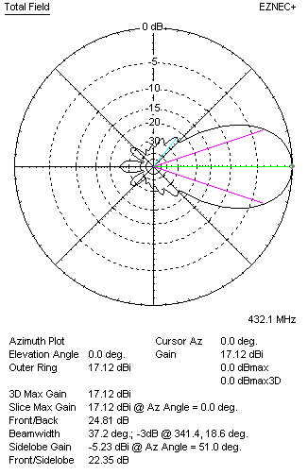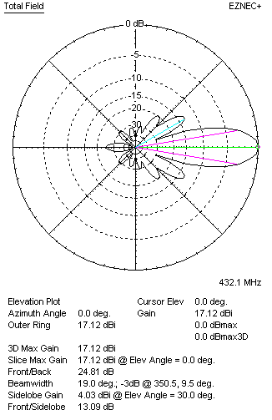
Two antennas stacked vertically
TWO ANTENNAS STACKED HORIZONTALLY
DISTANCE  (mm) |  |  | G  (dBi) |  |  |  |  | TA  (K) |  |  |  |  | Tloss  (K) |  |  |  |  |  | G/T  (dB)
1280 |  |  | 17.22 |  |  |  |  | 37.8 |  |  |  |  | 2.6 |  |  |  |  |  | +1.45
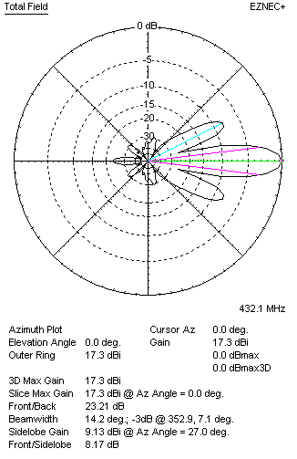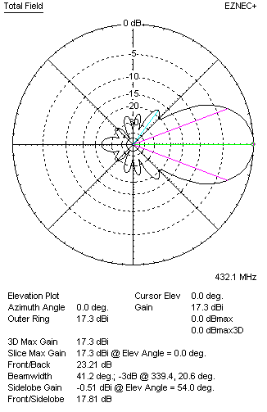
Two antennas stacked horizontally
FOUR ANTENNAS IN H-STACK
DISTANCE  (mm) |  |  | G  (dBi) |  |  |  |  | TA  (K) |  |  |  |  | Tloss  (K) |  |  |  |  |  | G/T  (dB)
H = 1280 |  |  | 20.11 |  |  |  |  | 36.1 |  |  |  |  | 2.6 |  |  |  |  |  | +3.54
V = 940
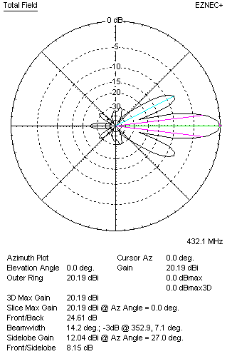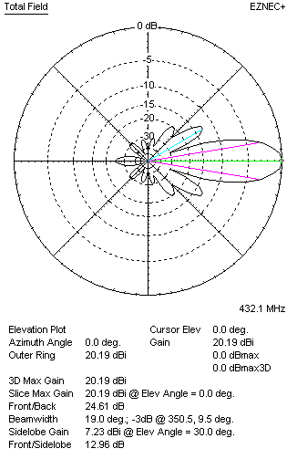
Four antennas in H-stack

