ANTENNA QY70905XL6D2
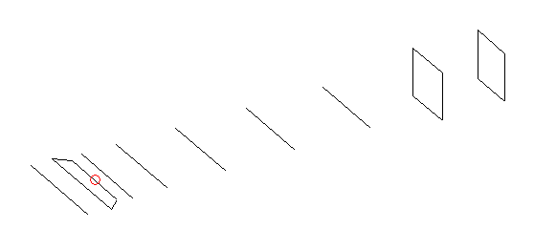
DESCRIPTION
Radiator |  |  | Number of  yagi elements |  |  |  |  | Number of  oblong elements |  |  |  | Total number  of elements |  |  |  |  |  | Boomlength  (mm)
LFA |  |  | 6 |  |  |  |  | 2 |  |  |  | 9 |  |  |  |  |  | 1475
DIMENSIONS
 | 0 |  | 75 |  | 120 |  | 163 |  | 282 |  | 483 |  |  |  | 723 | 982 |  |  |  | 1258 |  | 1475
Position | 336 |  | 350 |  | 264 |  | 306 |  | 306 |  | 296 |  |  |  | 290 | 279.5 |  |  |  | 171 |  | 159
Length | 0 |  | 75 |  | 120 |  | 163 |  | 282 |  | 483 |  |  |  | 723 | 982 |  |  |  | 1258 |  | 1475
Remark | All elements made of Al tubes Ǿ5 mm  The height of rectangles is 165 mm  All dimensions given in milimetres
PERFORMANCES (No loss condition)
G  (dBi) |  | F/B  (dB) |  | F/Sh  (dBi) |  | F/Sv  (dBi) |  |  |  | Hor  (◦) |  |  |  | Ver  (◦) |  |  | Temp  (◦K) |  |  |  | G/T  (dB)
14.19 |  | 25.21 |  | 20.91 |  | 17.75 |  |  |  | 37.8 |  |  |  | 42.0 |  |  | 34.1 |  |  |  | -0.79
DIAGRAMS
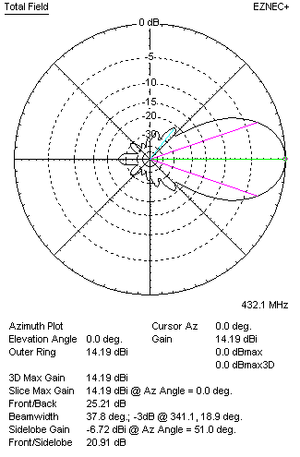 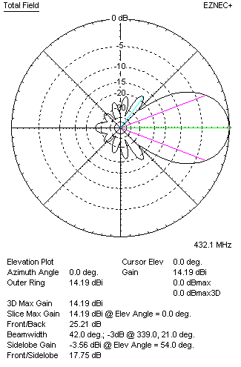Horizontal and verticall pattern in free space, no loss condition
PERFORMANCES (Loss included for aluminum)
Aluminum |  |  |  | G  (dBi) |  | Tloss  (K) |  |  |  | T_{A}  (◦K) |  |  |  | G/T  (dB) |  |  | Bandwidth for SWR=1.5  (MHz)
After NEC/EZNEC |  |  |  | 14.14 |  | 3.2 |  |  |  | 34.1 |  |  |  | -1.24 |  |  | 417.100 – 439.100
After KF2YN correction |  |  |  | 14.10 |  | 3.2 |  |  |  | 36.9 |  |  |  | -1.57
Remark: Red coloured data are the final antenna data, which means: KF2YN correction formula applied and loss for aluminum included
DIAGRAMS
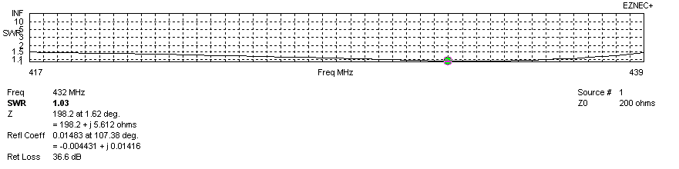
Frequency diagram for SWR better than 1.5
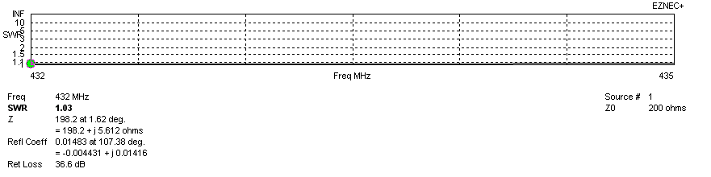
SWR diagram for the range from 432.000 – 435.000 MHz
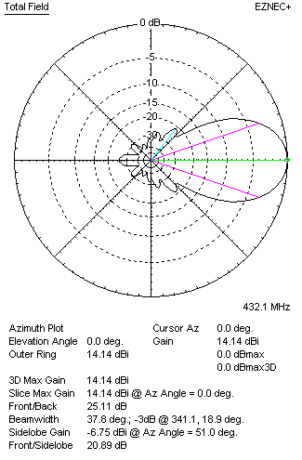 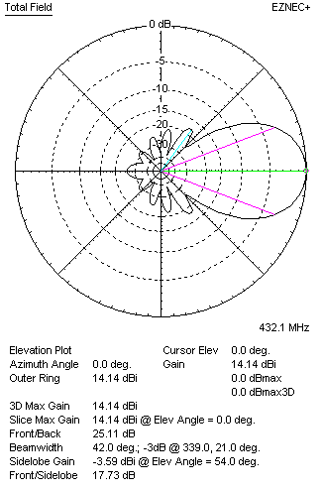Horizontal and vertical pattern in free space, loss included for aluminum
STACKING
(ALL DATA GIVEN IN ACCORDANCE WITH KF2YN CORRECTION, LOSS INCLUDED)
RECOMMENDED STACKING DISTANCES
 |  |  |  | Two antennas vertically  (mm) |  |  |  |  |  | Two antennas horizontally  (mm) |  |  |  |  |  |  | Four antennas in H-stack  (mm)
Horizontal distance |  |  |  |  |  |  |  |  |  | 1320 |  |  |  |  |  |  | 1320
Vertical distance |  |  |  | 960 |  |  |  |  |  |  |  |  |  |  |  |  | 960
TWO ANTENNAS STACKED VERTICALLY
DISTANCE  (mm) |  |  | G  (dBi) |  |  |  |  | TA  (K) |  |  |  | Tloss  (K) |  |  |  |  |  | G/T  (dB)
960 |  |  | 17.01 |  |  |  |  | 35.0 |  |  |  | 3.2 |  |  |  |  |  | +1.57
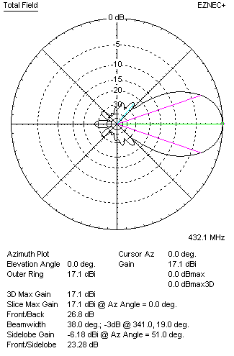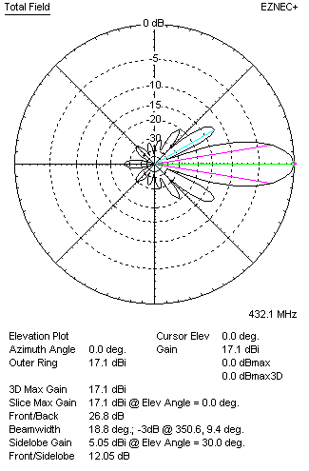
Two antennas stacked vertically
TWO ANTENNAS STACKED HORIZONTALLY
DISTANCE  (mm) |  |  | G  (dBi) |  |  |  |  | TA  (K) |  |  |  |  | Tloss  (K) |  |  |  |  |  | G/T  (dB)
1320 |  |  | 17.16 |  |  |  |  | 37.5 |  |  |  |  | 3.2 |  |  |  |  |  | +1.42
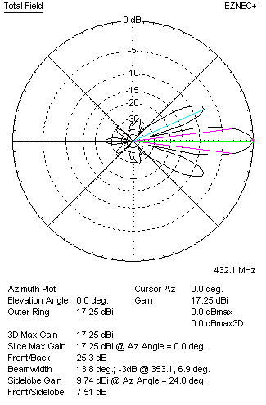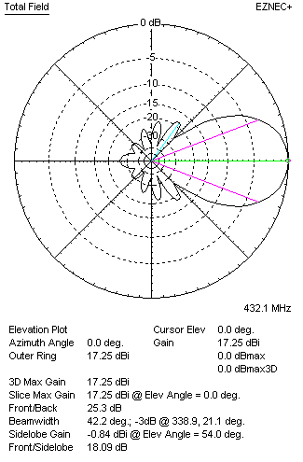
Two antennas stacked horizontally
FOUR ANTENNAS IN H-STACK
DISTANCE  (mm) |  |  | G  (dBi) |  |  |  |  | TA  (K) |  |  |  |  | Tloss  (K) |  |  |  |  |  | G/T  (dB)
H = 1320 |  |  | 20.08 |  |  |  |  | 36.2 |  |  |  |  | 3.2 |  |  |  |  |  | +4.49
V = 960
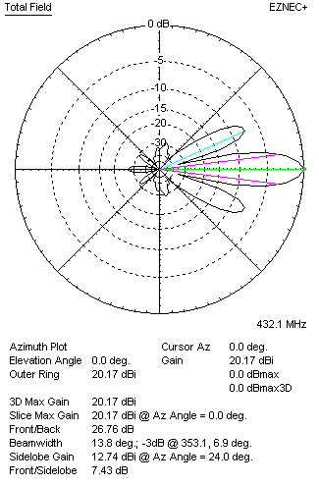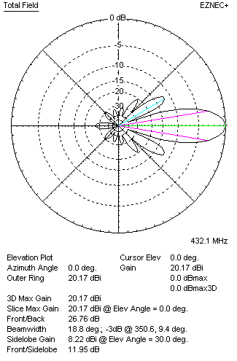
Four antennas in H-stack

