ANTENNA QY70810XL6D3
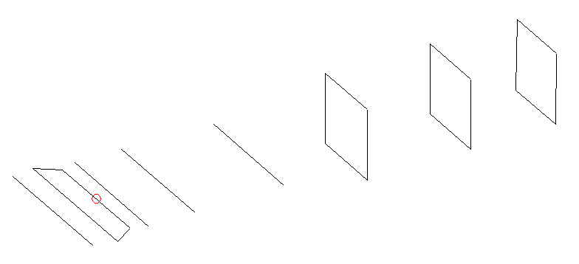
DESCRIPTION
Radiator |  |  | Number of  yagi elements |  |  |  |  | Number of  oblong elements |  |  |  | Total number  of elements |  |  |  |  |  | Boomlength  (mm)
LFA |  |  | 4 |  |  |  |  | 3 |  |  |  | 8 |  |  |  |  |  | 1165
DIMENSIONS
 | Ref |  |  | De1 |  | De2 |  |  | D1 |  | D2 |  |  | D3 |  | DQ1 |  |  | DQ2 |  | DQ3
Position | 0 |  |  | 45 |  | 96 |  |  | 140 |  | 247 |  |  | 459 |  | 704 |  |  | 953 |  | 1165
Length | 335 |  |  | 348 |  | 290 |  |  | 296 |  | 298 |  |  | 279.5 |  | 175 |  |  | 169 |  | 166
Remark | All elements made of Al tubes Ǿ10 mm  The height of rectangles is 170 mm  All dimensions given in milimetres
PERFORMANCES (No loss condition)
G  (dBi) |  | F/B  (dB) |  |  | F/Sh  (dBi) |  | F/Sv  (dBi) |  |  | Hor  (◦) |  |  |  |  | Ver  (◦) |  | Temp  (◦K) |  |  | G/T  (dB)
13.67 |  | 21.23 |  |  | 19.34 |  | 16.02 |  |  | 39.4 |  |  |  |  | 43.2 |  | 40.4 |  |  | -1.99
DIAGRAMS
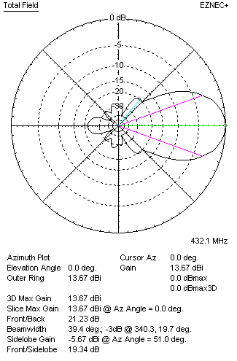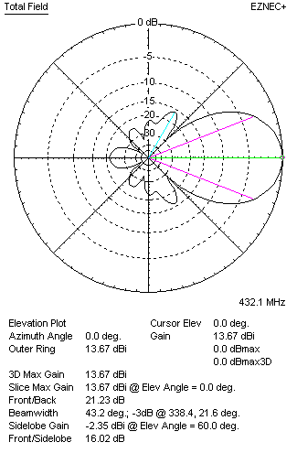
Horizontal and verticall pattern in free space, no loss condition
PERFORMANCES (Loss included for aluminum)
Aluminum |  |  |  |  | G  (dBi) |  | Tloss  (K) |  |  | T_{A}  (◦K) |  |  |  |  | G/T  (dB) |  | Bandwidth for SWR=1.5  (MHz)
After NEC/EZNEC |  |  |  |  | 13.64 |  | 2.0 |  |  | 40.5 |  |  |  |  | -2.28 |  | 423.500 – 438.500
After KF2YN correction |  |  |  |  | 13.59 |  | 2.0 |  |  | 42.2 |  |  |  |  | -2.67
Remark: Red coloured data are the final antenna data, which means: KF2YN correction formula applied and loss for aluminum included
DIAGRAMS
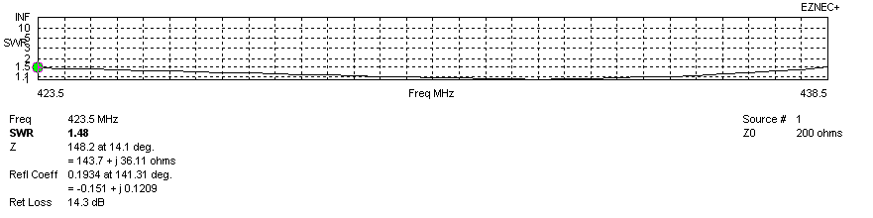
Frequency diagram for SWR better than 1.5
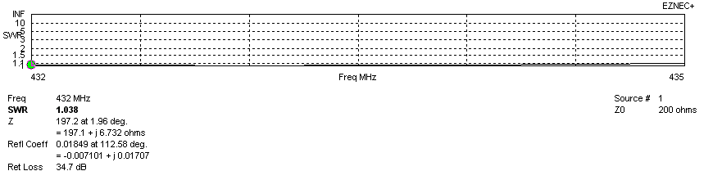
SWR diagram for the range from 432.000 – 435.000 MHz
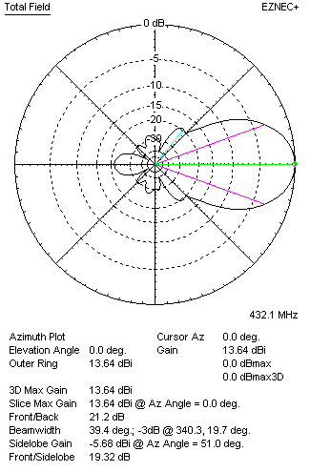 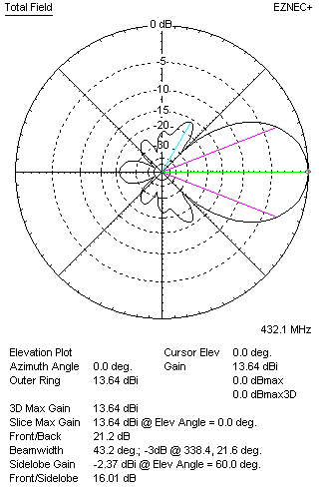Horizontal and vertical pattern in free space, loss included for aluminum
STACKING
(ALL DATA GIVEN IN ACCORDANCE WITH KF2YN CORRECTION, LOSS INCLUDED)
RECOMMENDED STACKING DISTANCES
 |  |  |  |  | Two antennas vertically  (mm) |  |  |  |  | Two antennas horizontally  (mm) |  |  |  |  |  |  | Four antennas in H-stack  (mm)
Horizontal distance |  |  |  |  |  |  |  |  |  | 1200 |  |  |  |  |  |  | 1200
Vertical distance |  |  |  |  | 880 |  |  |  |  |  |  |  |  |  |  |  | 880
TWO ANTENNAS STACKED VERTICALLY
DISTANCE  (mm) |  |  | G  (dBi) |  |  |  |  | TA  (K) |  |  |  | Tloss  (K) |  |  |  |  |  | G/T  (dB)
880 |  |  | 16.40 |  |  |  |  | 38.9 |  |  |  | 2.0 |  |  |  |  |  | +0.50
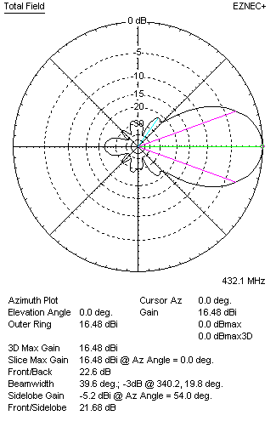 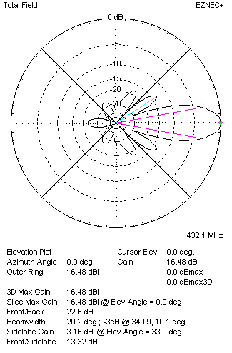Two antennas stacked vertically
TWO ANTENNAS STACKED HORIZONTALLY
DISTANCE  (mm) |  |  | G  (dBi) |  |  |  |  | TA  (K) |  |  |  |  | Tloss  (K) |  |  |  |  |  | G/T  (dB)
1200 |  |  | 16.65 |  |  |  |  | 42.2 |  |  |  |  | 2.0 |  |  |  |  |  | +0.39
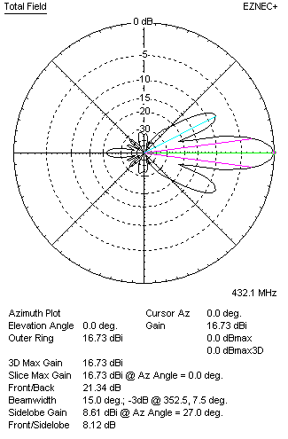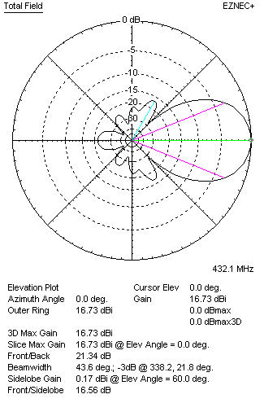
Two antennas stacked horizontally
FOUR ANTENNAS IN H-STACK
DISTANCE  (mm) |  |  | G  (dBi) |  |  |  |  | TA  (K) |  |  |  |  | Tloss  (K) |  |  |  |  |  | G/T  (dB)
H = 1200 |  |  | 19.48 |  |  |  |  | 39.6 |  |  |  |  | 2.0 |  |  |  |  |  | +3.50
V = 880
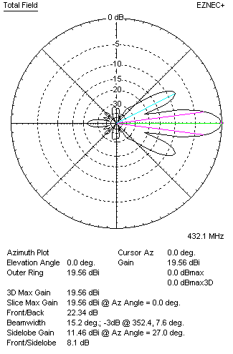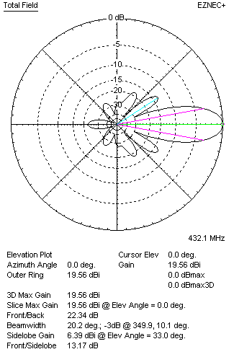
Four antennas in H-stack

