ANTENNA QY70808XL6D3
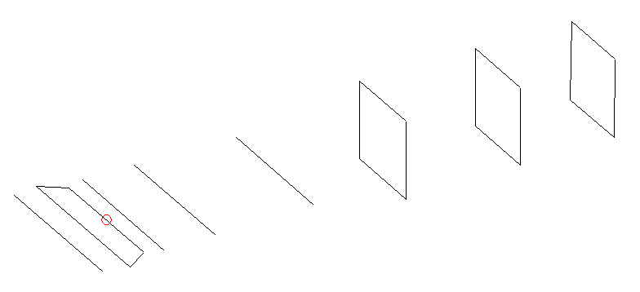
DESCRIPTION
Radiator |  |  | Number of  yagi elements |  |  |  |  | Number of  oblong elements |  |  |  | Total number  of elements |  |  |  |  |  | Boomlength  (mm)
LFA |  |  | 4 |  |  |  |  | 3 |  |  |  | 8 |  |  |  |  |  | 1165
DIMENSIONS
 | Ref |  |  | De1 |  | De2 |  |  | D1 |  | D2 |  |  | D3 |  | DQ1 |  |  | DQ2 |  | DQ3
Position | 0 |  |  | 50 |  | 100 |  |  | 141 |  | 254 |  |  | 472 |  | 708 |  |  | 952 |  | 1165
Length | 335 |  |  | 348 |  | 282 |  |  | 299 |  | 300 |  |  | 285 |  | 177 |  |  | 171 |  | 165
Remark | All elements made of Al tubes Ǿ8 mm  The height of rectangles is 170 mm  All dimensions given in milimetres
PERFORMANCES (No loss condition)
G  (dBi) |  | F/B  (dB) |  |  | F/Sh  (dBi) |  | F/Sv  (dBi) |  |  | Hor  (◦) |  |  |  |  | Ver  (◦) |  | Temp  (◦K) |  |  | G/T  (dB)
13.69 |  | 21.98 |  |  | 18.31 |  | 15.63 |  |  | 39.2 |  |  |  |  | 43.0 |  | 40.4 |  |  | -1.99
DIAGRAMS
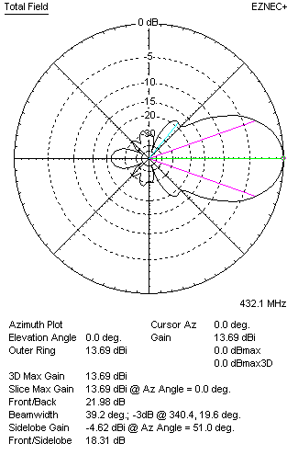 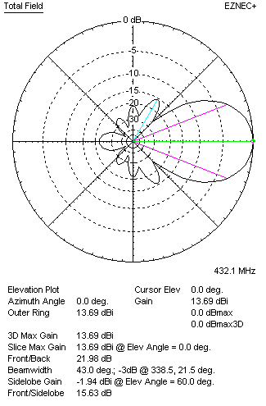Horizontal and verticall pattern in free space, no loss condition
PERFORMANCES (Loss included for aluminum)
Aluminum |  |  |  |  | G  (dBi) |  | Tloss  (K) |  |  | T_{A}  (◦K) |  |  |  |  | G/T  (dB) |  | Bandwidth for SWR=1.5  (MHz)
After NEC/EZNEC |  |  |  |  | 13.66 |  | 2.3 |  |  | 40.4 |  |  |  |  | -2.26 |  | 422.00 – 438.500
After KF2YN correction |  |  |  |  | 13.60 |  | 2.3 |  |  | 42.4 |  |  |  |  | -2.68
Remark: Red coloured data are the final antenna data, which means: KF2YN correction formula applied and loss for aluminum included
DIAGRAMS
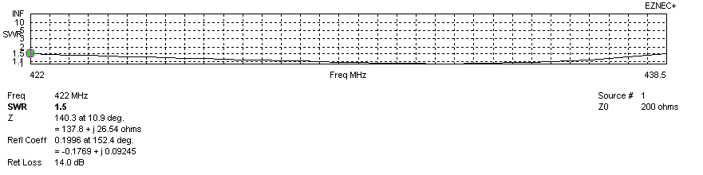
Frequency diagram for SWR better than 1.5
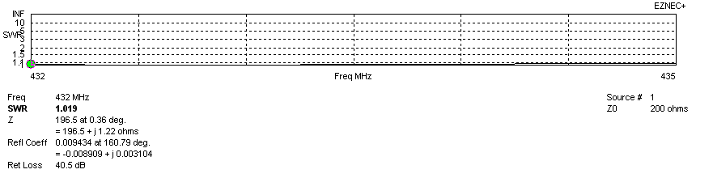
SWR diagram for the range from 432.000 – 435.000 MHz
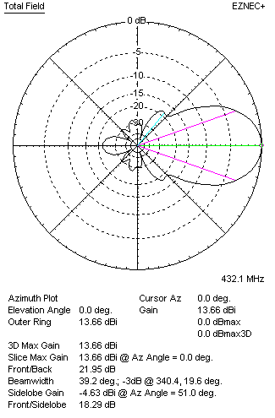 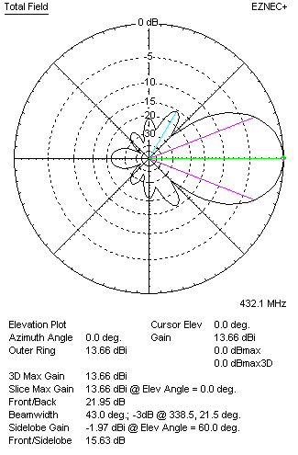Horizontal and vertical pattern in free space, loss included for aluminum
STACKING
(ALL DATA GIVEN IN ACCORDANCE WITH KF2YN CORRECTION, LOSS INCLUDED)
RECOMMENDED STACKING DISTANCES
 |  |  |  |  | Two antennas vertically  (mm) |  |  |  |  | Two antennas horizontally  (mm) |  |  |  |  |  |  | Four antennas in H-stack  (mm)
Horizontal distance |  |  |  |  |  |  |  |  |  | 1240 |  |  |  |  |  |  | 1240
Vertical distance |  |  |  |  | 880 |  |  |  |  |  |  |  |  |  |  |  | 880
TWO ANTENNAS STACKED VERTICALLY
DISTANCE  (mm) |  |  | G  (dBi) |  |  |  |  | TA  (K) |  |  |  | Tloss  (K) |  |  |  |  |  | G/T  (dB)
880 |  |  | 16.43 |  |  |  |  | 38.6 |  |  |  | 2.3 |  |  |  |  |  | +0.56
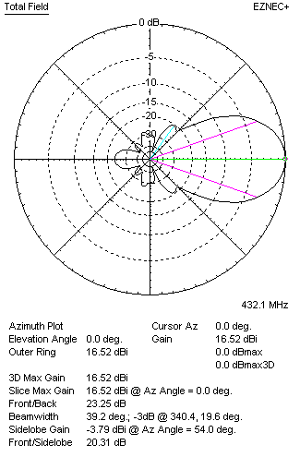 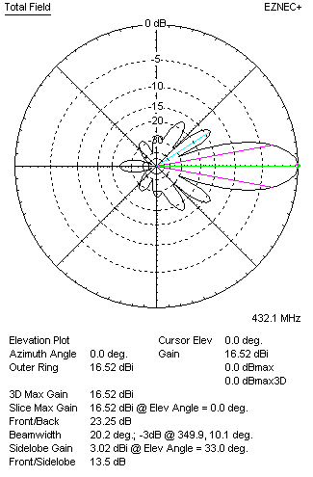Two antennas stacked vertically
TWO ANTENNAS STACKED HORIZONTALLY
DISTANCE  (mm) |  |  | G  (dBi) |  |  |  |  | TA  (K) |  |  |  |  | Tloss  (K) |  |  |  |  |  | G/T  (dB)
1240 |  |  | 16.67 |  |  |  |  | 42.5 |  |  |  |  | 2.3 |  |  |  |  |  | +0.38
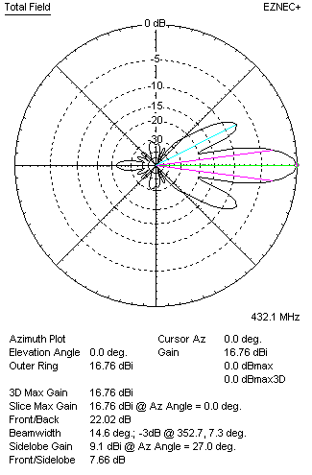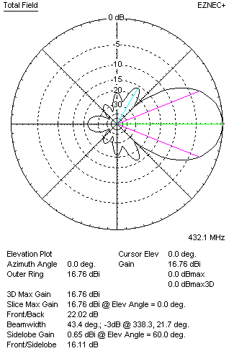
Two antennas stacked horizontally
FOUR ANTENNAS IN H-STACK
DISTANCE  (mm) |  |  | G  (dBi) |  |  |  |  | TA  (K) |  |  |  |  | Tloss  (K) |  |  |  |  |  | G/T  (dB)
H = 1240 |  |  | 19.51 |  |  |  |  | 39.6 |  |  |  |  | 2.3 |  |  |  |  |  | +3.53
V = 880
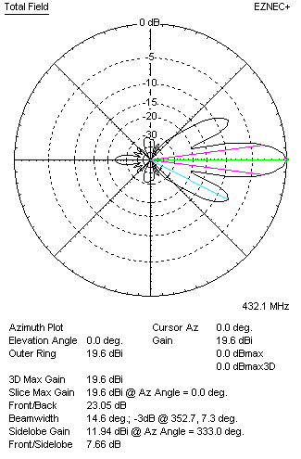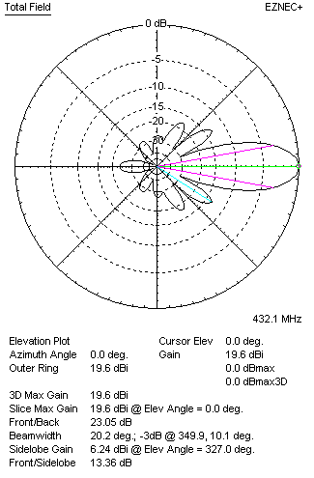
Four antennas in H-stack

