ANTENNA Y21808XL4D12
Good stacking characteristics at big vertical and horizontal distances.
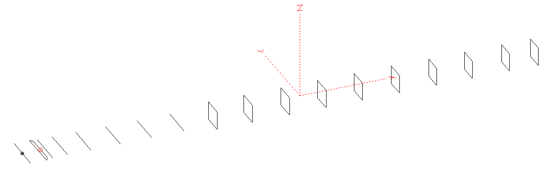
PERFORMANCES: (No loss condition)
TYPE | ELE | L (mm) | G (dBi) | F/B (dB) | F/Sh (dBi) | F/Sv (dBi) | Hor (◦) | Ver (◦) | Temp (◦K) | G/T (dB) | ΔF * (kHz)
QY21808XL4D12 | 18 | 12585 | 17.86 | 28.10 | 21.81 | 17.63 | 25.8 | 26.2 | 213.6 | -5.44 | 3700
* ΔF given for SWR=1,5

PERFORMANCES: (Loss included)
Element material | G (dBi) | Temp (◦K) | G/T (dB)
Aluminum rods | 17.77 | 215.3 | -5.56

DIMENSIONS:
 | Ref | De1 | De2 | D1 | D2 | D3 | D4 | DQ1 | DQ2 | DQ3 | DQ4 | DQ5 | DQ6 | DQ7 | DQ8 | DQ9 | DQ10 | DQ11 | DQ12
Pos | 0 | 255 | 355 | 434 | 727 | 1278 | 1984 | 2722 | 3555 | 4395 | 5305 | 6222 | 7136 | 8075 | 8955 | 9955 | 10815 | 11755 | 12585
Length | 1010 | 1016 | 870 | 940 | 950 | 922 | 900 | 532 | 516 | 504 | 496 | 484 | 476 | 472 | 466 | 458 | 444 | 438 | 430
REMARKS : All elements made of Al rods Ǿ8mm
The height of the rectangles 500mm
All dimensions given in milimetres
Building hints: No boom correction included.

COMPARISON
Antenna | Boomlength (mm) | Material | Gain (dBi) | TA (◦K) | G/T (dB) | Bandwidth  (MHz)
QY21808XL4D12 | 12585 | No loss | 17.86 | 213.6 | -5.44 | 142.600 – 146.300
QY21808XL4D12 | 12585 | Aluminum | 17.77 | 215.3 | -5.56 | 142.600 – 146.300

DIAGRAMS (no loss included)
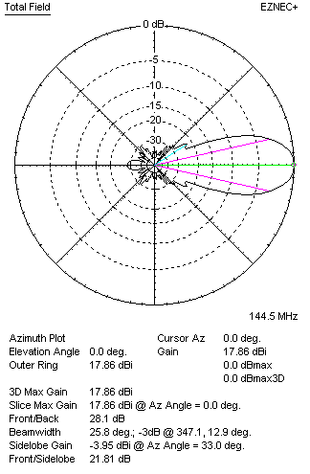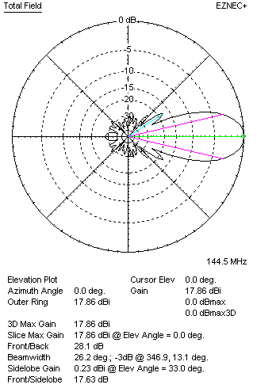

DIAGRAMS (loss included)
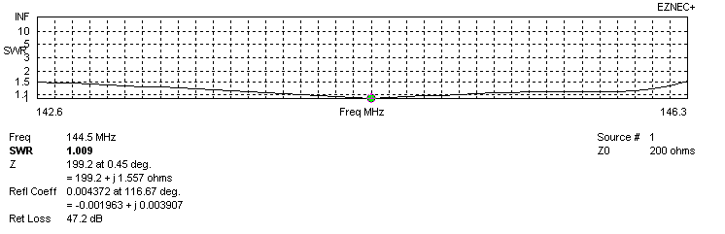
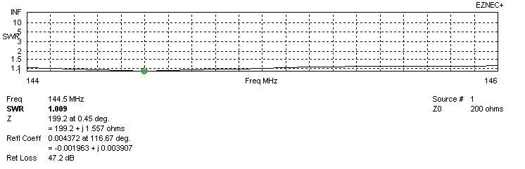
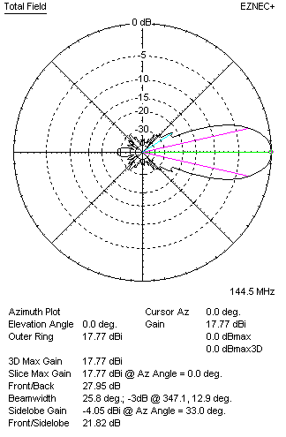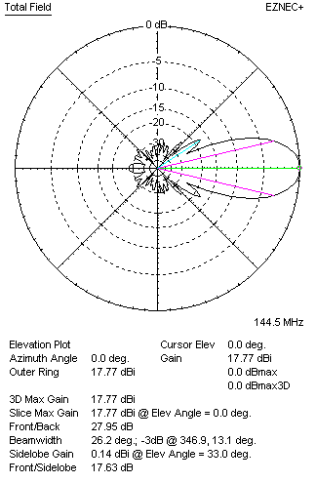
STACKING

QY21808XL3D10 - STACKING TABLE
(including loss for aluminum – AGT = -0.09 dB)
VERTICAL  DISTANCE  (cm) | G  (dB) | TA  (°K) | G/T  (dB) | HORIZONTAL  DISTANCE (cm) | G  (dB) | TA  (°K) | G/T  (dB)
100 | 17.09 | 246.8 | -6.83 | 100
110 | 17.79 | 231.0 | -5.85 | 110
120 | 18.19 | 223.5 | -5.30 | 120 | 17.43 | 246.7 | -6.49
130 | 18.46 | 219.9 | -4.96 | 130 | 18.07 | 232.8 | -5.60
140 | 18.66 | 217.8 | -4.72 | 140 | 18.43 | 225.9 | -5.11
150 | 18.81 | 216.0 | -4.53 | 150 | 18.66 | 222.1 | -4.81
160 | 18.93 | 214.8 | -4.39 | 160 | 18.83 | 220.1 | -4.60
170 | 19.04 | 214.1 | -4.27 | 170 | 18.96 | 219.0 | -4.44
180 | 19.14 | 213.7 | -4.16 | 180 | 19.07 | 218.6 | -4.33
190 | 19.22 | 213.6 | -4.08 | 190 | 19.16 | 218.5 | -4.24
200 | 19.30 | 213.8 | -4.00 | 200 | 19.24 | 218.7 | -4.16
210 | 19.37 | 214.2 | -3.94 | 210 | 19.32 | 219.0 | -4.08
220 | 19.44 | 214.8 | -3.88 | 220 | 19.39 | 219.3 | -4.02
230 | 19.50 | 215.3 | -3.83 | 230 | 19.45 | 219.5 | -3.96
240 | 19.56 | 215.9 | -3.78 | 240 | 19.52 | 219.7 | -3.90
250 | 19.62 | 216.4 | -3.73 | 250 | 19.58 | 219.7 | -3.84
260 | 19.67 | 216.9 | -3.69 | 260 | 19.64 | 219.6 | -3.78
270 | 19.73 | 217.3 | -3.64 | 270 | 19.70 | 219.5 | -3.71
280 | 19.79 | 217.7 | -3.59 | 280 | 19.77 | 219.1 | -3.64
290 | 19.84 | 218.0 | -3.54 | 290 | 19.83 | 218.6 | -3.57
300 | 19.90 | 218.2 | -3.49 | 300 | 19.89 | 218.1 | -3.50
310 | 19.96 | 218.1 | -3.43 | 310 | 19.95 | 217.4 | -3.42
320 | 20.01 | 217.9 | -3.37 | 320 | 20.01 | 216.8 | -3.35
330 | 20.07 | 217.7 | -3.31 | 330 | 20.06 | 216.2 | -3.29
340 | 20.13 | 217.3 | -3.24 | 340 | 20.12 | 215.6 | -3.22
350 | 20.18 | 217.0 | -3.18 | 350 | 20.18 | 215.0 | -3.14
360 | 20.24 | 216.7 | -3.12 | 360 | 20.24 | 214.4 | -3.07
370 | 20.29 | 216.6 | -3.07 | 370 | 20.29 | 214.0 | -3.01
380 | 20.34 | 216.4 | -3.01 | 380 | 20.34 | 213.6 | -2.96
390 | 20.39 | 216.4 | -2.96 | 390 | 20.40 | 213.3 | -2.89
400 | 20.43 | 216.3 | -2.92 | 400 | 20.44 | 213.1 | -2.85
410 | 20.48 | 216.1 | -2.87 | 410 | 20.49 | 213.0 | -2.79
420 | 20.52 | 215.8 | -2.82 | 420 | 20.53 | 212.9 | -2.75
430 | 20.56 | 215.5 | -2.77 | 430 | 20.57 | 212.9 | -2.71
440 | 20.60 | 215.1 | -2.73 | 440 | 20.60 | 212.9 | -2.68
450 | 20.64 | 214.7 | -2.68 | 450 | 20.63 | 213.1 | -2.66
460 | 20.67 | 214.2 | -2.64 | 460 | 20.66 | 213.2 | -2.63
470 | 20.70 | 213.9 | -2.60 | 470 | 20.69 | 213.4 | -2.60
480 | 20.72 | 213.5 | -2.57 | 480 | 20.71 | 213.6 | -2.59
490 | 20.75 | 213.1 | -2.54 | 490 | 20.73 | 213.7 | -2.57
500 | 20.77 | 212.8 | -2.51 | 500 | 20.75 | 213.9 | -2.55
510 | 20.78 | 212.5 | -2.49 | 510 | 20.76 | 214.0 | -2.54
520 | 20.80 | 212.2 | -2.47 | 520 | 20.77 | 214.2 | -2.54
530 | 20.81 | 212.0 | -2.45 | 530 | 20.78 | 214.3 | -2.53
540 | 20.82 | 211.8 | -2.44 | 540 | 20.79 | 214.4 | -2.52
550 | 20.83 | 211.6 | -2.43 | 550 | 20.80 | 214.5 | -2.51
560 | 20.83 | 211.5 | -2.42 | 560 | 20.81 | 214.5 | -2.51
570 | 20.84 | 211.6 | -2.41 | 570 | 20.81 | 214.6 | -2.51
Remark: brown colour letters show not consistent data!

TWO ANTENNAS VERTICALLY STACKED AT 570CM
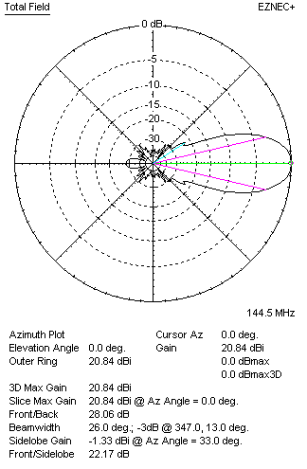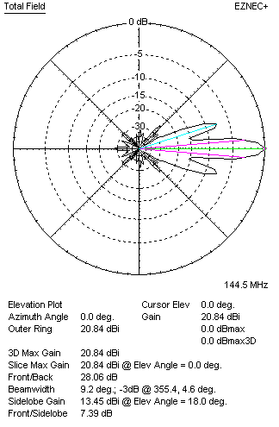

Performances
TYPE | Condition | G  (dBi) | F/B  (dB) | F/Sh  (dBi) | F/Sv (dBi) | Hor  (◦) | Ver  (◦) | Temp (◦K) | G/T (dB) | B (MHz)  for SWR=1.5
2xQY21808XL4D12 | No loss | 20.93 | 28.22 | 22.16 | 7.38 | 26.0 | 9.2 | 209.7 | -2.29 | 142.600 – 146.300
2xQY21808XL4D12 | Aluminum | 20.84 | 28.06 | 22.17 | 7.39 | 26.0 | 9.2 | 211.6 | -2.41 | 142.600 – 146.300

FOUR ANTENNAS VERTICALLY STACKED AT 550+550+550 CM
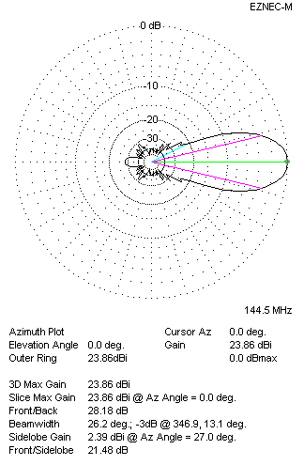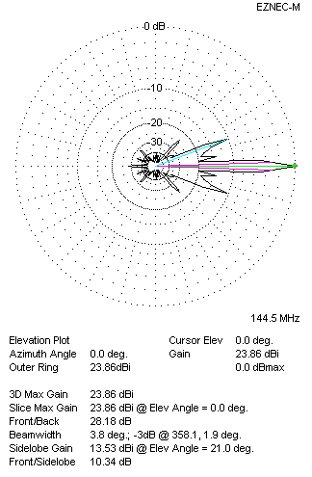
Performances
TYPE | Condition | G  (dBi) | F/B  (dB) | F/Sh  (dBi) | F/Sv (dBi) | Hor  (◦) | Ver  (◦) | Temp (◦K) | G/T (dB) | B (MHz)  for SWR=1.5
4xQY21808XL3D10 | No losss | 23.95 | 28.33 | 21.48 | 10.31 | 26.2 | 3.8 | 209.9 | +0.73 | 142.600 – 146.300
4xQY21808XL3D10 | Aluminum | 23.86 | 28.18 | 21.48 | 10.34 | 26.2 | 3.8 | 211.7 | +0.60 | 142.600 – 146.300

FOUR ANTENNAS IN H- STACK, H=550 CM, V=560 CM
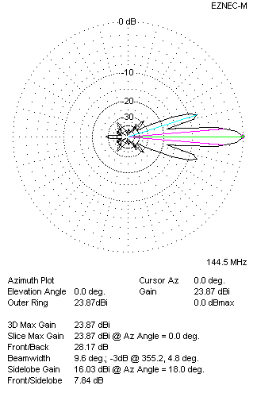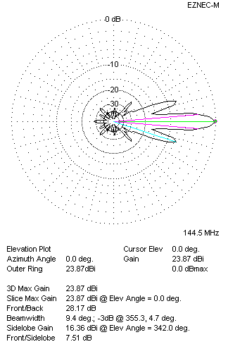
Performances
TYPE | Condition | G  (dBi) | F/B  (dB) | F/Sh  (dBi) | F/Sv (dBi) | Hor  (◦) | Ver  (◦) | Temp (◦K) | G/T (dB) | B (MHz)  for SWR=1.5
4xQY21808XL4D12 | No losss | 23.96 | 28.33 | 7.82 | 7.49 | 9.6 | 9.4 | 209.5 | +0.75 | 142.600 – 146.300
4xQY21808XL4D12 | Aluminum | 23.87 | 28.17 | 7.84 | 7.51 | 9.6 | 9.4 | 211.3 | +0.62 | 142.600 – 146.300

XPOL VERSION

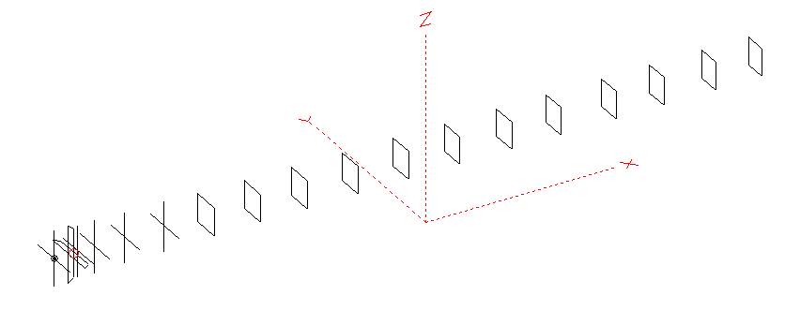
Horizontal components: Same as above
Vertical components: Same as above, except:
- All vertical yagi elements positioned 20 mm backward regarding horizontals.
- All crossed elements must cross each other in their centerlines

HORIZONTAL PERFORMANCES
Everything as the above data

VERTICAL PERFORMANCES with no corrections
Loss included condition (for Aluminum)
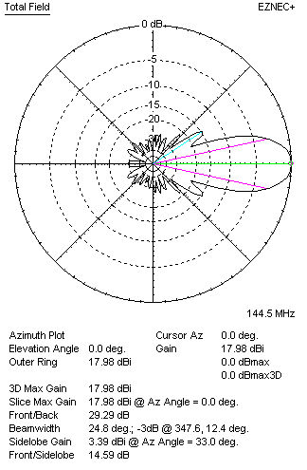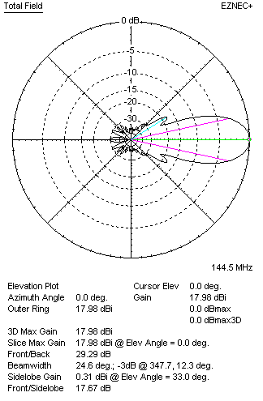
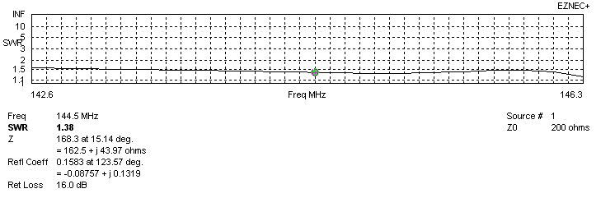
VERTICAL PERFORMANCES after corrections, loss included condition
If you want to get better SWR diagram for vertical antenna you can do the following:
- Change length of DE1 from 1016 to 1070 mm
- Change length of DE2 from 870 to 850 mm
- Change length of D1 from 940 to 952 mm
- Change length of D2 from 950 to 948 mm
- Change length of D3 from 922 to 920 mm
- Change position of D1 for -2 mm

In this case the SWR diagram will be like this:
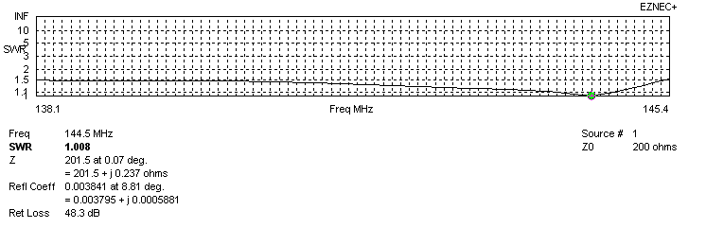
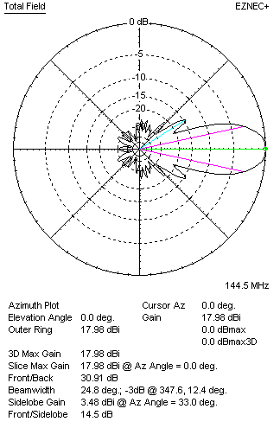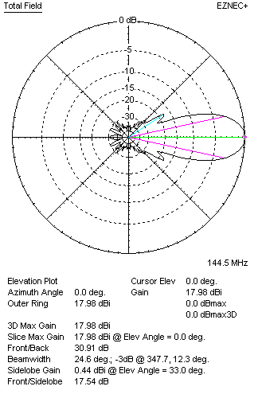

PERFORMANCES
 | TYPE | Condition | G  (dBi) | F/B  (dB) | F/Sh  (dBi) | F/Sv (dBi) | Hor  (◦) | Ver  (◦) | Temp (◦K) | G/T (dB) | B (MHz)  for SWR=1.5
 | Horizontal  part | No loss | 17.86 | 28.10 | 21.81 | 17.63 | 25.8 | 26.2 | 213.6 | -5.44 | 142.400 - 146.150
 | Horizontal  part | Aluminum | 17.77 | 27.95 | 21.82 | 17.63 | 25.8 | 26.2 | 215.3 | -5.56 | 142.400 - 146.150
 | Vertical  part | No losss | 18.07 | 30.91 | 14.50 | 17.54 | 24.8 | 24.6 | 219.1 | -5.34 | 138.100 – 145.400
 | Vertical  part | Aluminum | 17.98 | 30.91 | 14.50 | 17.54 | 24.8 | 24.6 | 220.7 | -5.46 | 138.100 – 145.400

