ANTENNA Y21805XL7D11
Good stacking characteristics at big vertical and horizontal distances
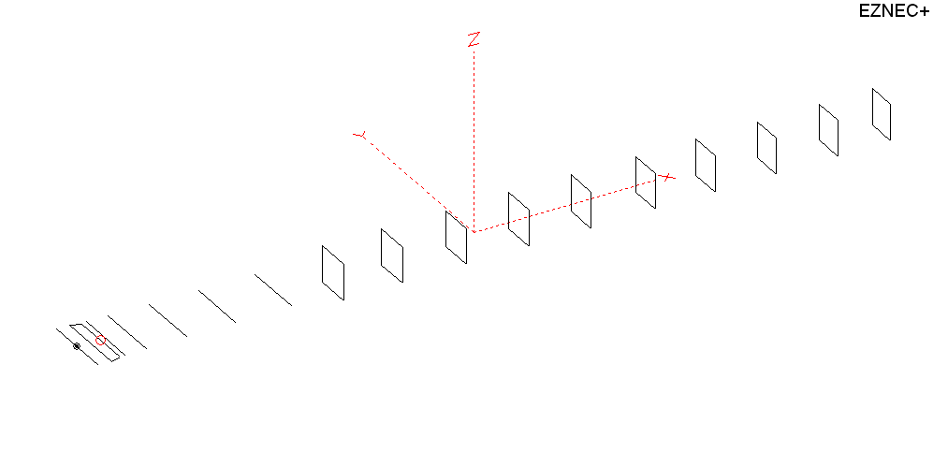
PERFORMANCES: (No loss condition)
TYPE | ELE | L (mm) | G (dBi) | F/B (dB) | F/Sh (dBi) | F/Sv (dBi) | Hor (◦) | Ver (◦) | Temp (◦K) | G/T (dB) | ΔF * (kHz)
QY21805XL7D11 | 17 | 12525 | 17.78 | 32.03 | 21.19 | 17.64 | 26.0 | 26.8 | 213.1 | -5.51 | 3500
* ΔF given for SWR=1,5

PERFORMANCES: (Loss included)
Element material | G (dBi) | Temp (◦K) | G/T (dB)
Aluminum rods | 17.66 | 215.5 | -5.68

DIMENSIONS:
 | Ref | De1 | De2 | D1 | D2 | D3 | D4 | D5 | DQ1 | DQ2 | DQ3 | DQ4 | DQ5 | DQ6 | DQ7 | DQ8 | DQ9 | DQ10 | DQ11
Pos | 0 | 275 | 375 | 426 | 704 | 1256 | 1938 | 2685 | 3535 | 4385 | 5293 | 6198 | 7105 | 8046 | 8955 | 9915 | 10805 | 11725 | 12525
Length | 1018 | 1018 | 820 | 938 | 960 | 932 | 920 | 900 | 522 | 502 | 492 | 488 | 482 | 474 | 466 | 456 | 450 | 444 | 440
REMARKS : All elements made of Al rods Ǿ5mm
The height of the rectangles 500mm
All dimensions given in milimetres
Building hints: No boom correction included.

COMPARISON
Antenna | Boomlength (mm) | Material | Gain (dBi) | TA (◦K) | G/T (dB) | Bandwidth  (MHz)
QY21805XL7D11 | 12525 | No loss | 17.78 | 213.1 | -5.51 | 142.900 – 146.400
QY21805XL7D11 | 12525 | Aluminum | 17.66 | 215.5 | -5.68 | 142.900 – 146.400
EF0217-5X | 11940 | No loss | 17.66 | 217.1 | -5.71 | 141.500 - 145.600
EF0217-5X | 11940 | Aluminum | 17.51 | 220.0 | -5.91 | 141.500 - 145.600

DIAGRAMS (no loss included)
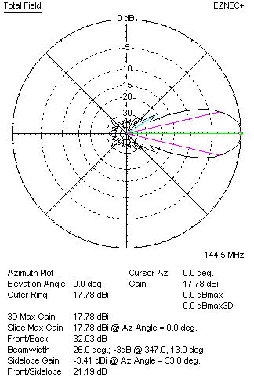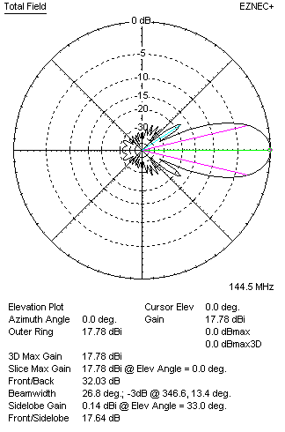
DIAGRAMS (loss included)
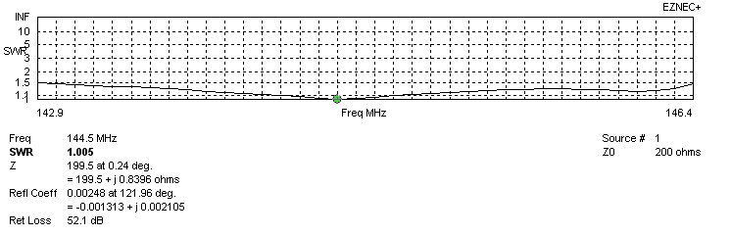
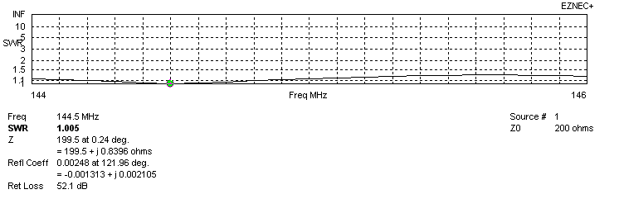
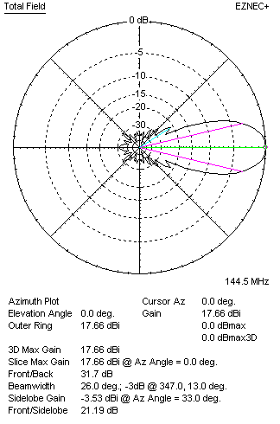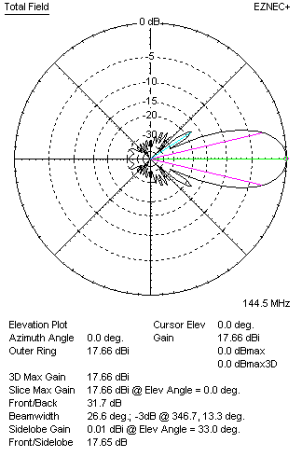
STACKING

QY21805XL7D11 - STACKING TABLE
(including loss for aluminum – AGT = -0.13 dB)
VERTICAL  DISTANCE  (cm) | G  (dB) | TA  (°K) | G/T  (dB) | HORIZONTAL  DISTANCE (cm) | G  (dB) | TA  (°K) | G/T  (dB)
100 | 17.56 | 236.1 | -6.17 | 100
110 | 18.05 | 226.1 | -5.49 | 110
120 | 18.36 | 220.9 | -5.08 | 120 | 17.54 | 242.8 | -6.31
130 | 18.57 | 218.0 | -4.82 | 130 | 18.15 | 231.0 | -5.49
140 | 18.72 | 216.0 | -4.63 | 140 | 18.48 | 224.7 | -5.04
150 | 18.84 | 214.7 | -4.48 | 150 | 18.69 | 221.6 | -4.77
160 | 18.93 | 214.2 | -4.38 | 160 | 18.84 | 220.1 | -4.59
170 | 19.02 | 214.1 | -4.29 | 170 | 18.95 | 219.5 | -4.46
180 | 19.09 | 214.1 | -4.22 | 180 | 19.04 | 219.3 | -4.37
190 | 19.17 | 213.9 | -4.13 | 190 | 19.12 | 219.3 | -4.29
200 | 19.24 | 213.8 | -4.06 | 200 | 19.19 | 219.5 | -4.22
210 | 19.31 | 123.8 | -3.99 | 210 | 19.26 | 219.7 | -4.16
220 | 19.38 | 214.0 | -3.92 | 220 | 19.32 | 219.9 | -4.10
230 | 19.44 | 214.4 | -3.87 | 230 | 19.38 | 220.1 | -4.05
240 | 19.49 | 215.0 | -3.84 | 240 | 19.44 | 220.2 | -3.99
250 | 19.55 | 215.7 | -3.79 | 250 | 19.49 | 220.3 | -3.94
260 | 19.60 | 216.5 | -3.75 | 260 | 19.55 | 220.2 | -3.88
270 | 19.65 | 217.3 | -3.72 | 270 | 19.61 | 220.0 | -3.81
280 | 19.70 | 218.1 | -3.69 | 280 | 19.67 | 219.6 | -3.75
290 | 19.75 | 218.7 | -3.65 | 290 | 19.72 | 219.2 | -3.69
300 | 19.81 | 219.1 | -3.60 | 300 | 19.78 | 218.6 | -3.62
310 | 19.86 | 219.3 | -3.55 | 310 | 19.84 | 218.0 | -3.54
320 | 19.91 | 219.2 | -3.50 | 320 | 19.89 | 217.4 | -3.48
330 | 19.97 | 218.9 | -3.43 | 330 | 19.95 | 216.7 | -3.41
340 | 20.02 | 218.6 | -3.38 | 340 | 20.01 | 216.1 | -3.34
350 | 20.08 | 218.2 | -3.31 | 350 | 20.06 | 215.5 | -3.28
360 | 20.18 | 217.4 | -3.19 | 360 | 20.12 | 215.1 | -3.21
370 | 20.23 | 217.1 | -3.14 | 370 | 20.17 | 214.7 | -3.15
380 | 20.28 | 216.8 | -3.08 | 380 | 20.22 | 214.4 | -3.09
390 | 20.33 | 216.5 | -3.03 | 390 | 20.27 | 214.2 | -3.04
400 | 20.37 | 216.3 | -2.98 | 400 | 20.32 | 214.0 | -2.98
410 | 20.42 | 216.0 | -2.92 | 410 | 20.36 | 213.9 | -2.94
420 | 20.46 | 215.6 | -2.88 | 420 | 20.41 | 213.8 | -2.89
430 | 20.49 | 215.2 | -2.84 | 430 | 20.45 | 213.8 | -2.85
440 | 20.53 | 214.9 | -2.79 | 440 | 20.48 | 213.7 | -2.82
450 | 20.56 | 214.5 | -2.75 | 450 | 20.52 | 213.7 | -2.78
460 | 20.59 | 214.0 | -2.72 | 460 | 20.55 | 213.6 | -2.75
470 | 20.62 | 213.6 | -2.68 | 470 | 20.57 | 213.6 | -2.73
480 | 20.64 | 213.2 | -2.65 | 480 | 20.60 | 213.5 | -2.69
490 | 20.66 | 212.8 | -2.62 | 490 | 20.62 | 213.4 | -2.67
500 | 20.70 | 212.1 | -2.56 | 500 | 20.64 | 213.4 | -2.65
510 | 20.71 | 211.7 | -2.55 | 510 | 20.66 | 213.4 | -2.63
520 | 20.72 | 211.5 | -2.53 | 520 | 20.67 | 213.4 | -2.62
530 | 20.73 | 211.3 | -2.52 | 530 | 20.69 | 213.4 | -2.60
540 | 20.74 | 211.2 | -2.51 | 540 | 20.70 | 213.5 | -2.59
550 | 20.74 | 211.3 | -2.51 | 550 | 20.70 | 213.5 | -2.59
560 | 20.75 | 211.4 | -2.50 | 560 | 20.70 | 213.6 | -2.60
570 | 20.75 | 211.7 | -2.51 | 570 | 20.70 | 213.6 | -2.60
Remark: brown colour letters show not consistent data!

TWO ANTENNAS VERTICALLY STACKED AT 540CM
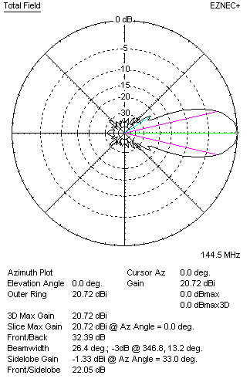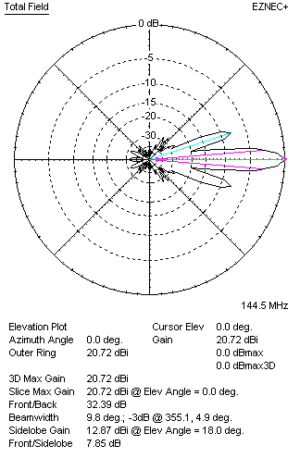

Performances
TYPE | Condition | G  (dBi) | F/B  (dB) | F/Sh  (dBi) | F/Sv (dBi) | Hor  (◦) | Ver  (◦) | Temp (◦K) | G/T (dB) | B (MHz)  for SWR=1.5
2xQY21805XL7D11 | No loss | 20.84 | 32.76 | 22.04 | 7.83 | 26.4 | 9.8 | 208.9 | -2.36 | 142.900 – 146.400
2xQY21805XL7D11 | Aluminum | 20.72 | 32.39 | 22.05 | 7.85 | 26.4 | 9.8 | 211.5 | -2.53 | 142.900 – 146.400

FOUR ANTENNAS VERTICALLY STACKED AT 540+540+540 CM
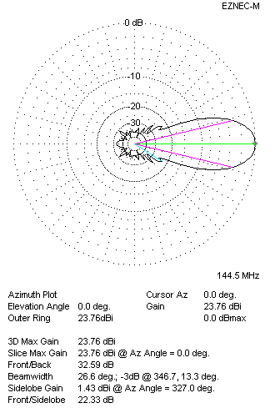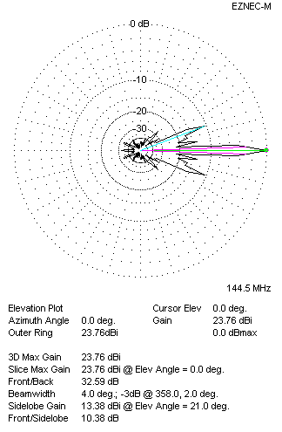
Performances
TYPE | Condition | G  (dBi) | F/B  (dB) | F/Sh  (dBi) | F/Sv (dBi) | Hor  (◦) | Ver  (◦) | Temp (◦K) | G/T (dB) | B (MHz)  for SWR=1.5
4xQY21805XL7D11 | No losss | 23.88 | 32.96 | 22.33 | 10.34 | 26.6 | 4.0 | 208.0 | +0.70 | 142.900 – 146.400
4xQY21805XL7D11 | Aluminum | 23.76 | 32.59 | 22.33 | 10.38 | 26.6 | 4.0 | 210.6 | +0.53 | 142.900 – 146.400

FOUR ANTENNAS IN H- STACK, H=540 CM, V=540 CM
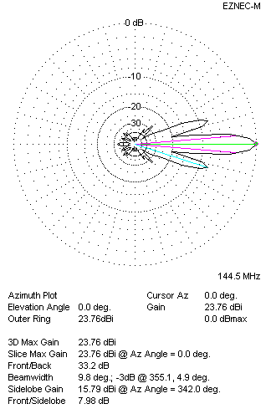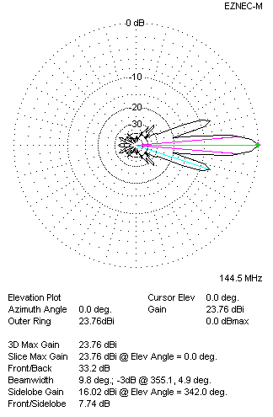
Performances
TYPE | Condition | G  (dBi) | F/B  (dB) | F/Sh  (dBi) | F/Sv (dBi) | Hor  (◦) | Ver  (◦) | Temp (◦K) | G/T (dB) | B (MHz)  for SWR=1.5
4xQY21805XL7D11 | No losss | 23.88 | 33.61 | 7.95 | 7.71 | 9.8 | 9.8 | 207.5 | +0.71 | 142.900 – 146.400
4xQY21805XL7D11 | Aluminum | 23.76 | 33.20 | 7.98 | 7.74 | 9.8 | 9.8 | 210.2 | +0.53 | 142.900 – 146.400

XPOL VERSION

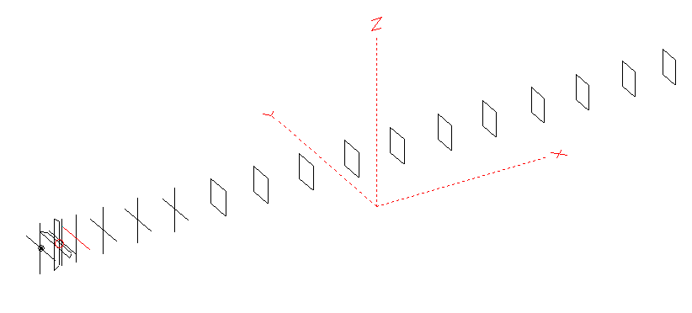
Horizontal components: Same as above
Vertical components: Same as above, except:
- All vertical yagi elements positioned 20 mm backward regarding horizontals.
- All crossed elements must cross each other in their centerlines

HORIZONTAL PERFORMANCES
Everything as the above data

VERTICAL PERFORMANCES with no corrections
Loss included condition (for Aluminum)

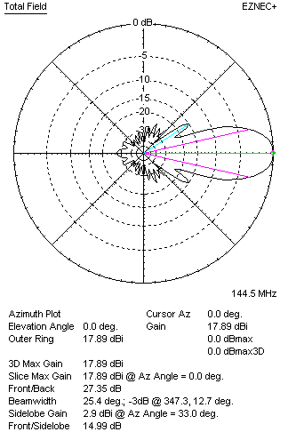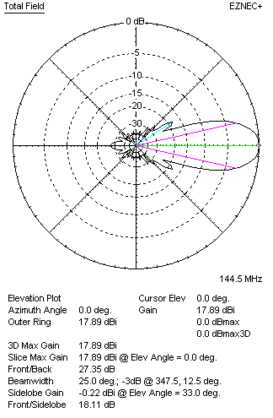
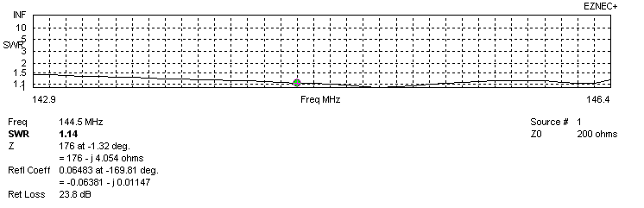
VERTICAL PERFORMANCES after corrections, loss included condition
If you want to get better SWR diagram for vertical antenna you can do the following:
- Change length of DE2 from 810 to 850 mm
- Change length of D1 from 938 to 936 mm
- Change length of D2 from 960 to 958 mm
- Change length of D3 from 932 to 930 mm
- Change length of D4 from 920 to 916 mm
- Change length of D5 from 900 to 902 mm
- Change position of D2 for +5 mm

In this case the SWR diagram will be like this:
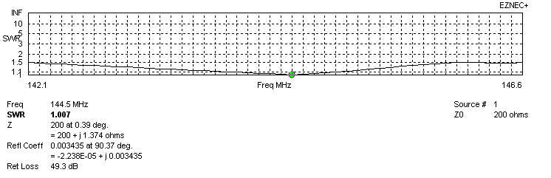
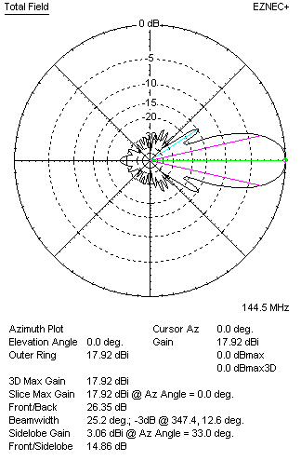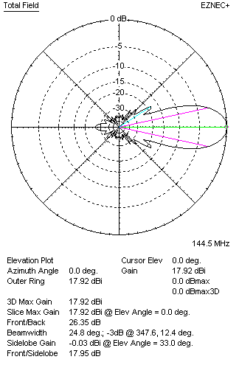

PERFORMANCES
 | TYPE | Condition | G  (dBi) | F/B  (dB) | F/Sh  (dBi) | F/Sv (dBi) | Hor  (◦) | Ver  (◦) | Temp (◦K) | G/T (dB) | B (MHz)  for SWR=1.5
 | Horizontal  part | No loss | 17.78 | 32.03 | 21.19 | 17.64 | 26.0 | 26.8 | 213.1 | -5.51 | 142.900 – 146.400
 | Horizontal  part | Aluminum | 17.66 | 31.70 | 21.19 | 17.65 | 26.0 | 26.6 | 215.5 | -5.68 | 142.900 – 146.400
 | Vertical  part | No losss | 18.03 | 26.48 | 14.85 | 17.93 | 25.4 | 25.0 | 216.6 | -5.33 | 142.100 – 146.600
 | Vertical  part | Aluminum | 17.92 | 26.35 | 14.86 | 17.95 | 25.2 | 24.8 | 218.9 | -5.48 | 142.100 – 146.600

