ANTENNA Y21710X3D9
Good stacking characteristics at big vertical and horizontal distances. Not suitable for XPOL
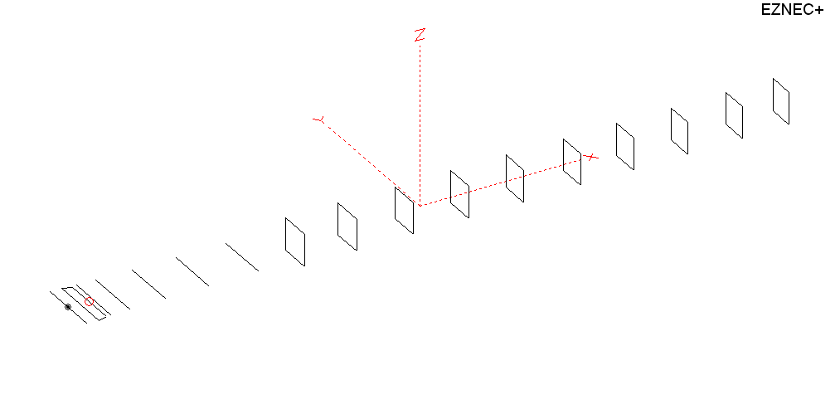
PERFORMANCES: (No loss condition)
TYPE | ELE | L (mm) | G (dBi) | F/B (dB) | F/Sh (dBi) | F/Sv (dBi) | Hor (◦) | Ver (◦) | Temp (◦K) | G/T (dB) | ΔF * (kHz)
QY21710XL3D9 | 17 | 11708 | 17.65 | 31.56 | 19.20 | 17.64 | 25.8 | 26.8 | 218.2 | -5.74 | 3600
* ΔF given for SWR=1,5

PERFORMANCES: (Loss included)
Element material | G (dBi) | Temp (◦K) | G/T (dB)
Aluminum rods | 17.58 | 219.5 | -5.83

DIMENSIONS:
 | Ref | De1 | De2 | D1 | D2 | D3 | D4 | D5 | D6 | DQ1 | DQ2 | DQ3 | DQ4 | DQ5 | DQ6 | DQ7 | DQ8 | DQ9
Pos | 0 | 382 | 449 | 559 | 926 | 1506 | 2235 | 3005 | 3815 | 4698 | 5565 | 6485 | 7389 | 8285 | 9205 | 10125 | 11012 | 11708
Length | 1008 | 1000 | 868 | 933 | 933 | 914 | 892 | 880 | 866 | 538 | 522 | 518 | 510 | 504 | 494 | 486 | 478 | 470
REMARKS : All elements made of Al rods Ǿ10mm
The height of the rectangles 450mm
All dimensions given in milimetres
Building hints: No boom correction included.

COMPARISON
Antenna | Boomlength (mm) | Material | Gain (dBi) | TA (◦K) | G/T (dB) | Bandwidth  (MHz)
QY21710XL3D9 | 11708 | No loss | 17.65 | 218.2 | -5.74 | 142.900 – 146.500
QY21710XL3D9 | 11708 | Aluminum | 17.58 | 219.5 | -5.83 | 142.900 – 146.500

DIAGRAMS (no loss included)
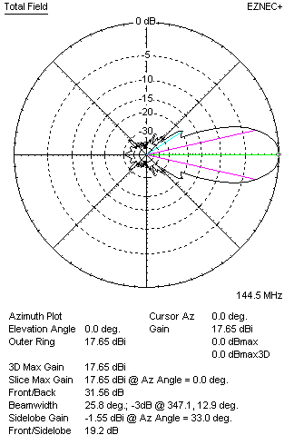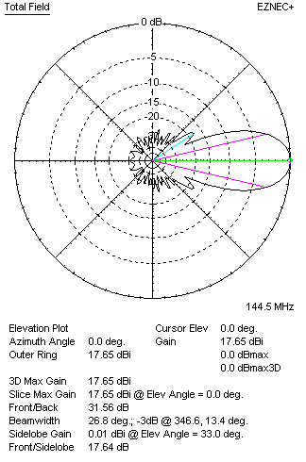
DIAGRAMS (loss included)
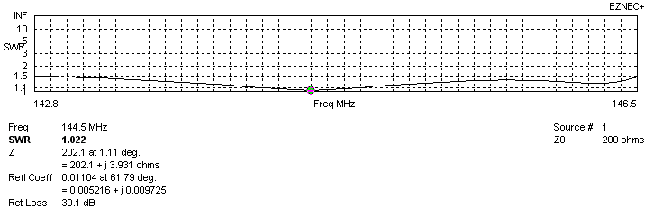
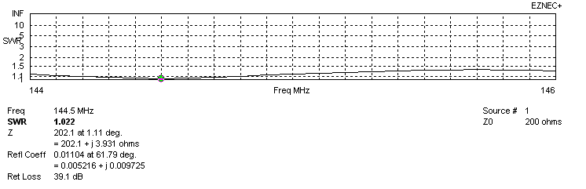
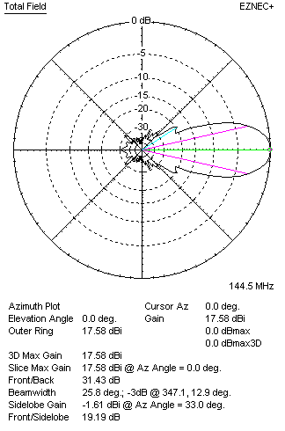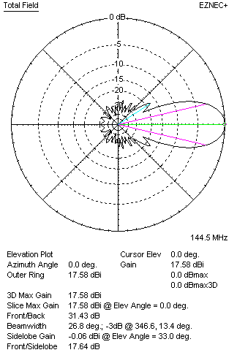
STACKING

QY21710XL3D9 - STACKING TABLE
(including loss for aluminum – AGT = -0.06 dB)
VERTICAL  DISTANCE  (cm) | G  (dB) | TA  (°K) | G/T  (dB) | HORIZONTAL  DISTANCE (cm) | G  (dB) | TA  (°K) | G/T  (dB)
100 | 17.57 | 230.5 | -6.06 | 100
110 | 17.92 | 224.7 | -5.60 | 110
120 | 18.15 | 223.5 | -5.34 | 120 | 17.27 | 239.6 | -6.52
130 | 18.31 | 226.4 | -5.24 | 130 | 17.81 | 235.9 | -5.92
140 | 18.42 | 230.6 | -5.21 | 140 | 18.12 | 235.0 | -5.59
150 | 18.53 | 231.1 | -5.11 | 150 | 18.36 | 232.9 | -5.31
160 | 18.67 | 227.3 | -4.90 | 160 | 18.54 | 230.7 | -5.09
170 | 18.80 | 223.2 | -4.69 | 170 | 18.69 | 229.0 | -4.91
180 | 18.92 | 220.5 | -4.51 | 180 | 18.81 | 227.8 | -4.77
190 | 19.02 | 219.0 | -4.38 | 190 | 18.92 | 226.9 | -4.64
200 | 19.11 | 218.2 | -4.28 | 200 | 19.02 | 226.1 | -4.52
210 | 19.19 | 217.9 | -4.19 | 210 | 19.11 | 225.6 | -4.42
220 | 19.27 | 217.7 | -4.11 | 220 | 19.19 | 225.2 | -4.34
230 | 19.34 | 217.8 | -4.04 | 230 | 19.27 | 224.9 | -4.25
240 | 19.41 | 218.1 | -3.98 | 240 | 19.34 | 224.6 | -4.17
250 | 19.47 | 218.6 | -3.93 | 250 | 19.41 | 224.3 | -4.10
260 | 19.54 | 219.2 | -3.87 | 260 | 19.47 | 224.0 | -4.03
270 | 19.60 | 219.9 | -3.82 | 270 | 19.54 | 223.6 | -3.95
280 | 19.66 | 220.6 | -3.78 | 280 | 19.60 | 223.1 | -3.89
290 | 19.72 | 221.2 | -3.73 | 290 | 19.66 | 222.5 | -3.81
300 | 19.77 | 221.4 | -3.68 | 300 | 19.72 | 221.9 | -3.74
310 | 19.83 | 221.5 | -3.62 | 310 | 19.78 | 221.2 | -3.67
320 | 19.89 | 221.5 | -3.56 | 320 | 19.84 | 220.6 | -3.60
330 | 19.95 | 221.5 | -3.50 | 330 | 19.90 | 219.9 | -3.52
340 | 20.01 | 221.6 | -3.45 | 340 | 19.96 | 219.3 | -3.45
350 | 20.06 | 222.0 | -3.40 | 350 | 20.02 | 218.7 | -3.38
360 | 20.11 | 222.4 | -3.36 | 360 | 20.07 | 218.2 | -3.32
370 | 20.15 | 222.6 | -3.33 | 370 | 20.13 | 217.8 | -3.25
380 | 20.21 | 222.4 | -3.26 | 380 | 20.18 | 217.5 | -3.19
390 | 20.26 | 221.8 | -3.20 | 390 | 20.23 | 217.3 | -3.14
400 | 20.31 | 221.1 | -3.14 | 400 | 20.28 | 217.1 | -3.09
410 | 20.36 | 220.3 | -3.07 | 410 | 20.32 | 217.0 | -3.05
420 | 20.40 | 219.6 | -3.02 | 420 | 20.36 | 217.0 | -3.00
430 | 20.44 | 218.9 | -2.96 | 430 | 20.40 | 217.0 | -2.96
440 | 20.48 | 218.3 | -2.91 | 440 | 20.44 | 217.0 | -2.92
450 | 20.51 | 217.8 | -2.87 | 450 | 20.47 | 217.0 | -2.89
460 | 20.54 | 217.2 | -2.83 | 460 | 20.50 | 217.0 | -2.86
470 | 20.56 | 216.6 | -2.80 | 470 | 20.52 | 217.0 | -2.84
480 | 20.59 | 216.1 | -2.76 | 480 | 20.55 | 217.0 | -2.81
490 | 20.61 | 215.5 | -2.72 | 490 | 20.57 | 217.0 | -2.79
500 | 20.62 | 215.0 | -2.70 | 500 | 20.58 | 217.0 | -2.78
510 | 20.64 | 214.6 | -2.68 | 510 | 20.60 | 217.1 | -2.77
520 | 20.65 | 214.2 | -2.66 | 520 | 20.61 | 217.1 | -2.76
530 | 20.66 | 214.0 | -2.64 | 530 | 20.62 | 217.2 | -2.75
540 | 20.67 | 214.0 | -2.63 | 540 | 20.63 | 217.3 | -2.74
550 | 20.67 | 214.3 | -2.64 | 550 | 20.64 | 217.4 | -2.73
560 | 20.67 | 214.8 | -2.65 | 560 | 20.65 | 217.5 | -2.73
Remark: brown colour letters show not consistent data!

TWO ANTENNAS VERTICALLY STACKED AT 530CM
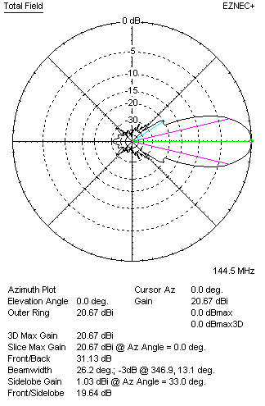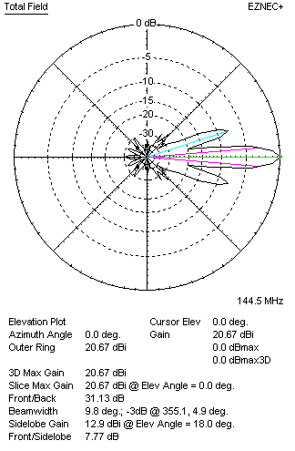

Performances
TYPE | Condition | G  (dBi) | F/B  (dB) | F/Sh  (dBi) | F/Sv (dBi) | Hor  (◦) | Ver  (◦) | Temp (◦K) | G/T (dB) | B (MHz)  for SWR=1.5
2xQY21710XL3D9 | No loss | 20.73 | 31.24 | 19.63 | 7.75 | 26.2 | 9.8 | 212.7 | -2.55 | 142.900 – 146.500
2xQY21710XL3D9 | Aluminum | 20.67 | 31.13 | 19.64 | 7.77 | 26.2 | 9.8 | 214.0 | -2.63 | 142.900 – 146.500

FOUR ANTENNAS VERTICALLY STACKED AT 530+530+530 CM
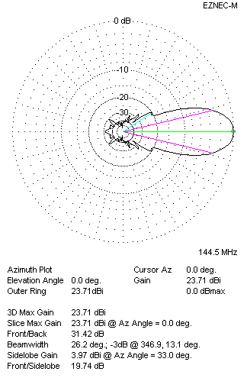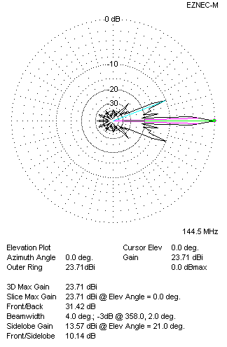
Performances
TYPE | Condition | G  (dBi) | F/B  (dB) | F/Sh  (dBi) | F/Sv (dBi) | Hor  (◦) | Ver  (◦) | Temp (◦K) | G/T (dB) | B (MHz)  for SWR=1.5
4xQY21710XL3D9 | No losss | 23.77 | 31.53 | 19.74 | 10.12 | 26.2 | 4.0 | 211.5 | +0.52 | 142.900 – 146.500
4xQY21710XL3D9 | Aluminum | 23.71 | 31.42 | 19.74 | 10.14 | 26.2 | 4.0 | 212.8 | +0.43 | 142.900 – 146.500

FOUR ANTENNAS IN H- STACK, H=540 CM, V=530 CM
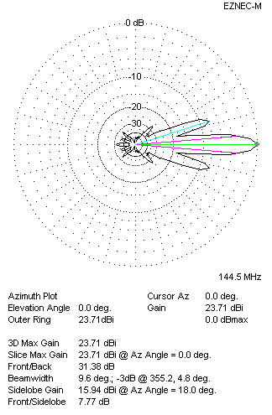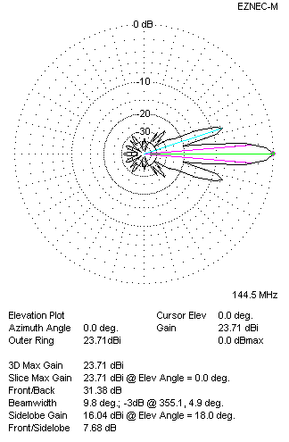
Performances
TYPE | Condition | G  (dBi) | F/B  (dB) | F/Sh  (dBi) | F/Sv (dBi) | Hor  (◦) | Ver  (◦) | Temp (◦K) | G/T (dB) | B (MHz)  for SWR=1.5
4xQY21710XL3D9 | No losss | 23.78 | 31.50 | 7.76 | 7.66 | 9.6 | 9.8 | 211.5 | +0.53 | 142.900 – 146.500
4xQY21710XL3D9 | Aluminum | 23.71 | 31.38 | 7.77 | 7.68 | 9.6 | 9.8 | 212.8 | +0.43 | 142.900 – 146.500

