ANTENNA Y21706XL2D10
Good stacking characteristics at big vertical and horizontal distances
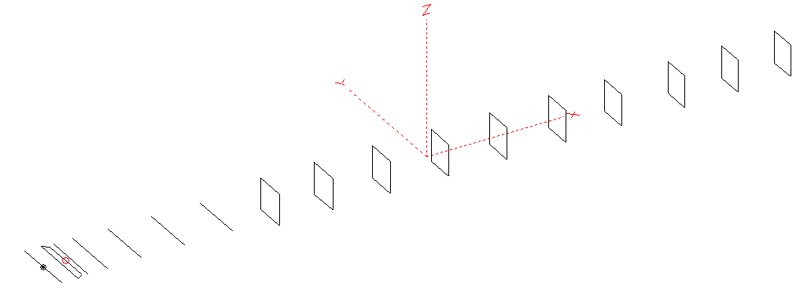
PERFORMANCES: (No loss condition)
TYPE | ELE | L (mm) | G (dBi) | F/B (dB) | F/Sh (dBi) | F/Sv (dBi) | Hor (◦) | Ver (◦) | Temp (◦K) | G/T (dB) | ΔF * (kHz)
QY21706XL2D10 | 17 | 11605 | 17.53 | 30.98 | 21.46 | 17.90 | 26.8 | 27.6 | 213.9 | -5.77 | 4550
* ΔF given for SWR=1.5

PERFORMANCES: (Loss included)
Element material | G (dBi) | Temp (◦K) | G/T (dB)
Aluminum rods | 17.44 | 215.9 | -5.90

DIMENSIONS:
 | Ref | De1 | De2 | D1 | D2 | D3 | D4 | D5 | DQ1 | DQ2 | DQ3 | DQ4 | DQ5 | DQ6 | DQ7 | DQ8 | DQ9 | DQ10
Pos | 0 | 250 | 350 | 429 | 735 | 1279 | 1954 | 2715 | 3555 | 4395 | 5305 | 6222 | 7136 | 8065 | 8945 | 9935 | 10775 | 11605
Length | 1016 | 1016 | 866 | 944 | 952 | 928 | 914 | 894 | 518 | 504 | 490 | 482 | 476 | 472 | 466 | 458 | 444 | 438
REMARKS : All elements made of Al rods Ǿ6mm
The height of the rectangles 500mm
All dimensions given in milimetres
Building hints: No boom correction included.

COMPARISON
Antenna | Boomlength (mm) | Material | Gain (dBi) | TA (◦K) | G/T (dB) | Bandwidth  (MHz)
QY21706XL2D10 | 11605 | No loss | 17.53 | 213.9 | -5.77 | 142.000 – 146.550
QY21706XL2D10 | 11605 | Aluminum | 17.44 | 215.9 | -5.90 | 142.000 – 146.550
G0KSC 16ELKKA | 10696 | No loss | 17.10 | 209.0 | -6.10 | 142.800 – 145.260
G0KSC 16ELKKA | 10696 | Aluminum | 17.00 | 211.0 | -6.24 | 142.800 – 145.260
EF0217-5X | 11940 | No loss | 17.66 | 217.1 | -5.71 | 141.500-145.600
EF0217-5X | 11940 | Aluminum | 17.51 | 220.0 | -5.91 | 141.500-145.600

DIAGRAMS (no loss included)
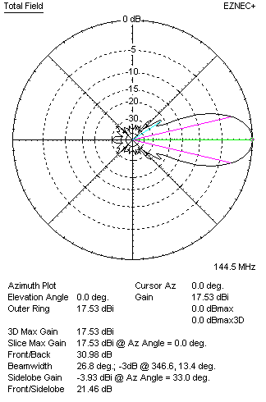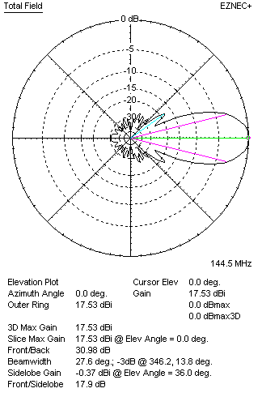
DIAGRAMS (loss included)
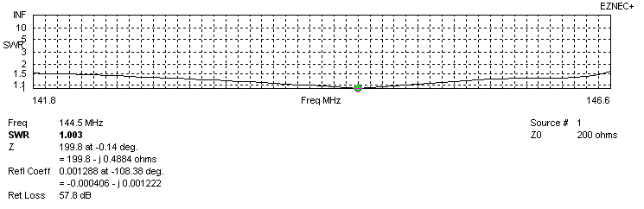
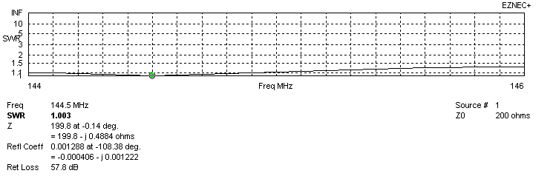
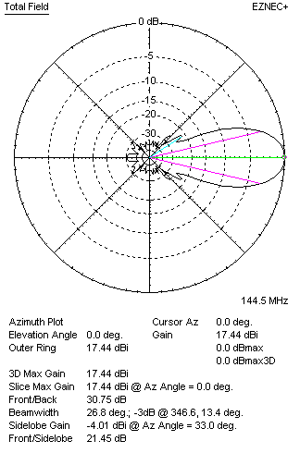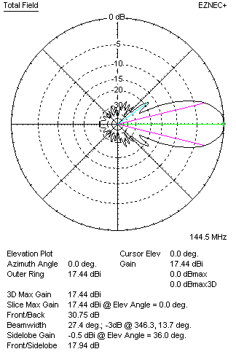
STACKING

QY21706XL2D10 - STACKING TABLE
(including loss for aluminum – AGT = -0.10 dB)
VERTICAL  DISTANCE (cm) | G  (dB) | TA  (°K) | G/T  (dB) | HORIZONTAL  DISTANCE (cm) | G  (dB) | TA  (°K) | G/T  (dB)
100 | 17.53 | 232.9 | -6.14 | 100
110 | 17.94 | 224.5 | -5.57 | 110
120 | 18.21 | 220.5 | -5.22 | 120 | 17.48 | 244.2 | -6.40
130 | 18.39 | 218.7 | -5.01 | 130 | 17.93 | 236.0 | -5.80
140 | 18.53 | 217.5 | -4.85 | 140 | 18.23 | 229.1 | -5.37
150 | 18.64 | 216.1 | -4.71 | 150 | 18.43 | 225.3 | -5.10
160 | 18.74 | 214.9 | -4.58 | 160 | 18.58 | 223.3 | -4.91
170 | 18.83 | 214.2 | -4.48 | 170 | 18.69 | 222.3 | -4.78
180 | 18.91 | 213.8 | -4.39 | 180 | 18.78 | 221.8 | -4.68
190 | 18.98 | 213.6 | -4.32 | 190 | 18.86 | 221.4 | -4.59
200 | 19.06 | 213.6 | -4.24 | 200 | 18.93 | 221.3 | -4.52
210 | 19.13 | 213.8 | -4.17 | 210 | 19.00 | 221.2 | -4.45
220 | 19.19 | 214.2 | -4.12 | 220 | 19.07 | 221.0 | -4.37
230 | 19.25 | 214.7 | -4.07 | 230 | 19.13 | 220.9 | -4.31
240 | 19.31 | 215.4 | -4.02 | 240 | 19.19 | 220.7 | -4.25
250 | 19.37 | 216.3 | -3.98 | 250 | 19.25 | 220.5 | -4.18
260 | 19.42 | 217.2 | -3.95 | 260 | 19.31 | 220.2 | -4.12
270 | 19.47 | 218.1 | -3.92 | 270 | 19.37 | 219.7 | -4.05
280 | 19.52 | 218.9 | -3.88 | 280 | 19.43 | 219.2 | -3.98
290 | 19.57 | 219.5 | -3.84 | 290 | 19.49 | 218.7 | -3.91
300 | 19.63 | 219.8 | -3.79 | 300 | 19.55 | 218.0 | -3.84
310 | 19.68 | 219.8 | -3.74 | 310 | 19.61 | 217.4 | -3.76
320 | 19.74 | 219.6 | -3.68 | 320 | 19.67 | 216.8 | -3.69
330 | 19.79 | 219.2 | -3.62 | 330 | 19.72 | 216.3 | -3.63
340 | 19.85 | 218.8 | -3.55 | 340 | 19.78 | 215.7 | -3.56
350 | 19.91 | 218.4 | -3.48 | 350 | 19.84 | 215.3 | -3.49
360 | 19.96 | 218.0 | -3.42 | 360 | 19.89 | 215.0 | -3.43
370 | 20.02 | 217.6 | -3.36 | 370 | 19.95 | 214.8 | -3.37
380 | 20.07 | 217.2 | -3.30 | 380 | 20.00 | 214.6 | -3.32
390 | 20.11 | 216.9 | -3.25 | 390 | 20.05 | 214.5 | -3.26
400 | 20.16 | 216.5 | -3.20 | 400 | 20.09 | 214.5 | -3.22
410 | 20.20 | 216.2 | -3.15 | 410 | 20.13 | 214.5 | -3.18
420 | 20.24 | 215.8 | -3.10 | 420 | 20.17 | 214.5 | -3.14
430 | 20.28 | 215.5 | -3.05 | 430 | 20.21 | 214.6 | -3.11
440 | 20.32 | 215.1 | -3.01 | 440 | 20.24 | 214.6 | -3.08
450 | 20.35 | 214.7 | -2.97 | 450 | 20.27 | 214.6 | -3.05
460 | 20.38 | 214.3 | -2.93 | 460 | 20.30 | 214.6 | -3.02
470 | 20.40 | 213.9 | -2.90 | 470 | 20.32 | 214.7 | -3.00
480 | 20.43 | 213.5 | -2.86 | 480 | 20.34 | 214.6 | -2.98
490 | 20.45 | 213.1 | -2.84 | 490 | 20.36 | 214.6 | -2.96
500 | 20.46 | 212.7 | -2.82 | 500 | 20.38 | 214.6 | -2.94
510 | 20.48 | 212.4 | -2.79 | 510 | 20.39 | 214.6 | -2.93
520 | 20.49 | 212.0 | -2.77 | 520 | 20.40 | 214.6 | -2.92
530 | 20.50 | 211.8 | -2.76 | 530 | 20.41 | 214.6 | -2.91
540 | 20.51 | 211.6 | -2.75 | 540 | 20.42 | 214.7 | -2.90
550 | 20.52 | 211.6 | -2.73 | 550 | 20.42 | 214.8 | -2.90
560 | 20.52 | 211.6 | -2.74 | 560 | 20.43 | 215.0 | -2.89
Remark: brown colour letters show not consistent data!

TWO ANTENNAS VERTICALLY STACKED AT 550CM
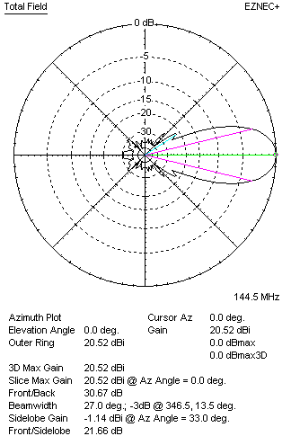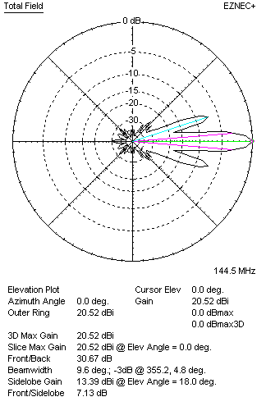

Performances
TYPE | Condition | G  (dBi) | F/B  (dB) | F/Sh  (dBi) | F/Sv (dBi) | Hor  (◦) | Ver  (◦) | Temp (◦K) | G/T (dB) | B (MHz)  for SWR=1.5
2xQY21606XL2D9 | No loss | 20.62 | 30.91 | 21.68 | 7.11 | 27.0 | 9.6 | 209.4 | -2.59 | 141.850 – 146.550
2xQY21606XL2D9 | Aluminum | 20.52 | 30.67 | 21.66 | 7.13 | 27.0 | 9.6 | 211.6 | -2.73 | 141.850 – 146.550

FOUR ANTENNAS VERTICALLY STACKED AT 550+550+550 CM
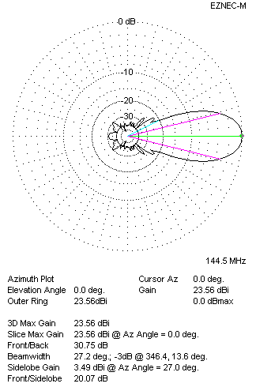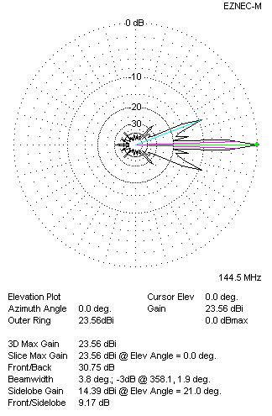
Performances
TYPE | Condition | G  (dBi) | F/B  (dB) | F/Sh  (dBi) | F/Sv (dBi) | Hor  (◦) | Ver  (◦) | Temp (◦K) | G/T (dB) | B (MHz)  for SWR=1.5
4xQY21606XL2D9 | No losss | 23.66 | 30.97 | 20.05 | 9.14 | 27.2 | 3.8 | 209.2 | +0.45 | 141.850 – 146.550
4xQY21606XL2D9 | Aluminum | 23.56 | 30.75 | 20.07 | 9.17 | 27.2 | 3.8 | 211.4 | +0.31 | 141.850 – 146.550

FOUR ANTENNAS IN H- STACK, H=540 CM, V=550 CM
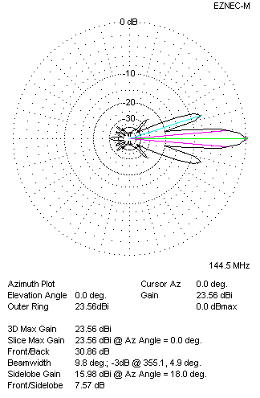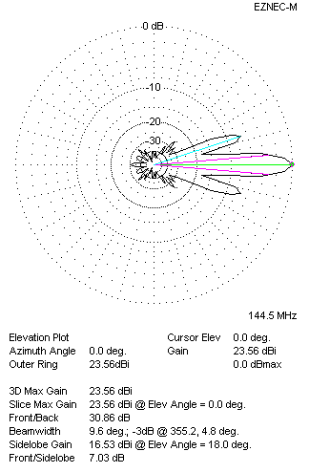
Performances
TYPE | Condition | G  (dBi) | F/B  (dB) | F/Sh  (dBi) | F/Sv (dBi) | Hor  (◦) | Ver  (◦) | Temp (◦K) | G/T (dB) | B (MHz)  for SWR=1.5
4xQY21606XL2D9 | No losss | 23.66 | 31.10 | 7.55 | 7.01 | 9.8 | 9.6 | 208.6 | +0.47 | 141.850 – 146.550
4xQY21606XL2D9 | Aluminum | 23.56 | 30.86 | 7.57 | 7.03 | 9.8 | 9.6 | 210.8 | +0.32 | 141.850 – 146.550

XPOL VERSION

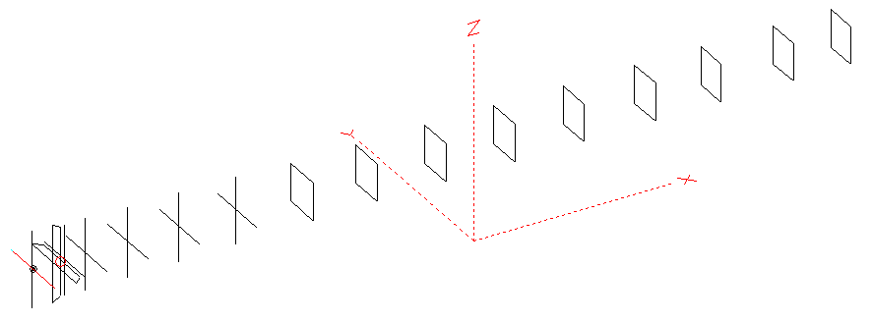
Horizontal components: Same as above
Vertical components: Same as above, except:
- All vertical yagi elements positioned 20 mm backward regarding horizontals.
- All crossed elements must cross each other in their centerlines

HORIZONTAL PERFORMANCES
Everything as the above data

VERTICAL PERFORMANCES with no corrections
Loss included condition (for Aluminum)
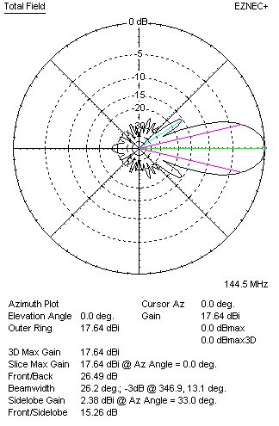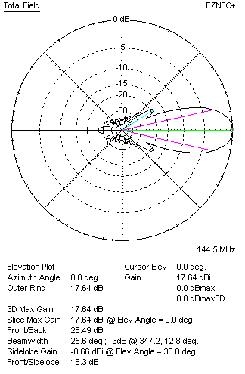
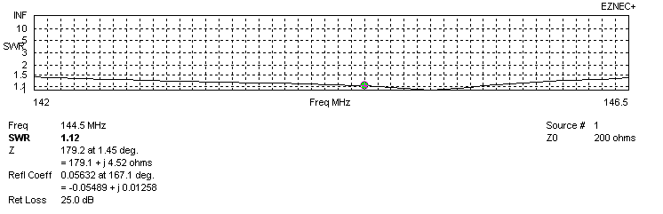
VERTICAL PERFORMANCES after corrections, loss included condition
If you want to get better SWR diagram for vertical antenna you can do the following:
- Change length of D1 from 944 to 940 mm
- Change length of D3 from 928 to 930 mm
- Change length of D4 from 914 to 912 mm
- Change length of D5 from 894 to 892 mm
- Change position of D1 for -14 mm
- Change position of D2 for -2 mm

In this case the SWR diagram will be like this:
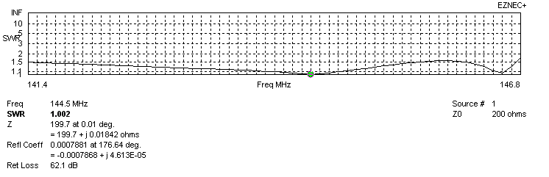
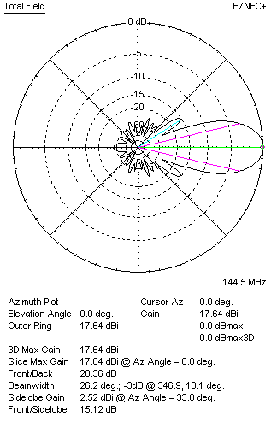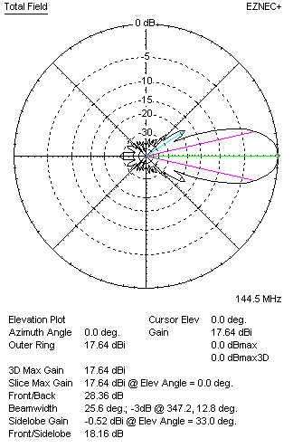

PERFORMANCES
 | TYPE | Condition | G  (dBi) | F/B  (dB) | F/Sh  (dBi) | F/Sv (dBi) | Hor  (◦) | Ver  (◦) | Temp (◦K) | G/T (dB) | B (MHz)  for SWR=1.5
 | Horizontal  part | No loss | 17.53 | 30.98 | 21.46 | 17.90 | 26.8 | 27.6 | 213.9 | -5.77 | 141.850 – 146.550
 | Horizontal  part | Aluminum | 17.44 | 30.75 | 21.45 | 17.94 | 26.8 | 27.4 | 215.9 | -5.90 | 141.850 – 146.550
 | Vertical  part | No losss | 17.74 | 28.41 | 15.12 | 18.15 | 26.2 | 25.6 | 217.0 | -5.62 | 141.400 – 146.750
 | Vertical  part | Aluminum | 17.64 | 28.36 | 15.12 | 18.16 | 26.2 | 25.6 | 219.0 | -5.76 | 141.400 – 146.750

