ANTENNA Y21610XL3D8
Good stacking characteristics at big vertical and horizontal distances. Not suitable for XPOL
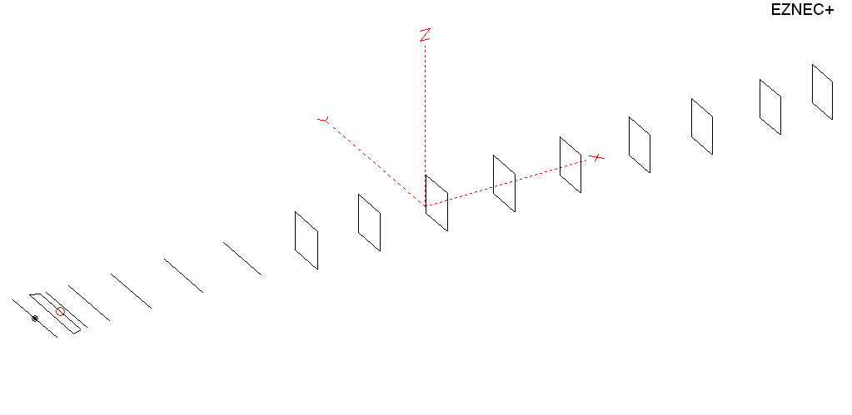
PERFORMANCES: (No loss condition)
TYPE | ELE | L (mm) | G (dBi) | F/B (dB) | F/Sh (dBi) | F/Sv (dBi) | Hor (◦) | Ver (◦) | Temp (◦K) | G/T (dB) | ΔF * (kHz)
QY21610XL3D8 | 16 | 10905 | 17.43 | 38.39 | 18.68 | 17.48 | 26.4 | 27.4 | 219.1 | -5.98 | 4850
* ΔF given for SWR=1,5

PERFORMANCES: (Loss included)
Element material | G (dBi) | Temp (◦K) | G/T (dB)
Aluminum rods | 17.37 | 220.3 | -6.06

DIMENSIONS:
 | Ref | De1 | De2 | D1 | D2 | D3 | D4 | D5 | DQ1 | DQ2 | DQ3 | DQ4 | DQ5 | DQ6 | DQ7 | DQ8 | DQ9
Pos | 0 | 390 | 455 | 560 | 926 | 1506 | 2235 | 3005 | 3815 | 4698 | 5565 | 6485 | 7389 | 8295 | 9215 | 10092 | 10905
Length | 1008 | 1008 | 880 | 932 | 932 | 912 | 892 | 882 | 864 | 538 | 524 | 518 | 510 | 504 | 494 | 486 | 470
REMARKS : All elements made of Al rods Ǿ10mm
The height of the rectangles 450mm
All dimensions given in milimetres
Building hints: No boom correction included.

COMPARISON
Antenna | Boomlength (mm) | Material | Gain (dBi) | TA (◦K) | G/T (dB) | Bandwidth  (MHz)
QY21610XL3D8 | 10905 | No loss | 17.43 | 219.1 | -5.98 | 141.800- 146.600
QY21610XL3D8 | 10905 | Aluminum | 17.37 | 220.3 | -6.06 | 141.800- 146.600

DIAGRAMS (no loss included)
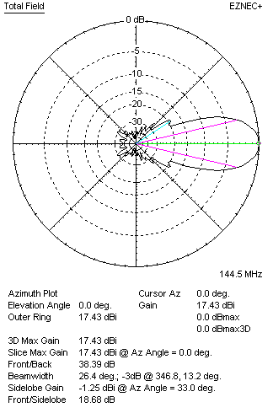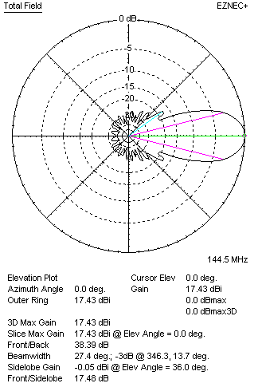
DIAGRAMS (loss included)
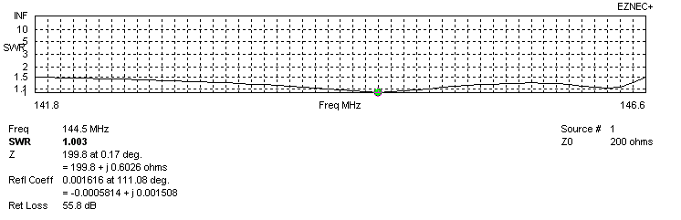
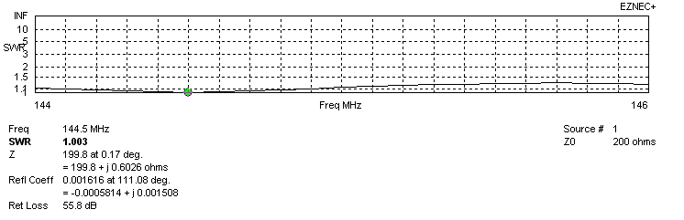
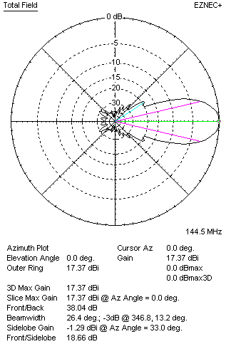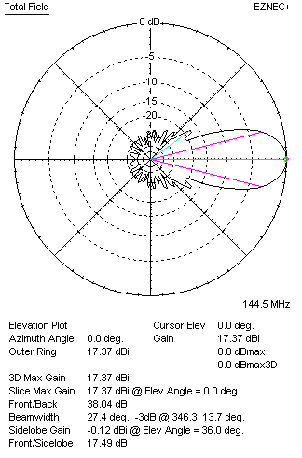
STACKING

QY21610XL3D8 - STACKING TABLE
(including loss for aluminum – AGT = -0.06 dB)
VERTICAL  DISTANCE (cm) | G  (dB) | TA  (°K) | G/T  (dB) | HORIZONTAL  DISTANCE (cm) | G  (dB) | TA  (°K) | G/T  (dB)
100 | 17.36 | 233.6 | -6.32 | 100
110 | 17.71 | 226.5 | -5.84 | 110
120 | 17.95 | 224.6 | -5.56 | 120 | 17.05 | 237.9 | -6.71
130 | 18.11 | 226.7 | -5.44 | 130 | 17.57 | 239.4 | -6.22
140 | 18.23 | 229.9 | -5.39 | 140 | 17.91 | 237.5 | -5.85
150 | 18.35 | 229.6 | -5.26 | 150 | 18.15 | 234.3 | -5.55
160 | 18.48 | 225.6 | -5.05 | 160 | 18.34 | 231.7 | -5.31
170 | 18.61 | 221.6 | -4.85 | 170 | 18.49 | 229.8 | -5.12
180 | 18.72 | 219.2 | -4.69 | 180 | 18.62 | 228.6 | -4.97
190 | 18.82 | 217.9 | -4.56 | 190 | 18.73 | 227.6 | -4.84
200 | 18.91 | 217.2 | -4.46 | 200 | 18.83 | 227.0 | -4.73
210 | 19.00 | 217.0 | -4.36 | 210 | 18.92 | 226.5 | -4.63
220 | 19.08 | 217.1 | -4.29 | 220 | 19.00 | 226.0 | -4.54
230 | 19.15 | 217.5 | -4.22 | 230 | 19.08 | 225.6 | -4.45
240 | 19.22 | 218.1 | -4.17 | 240 | 19.15 | 225.3 | -4.38
250 | 19.29 | 219.1 | -4.12 | 250 | 19.22 | 224.9 | -4.30
260 | 19.35 | 220.1 | -4.08 | 260 | 19.29 | 224.4 | -4.22
270 | 19.41 | 221.2 | -4.04 | 270 | 19.35 | 223.9 | -4.15
280 | 19.47 | 222.1 | -4.00 | 280 | 19.42 | 223.3 | -4.07
290 | 19.53 | 222.7 | -3.95 | 290 | 19.48 | 222.7 | -4.00
300 | 19.60 | 222.9 | 3.88 | 300 | 19.54 | 222.1 | -3.92
310 | 19.66 | 222.9 | -3.82 | 310 | 19.60 | 221.4 | -3.85
320 | 19.72 | 222.7 | -3.76 | 320 | 19.66 | 220.7 | -3.78
330 | 19.78 | 222.5 | -3.69 | 330 | 19.72 | 220.1 | -3.71
340 | 19.84 | 222.6 | -3.63 | 340 | 19.78 | 219.5 | -3.64
350 | 19.89 | 222.8 | -3.59 | 350 | 19.84 | 219.1 | -3.57
360 | 19.94 | 223.2 | -3.55 | 360 | 19.90 | 218.6 | -3.50
370 | 19.99 | 223.3 | -3.50 | 370 | 19.95 | 218.3 | -3.44
380 | 20.04 | 223.0 | -3.44 | 380 | 20.00 | 218.1 | 3.39
390 | 20.09 | 222.4 | -3.38 | 390 | 20.05 | 218.0 | -3.33
400 | 20.14 | 221.7 | -3.32 | 400 | 20.10 | 217.9 | -3.28
410 | 20.18 | 221.0 | -3.26 | 410 | 20.14 | 217.9 | -3.24
420 | 20.22 | 220.4 | -3.21 | 420 | 20.18 | 217.9 | -3.20
430 | 20.26 | 219.8 | -3.16 | 430 | 20.21 | 218.0 | -3.17
440 | 20.29 | 219.2 | -3.12 | 440 | 20.24 | 218.1 | -3.15
450 | 20.32 | 218.7 | -3.08 | 450 | 20.27 | 218.1 | -3.12
460 | 20.34 | 218.1 | -3.05 | 460 | 20.30 | 218.2 | -3.09
470 | 20.36 | 217.5 | -3.01 | 470 | 20.32 | 218.3 | -3.07
480 | 20.38 | 216.9 | -2.98 | 480 | 20.34 | 218.3 | -3.05
490 | 20.40 | 216.3 | -2.95 | 490 | 20.36 | 218.4 | -3.03
500 | 20.42 | 215.8 | -2.92 | 500 | 20.38 | 218.4 | -3.01
510 | 20.43 | 215.3 | -2.90 | 510 | 20.39 | 218.4 | -3.00
520 | 20.44 | 215.0 | -2.88 | 520 | 20.40 | 218.5 | -2.99
530 | 20.45 | 214.8 | -2.87 | 530 | 20.41 | 218.6 | -2.99
540 | 20.45 | 214.8 | -2.87 | 540 | 20.42 | 218.6 | -2.98
550 | 20.45 | 215.1 | -2.88 | 550 | 20.42 | 218.8 | -2.98
Remark: brown colour letters show not consistent data!

TWO ANTENNAS VERTICALLY STACKED AT 530CM
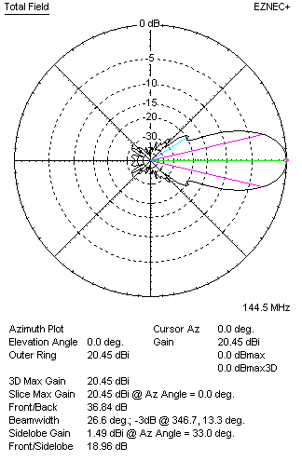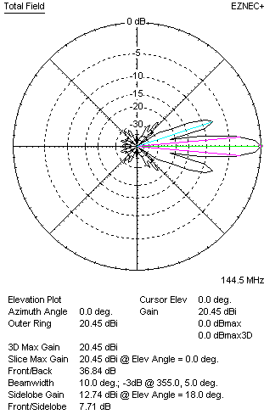

Performances
TYPE | Condition | G  (dBi) | F/B  (dB) | F/Sh  (dBi) | F/Sv (dBi) | Hor  (◦) | Ver  (◦) | Temp (◦K) | G/T (dB) | B (MHz)  for SWR=1.5
2xQY21610XL3D8 | No loss | 20.51 | 37.13 | 18.98 | 7.70 | 26.6 | 10.0 | 213.5 | -2.78 | 141.800- 146.600
2xQY21610XL3D8 | Aluminum | 20.45 | 36.84 | 18.96 | 7.71 | 26.6 | 10.0 | 214.8 | -2.87 | 141.800- 146.600

FOUR ANTENNAS VERTICALLY STACKED AT 530+530+530 CM
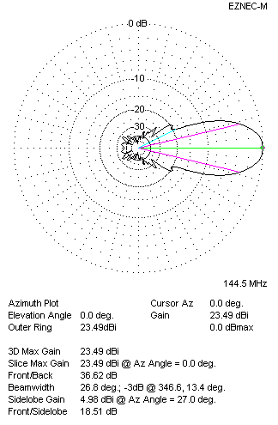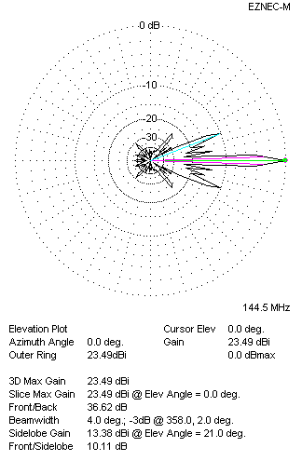
Performances
TYPE | Condition | G  (dBi) | F/B  (dB) | F/Sh  (dBi) | F/Sv (dBi) | Hor  (◦) | Ver  (◦) | Temp (◦K) | G/T (dB) | B (MHz)  for SWR=1.5
4xQY21610XL3D8 | No losss | 23.55 | 36.90 | 18.51 | 10.09 | 26.8 | 4.0 | 211.8 | +0.29 | 141.800- 146.600
4xQY21610XL3D8 | Aluminum | 23.49 | 36.62 | 18.51 | 10.11 | 26.8 | 4.0 | 213.1 | +0.20 | 141.800- 146.600

FOUR ANTENNAS IN H- STACK, H=540 CM, V=530 CM
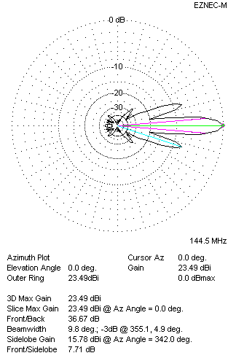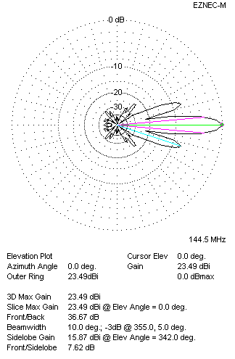
Performances
TYPE | Condition | G  (dBi) | F/B  (dB) | F/Sh  (dBi) | F/Sv (dBi) | Hor  (◦) | Ver  (◦) | Temp (◦K) | G/T (dB) | B (MHz)  for SWR=1.5
4xQY21610XL3D8 | No losss | 23.55 | 36.95 | 7.69 | 7.61 | 9.8 | 10.0 | 212.5 | +0.28 | 141.800- 146.600
4xQY21610XL3D8 | Aluminum | 23.49 | 36.67 | 7.71 | 7.62 | 9.8 | 10.0 | 213.8 | +0.19 | 141.800- 146.600

