ANTENNA Y21608XL3D9
Good stacking characteristics at big vertical and horizontal distances
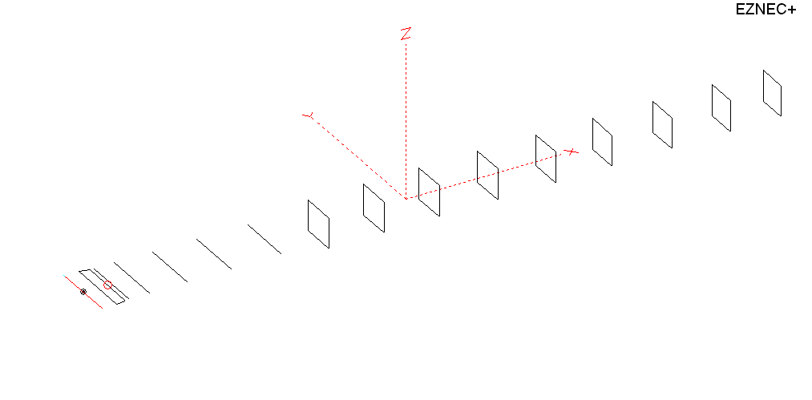
PERFORMANCES: (No loss condition)
TYPE | ELE | L (mm) | G (dBi) | F/B (dB) | F/Sh (dBi) | F/Sv (dBi) | Hor (◦) | Ver (◦) | Temp (◦K) | G/T (dB) | ΔF * (kHz)
QY21608XL3D9 | 16 | 10265 | 17.15 | 27.98 | 20.66 | 17.61 | 27.6 | 28.4 | 216.0 | -6.20 | 2950
* ΔF given for SWR=1.5

PERFORMANCES: (Losses included)
Element material | G (dBi) | Temp (◦K) | G/T (dB)
Aluminum rods | 17.06 | 217.8 | -6.32

DIMENSIONS:
 | Ref | De1 | De2 | D1 | D2 | D3 | D4 | D5 | DQ1 | DQ2 | DQ3 | DQ4 | DQ5 | DQ6 | DQ7 | DQ8 | DQ9
Pos | 0 | 205 | 335 | 416 | 704 | 1252 | 1936 | 2705 | 3525 | 4355 | 5223 | 6108 | 6965 | 7865 | 8679 | 9525 | 10265
Length | 1010 | 1000 | 890 | 944 | 952 | 924 | 904 | 890 | 524 | 504 | 500 | 486 | 478 | 470 | 464 | 458 | 438
REMARKS : All elements made of Al rods Ǿ8 mm
The height of the rectangles 500 mm
All dimensions given in milimetres
Building hints: No boom correction included.

COMPARISON
Antenna | Boomlength (mm) | Material | Gain (dBi) | TA (◦K) | G/T (dB) | Bandwidth  (MHz)
QY21608XL3D9 | 10265 | No loss | 17.15 | 216.0 | -6.20 | 143.100 - 146.050
QY21608XL3D9 | 10265 | Aluminum | 17.06 | 217.8 | -6.32 | 143.100 - 146.050
EF0215-06 | 10060 | No loss | 17.23 | 226.3 | -6.32 | 143.700 – 144.450
EF0215-06 | 10060 | Aluminum | 17.04 | 229.6 | -6.57 | 143.700 – 144.450
G0KSC  16ELKKA | 10696 | No loss | 17.06 | 209.8 | -6.16 | 143.000 – 145.260
G0KSC  16ELKKA | 10696 | Aluminum | 16.95 | 211.8 | -6.31 | 143.000 – 145.260

DIAGRAMS (no loss included)
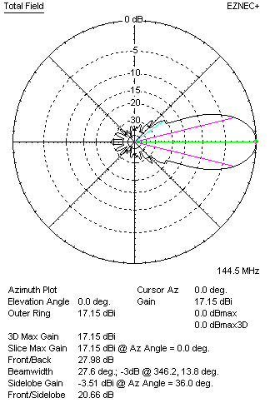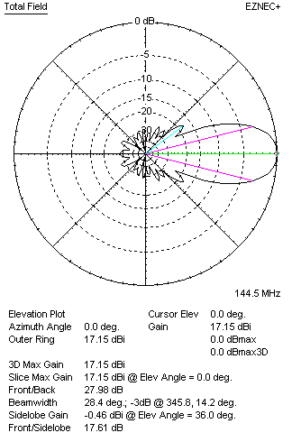
DIAGRAMS (loss included)
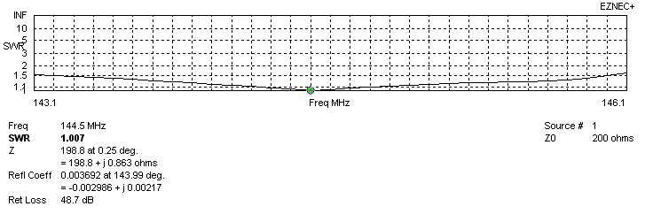
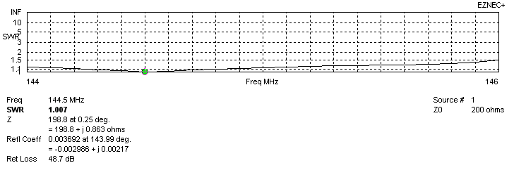
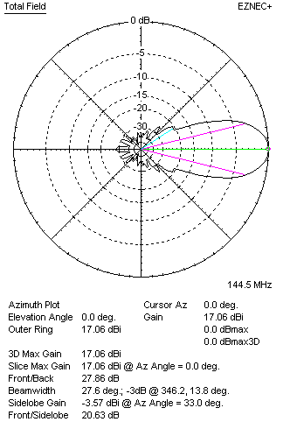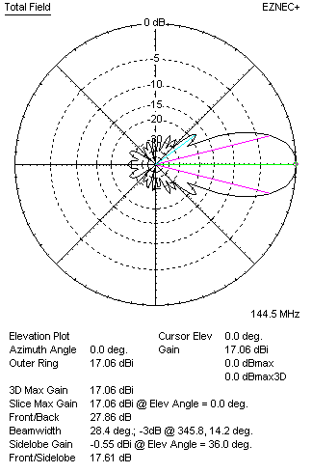
STACKING

QY21608XL3D9 - STACKING TABLE
(including loss for aluminum – AGT = -0.10 dB)
VERTICAL  DISTANCE (cm) | G  (dB) | TA  (°K) | G/T  (dB) | HORIZONTAL  DISTANCE (cm) | G  (dB) | TA  (°K) | G/T  (dB)
100 | 17.05 | 228.6 | -6.40 | 100
110 | 17.40 | 223.4 | -6.09 | 110
120 | 17.66 | 220.7 | -5.78 | 120 | 16.94 | 241.7 | -6.89
130 | 17.85 | 219.4 | -5.56 | 130 | 17.43 | 234.5 | -6.27
140 | 18.01 | 218.4 | -5.38 | 140 | 17.73 | 230.4 | -5.90
150 | 18.15 | 216.7 | -5.21 | 150 | 17.95 | 227.8 | -5.62
160 | 18.27 | 215.2 | -5.06 | 160 | 18.12 | 226.0 | -5.42
170 | 18.38 | 214.6 | -4.94 | 170 | 18.26 | 224.8 | -5.26
180 | 18.47 | 214.6 | -4.85 | 180 | 18.38 | 224.0 | -5.12
190 | 18.57 | 214.9 | -4.75 | 190 | 18.48 | 223.5 | -5.01
200 | 18.65 | 215.2 | -4.68 | 200 | 18.58 | 223.1 | -4.91
210 | 18.73 | 215.7 | -4.61 | 210 | 18.66 | 222.9 | -4.82
220 | 18.81 | 216.3 | -4.54 | 220 | 18.75 | 222.7 | -4.73
230 | 18.89 | 217.0 | -4.47 | 230 | 18.82 | 222.6 | -4.65
240 | 18.96 | 217.9 | -4.42 | 240 | 18.90 | 222.3 | -4.57
250 | 19.03 | 218.9 | -4.37 | 250 | 18.97 | 222.0 | -4.49
260 | 19.09 | 219.8 | -4.33 | 260 | 19.04 | 221.6 | -4.42
270 | 19.15 | 220.6 | -4.29 | 270 | 19.11 | 221.1 | -4.34
280 | 19.22 | 221.2 | -4.23 | 280 | 19.18 | 220.5 | -4.25
290 | 19.28 | 221.3 | -4.17 | 290 | 19.24 | 219.8 | -4.18
300 | 19.34 | 221.2 | -4.11 | 300 | 19.31 | 219.1 | -4.10
310 | 19.41 | 220.8 | -4.03 | 310 | 19.38 | 218.3 | -4.01
320 | 19.47 | 220.2 | -3.96 | 320 | 19.44 | 217.6 | -3.94
330 | 19.54 | 219.6 | -3.88 | 330 | 19.50 | 217.0 | -3.86
340 | 19.60 | 219.1 | -3.81 | 340 | 19.57 | 216.4 | -3.78
350 | 19.66 | 218.6 | -3.74 | 350 | 19.62 | 216.0 | -3.72
360 | 19.71 | 218.3 | -3.68 | 360 | 19.68 | 215.7 | -3.66
370 | 19.76 | 218.0 | -3.62 | 370 | 19.73 | 215.4 | -3.60
380 | 19.81 | 217.7 | -3.57 | 380 | 19.78 | 215.3 | -3.55
390 | 19.85 | 217.5 | -3.52 | 390 | 19.82 | 215.2 | -3.51
400 | 19.89 | 217.3 | -3.48 | 400 | 19.86 | 215.3 | -3.47
410 | 19.93 | 217.1 | -3.44 | 410 | 19.90 | 215.3 | -3.43
420 | 19.96 | 217.0 | -3.40 | 420 | 19.93 | 215.4 | -3.40
430 | 19.99 | 216.9 | -3.37 | 430 | 19.96 | 215.5 | -3.37
440 | 20.01 | 216.7 | -3.35 | 440 | 19.99 | 215.6 | -3.35
450 | 20.04 | 216.5 | -3.31 | 450 | 20.01 | 215.7 | -3.33
460 | 20.05 | 216.3 | -3.30 | 460 | 20.03 | 215.8 | -3.31
470 | 20.07 | 216.0 | -3.27 | 470 | 20.05 | 215.9 | -3.29
480 | 20.09 | 215.7 | -3.24 | 480 | 20.06 | 215.9 | -3.28
490 | 20.10 | 215.3 | -3.23 | 490 | 20.08 | 216.0 | -3.26
500 | 20.11 | 214.9 | -3.21 | 500 | 20.09 | 216.1 | -3.26
510 | 20.12 | 214.5 | -3.19 | 510 | 20.09 | 216.2 | -3.26
520 | 20.12 | 214.1 | -3.19 | 520 | 20.10 | 216.2 | -3.25
530 | 20.13 | 213.8 | -3.17 | 530 | 20.10 | 216.4 | -3.25
540 | 20.13 | 213.6 | -3.17 | 540 | 20.11 | 216.5 | -3.24
550 | 20.14 | 213.6 | -3.16 | 550 | 20.11 | 216.7 | -3.25
Remark: brown colour letters show not consistent data!

TWO ANTENNAS VERTICALLY STACKED AT 550CM
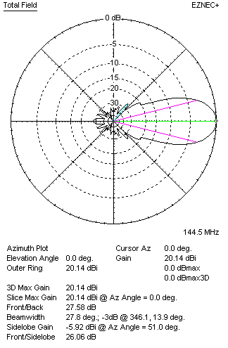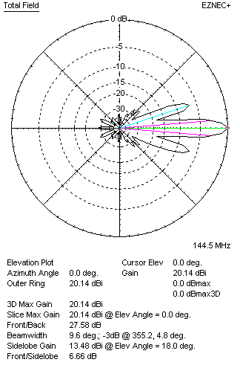

Performances
TYPE | Condition | G  (dBi) | F/B  (dB) | F/Sh  (dBi) | F/Sv (dBi) | Hor  (◦) | Ver  (◦) | Temp (◦K) | G/T (dB) | B (MHz)  for SWR=1.5
2xQY21608XL3D9 | No loss | 20.23 | 27.70 | 20.34 | 6.64 | 27.8 | 9.6 | 211.7 | -3.03 | 143.100 - 146.050
2xQY21608XL3D9 | Aluminum | 20.14 | 27.58 | 20.34 | 6.66 | 27.8 | 9.6 | 213.6 | -3.16 | 143.100 - 146.050

FOUR ANTENNAS VERTICALLY STACKED AT 550+550+550 CM
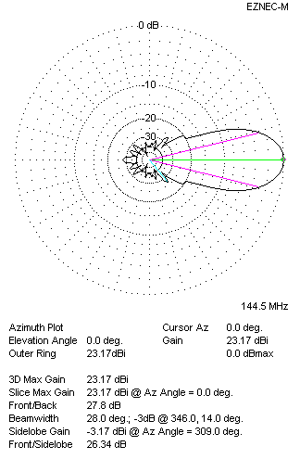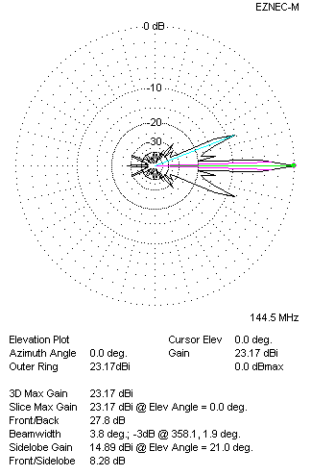
Performances
TYPE | Condition | G  (dBi) | F/B  (dB) | F/Sh  (dBi) | F/Sv (dBi) | Hor  (◦) | Ver  (◦) | Temp (◦K) | G/T (dB) | B (MHz)  for SWR=1.5
4xQY21608XL3D9 | No losss | 23.26 | 27.93 | 20.21 | 8.27 | 28.0 | 3.8 | 210.8 | +0.02 | 143.100 - 146.050
4xQY21608XL3D9 | Aluminum | 23.17 | 27.80 | 20.22 | 8.28 | 28.0 | 3.8 | 211.6 | -0.11 | 143.100 - 146.050

FOUR ANTENNAS IN H- STACK, H=520 CM, V=550 CM
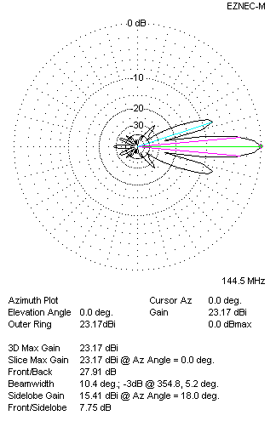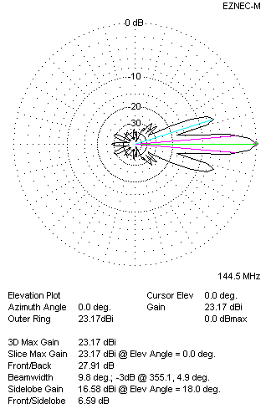
Performances
TYPE | Condition | G  (dBi) | F/B  (dB) | F/Sh  (dBi) | F/Sv (dBi) | Hor  (◦) | Ver  (◦) | Temp (◦K) | G/T (dB) | B (MHz)  for SWR=1.5
4xQY21608XL3D9 | No losss | 23.26 | 28.04 | 7.74 | 6.58 | 10.4 | 9.8 | 211.1 | +0.01 | 143.100 - 146.050
4xQY21608XL3D9 | Aluminum | 23.17 | 27.91 | 7.75 | 6.59 | 10.4 | 9.8 | 213.0 | -0.11 | 143.100 - 146.050

XPOL VERSION

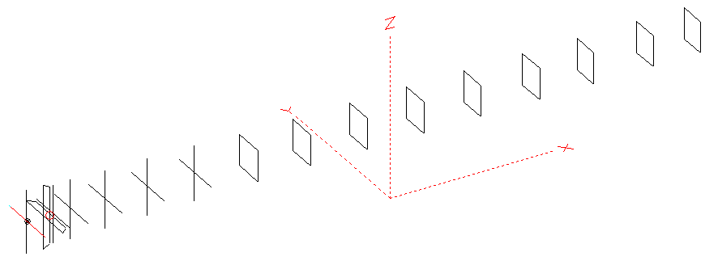
Horizontal components: Same as above
Vertical components: Same as above, except:
- All vertical yagi elements positioned 20 mm backward regarding horizontals.
- All crossed elements must cross each other in their centerlines

HORIZONTAL PERFORMANCES
Everything as the above data

VERTICAL PERFORMANCES with no corrections
Loss included condition (for Aluminum)
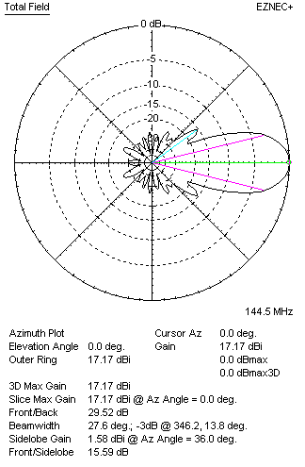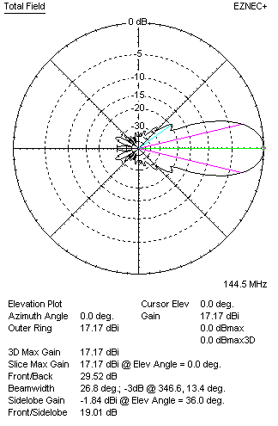
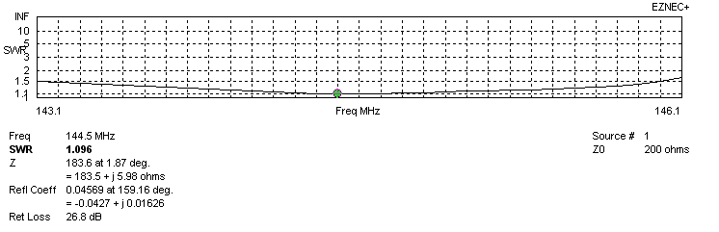
VERTICAL PERFORMANCES after corrections, loss included condition
If you want to get better SWR diagram for vertical antenna you can do the following:
- Change length of DE2 from 890 to 900 mm
- Change length of D3 from 924 to 922 mm
- Change length of D4 from 904 to 902 mm

In this case the SWR diagram will be like this:
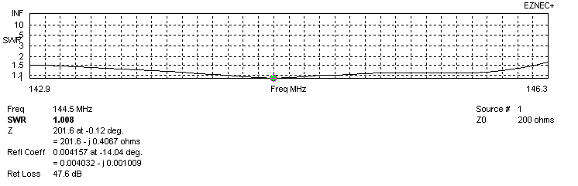
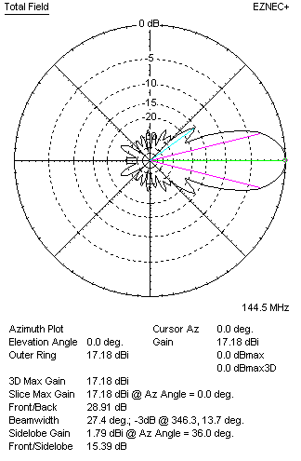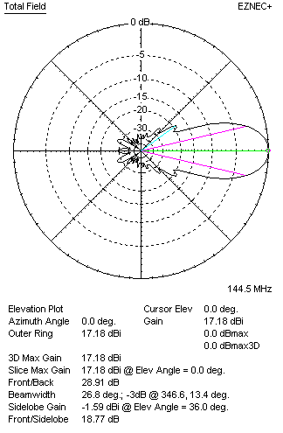

PERFORMANCES
 | TYPE | Condition | G  (dBi) | F/B  (dB) | F/Sh  (dBi) | F/Sv (dBi) | Hor  (◦) | Ver  (◦) | Temp (◦K) | G/T (dB) | B (MHz)  for SWR=1.5
 | Horizontal  part | No loss | 17.15 | 27.98 | 20.66 | 17.61 | 27.6 | 28.4 | 216.0 | -6.20 | 143.100 - 146.050
 | Horizontal  part | Aluminum | 17.06 | 27.86 | 20.63 | 17.61 | 27.6 | 28.4 | 217.8 | -6.32 | 143.100 - 146.050
 | Vertical  part | No losss | 17.26 | 29.05 | 15.37 | 18.75 | 27.6 | 26.8 | 221.6 | -6.20 | 142.900 – 146.200
 | Vertical  part | Aluminum | 17.18 | 28.91 | 15.39 | 18.77 | 27.4 | 26.8 | 223.2 | -6.31 | 142.900 – 146.200

