ANTENNA Y21510XL4D8
Good stacking characteristics at big vertical and horizontal distances
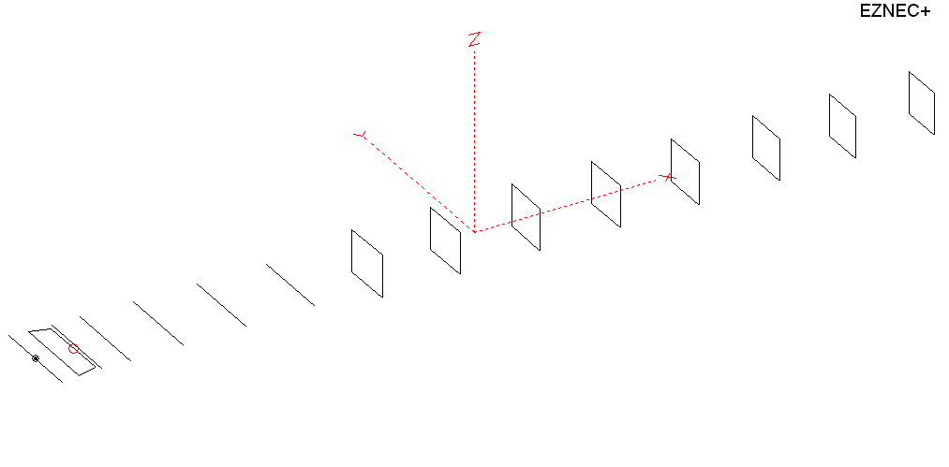
PERFORMANCES: (No loss condition)
TYPE | ELE | L (mm) | G (dBi) | F/B (dB) | F/Sh (dBi) | F/Sv (dBi) | Hor (◦) | Ver (◦) | Temp (◦K) | G/T (dB) | ΔF * (kHz)
Y21510XL4D8 | 15 | 9455 | 16.94 | 27.78 | 19.52 | 17.12 | 28.0 | 29.0 | 219.1 | -6.47 | 3850
* ΔF given for SWR=1,5

PERFORMANCES: (Loss included)
Element material | G (dBi) | Temp (◦K) | G/T (dB)
Aluminum rods | 16.87 | 220.4 | -6.56

DIMENSIONS:
 | Ref | De1 | De2 | D1 | D2 | D3 | D4 | D5 | DQ1 | DQ2 | DQ3 | DQ4 | DQ5 | DQ6 | DQ7 | DQ8
Pos | 0 | 205 | 335 | 416 | 706 | 1255 | 1939 | 2705 | 3535 | 4355 | 5233 | 6118 | 6981 | 7888 | 8815 | 9455
Length | 1009 | 1010 | 940 | 938 | 945 | 917 | 898 | 877 | 522 | 502 | 498 | 486 | 478 | 472 | 466 | 456
REMARKS : All elements made of Al rods Ǿ10mm
The height of the rectangles 500mm
All dimensions given in milimetres
Building hints: No boom correction included.
COMPARISON
Antenna | Boomlength (mm) | Material | Gain (dBi) | TA (◦K) | G/T (dB) | Bandwidth  (MHz)
Y21510XL4D8 | 9455 | No loss | 16.94 | 219.3 | -6.48 | 142.300- 146.150
Y21510XL4D8 | 9455 | Aluminum | 16.87 | 220.4 | -6.56 | 142.300- 146.150
G0KSC  14ELJJB | 9757 | No loss | 16.83 | 213.7 | -6.47 | 142.850- 145.320
G0KSC  14ELJJB | 9757 | Aluminum | 16.74 | 215.5 | -6.59 | 142.850- 145.320
EF0215-5 | 10060 | No loss | 17.23 | 226.3 | -6.32 | 143.700 - 144.450
EF0215-5 | 10060 | Aluminum | 17.04 | 229.6 | -6.57 | 143.700 - 144.450

DIAGRAMS (no loss included)
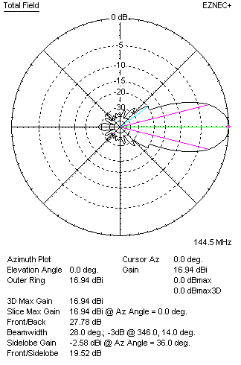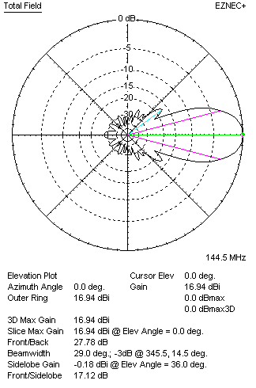
DIAGRAMS (loss included)
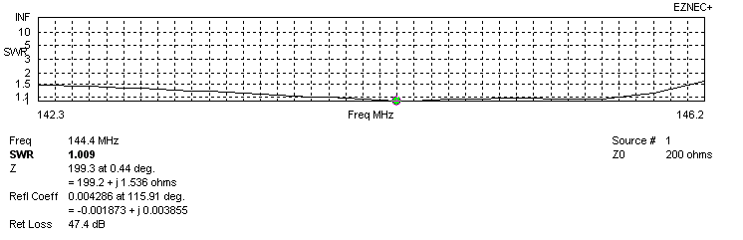
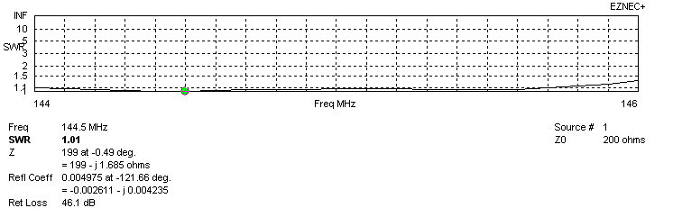
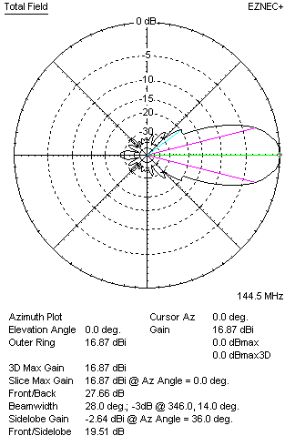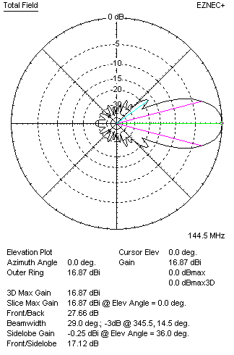
STACKING

QY21510XL4D8 STACKING TABLE
(including loss for aluminum – AGT = -0.09 dB)
VERTICAL  DISTANCE (cm) | G  (dB) | TA  (°K) | G/T  (dB) | HORIZONTAL  DISTANCE (cm) | G  (dB) | TA  (°K) | G/T  (dB)
100 | 16.80 | 230.4 | -6.83 | 100
110 | 17.18 | 224.4 | -6.33 | 110
120 | 17.44 | 221.1 | -6.01 | 120 | 16.77 | 241.7 | -7.06
130 | 17.65 | 219.3 | -5.76 | 130 | 17.24 | 235.8 | -6.49
140 | 17.82 | 218.0 | -5.56 | 140 | 17.54 | 232.1 | -6.12
150 | 17.96 | 216.3 | -5.39 | 150 | 17.76 | 229.7 | -5.85
160 | 18.09 | 214.9 | -5.23 | 160 | 17.93 | 228.1 | -5.65
170 | 18.20 | 214.3 | -5.11 | 170 | 18.07 | 227.0 | -5.49
180 | 18.31 | 214.2 | -5.00 | 180 | 18.20 | 226.4 | -5.35
190 | 18.40 | 214.6 | -4.92 | 190 | 18.30 | 226.0 | -5.24
200 | 18.49 | 215.2 | -4.84 | 200 | 18.40 | 225.8 | -5.14
210 | 18.57 | 216.2 | -4.78 | 210 | 18.49 | 225.7 | -5.04
220 | 18.64 | 217.4 | -4.73 | 220 | 18.57 | 225.6 | -4.96
230 | 18.72 | 218.8 | -4.68 | 230 | 18.65 | 225.4 | -4.88
240 | 18.78 | 220.4 | -4.65 | 240 | 18.72 | 225.1 | -4.80
250 | 18.85 | 221.9 | -4.61 | 250 | 18.80 | 224.7 | -4.72
260 | 18.91 | 223.4 | -4.58 | 260 | 18.87 | 224.1 | -4.64
270 | 18.97 | 224.4 | -4.54 | 270 | 18.94 | 223.5 | -4.55
280 | 19.04 | 225.0 | -4.48 | 280 | 19.01 | 222.6 | -4.47
290 | 19.10 | 225.1 | -4.42 | 290 | 19.08 | 221.8 | -4.38
300 | 19.17 | 224.9 | -4.35 | 300 | 19.15 | 220.9 | -4.29
310 | 19.24 | 224.3 | -4.27 | 310 | 19.21 | 220.1 | -4.22
320 | 19.31 | 223.6 | -4.18 | 320 | 19.28 | 219.3 | -4.13
330 | 19.37 | 222.8 | -4.11 | 330 | 19.34 | 218.6 | -4.06
340 | 19.44 | 222.0 | -4.02 | 340 | 19.40 | 218.1 | -3.99
350 | 19.50 | 221.4 | -3.95 | 350 | 19.46 | 217.6 | -3.92
360 | 19.55 | 220.9 | -3.89 | 360 | 19.52 | 217.4 | -3.85
370 | 19.60 | 220.5 | -3.83 | 370 | 19.57 | 217.2 | -3.80
380 | 19.65 | 220.2 | -3.78 | 380 | 19.62 | 217.2 | -3.75
390 | 19.69 | 219.9 | -3.73 | 390 | 19.66 | 217.2 | -3.71
400 | 19.73 | 219.8 | -3.69 | 400 | 19.70 | 217.3 | -3.67
410 | 19.77 | 219.6 | -3.65 | 410 | 19.73 | 217.5 | -3.64
420 | 19.79 | 219.5 | -3.62 | 420 | 19.76 | 217.7 | -3.62
430 | 19.82 | 219.4 | -3.59 | 430 | 19.79 | 217.8 | -3.59
440 | 19.84 | 219.1 | -3.57 | 440 | 19.81 | 218.0 | -3.58
450 | 19.86 | 218.9 | -3.54 | 450 | 19.83 | 218.2 | -3.56
460 | 19.88 | 218.5 | -3.52 | 460 | 19.85 | 218.4 | -3.54
470 | 19.89 | 218.1 | -3.50 | 470 | 19.86 | 218.5 | -3.53
480 | 19.90 | 217.7 | -3.48 | 480 | 19.88 | 218.7 | -3.52
490 | 19.91 | 217.2 | -3.46 | 490 | 19.89 | 218.8 | -3.51
500 | 19.92 | 216.7 | -3.44 | 500 | 19.89 | 219.0 | -3.51
510 | 19.93 | 216.2 | -3.42 | 510 | 19.90 | 219.2 | -3.51
520 | 19.93 | 215.8 | -3.41 | 520 | 19.91 | 219.3 | -3.50
530 | 19.94 | 215.6 | -3.40 | 530 | 19.91 | 129.5 | -3.51
540 | 19.94 | 215.5 | -3.40 | 540
550 | 19.94 | 215.6 | -3.40 | 550
Remark: brown colour letters show not consistent data!

TWO ANTENNAS VERTICALLY STACKED AT 530CM
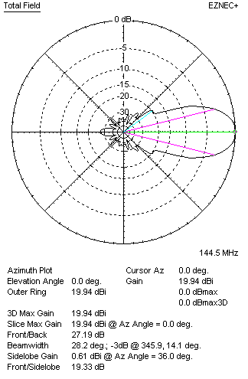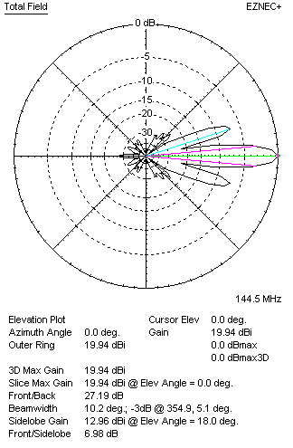

Performances
TYPE | Condition | G  (dBi) | F/B  (dB) | F/Sh  (dBi) | F/Sv (dBi) | Hor  (◦) | Ver  (◦) | Temp (◦K) | G/T (dB) | B (MHz)  for SWR=1.5
2xQY21510XL4D8 | No losss | 20.01 | 27.30 | 19.33 | 6.97 | 28.4 | 10.2 | 214.2 | -3.30 | 142.300- 146.150
2xQY21510XL4D8 | Aluminum | 19.94 | 27.19 | 19.33 | 6.98 | 28.2 | 10.2 | 215.6 | -3.40 | 142.300- 146.150

FOUR ANTENNAS VERTICALLY STACKED AT 490+490+490 CM
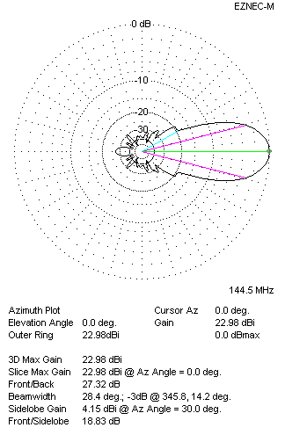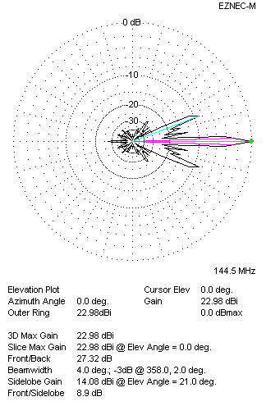
Performances
TYPE | Condition | G  (dBi) | F/B  (dB) | F/Sh  (dBi) | F/Sv (dBi) | Hor  (◦) | Ver  (◦) | Temp (◦K) | G/T (dB) | B (MHz)  for SWR=1.5
4xQY21510XL4D8 | No losss | 23.05 | 27.43 | 18.85 | 8.88 | 28.4 | 4.0 | 212.3 | -0.22 | 142.300- 146.150
4xQY21510XL4D8 | Aluminum | 22.98 | 27.32 | 18.83 | 8.90 | 28.4 | 4.0 | 213.8 | -0.32 | 142.300- 146.150

FOUR ANTENNAS IN H- STACK, H=490 CM, V=480 CM
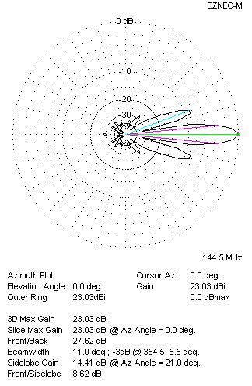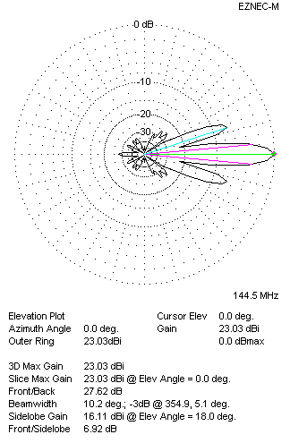
Performances
TYPE | Condition | G  (dBi) | F/B  (dB) | F/Sh  (dBi) | F/Sv (dBi) | Hor  (◦) | Ver  (◦) | Temp (◦K) | G/T (dB) | B (MHz)  for SWR=1.5
4xQY21510XL4D8 | No losss | 23.03 | 27.62 | 8.62 | 6.92 | 11.0 | 10.2 | 213.9 | -0.27 | 142.300- 146.150
4xQY21510XL4D8 | Aluminum | 22.96 | 27.50 | 8.63 | 6.93 | 11.0 | 10.2 | 215.3 | -0.37 | 142.300- 146.150

XPOL VERSION

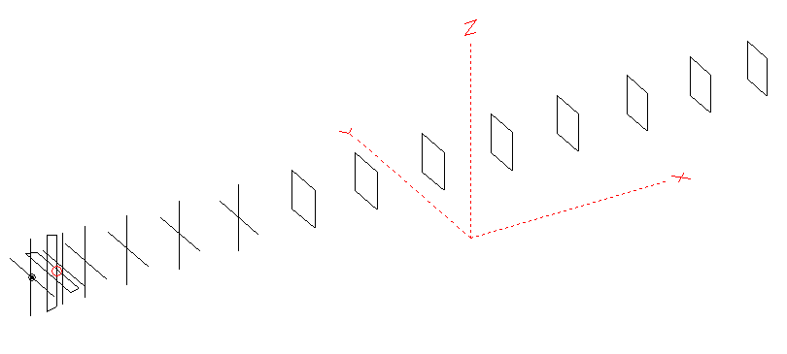
Horizontal components: Same as above
Vertical components: Same as above, except:
- All vertical yagi elements positioned 20 mm backward regarding horizontals.
- All crossed elements must cross each other in their centerlines

HORIZONTAL PERFORMANCES
Everything as the above data

VERTICAL PERFORMANCES with no corrections
Loss included condition (for Aluminum)
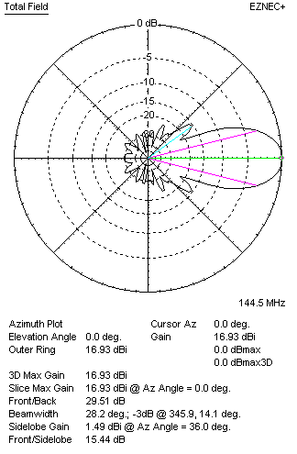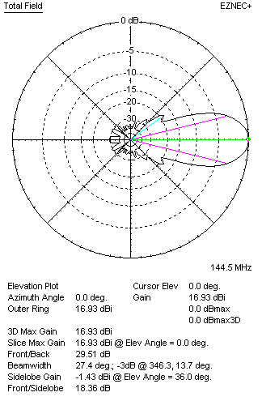
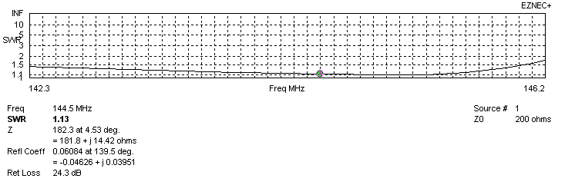
VERTICAL PERFORMANCES after corrections, loss included condition
If you want to get better SWR diagram for vertical antenna you can do the following:
- Change length of DE2 from 940 to 954 mm
- Change length of D2 from 945 to 944 mm
- Change length of D3 from 917 to 914 mm
- Change length of D4 from 898 to 894 mm
- Change length of D5 from 877 to 876 mm

In this case the SWR diagram will be like this:
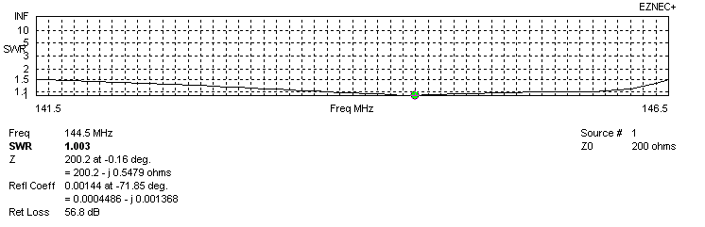
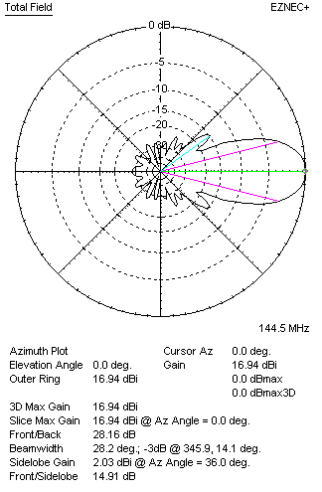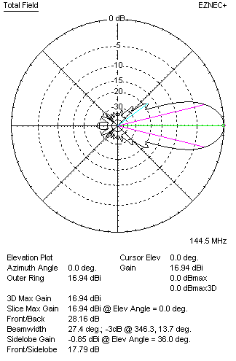

PERFORMANCES
 | TYPE | Condition | G  (dBi) | F/B  (dB) | F/Sh  (dBi) | F/Sv (dBi) | Hor  (◦) | Ver  (◦) | Temp (◦K) | G/T (dB) | B (MHz)  for SWR=1.5
 | Horizontal  part | No losss | 16.94 | 27.78 | 19.52 | 17.12 | 28.0 | 29.0 | 219.1 | -6.47 | 142.300- 146.150
 | Horizontal  part | Aluminum | 16.87 | 27.63 | 19.52 | 17.12 | 28.0 | 29.0 | 220.4 | -6.56 | 142.300- 146.150
 | Vertical  part | No losss | 17.01 | 28.29 | 14.92 | 17.80 | 28.2 | 27.4 | 222.2 | -6.46 | 141.100 – 146.600
 | Vertical  part | Aluminum | 16.94 | 28.16 | 14.91 | 17.79 | 28.2 | 27.4 | 223.4 | -6.55 | 141.100 – 146.600

